**Hari seth**

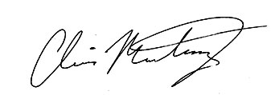



**Signature of Instructor:** __________________________________________________________________________________

**Signature of Qualified Manager:** ___________________________________________________________________________

Texas Department of Public Safety – Texas Private Security Board

**Private Security Program**

**Certificate of Completion**

**Level Two Training Course**

**This certificate is issued as proof that**

---------------------------------------------------------------------------------------------------------------------------------------------------------------------------------------------------------------------

(Please print or type name and Registration Number or social security number (last 6 digits) of student)

**Date of completion: 2/3/2017**

**Name of Instructor**: _____________________________________________________________________________________

**Name of Qualified Manager:** ______________________________________________________________________________

**School or Company Name: Contemporary Services Corporation**

**School Approval or Company License Number: B08726**

**Has successfully completed the Board approved, PSP Level Two Training Course**

**To meet the standards and requirements set forth in Texas Occupations Code,**

**Section 1702, Title 10 and Administrative Rules.**