**INITIAL ERD:**

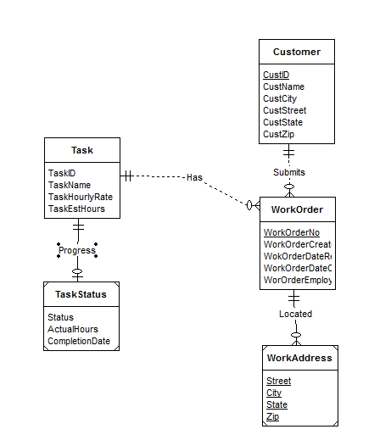

Customer, WorkOrder and Task entities are given in the narrative. Weak entities WorkAddress and TaskStatus provides additional information about WorkOrder and Task connected by identifying relationship. M-1 relationship to connect WorkOrders to Customer. 1-M relationship from Task to WorkOrders. TaskStatus to connect to each task using identifying relationship.

**REVISED ERD:**

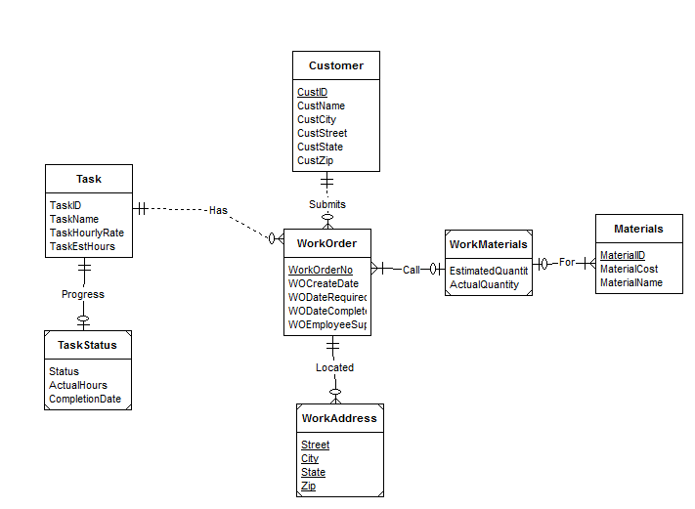

Edits:

1. Materials is added which connects to WorkOrders via weak entity WorkMaterials and identifying relationship.