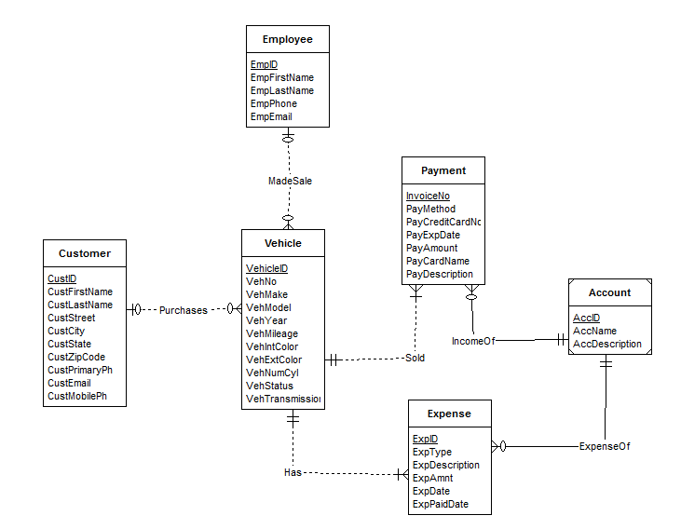

Errors:

1. Customer entity requires both primary and cell phone number
2. Process relationship is redundant
3. IncomeOf should have single and mandatory account since Account entity is a weak entity.
4. ExpenseOf connection to Account should be mandatory and single. Connection to ExpenseOf should be multiple and optional..
5. Purchases relationship should not have a mandatory customer.