**Given ERD Diagram:**

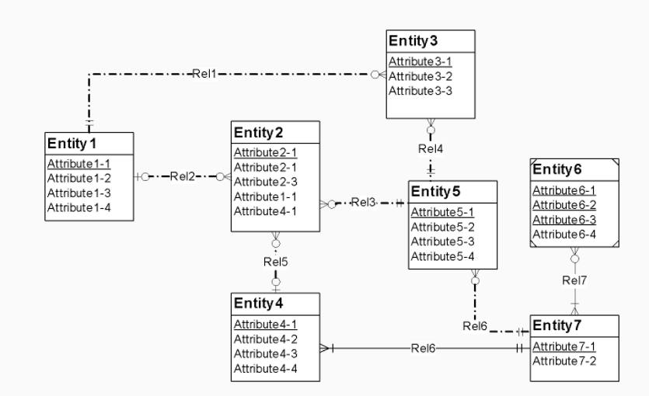

**ERD Rule Violations:**

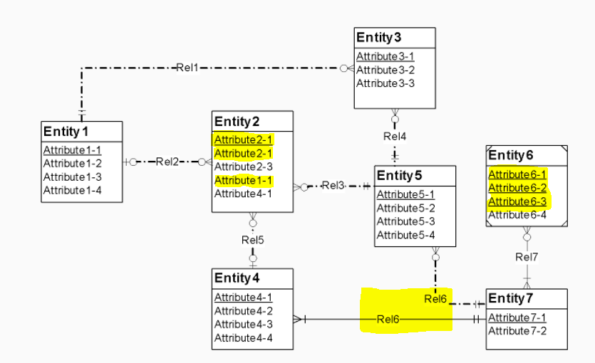

1. Weak Entity “Entity 6” has 3 primary keys.
2. Unique key violation for Attribute2-1 in Entity2
3. Identifying relationship violation for ‘Rel6’
4. ‘Attribute 1-1’ in “Entity2” is redundant foreign key.