**Write a C program to simulate disk scheduling algorithms**  
  
a)  FCFS  
b)    SCAN  
c)  C-SCAN

#include<stdio.h>

#include<conio.h>

int head,a[20],range,n;

void fcfs()

{

int headm=0,temp,i;

for(i=0;i<n;i++)

{

if(i==0)

{

if(a[i]<head)

headm=headm+(head-a[i]);

else

headm=headm+(a[i]-head);

}

else

{

if(a[i-1]<a[i])

headm=headm+(a[i]-a[i-1]);

else

headm=headm+(a[i-1]-a[i]);

}

}

printf("\nFCFS-Total head movement=%d\n",headm);

}

void scan()

{

int headm=0,i,dir,temp,cnt=0;

printf("\nEnter the direction, upward/right=1, downward/left=-1:");

scanf("%d",&dir);

if(dir==1)

{

for(i=0;i<n;i++)

{

if(a[i]<head)

{

cnt++;

continue;

}

else if(i==cnt)

headm=headm+(a[i]-head);

else

headm=headm+(a[i]-a[i-1]);

}

headm=headm+(range-a[i-1]);

headm+=(range-a[cnt-1]);

for(i=cnt-1;i>0;i--)

{

headm+=(a[i]-a[i-1]);

}

}

else

{

for(i=0;i<n;i++)

{

if(a[i]>head)

break;

else

cnt++;

}

headm+=(head-a[cnt-1]);

for(i=cnt-1;i>0;i--)

{

headm+=(a[i]-a[i-1]);

}

headm+=(a[0]-0);

headm+=(a[cnt]-0);

for(i=cnt;i<n-1;i++)

{

headm+=(a[i+1]-a[i]);

}

}

printf("\nSCAN-Total head movement=%d\n",headm);

}

void cscan()

{

int headm=0,i,dir,temp,cnt=0;

printf("\nEnter the direction, upward/right=1, downward/left=-1:");

scanf("%d",&dir);

if(dir==1)

{

for(i=0;i<n;i++)

{

if(a[i]<head)

{

cnt++;

continue;

}

else if(i==cnt)

headm=headm+(a[i]-head);

else

headm=headm+(a[i]-a[i-1]);

}

headm=headm+(range-a[i-1]);

for(i=cnt-1;i>0;i--)

{

headm+=(a[i]-a[i-1]);

}

headm+=(a[i]-0);

}

else

{

for(i=0;i<n;i++)

{

if(a[i]>head)

break;

else

cnt++;

}

headm+=(head-a[cnt-1]);

for(i=cnt-1;i>0;i--)

{

headm+=(a[i]-a[i-1]);

}

headm+=(a[0]-0);

for(i=cnt;i<n-1;i++)

{

headm+=(a[i+1]-a[i]);

}

headm=headm+(range-a[i]);

}

printf("\nCSCAN-Total head movement=%d\n",headm);

}

void main()

{

int i,j,temp;

printf("\nEnter the total range of cylinders:");

scanf("%d",&range);

printf("\nEnter the number of cylinders:");

scanf("%d",&n);

printf("\nEnter the cylinder numbers:");

for(i=0;i<n;i++)

{

scanf("%d",&a[i]);

}

printf("\nEnter the header:");

scanf("%d",&head);

fcfs();

for(i=0;i<n-1;i++)

{

for(j=0;j<n-i-1;j++)

{

if(a[j]>a[j+1])

{

temp=a[j];

a[j]=a[j+1];

a[j+1]=temp;

}

}

}

scan();

cscan();

}

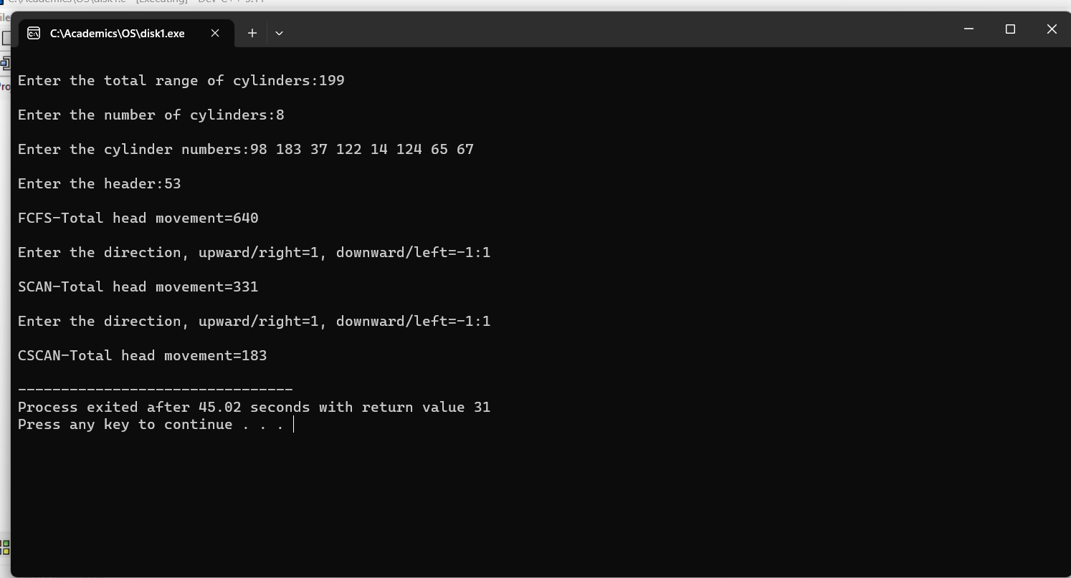

**Write a C program to simulate disk scheduling algorithms**  
  
a)    SSTF  
b)  LOOK  
c)  c-LOOK

#include<stdio.h>

#include<conio.h>

int head,a[20],range,n;

void sstf()

{

int c=0,i,j,headm=0,k,t,temp,b[20];

for(i=0;i<n;i++)

{

b[i]=a[i];

}

b[n]=head;

for(i=0;i<n;i++)

{

for(j=0;j<n-i;j++)

{

if(b[j]>b[j+1])

{

temp=b[j];

b[j]=b[j+1];

b[j+1]=temp;

}

}

}

for(i=0;i<n;i++)

{

if(b[i]==head)

break;

else

c++;

}

j=c;

k=c;

t=j;

for(i=0;i<n;i++)

{

if((b[k+1]-b[t])<(b[t]-b[j-1]) && j>0)

{

headm+=(b[k+1]-b[t]);

k++;

t=k;

}

else if(j==0)

{

headm+=(b[k+1]-b[t]);

k++;

t=k;

}

else

{

headm+=(b[t]-b[j-1]);

j--;

t=j;

}

}

printf("SSTF-Total head movement=%d\n",headm);

}

void look()

{

int headm=0,i,dir,temp,cnt=0;

printf("Enter the direction, upward/right=1, downward/left=-1:\n");

scanf("%d",&dir);

if(dir==1)

{

for(i=0;i<n;i++)

{

if(a[i]<head)

{

cnt++;

continue;

}

else if(i==cnt)

headm=headm+(a[i]-head);

else

headm=headm+(a[i]-a[i-1]);

}

headm+=a[n-1]-a[cnt-1];

for(i=cnt-1;i>0;i--)

{

headm+=(a[i]-a[i-1]);

}

}

else

{

for(i=0;i<n;i++)

{

if(a[i]>head)

break;

else

cnt++;

}

headm+=(head-a[cnt-1]);

for(i=cnt-1;i>0;i--)

{

headm+=(a[i]-a[i-1]);

}

headm+=(a[cnt]-a[0]);

for(i=cnt;i<n-1;i++)

{

headm+=(a[i+1]-a[i]);

}

}

printf("LOOK-Total head movement=%d\n",headm);

}

void clook()

{

int headm=0,i,dir,temp,cnt=0;

printf("Enter the direction, upward/right=1, downward/left=-1:\n");

scanf("%d",&dir);

if(dir==1)

{

for(i=0;i<n;i++)

{

if(a[i]<head)

{

cnt++;

continue;

}

else if(i==cnt)

headm=headm+(a[i]-head);

else

headm=headm+(a[i]-a[i-1]);

}

for(i=cnt-1;i>0;i--)

{

headm+=(a[i]-a[i-1]);

}

}

else

{

for(i=0;i<n;i++)

{

if(a[i]>head)

break;

else

cnt++;

}

headm+=(head-a[cnt-1]);

for(i=cnt-1;i>0;i--)

{

headm+=(a[i]-a[i-1]);

}

for(i=cnt;i<n-1;i++)

{

headm+=(a[i+1]-a[i]);

}

}

printf("\nCLOOK-Total head movement=%d\n",headm);

}

void main()

{

int i,j,temp;

printf("\nEnter the total range of cylinders:");

scanf("%d",&range);

printf("\nEnter the number of cylinders:");

scanf("%d",&n);

printf("\nEnter the header:");

scanf("%d",&head);

printf("\nEnter the cylinder numbers:");

for(i=0;i<n;i++)

{

scanf("%d",&a[i]);

}

for(i=0;i<n-1;i++)

{

for(j=0;j<n-i-1;j++)

{

if(a[j]>a[j+1])

{

temp=a[j];

a[j]=a[j+1];

a[j+1]=temp;

}

}

}

sstf();

look();

clook();

}

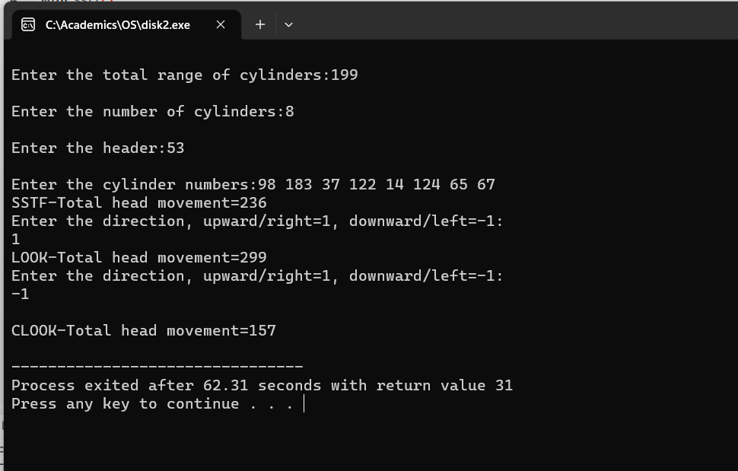

**Write a C program to simulate page replacement algorithms**  
a) FIFO  
b) LRU  
c)Optimal

#include<stdio.h>

#include<conio.h>

int n,m,a[20],p[10];

void fifo()

{

int i,j,flag,cnt=0,k=0;

for(i=0;i<n;i++)

{

flag=1;

for(j=0;j<m;j++)

{

if(a[i]==p[j])

{

flag=0;

break;

}

}

if(flag==1)

{

cnt++;

p[k]=a[i];

k=(k+1)%m;

}

}

printf("\nFIFO-Page faults=%d",cnt);

}

void optimal()

{

int i,j,flag,cnt=0,k=0,t,temp,f,help[10],ct;

for(i=0;i<n;i++)

{

flag=1,f=1,ct=0;

for(j=0;j<m;j++)

{

help[j]=0;

if(a[i]==p[j])

{

flag=0;

break;

}

}

if(flag==1)

{

cnt++;

for(j=0;j<m;j++)

{

if(p[j]==-1)

{

p[j]=a[i];

f=0;

break;

}

}

if(f==1)

{

for(k=i+1;k<n;k++)

{

for(j=0;j<m;j++)

{

if(p[j]==a[k]&&help[j]==0)

{

temp=j;

help[j]=1;

}

}

}

for(j=0;j<m;j++)

{

if(help[j]==0)

temp=j;

}

p[temp]=a[i];

}

}

}

printf("\nOPTIMAL-Page faults=%d",cnt);

}

void lru()

{

int flag,f,k,cnt=0,i,j,temp,ct,help[10];

for(i=0;i<n;i++)

{

flag=1,f=1,ct=0;

for(j=0;j<m;j++)

{

help[j]=0;

if(p[j]==a[i])

{

flag=0;

break;

}

}

if(flag==1)

{

cnt++;

for(j=0;j<m;j++)

{

if(p[j]==-1)

{

p[j]=a[i];

{

f=0;

break;

}

}

}

if(f==1)

{

for(k=i-1;k>=0;k--)

{

for(j=0;j<m;j++)

{

if(p[j]==a[k]&& help[j]==0)

{

temp=j;

help[j]=1;

}

}

}

p[temp]=a[i];

}

}

}

printf("\nLRU-Page faults=%d",cnt);

}

void main()

{

int i;

printf("Enter the number of pages:");

scanf("%d",&n);

printf("\nEnter the page numbers:");

for(i=0;i<n;i++)

{

scanf("%d",&a[i]);

}

printf("\nEnter the number of frames:");

scanf("%d",&m);

for(i=0;i<m;i++)

p[i]=-1;

fifo();

for(i=0;i<m;i++)

p[i]=-1;

optimal();

for(i=0;i<m;i++)

p[i]=-1;

lru();

}

