**iOS Document For Intune Release**

1. Make sure your app is added on the <https://appcenter.ms> with the correct Store connect and User Group in which it needs to be released.
2. Take the API Token, Organization name, Store name and App name that is registered on the appcentre.ms.
3. Now update the files (appcentre.sh, fastlane, Gemfile and .gitlab-ci.yml) according to the above information and add it in the project folder.

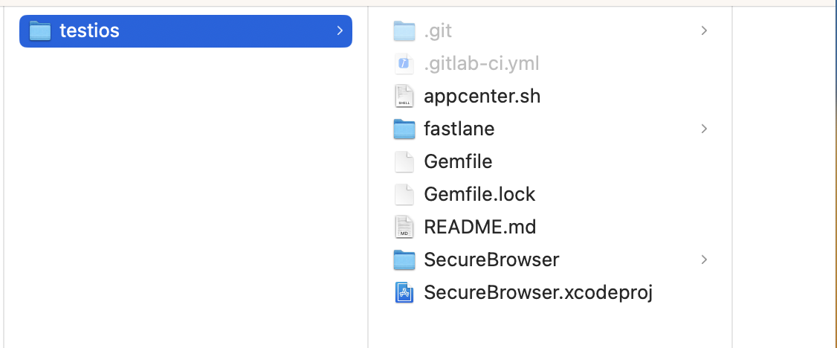

1. Now push the code on the branch which is mentioned in the yml file and you can see the pipeline running under the CI/CD Section on gitlab.

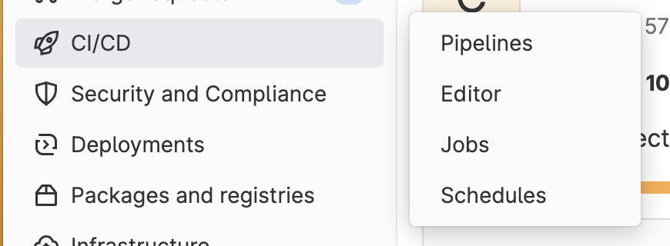

**NOTE:** For MAM and MDM approach separately, We need to release the app manually first time and then update the settings in the properties of app on the <https://endpoint.microsoft.com/>

**Test iOS Project For Intune**

[**https://gitlab.dell.com/des/mobility/maintenance/intunedemomobile/ios/intuneiosdemo/-/tree/grc?ref_type=heads**](https://gitlab.dell.com/des/mobility/maintenance/intunedemomobile/ios/intuneiosdemo/-/tree/grc?ref_type=heads)

**Appcentre.sh File**

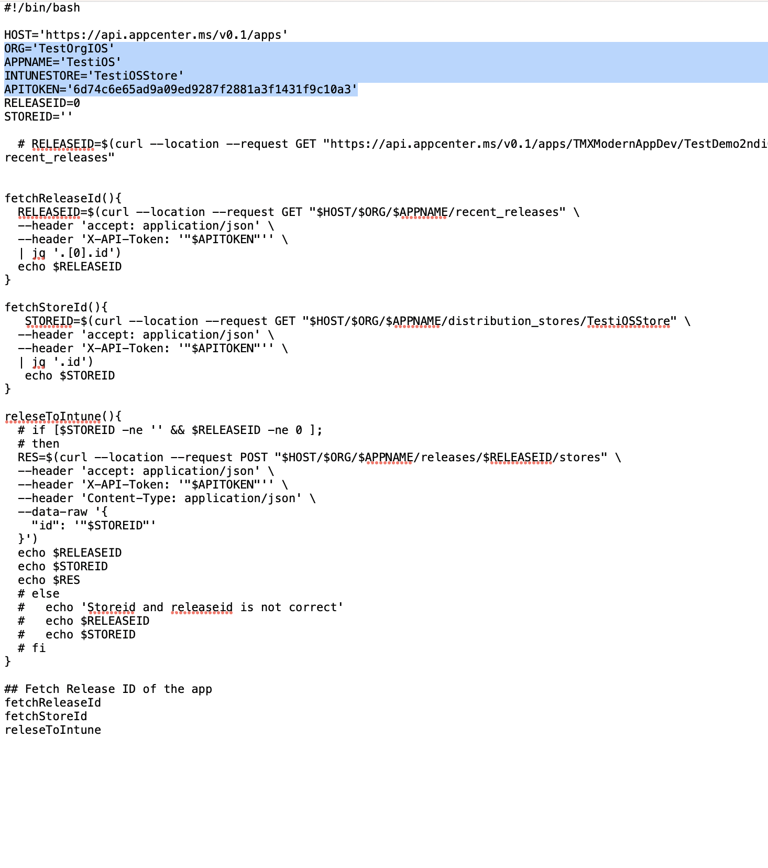

**.Gitlab-ci.yml**

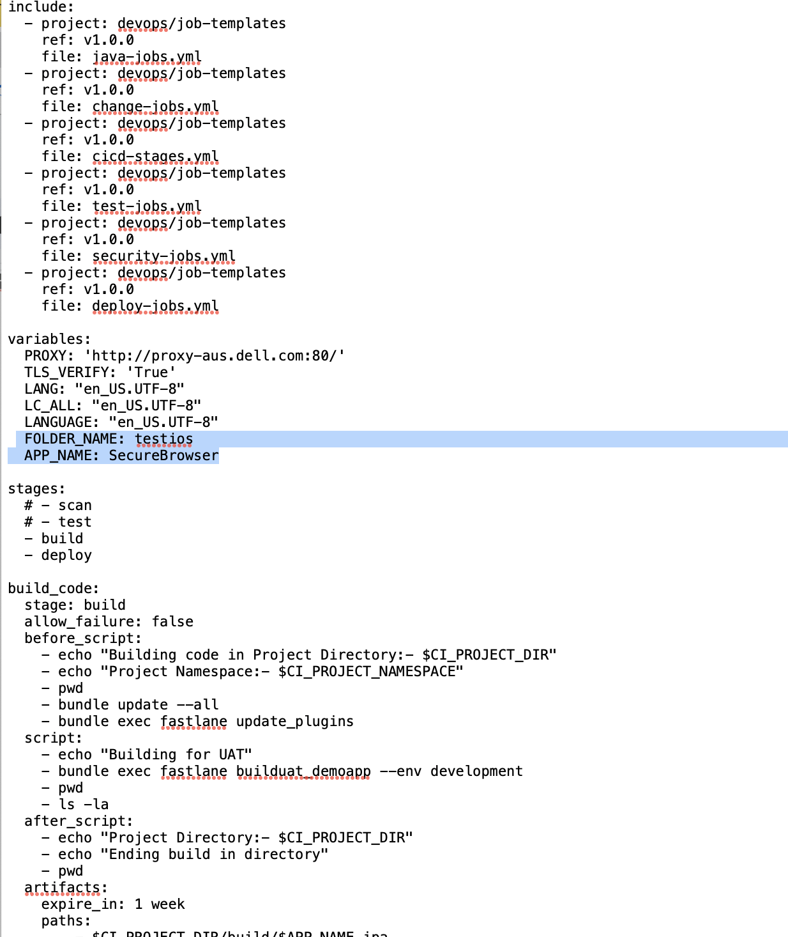

**Appfile**

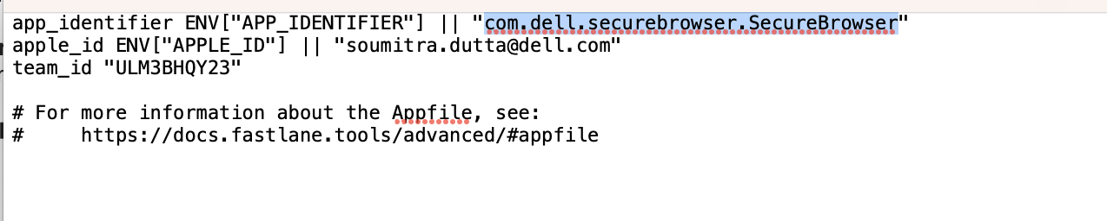

**Fastfile**

