DAY-1 TASK-1

NMAP Scan

Command: nmap -sS 192.168.31.204

Results:

Starting Nmap 7.97 ( https://nmap.org ) at 2025-09-22 16:24 +0530

Nmap scan report for 192.168.31.204

Host is up (0.00021s latency).

Not shown: 997 closed tcp ports (reset)

PORT STATE SERVICE

135/tcp open msrpc

139/tcp open netbios-ssn

445/tcp open microsoft-ds

Nmap done: 1 IP address (1 host up) scanned in 0.86 seconds

Services:

**TCP/135 is the Microsoft RPC endpoint mapper (MSRPC / epmap)** — it’s the port Windows uses to tell clients which dynamic RPC ports a particular RPC service is listening on.

**139-Service:** Microsoft RPC Endpoint Mapper (MSRPC / epmap)

**445-Service:** Microsoft Directory Services (SMB over TCP)

TCP Scan

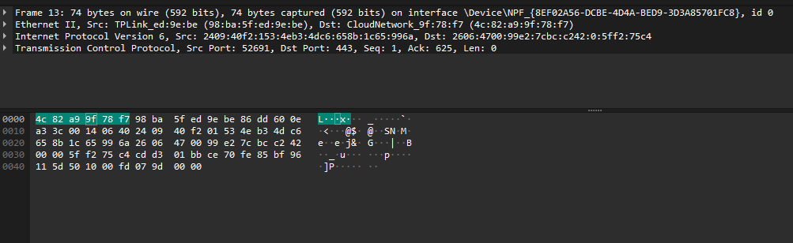

TLS Scan

