**Scripting and visualizing tools**

**.1 Need for protein visualization.**

A tool to graphically visualize proteins and other types of molecules are required to see what atom data is encoded inside the protein data bank and to manipulate the images to view a protein from different perspectives. Without a visualizing tool, we cannot read a .pdb (Protein data bank) file only as a text file and it gets tedious to draw those co-ordinates in three dimensional spaces. Hence, researchers need a tool which is capable of displaying large amounts of protein data. Many visualization tools have been developed to visualize proteins whose structures are known and are available in .pdb files. Different visualizing tools were developed on different displaying capabilities like displaying the sequence, selecting a set of amino acids in a given structure, display disulfide bonds, hydrogen bonds, hydrogen bond distances and display different types of protein surfaces[1]. We have used two such freely available protein visualization tools over the internet with scripting capabilities which will help us customize loading and customizing protein visualizations for our research. They are PyMol and JSMol. PyMol is a python based protein visualizer which runs as a standalone application on a cross platform environment whereas JSMol is based on java and javascript, it can used to render three dimensional protein visualizations over an internet browser. Both of which are explained in detail below.

**.2 PyMol**

PyMol is a free, modifiable and redistributable molecular visualization tool, which is frequently used by structural biologists and crystallographers. Images generated using PyMol can be seen in several research papers. PyMol users get a high resolution images and animations of biological structures such as proteins[2]. PyMol is an open source tool which is scripted using python. PyMol comes with a library of functions of its own. With simple knowledge of python and PyMol, its users can write custom scripts of their own to improve or highlight their visualizations.

PyMol accepts .pdb files to generate images and animations of macromolecules such as proteins which are available from the protein databank. .pdb files are generated by techniques like x-ray crystallography. By using this experimental data, structural biologists determine the location of each atom relative to each other in a molecule like protein.

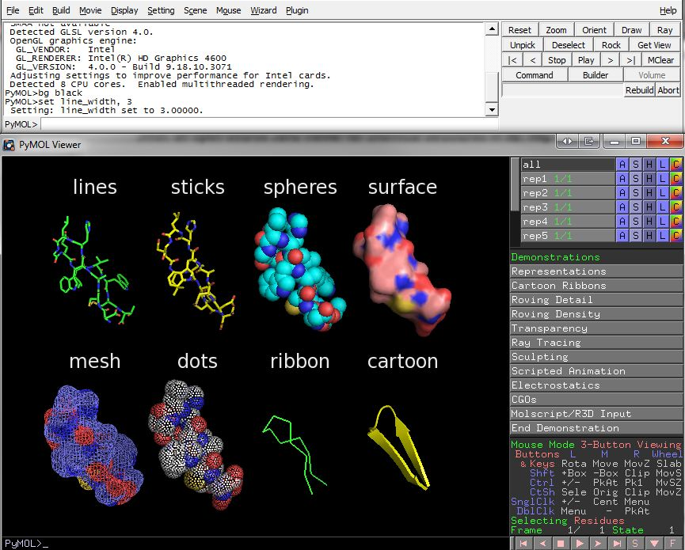

**Figure .1:** Different types of rendering offered by PyMol molecular visualizer.

**.3 Jmol**

Jmol is a free and open source molecule viewer developed for myriad of different users. It is cross platform and runs on Windows, Linux and Mac OS X systems. It is a multi-language tool which is translated into multiple languages like Chinese, French and German. There are three different ways of using Jmol.

1. JmolApplet: It is a web browser applet that can be included in the web pages[3]. Jmol buttons are used to invoke scripts which can be read by the applet. The scripts can alter the behavior of the default illustrations of important structural features.
2. Jmol Application: It is a standalone java application that runs as an application on desktops3.
3. Jmol Viewer: It is a development tool kit that can be integrated in any java application3.

**.3.1 JSmol**

JSmol is a JavaScript version of Jmol that allows developers to create web pages with Java or use HTML5 to create pages without Java. This enables Jmol to display three dimensional molecular structures on devices which does not support Java (such as a few smart phones and tablet computers).

JSmol with HTML5 is identical to JSmol with Java in terms of rendering. Java version gives a much smoother rotation than the HTML5 version. This is usually not noticeable, it is noticed for molecular structures with more than 20,000 atoms.

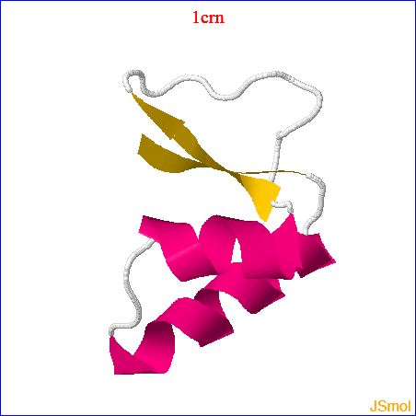

**Figure .2:** JSmol example.

1. Shaheda N Ansqri and Sayyed lliyos. A comparative study of protein structure visualization tools for various display capabilities. Bioscience Discovery, 2011
2. vlab.amrita.edu,. (2012). Visualizing the Secondary Structure of a Protein. Retrieved 30 December 2015, from vlab.amrita.edu/?sub=3&brch=275&sim=1427&cnt=1
3. http://jmol.sourceforge.net/