# Proteins and Protein folding

# .1 Proteins

Proteins are fundamental entities for all living beings. Proteins aid in almost every function that is carried out inside the body, mostly in the cells. They are large and complex molecules. Each protein is associated with a specific function in the body. Few of those functions include:

* DNA replication: Helps in producing two identical chains of DNA.
* Messenger: Transmits signals to co-ordinate biological processes.
* Transportation: Binds small atoms inside them and transport across the body.
* Structural components: They form the structure of many tissues in our body such as muscle, hair, etc.,

# .2 Structure of a Protein

From chemical point of view, proteins are the structurally most complex and functionally rich molecules ever known. Proteins are made up of amino acids, a sequence of twenty different amino acids are bonded in different configurations to form a long string of protein. Every amino acid is linked with its neighbor through a covalent peptide bond, proteins are therefore called polypeptides. Order in which these amino acids are bonded defines the shape and structure of the protein chain. The structure of the protein determines the function of a protein in a cell[1]. Each protein chain has a different sequence of amino acids, many hundreds or thousands of protein structures are known to us and each of them have different sequence of amino acids1. The sequence of connected atoms at the core of the chain is called as polypeptide backbone. The atoms attached to this chain are those amino acids which are not involved in making of peptide bond and they give each amino acid a unique property. The entire sequence of amino acids determines the function of the protein.

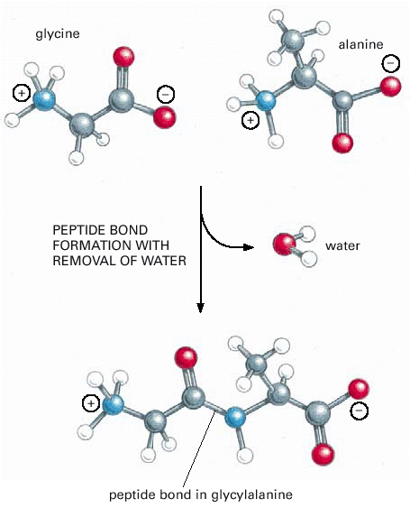

**Figure .1:** Formation of a peptide bond by removal of water. This covalent bond forms when the carbon atom from the carboxyl group of one amino acid shares electrons with the nitrogen atom (blue) from the amino group of a second amino acid.1

## .2.1 Levels of Protein Structure

* Primary structure: It consists of linear sequence of amino acids, covalent bonds and disulfide bonds in a protein structure.
* Secondary structure: It refers to the local structure of the backbone of the protein which is stabilized by intermolecular hydrogen bonding[2]. There are two types of secondary structures which are common, Alpha helices and Beta strands.
  + Alpha helix: It is a right handed spiral conformation in which every backbone N-H group denotes a hydrogen bond to the backbone C =O group of the amino acid2 above.
  + Beta Strands: It is a polypeptide chain with 3-10 amino acids. Two or more parallel or antiparallel beta strands linked by hydrogen bonds form beta sheets.
* Tertiary structure: The three dimensional arrangement of secondary structures with a large number of non-covalent bonds between amino acids.
* Quaternary structure: Multiple polypeptide chains linking via non covalent bonds to form a single and larger protein[3].

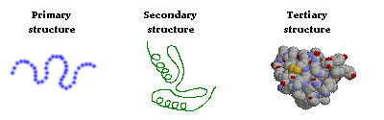

**Figure .2:** A simple visualization of primary, secondary, tertiary protein structures3. lization of er protein one of the protein

# 

# .3 Protein Folding

Proteins fold and are held together by molecular interactions. The molecular interactions include thermodynamic stability, hydrophobic interactions and disulfide bonds formed inside the proteins[4].

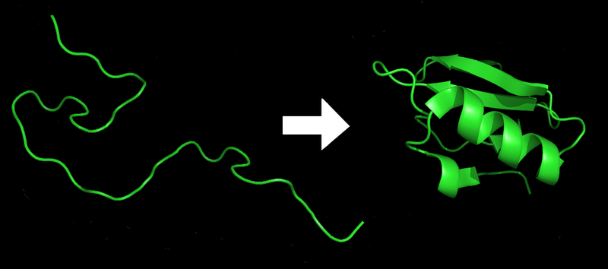

**Figure .3:** Protein folding sample4. lization of er protein one of the protein

## .3.1 Thermodynamic interactions

Thermodynamics of a protein is plays a major role in protein folding. The interaction includes the inclination to form extended conformations, long range contact potentials depending on the residues and the formation of hydrogen bonds depending on the orientation[5]. The thermodynamic abilities inside the proteins are a major stabilizing force because if the protein is not in its lowest energy conformation it will continue to move and adjust until it finds its most stable state. The energy diagrams and maps are important to find out if the protein has reached its most stable state possible.

## .3.2 Hydrophobic Interactions

The hydrophobic model primarily relies on the short-range interactions of the secondary structure. Hydrophobic interactions have an impact not just on the primary structure but also the changes that happen in the secondary and tertiary proteins structures as well. Globular proteins get unique compact native conformations in water due to the hydrophobic effect. Even the proteins which are folded correctly have a hydrophobic core as a result of being hydrated by the water around it which is important because it creates a charged core which in turn leads to the creation of channels within the protein. The hydrophobic interactions have an impact on the protein even if the protein has found the most stable conformation on how they can interact with each other as well as fold themselves.

## .3.3 Disulfide bonds

Disulfide linkages are another type of interactions that happen in protein folding. The disulfide bond is a sulfur-sulfur chemical bond that results from an oxidative process that links nonadjacent cysteine’s (amino acid) of a protein[6]. These are one of the major ways in which protein get folded. The disulfide bonds are cysteine-cysteine linkages that are a part of the final stable folded structure and those in which the pairs of cysteines alternate between the reduced oxidized states6. The bonds between the cysteines are quite stable once they are created.

1. http://www.ncbi.nlm.nih.gov/books/NBK26830/
2. https://www.ebi.ac.uk/training/online/course/biomacromolecular-structures-introduction-ebi-reso/proteins/levels-protein-structure
3. http://www.vivo.colostate.edu/hbooks/genetics/biotech/basics/prostruct.html
4. http://chemwiki.ucdavis.edu/Biological_Chemistry/Proteins/Protein_Structure/Protein_Folding
5. Cieplaka M. and Niewieczerza S. Hydrodynamic interactions in protein folding. Journal of Chemical Physics 2009.
6. Kadokura, H., Katzen F. and Beckwith, J. Protein disulfide bond formation in prokatyotes. Annual Review Biochem 2003