**Protein Knot Server – knots.mit.edu**

Knots.mit.edu[1] is a server that processes protein structures and detects knots. The server accepts a protein structure either by its PDB ID or the user can upload the three dimensional structure in PDB or mmCIF format. The server uses Alexander polynomial to determine the type of the knot formed by the given protein structure. A visualization focusing the knot is presented and the server maintains a list of known proteins with knots.

**.1 How knots are determined**

Mathematically, knots are not well defined in open chains[2] such as proteins. Both the termini of the chain (N and C terminals) of open protein chains must be connected to make the entire chain a closed loop. To get a closed loop, the protein chain is reduced to its backbone and two lines are drawn from the termini towards the connection line between the center of mass of the backbone and the respective terminals. The two lines are then connected by a loop which makes the chain a closed loop and the Alexander polynomial2[3] can be applied on the resulting loop to classify the type of the knot formed by the loop. To calculate the size of the knot core, amino acids are removed successively from the N-terminus until the chain gets unknotted[4]. The procedure is again repeated from the C-terminus starting from the last deletion in the N-terminus of the chain which contained the knot. After every deletion an outward pointing line parallel to the respective lines are drawn for the entire chain. The size of the knot calculated by this method is not always precise and is approximate.

KMT algorithm is used to speed up the calculations[5]. This algorithm iteratively deletes amino acids from the chain which are not a part of the knot core. After analysis of the entire chain only the knot core remains. And the resulting sequence can be used to precisely visualize the knot.

There are a set of criteria that a protein chain has to satisfy in order to be considered as knotted:

1. The calculated alexander polynomial should result in a knot.
2. The polypeptide chain should not be broken or have any gaps in between.
3. The knot should exist even if two amino acids are removed from the terminals (This avoids shallow knots or the knots which appear due to the closure method of the protein chain. The resulting knots are only deep knots.)

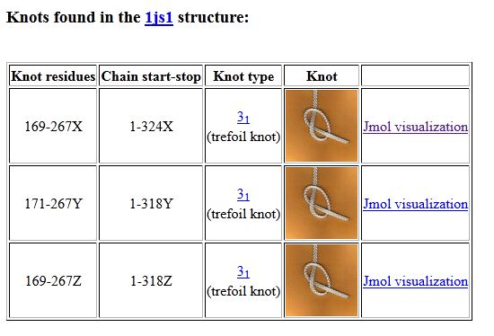

**Figure .1:** 1js1 protein knot visualized by knots server1.

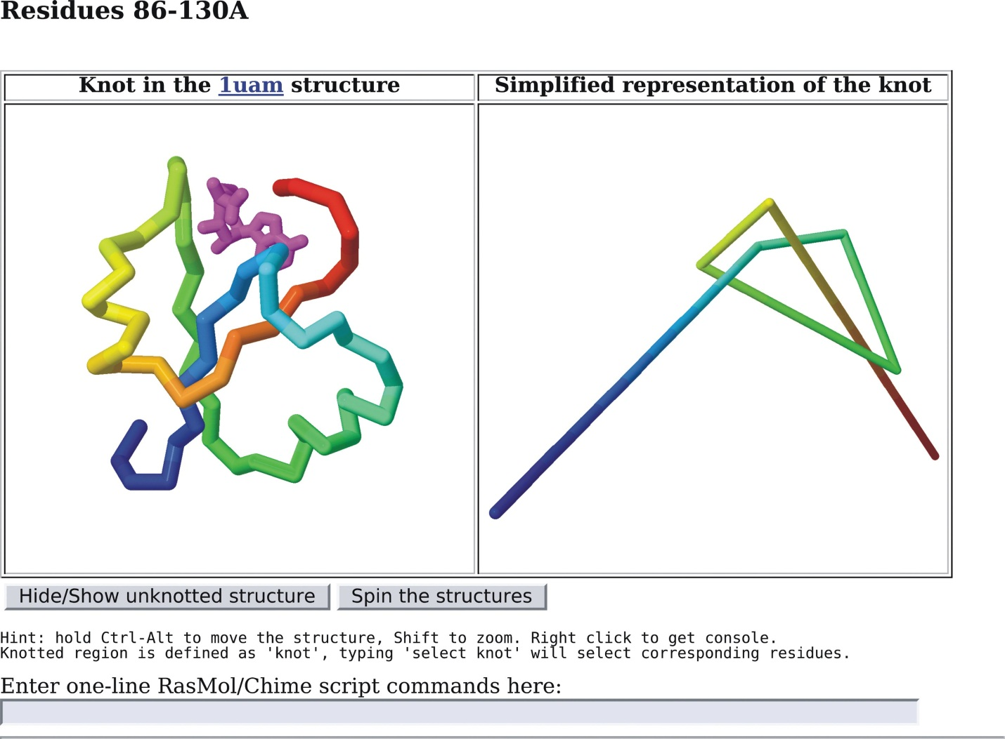

**Figure .2:** RasMol views of the knot generated by the knots server1.

1. Grigory Kolesov, Peter Virnau, Mehran Kardar and Leonid A. Mirny (2007) Protein knot server: detection of knots in protein structures. Nucleic Acids Research.
2. Adams,C.C. (1994) The Knot Book: An Elementary Introduction to the Mathematical Theory of Knots. Freeman, New York.
3. Virnau,P., Kantor,Y. and Kardar,M. (2005) Knots in globule and coil phases of a model polyethylene. J. Am. Chem. Soc., 127, 15102–15106.
4. Virnau,P., Mirny,L.A. and Kardar,M. (2006) Intricate knots in proteins: function and evolution. PLoS Comp. Biol., 2, 1074–1079.
5. Koniaris,K. and Muthukumar,M. (1991) Self-entanglement in ring polymers. J. Chem. Phys., 95, 2873–2881.