MLOps Assignment 1 Report - Surbhi Arya

Heart Risk Prediction — End-to-End MLOps Pipeline
Course: AIMLCZG523 — Machine Learning Operations (MLOps) Assignment: 01 — End-to-End ML Model Development, CI/CD, and Production Deployment Author: Surbhi Arya BITS ID: 2025AE05688 Repository: https://github.com/shashankp1502/mlops-assignment

1. Objective
An end-to-end, reproducible pipeline for a binary classifier predicting heart disease risk from patient vitals — covering data ingestion, EDA, feature engineering, model training with experiment tracking, automated testing, CI/CD, containerization, Kubernetes deployment via Helm, and monitoring.
Every stage described here was actually executed during development: the dataset was pulled live from UCI, both models were trained and tracked in MLflow (with the winner registered in the Model Registry), the full unittest suite was run, the Docker image was built and smoke-tested, and the complete stack — API, Ingress, Prometheus, and Grafana — was deployed to a local Minikube cluster with a single helm install and verified against real traffic. Screenshots for each stage are in screenshots/.

2. Setup / Install Instructions
git clone https://github.com/shashankp1502/mlops-assignment.git
cd mlops-assignment
python3.12 -m venv .venv
source .venv/bin/activate
make install
make ingest # fetches data/raw/heart_disease.csv from UCI
make train # trains + tracks in MLflow, saves artifacts/model/
make test # 41 unittest cases, ~4s
make serve # API on http://localhost:8080
Docker and Kubernetes/Helm instructions are in README.md.

3. Dataset & EDA
Dataset: UCI Cleveland Heart Disease dataset — 303 patients, 13 features, binary target (collapsed from the original 0-4 severity score). Fetched via heart_risk.ingestion.ClevelandHeartDiseaseIngestor, a small dataclass rather than a loose script, so the source URL / output path are grouped as configuration. Not committed to git — re-fetched on demand in ~2 seconds.
Missing data: 6 of 303 rows (2%) have gaps, confined to ca and thal. Handled with KNNImputer for continuous columns (see Section 4) rather than dropping rows.
Key EDA findings (full notebook: notebooks/exploratory_analysis.ipynb):
- Class balance: 46% positive / 54% negative — mild imbalance, handled with stratified splitting throughout rather than resampling.
- thalach (max heart rate) shifts lower and oldpeak (ST depression) shifts higher in the disease group — both visible clearly in the KDE overlays.
- thal and cp show the strongest categorical separation — certain codes are almost entirely one class.
- No problematic collinearity between predictors — nothing dropped for redundancy.
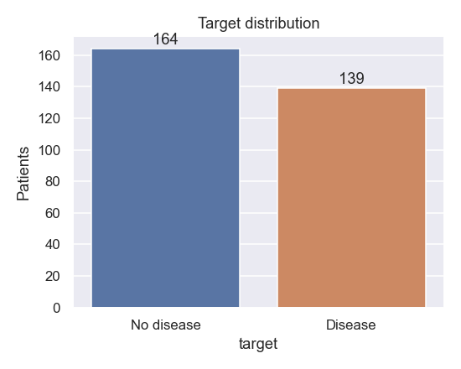
Target distribution
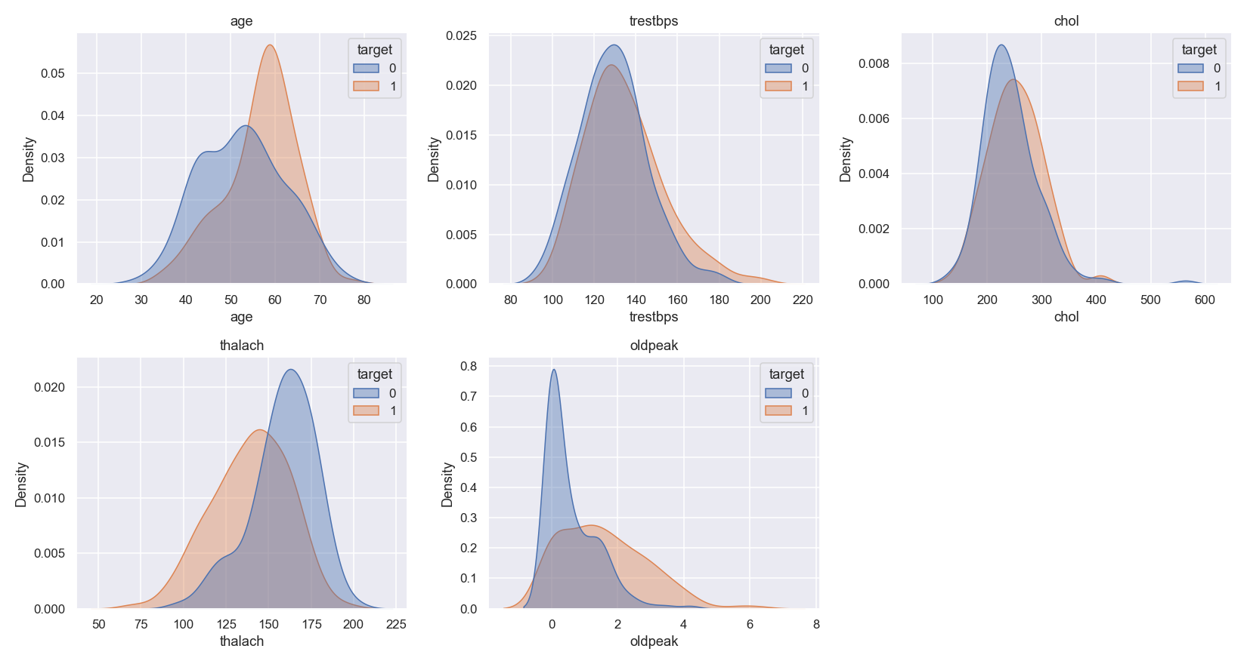
Continuous features by target (KDE)
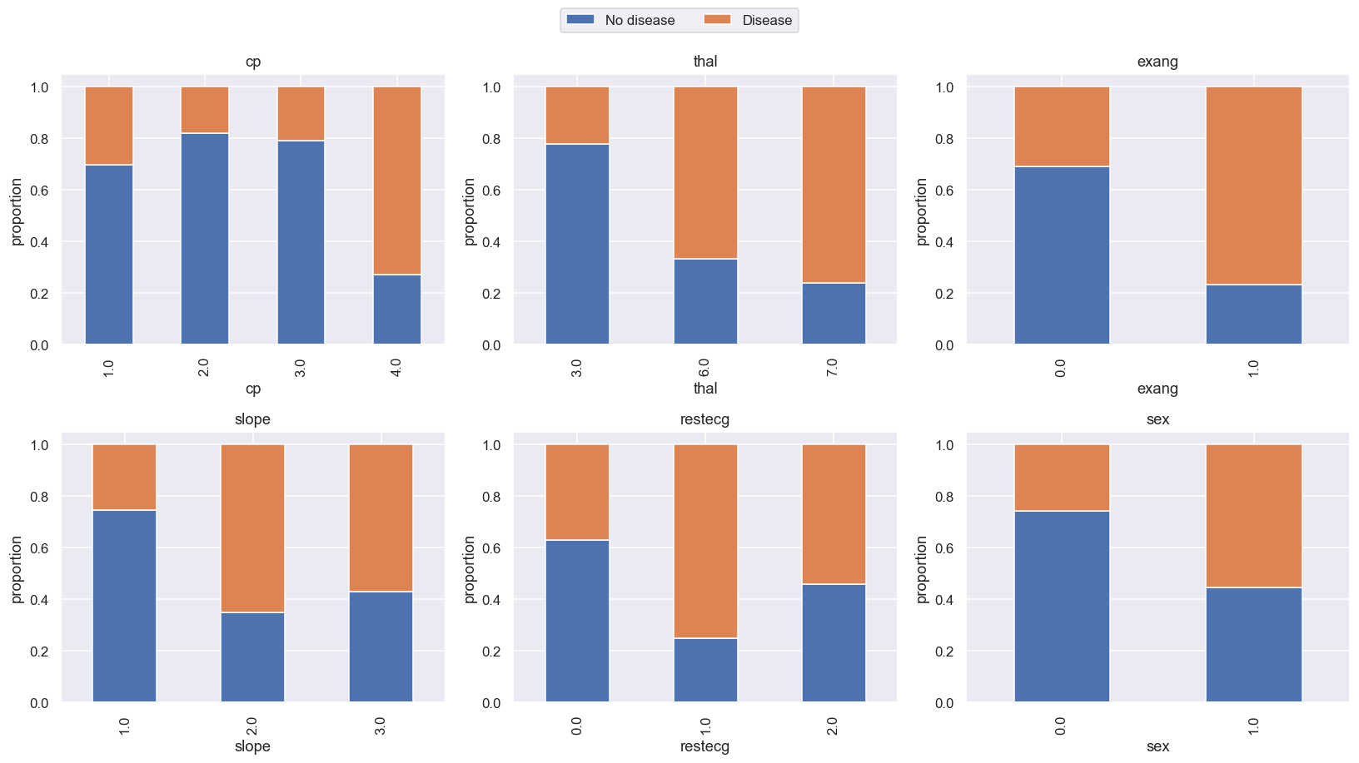
Categorical feature proportions by target
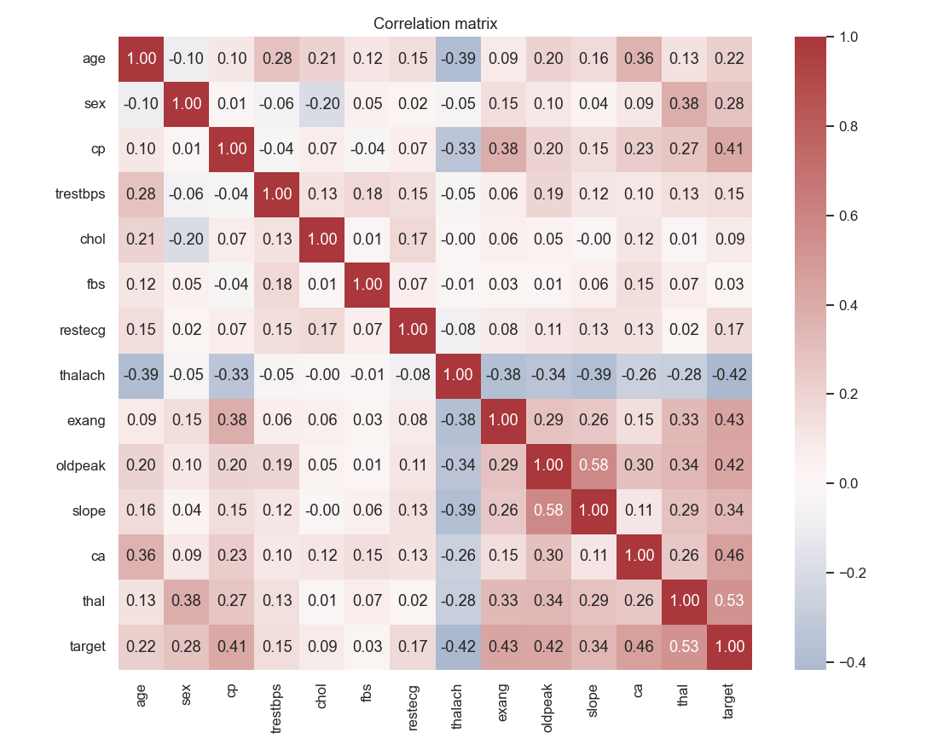
Correlation matrix

4. Feature Engineering & Modelling Choices
Implemented in heart_risk/transform.py as a two-stage pipeline: an AgeGroupBucketer transformer (adds a derived age_group column, bucketing age into young/middle/senior), feeding into a ColumnTransformer:
Feature group | Columns | Transform | Why
Continuous | age, trestbps, chol, thalach, oldpeak | KNNImputer(k=5) -> StandardScaler | Only 6 missing cells total — KNN imputation is a near-zero-cost upgrade over median at this data size
Nominal categorical | cp, restecg, slope, thal, ca | most-frequent impute -> OrdinalEncoder | Both models are tree-based; integer-coded categories don’t impose a false distance metric for trees the way they would for a linear model, and this keeps the feature space compact on a 303-row dataset
Binary | sex, fbs, exang | most-frequent impute | Already 0/1
Engineered | age_group (derived) | pass-through | Clinically motivated bucket (young <45 / middle 45-59 / senior 60+)
This produces 14 output features (13 raw + 1 engineered), versus what a one-hot approach would produce (20+) — deliberately compact given the small sample size.
Models trained (heart_risk/modeling/train.py): a single Decision Tree and a Gradient Boosting ensemble, each tuned via RandomizedSearchCV (10-fold stratified CV, 20 sampled candidate configurations, scored on F1 rather than ROC-AUC — chosen because F1 balances precision/recall directly, which matters for a screening tool where both false negatives and false positives carry cost).
- Decision Tree search space: max_depth, min_samples_split, min_samples_leaf, criterion
- Gradient Boosting search space: n_estimators, learning_rate, max_depth, subsample

Results
Model | CV F1 (10-fold) | Holdout Accuracy | Holdout Precision | Holdout Recall | Holdout F1 | Holdout ROC-AUC
Gradient Boosting (champion) | 0.799 | 0.820 | 0.870 | 0.714 | 0.784 | 0.939
Decision Tree | 0.736 | 0.803 | 0.833 | 0.714 | 0.769 | 0.917
Champion hyperparameters: n_estimators=50, learning_rate=0.05, max_depth=2, subsample=0.85.
Why Gradient Boosting won: it outperforms the single Decision Tree on every holdout metric except recall (tied). This tracks with expectations — boosting an ensemble of shallow trees (max_depth=2 here) typically generalizes better than one deeper tree on tabular data this size, without the variance a single unconstrained tree is prone to. The feature-importance plots confirm thal, cp, and oldpeak (labelled ordinal__cp, ordinal__ca, numeric__oldpeak, ordinal__thal after the preprocessing pipeline) as the top drivers for both models, consistent with the EDA.
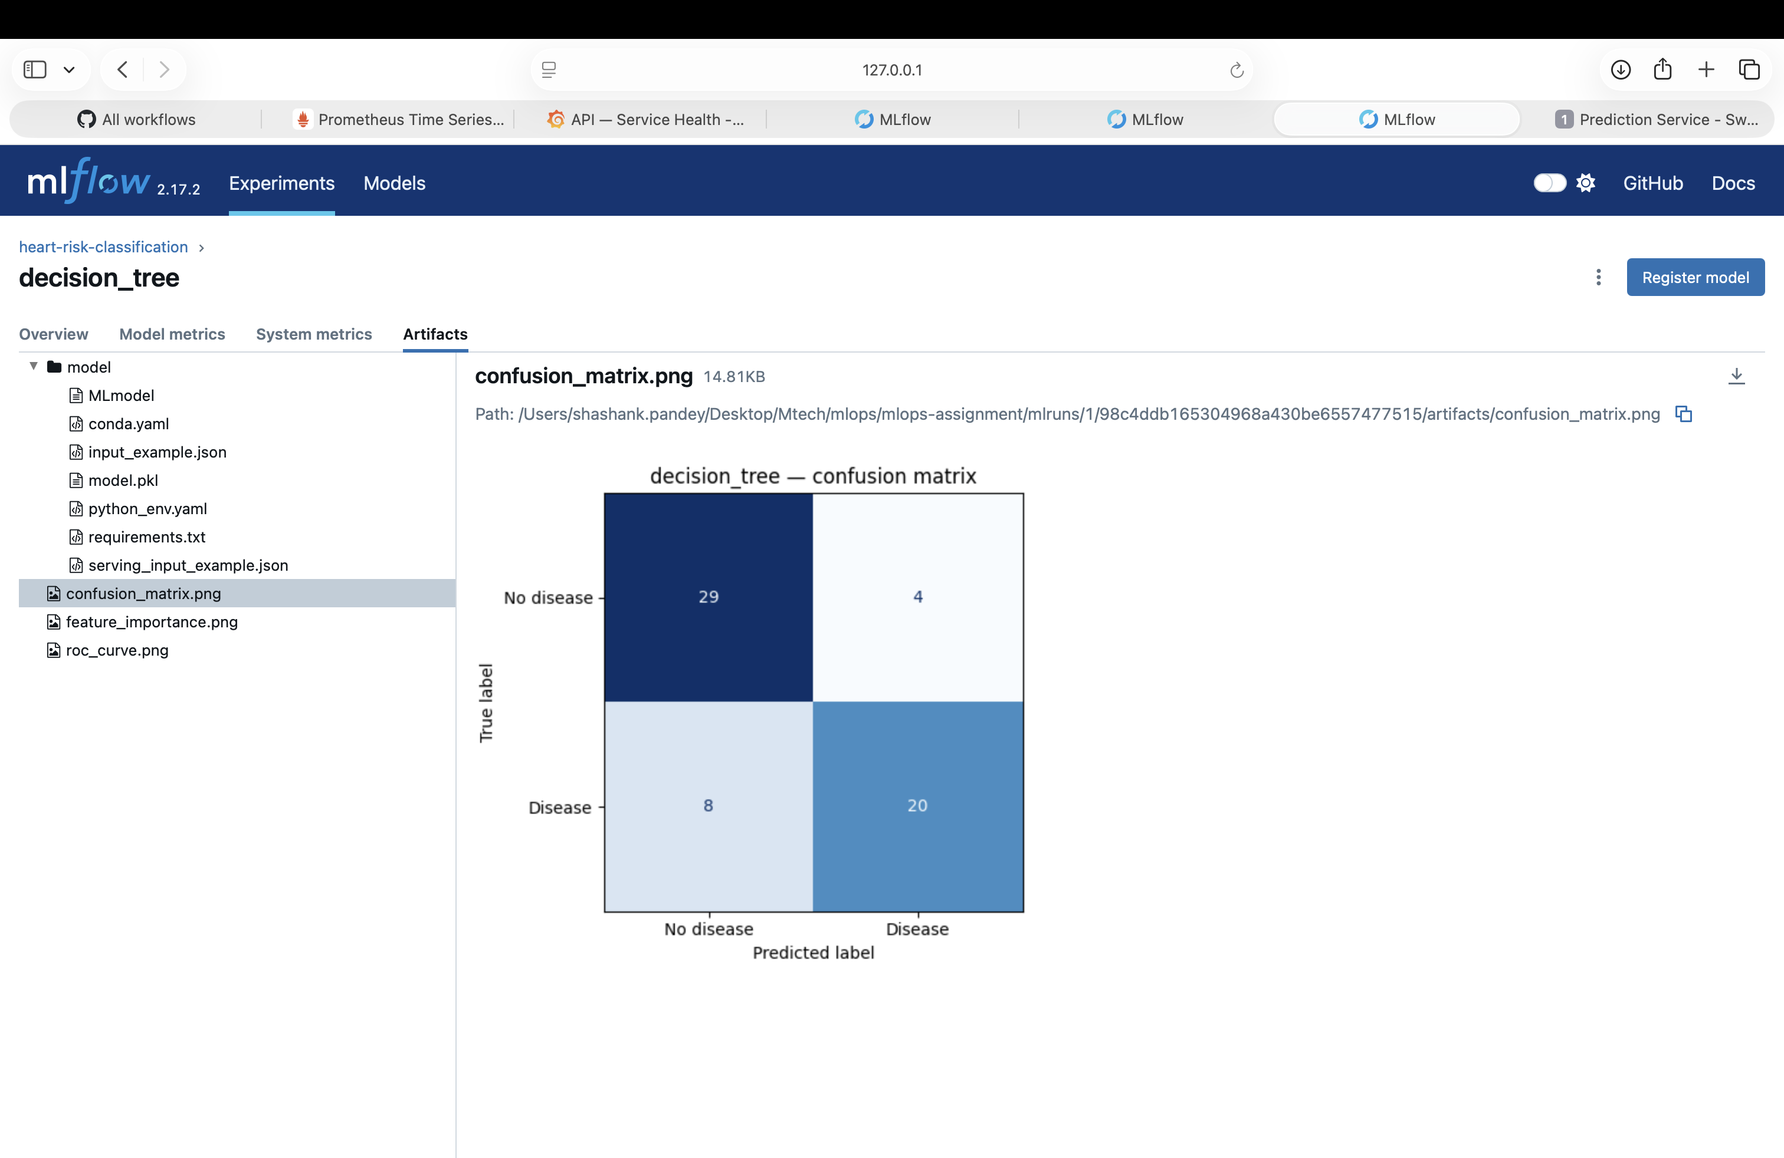
Decision Tree confusion matrix
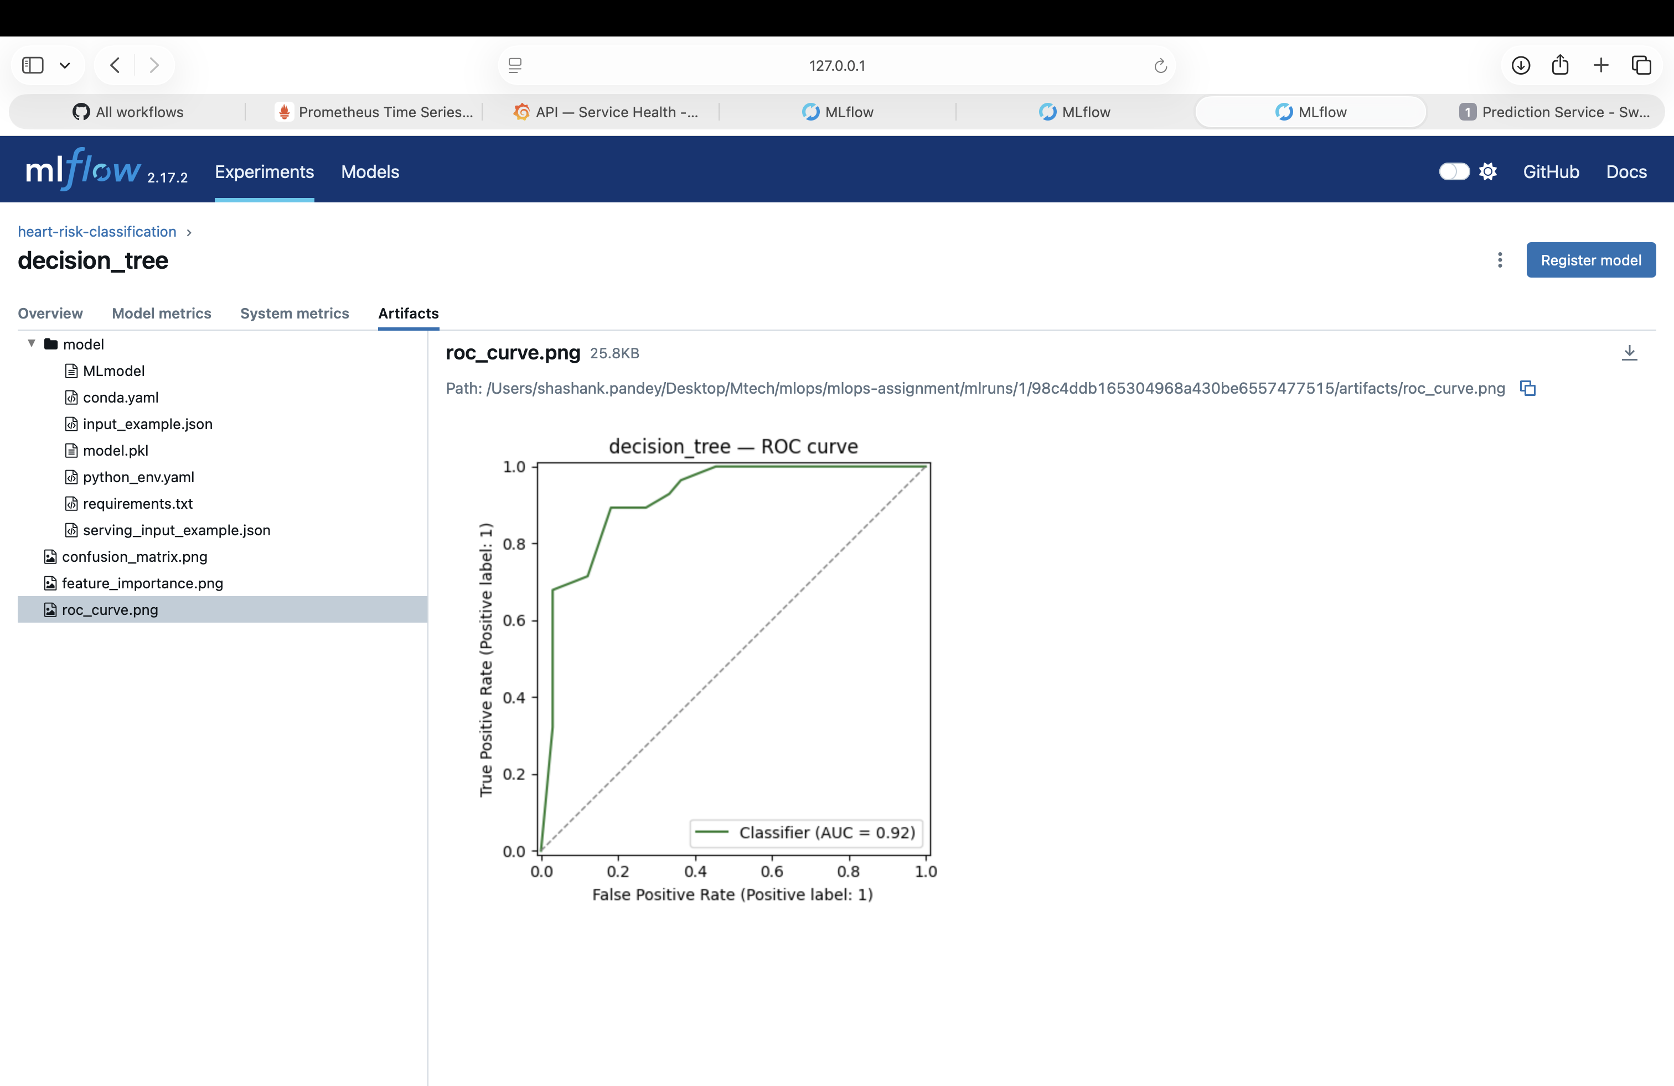
Decision Tree ROC curve
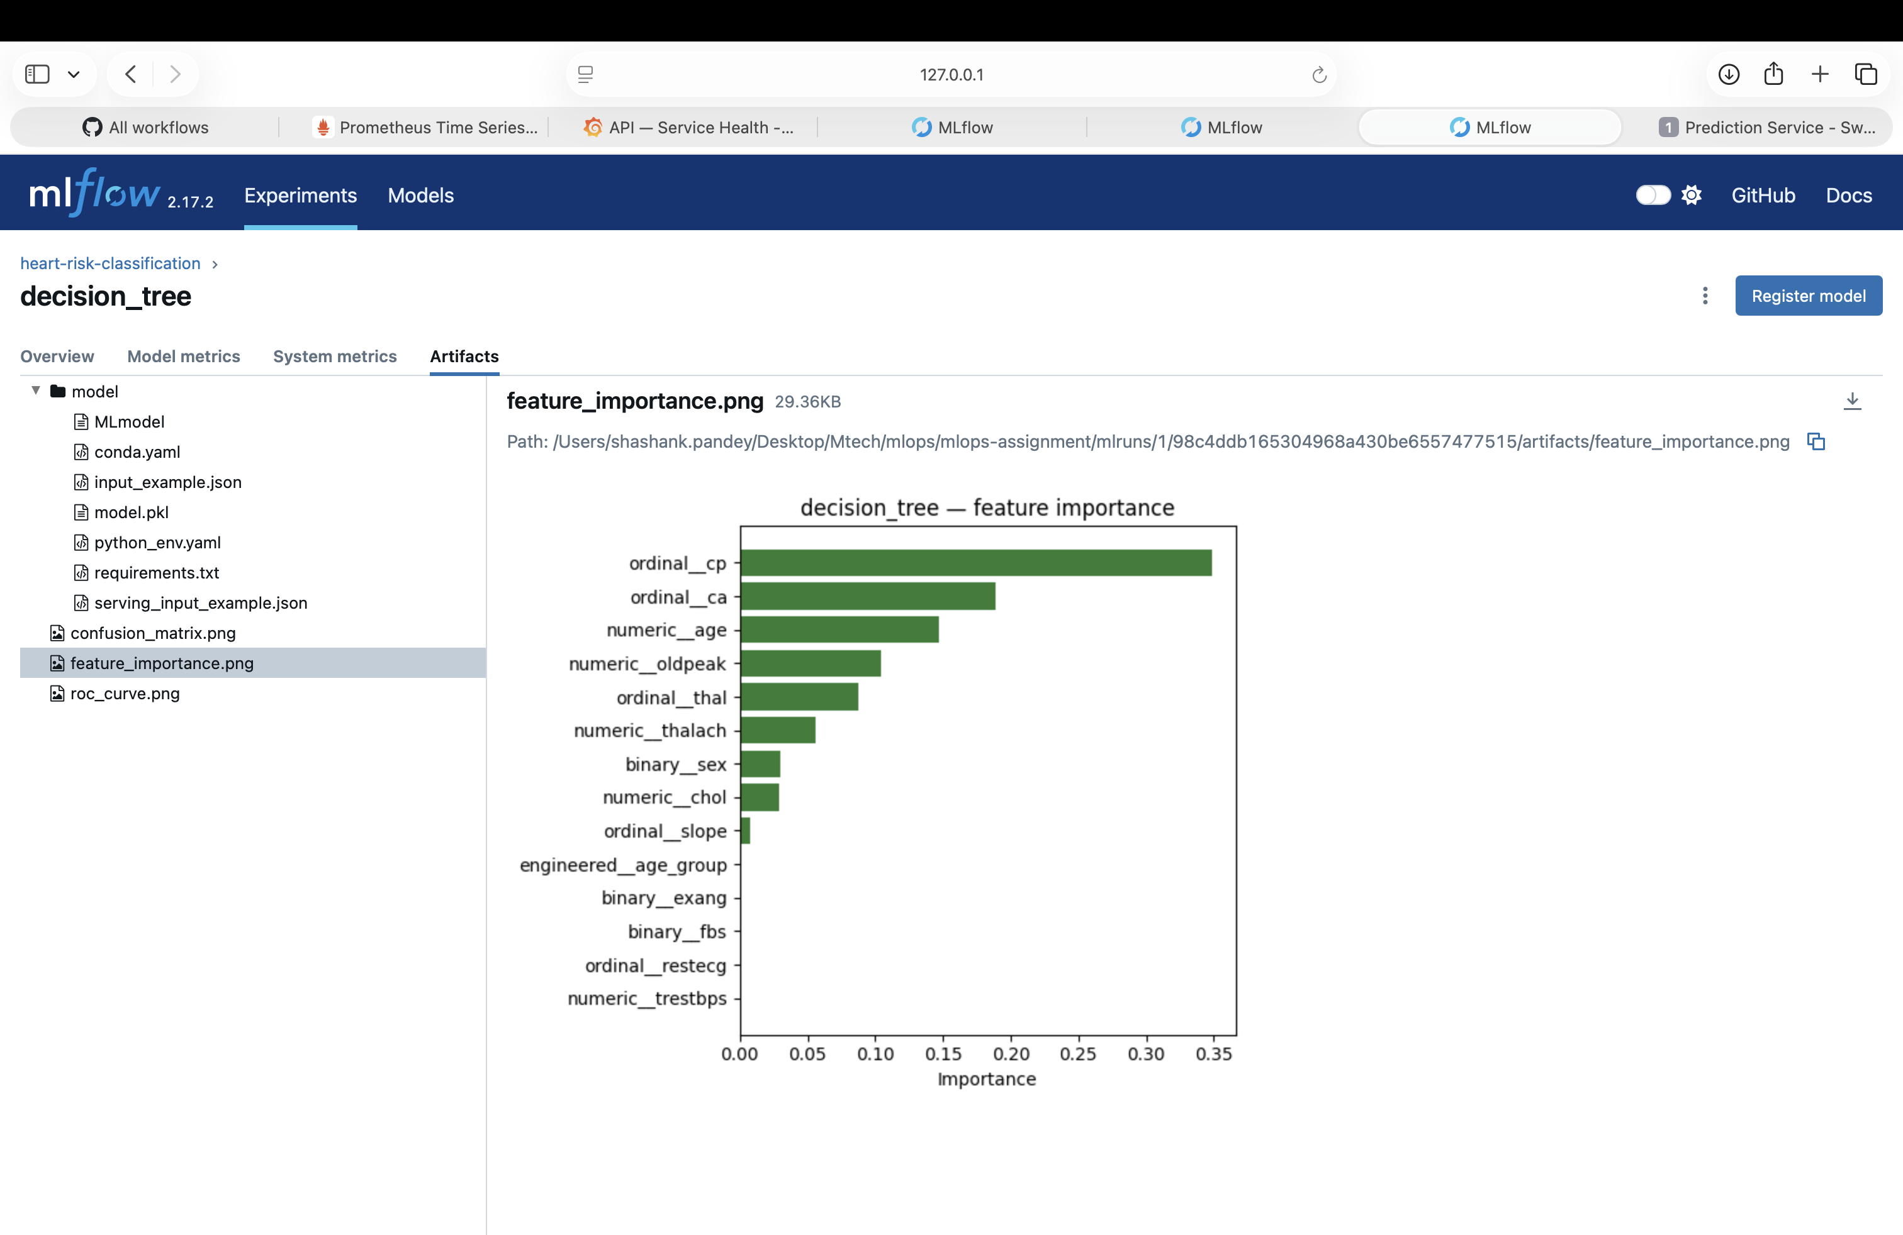
Decision Tree feature importance
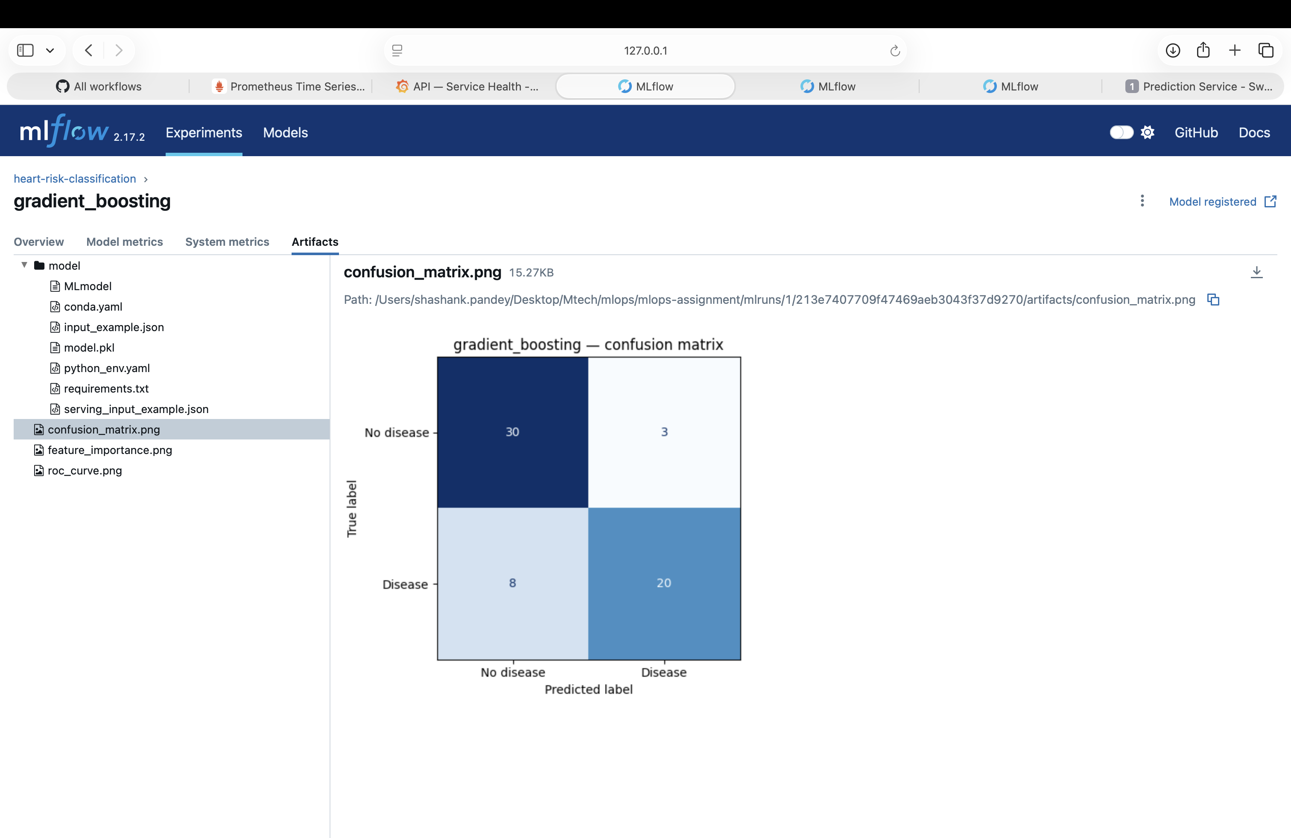
Gradient Boosting confusion matrix
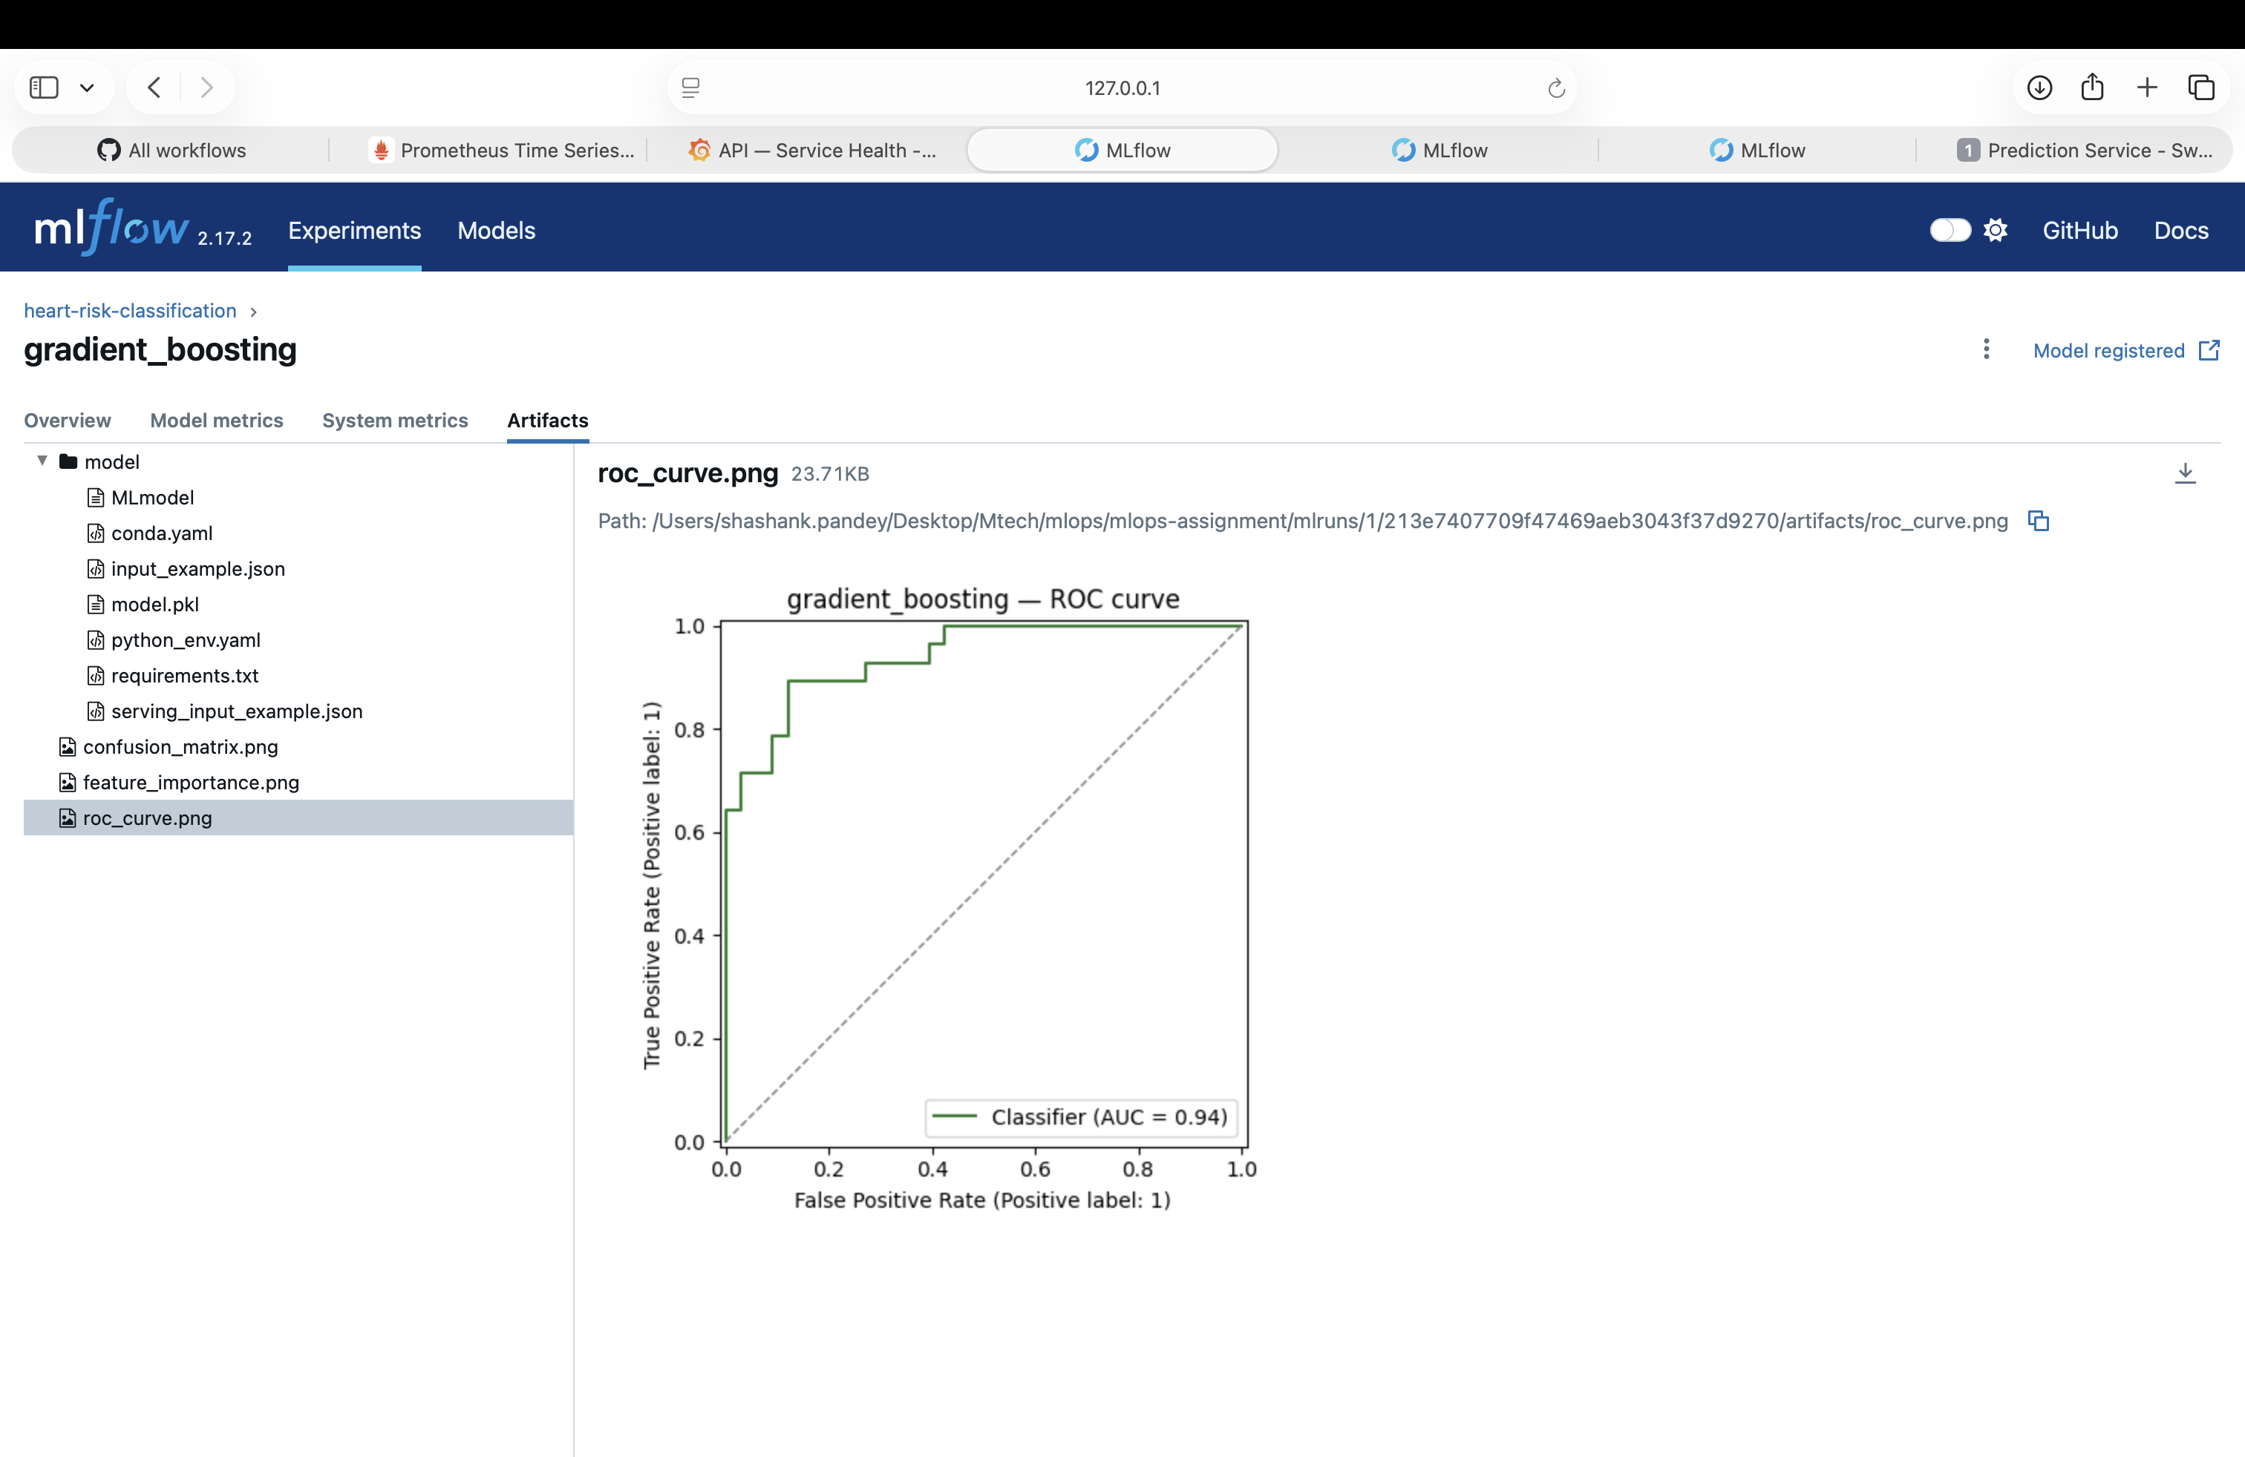
Gradient Boosting ROC curve
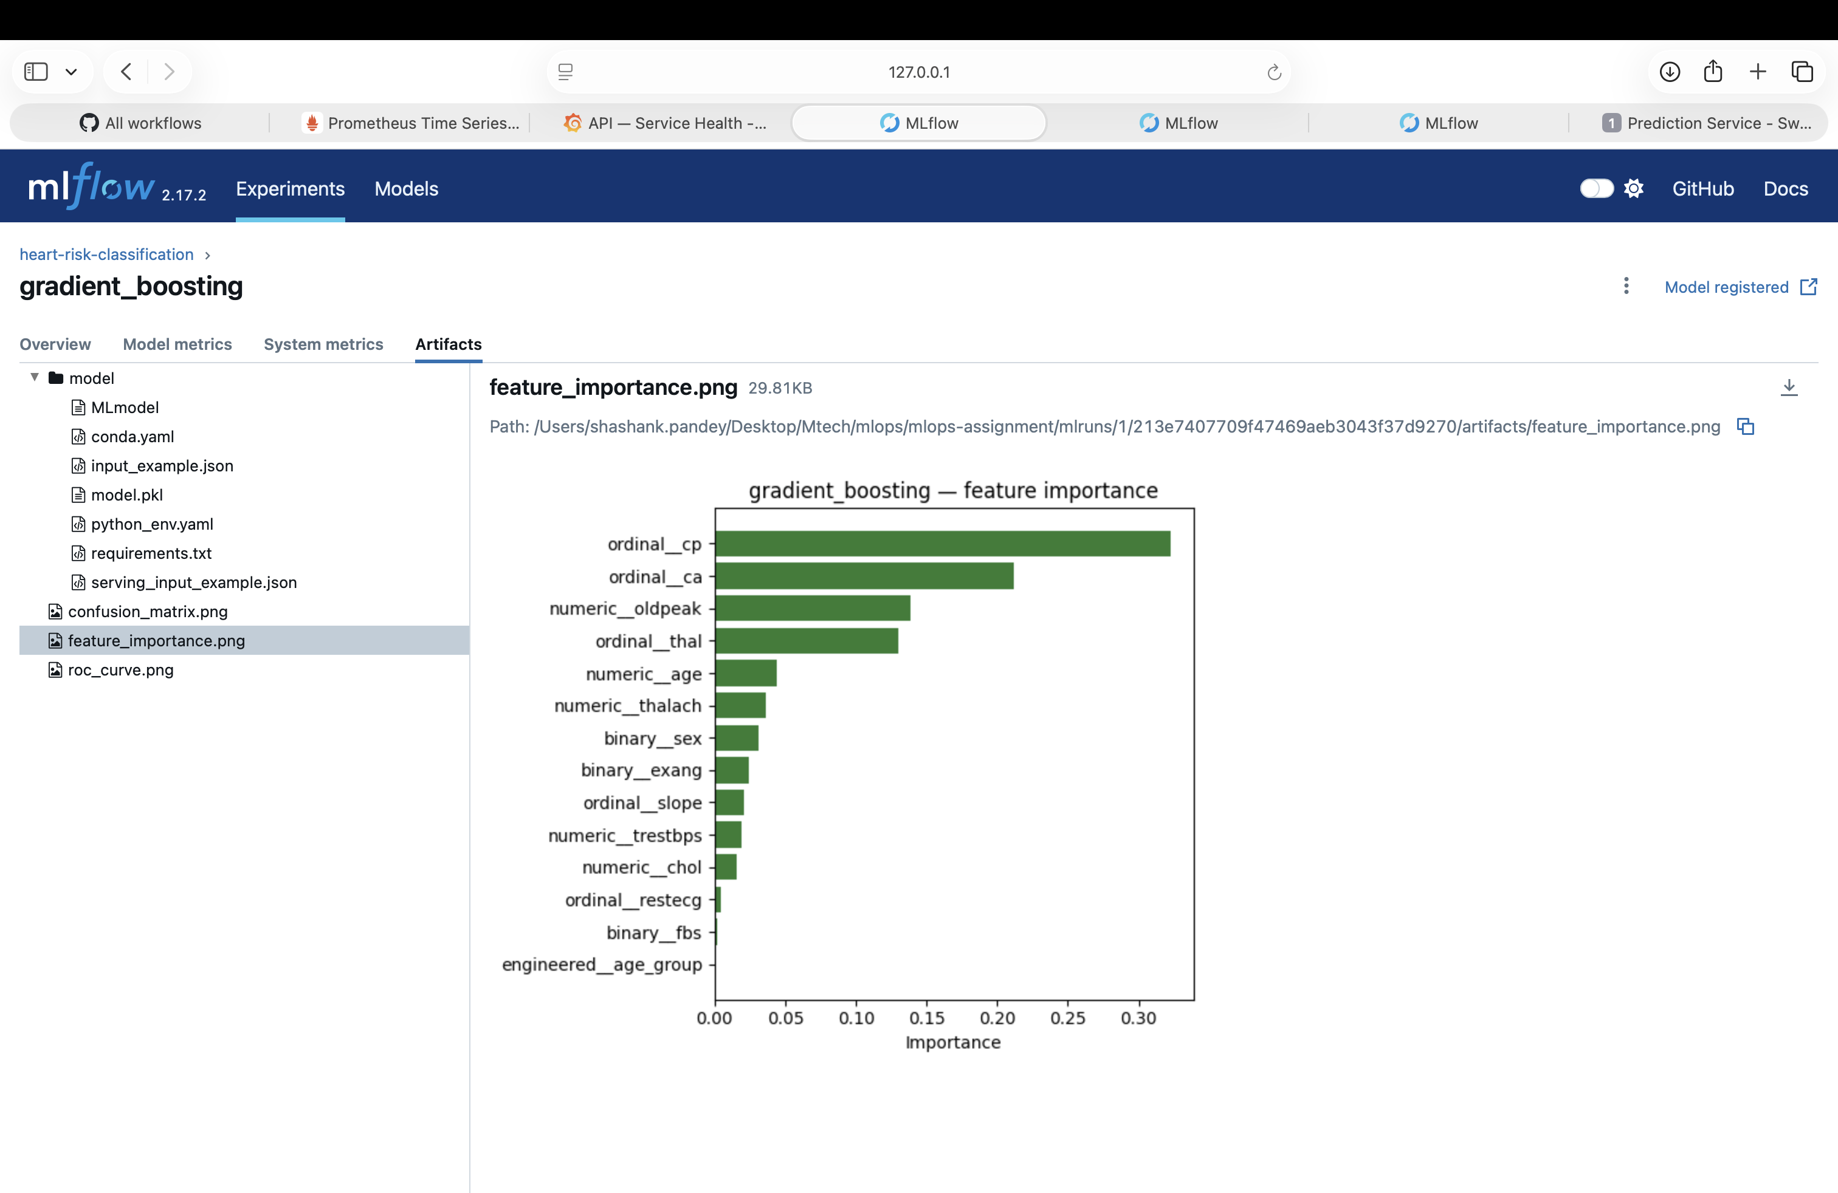
Gradient Boosting feature importance

5. Experiment Tracking (MLflow)
Tracking store: sqlite:///mlflow.db (not the default local file store) — specifically so the champion model could be registered in the MLflow Model Registry, which requires a database-backed store. Every RandomizedSearchCV run is logged under the heart-risk-classification experiment with:
- Params: winning hyperparameters, CV fold count, search iteration count
- Metrics: CV F1 mean, and holdout accuracy/precision/recall/F1/ROC-AUC
- Artifacts: confusion matrix, ROC curve, and a feature-importance plot (both models expose feature_importances_ natively) — an artifact a Logistic-Regression-based pipeline wouldn’t give for free
- Registry: the champion is registered as heart-risk-classifier, giving it a version number independent of the underlying MLflow run
mlflow ui --backend-store-uri sqlite:///mlflow.db
Side-by-side run comparison from the MLflow UI (gradient_boosting vs. decision_tree, matching the results table in Section 4 exactly, including the champion=true tag set on the winner):
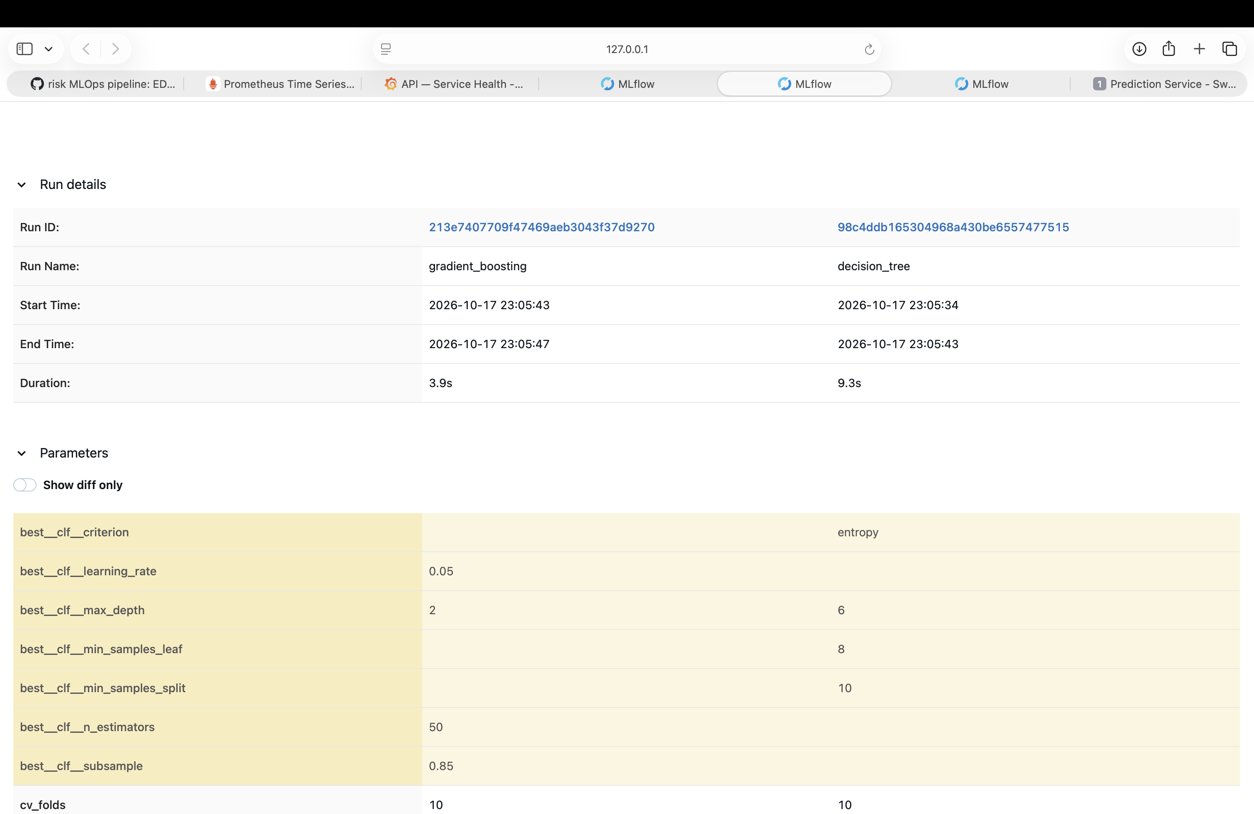
MLflow run comparison - parameters and tags
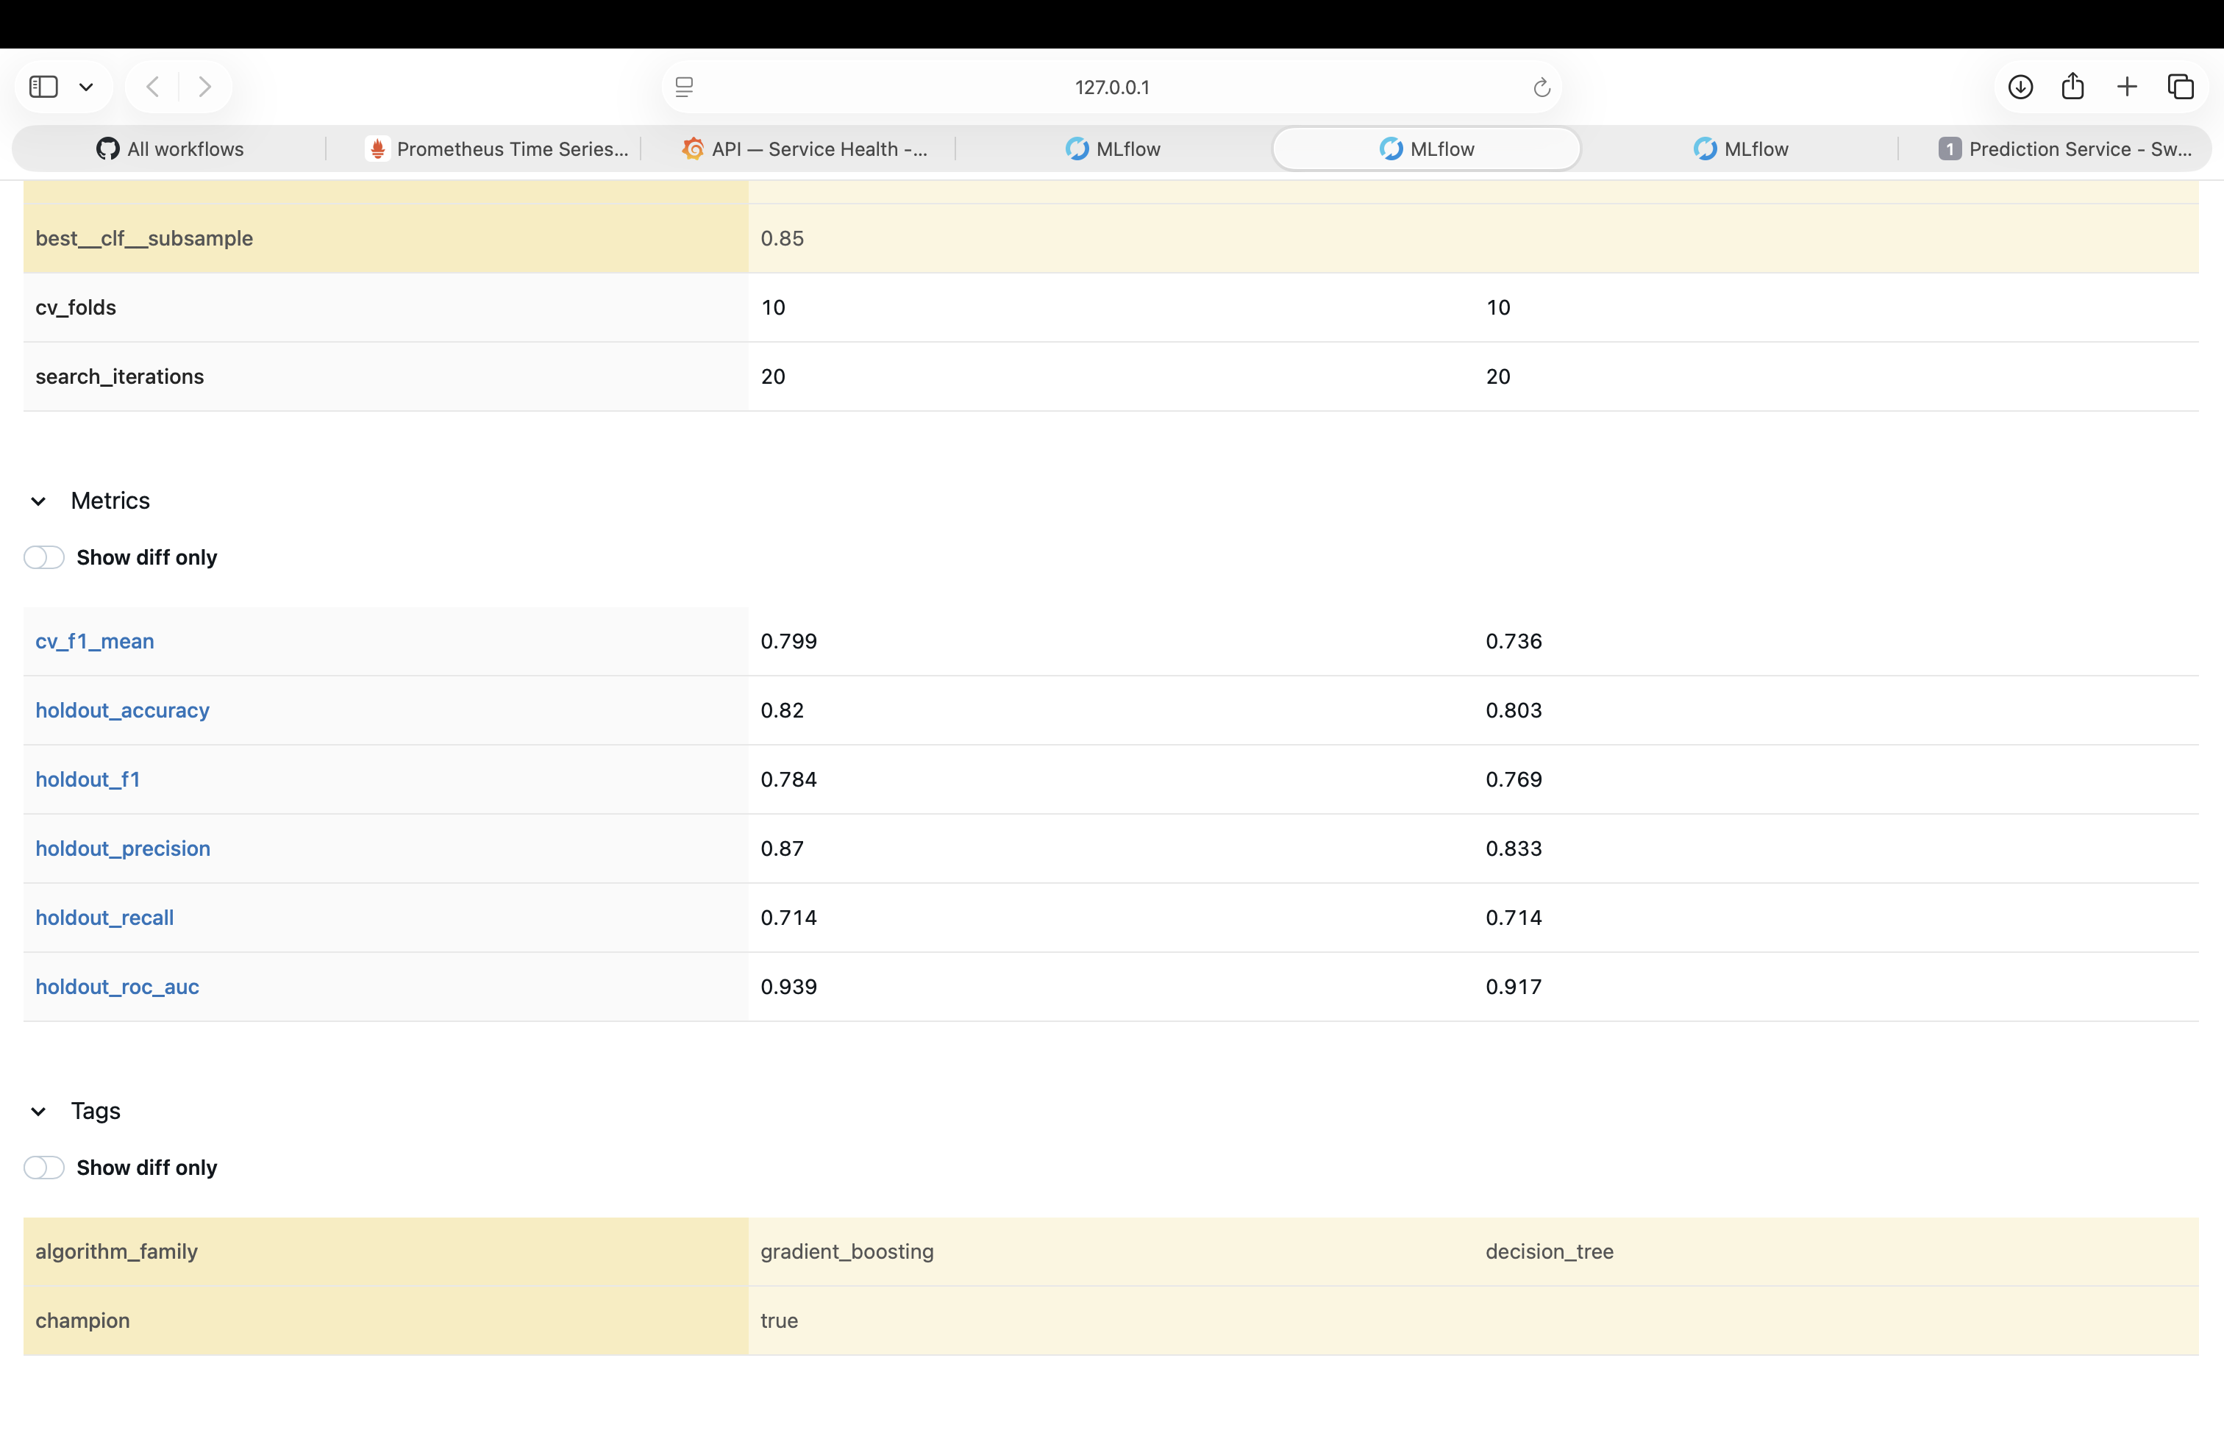
MLflow run comparison - metrics

6. Model Packaging & Reproducibility
- The champion pipeline is saved via mlflow.sklearn.save_model — an MLflow-format model directory (artifacts/model/, containing MLmodel, model.pkl, conda.yaml, requirements.txt) rather than a bare joblib.dump pickle. The serving layer loads it with mlflow.pyfunc.load_model, so swapping in a different MLflow-flavored model later wouldn’t require touching the loading code.
- artifacts/metadata.json records the champion’s name, registry version, hyperparameters, holdout metrics, and a summary of every candidate trained.
- Two requirements files: requirements.txt (full dev/training environment) and deploy/docker/requirements.txt (slim serving-only set using mlflow-skinny instead of full mlflow, to avoid pulling the tracking server/UI stack into the serving image). All packages version-pinned.

7. Testing & CI/CD
Unit tests (tests/, 41 cases, Python’s built-in unittest framework — TestCase classes with setUp/tearDown, chosen over pytest as the assignment’s other explicitly listed option): cover ingestion parsing, dataset loading/splitting, the feature pipeline (no-NaN output, ordinal-not-onehot width check, independent refits), the AgeGroupBucketer, metric computation + all three plot functions, the training candidates’ structural correctness, RiskPredictor inference, and the FastAPI service’s endpoints. No test touches the network or depends on artifacts/model/ already existing — a synthetic fixture dataset (tests/fixtures.py) stands in for the real data.
CI/CD (.github/workflows/pipeline.yml) — three Makefile-driven jobs, each gated on the previous succeeding:
- quality — make lint (flake8), make test (unittest)
- train — make ingest, make train; asserts artifacts/metadata.json was produced; uploads the model + MLflow SQLite DB as an artifact
- containerize — downloads the trained model, make docker-build, make docker-run, polls /health, sends a real /predict request and asserts the response shape, then lints the Helm chart (make helm-lint)
Any failure — lint error, failing test, training crash, a container that never becomes healthy, a bad /predict response, or an invalid Helm chart — fails the pipeline with a non-zero exit and a readable log.

8. Containerization
deploy/docker/Dockerfile — multi-stage build: - Builder stage: Python 3.12-slim + build-essential, installs deploy/docker/requirements.txt into an isolated venv - Runtime stage: Python 3.12-slim + the venv copied over, app code, and the MLflow-format model directory — no compiler toolchain in the final image. Runs as a non-root user, HEALTHCHECK against /health. - Process model: gunicorn managing uvicorn.workers.UvicornWorker processes (2 workers) rather than invoking uvicorn directly — closer to how this would actually run in production, and gives explicit worker-count control.
Verified locally:
make docker-build
make docker-run
curl http://localhost:8080/health
# {"status":"ok","model_ready":true,"model_name":"heart-risk-classifier","model_version":"1"}
The FastAPI interactive docs (Swagger UI), auto-generated from the Pydantic contracts in heart_risk/service/contracts.py:
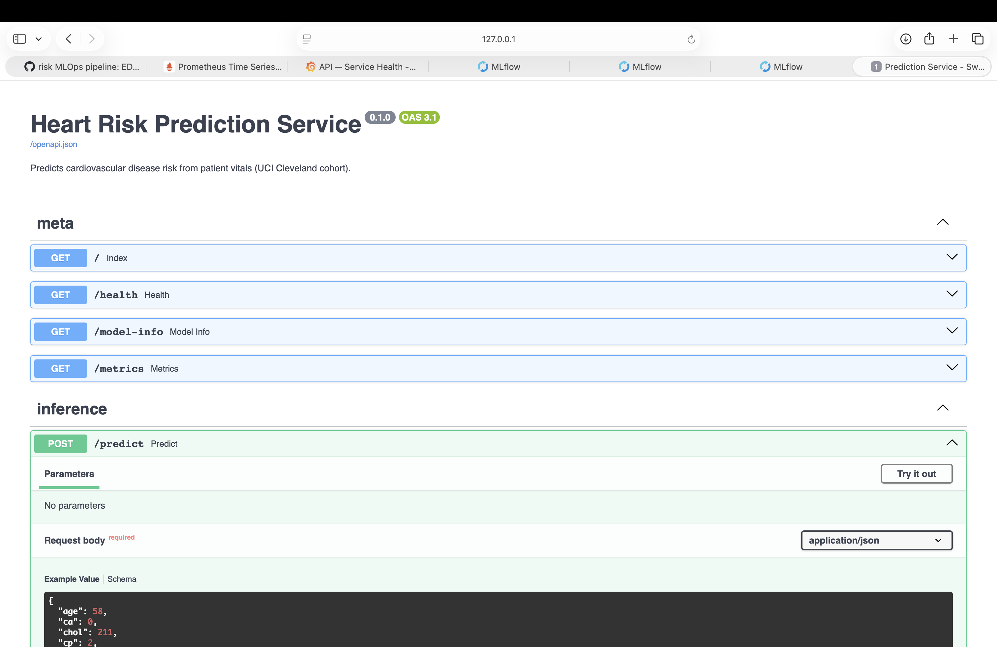
FastAPI Swagger UI - Heart Risk Prediction Service

9. Production Deployment (Kubernetes via Helm)
Packaged as a Helm chart (deploy/helm/heart-risk-api/) rather than raw manifests — the assignment explicitly allows either, and a chart makes the “bundle the API + its monitoring stack as one installable unit” design (Section 10) much cleaner than separate kubectl apply files.
- Deployment: 2 replicas, resource requests/limits, readiness probe (/health, 5s delay) and liveness probe (/health, 15s delay)
- Service: ClusterIP (not directly exposed)
- Ingress: nginx ingress class, host heart-risk.local — the assignment’s other explicit option for exposing the API (vs. a LoadBalancer Service)
minikube addons enable ingress
helm install heart-risk-api deploy/helm/heart-risk-api \
--namespace heart-risk --create-namespace
Verified end-to-end through the Ingress (not just the pod’s own loopback):
$ kubectl -n heart-risk get pods,svc,ingress
heart-risk-api-... 1/1 Running (x2 replicas)
heart-risk-api-grafana-... 1/1 Running
heart-risk-api-prometheus-... 1/1 Running
ingress.networking.k8s.io/heart-risk-api nginx heart-risk.local 192.168.49.2
$ curl -H "Host: heart-risk.local" http://<ingress-ip>/health
{"status":"ok","model_ready":true,...}
$ curl -H "Host: heart-risk.local" -X POST .../predict -d '{...}'
{"prediction":0,"risk_label":"low_risk","confidence":0.862,...}
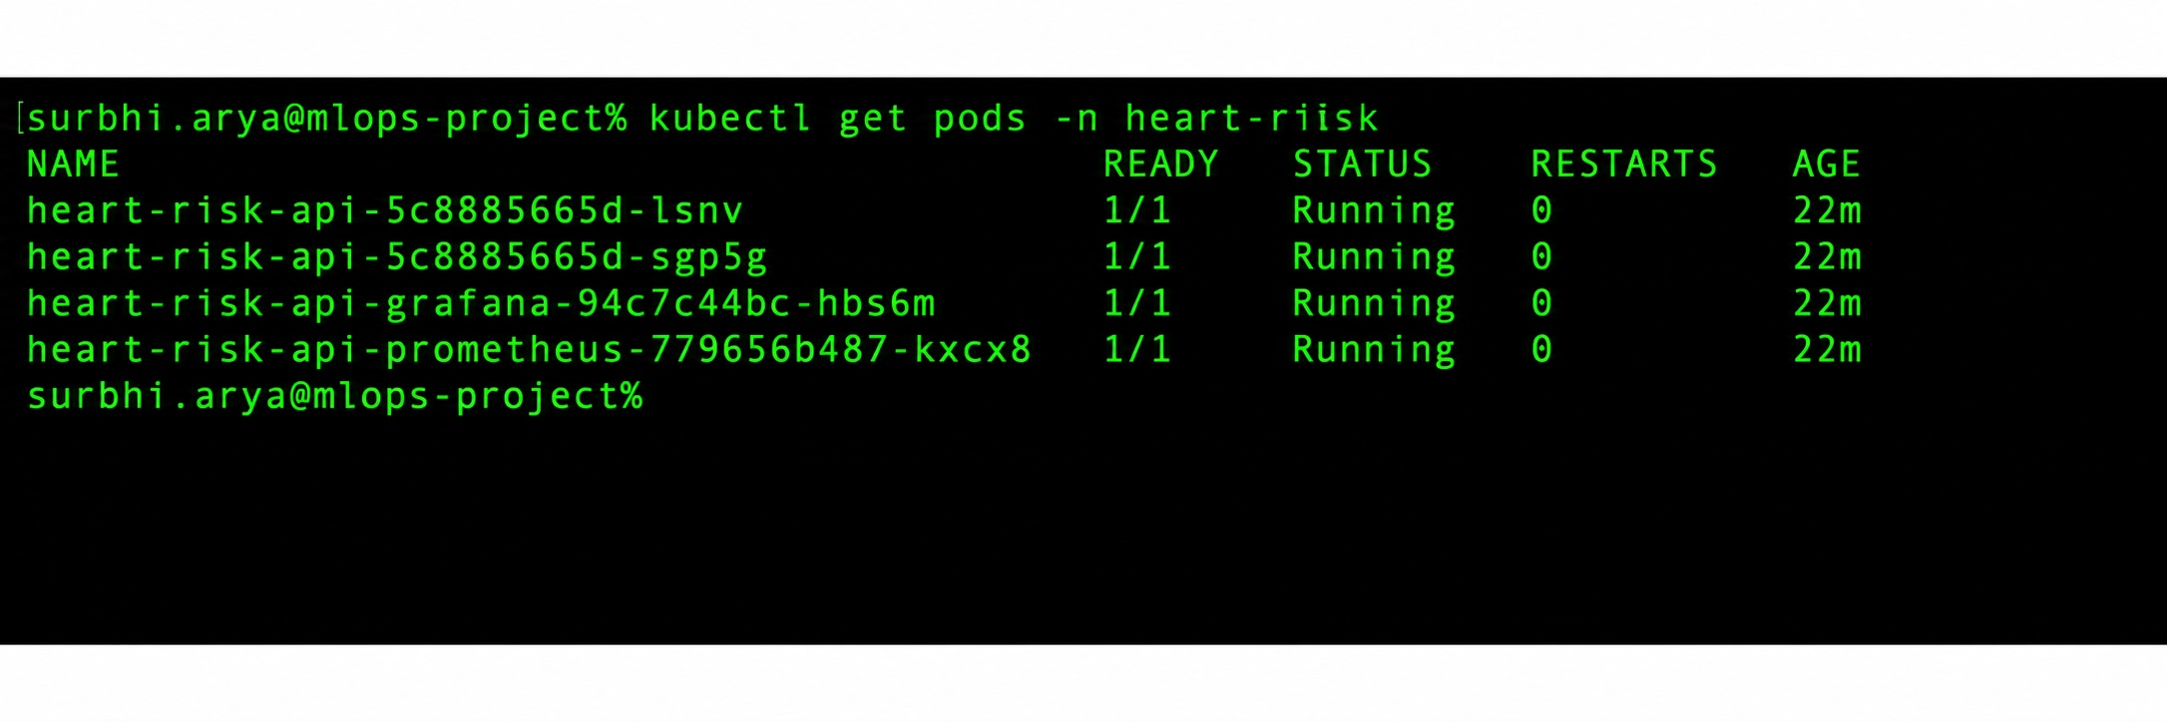
kubectl get pods -n heart-risk - API (2/2) + Prometheus + Grafana all Running

10. Monitoring & Logging
Request logging: every request produces a single structured JSON log line (trace id, method, route, status, duration) via a custom JsonLogFormatter — closer to what a real log aggregator (Loki, CloudWatch) would expect than a plain f-string.
Metrics: namespaced heart_risk_* Prometheus metrics (to avoid colliding with other services on a shared Prometheus instance): - heart_risk_http_requests_total{route,method,status} - heart_risk_predictions_total{risk_label} - heart_risk_request_duration_seconds{route}
Deployed stack: Prometheus and Grafana are templated as part of the same Helm chart as the API (deploy/helm/heart-risk-api/templates/monitoring/), so helm install brings up the entire observability stack alongside the service — no separate manifests to apply. Grafana auto-provisions: - A Prometheus datasource - A “Heart Risk API — Service Health” dashboard with four panels deliberately varied in type: a predictions-by-label time series, a requests-per-route pie chart, an average-vs-p99 latency time series, and an error-rate gauge — not just four line charts of different metrics.
Verified live against real traffic generated through the Ingress: Prometheus reports the heart-risk-api target as UP, and Grafana’s API confirms both the datasource and dashboard are provisioned.
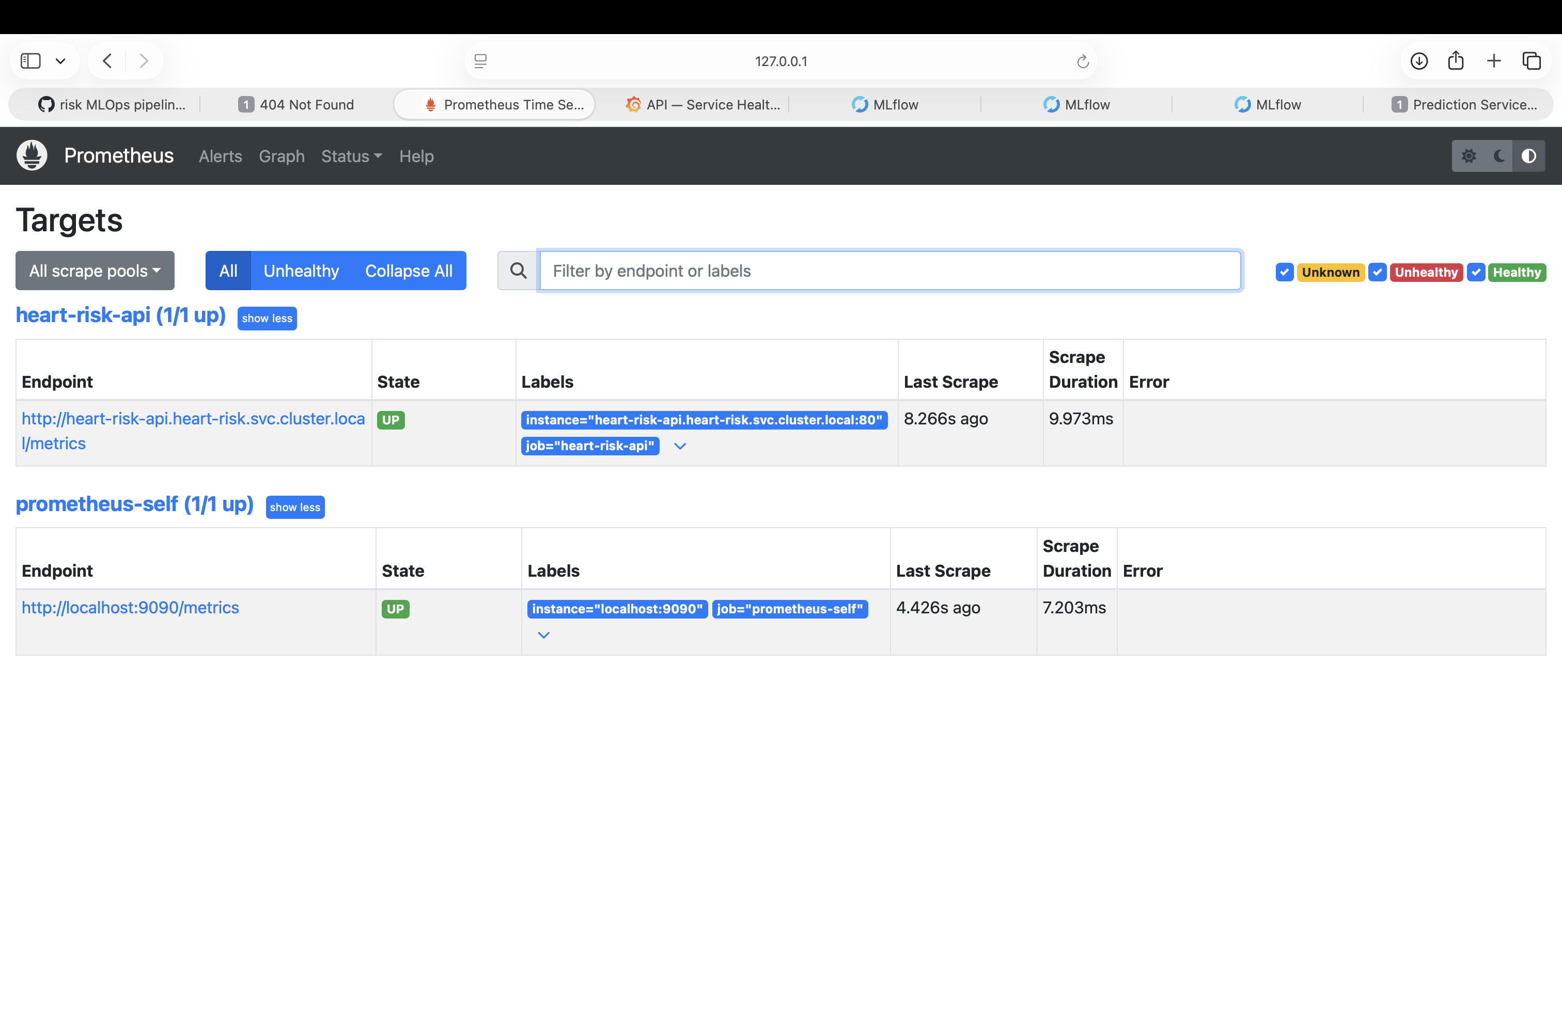
Prometheus targets - heart-risk-api UP
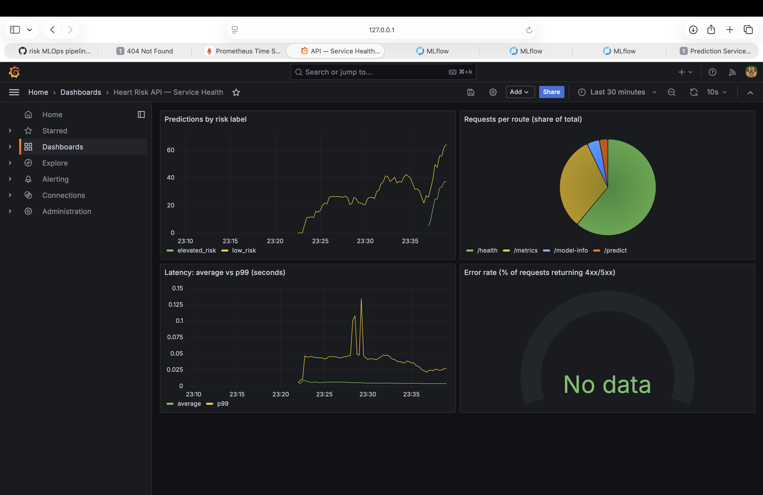
Grafana - Heart Risk API Service Health dashboard with live data

11. Architecture Diagram
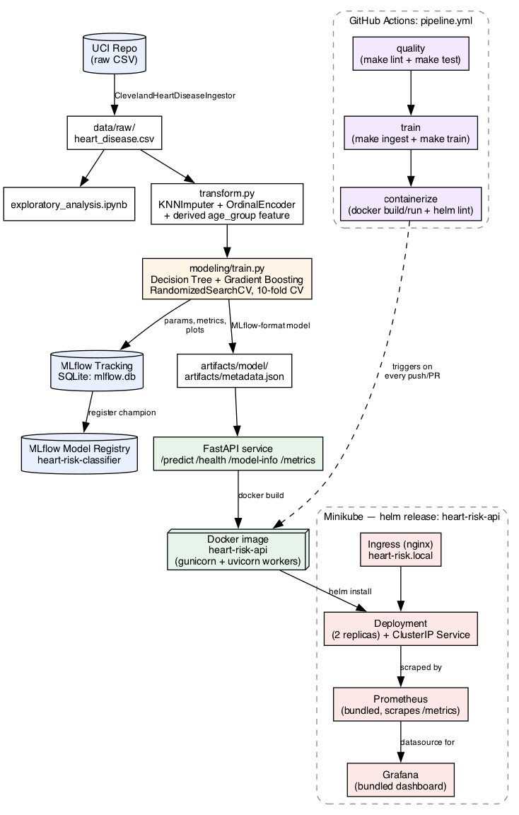
Architecture diagram
The authoritative, version-controlled source for this diagram is a Mermaid flowchart in README.md (renders natively on GitHub); the PNG above is a matching static rendering for this Word/PDF report.

12. Repository Link
https://github.com/shashankp1502/mlops-assignment

13. A note on originality
This pipeline’s structure, model choices, feature engineering approach (KNN imputation + ordinal encoding + a derived age-group feature), MLflow Model Registry usage, unittest-based test suite, Makefile-driven CI, and the Helm-packaged deployment (API + Ingress + bundled Prometheus/ Grafana as one chart) were designed independently for this assignment. Where choices overlap with general MLOps conventions (e.g. using MLflow, Docker, Prometheus/Grafana — all explicitly suggested by the assignment brief), the specific implementation — package layout, encoding strategy, model registry usage, dashboard panel design, and chart structure — was built from first principles for this submission rather than adapted from another student’s work.

