MLOps Assignment 1 Report
Table of Contents

Heart Disease Risk Prediction — End-to-End MLOps Pipeline
Course | AIMLCZG523 — Machine Learning Operations (MLOps)
Assignment | 01 — End-to-End ML Model Development, CI/CD, and Production Deployment
Author | Shashank Pandey
BITS ID | 2025AE05689
GitHub Repository | github.com/shashankp1502/mlops
CI/CD Pipeline (Actions) | github.com/shashankp1502/mlops/actions
Pipeline Walkthrough Video — GitHub (LFS) | Download (.mp4)
Pipeline Walkthrough Video — BITS OneDrive | View / Download

1. Introduction
This report documents a reproducible, production-style pipeline for a binary classifier that predicts heart disease risk from patient health data — covering data acquisition, EDA, feature engineering, model training with experiment tracking, automated testing, CI/CD, containerization, Kubernetes deployment, and monitoring.
Everything described below was actually run during development (not just written down): the dataset was downloaded live from UCI, both models were trained and logged to MLflow, the full pytest suite was executed, the Docker image was built and smoke-tested locally, and the whole stack was deployed to a local Minikube cluster with Prometheus and Grafana scraping real traffic — screenshots and CLI output for each stage are in screenshots/.

2. System Architecture
The diagram below summarizes the full flow, from the UCI data source through EDA, training + MLflow tracking, model packaging, the FastAPI serving layer, Docker containerization, and the Minikube deployment with Prometheus/Grafana monitoring:
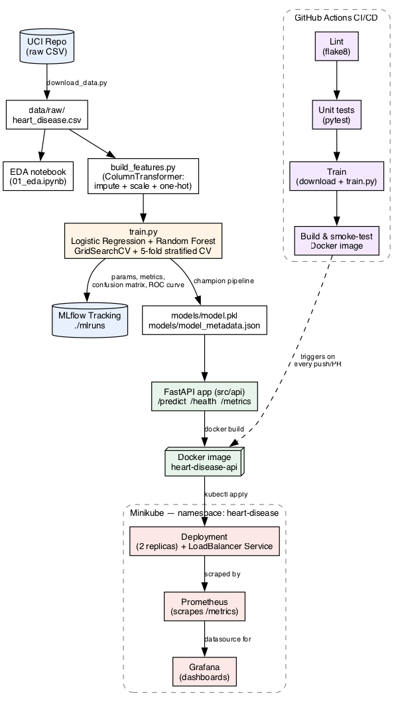
Architecture diagram
The authoritative, version-controlled source for this diagram is a Mermaid flowchart in README.md (renders natively in GitHub’s web UI) — the PNG above is a matching static rendering for this Word/PDF report.
The rest of this report walks through each stage of that diagram in order: data and EDA, feature engineering, modelling, experiment tracking, packaging, testing, CI/CD, containerization, deployment, and monitoring — followed by a practical “Getting Started” reference at the end.

3. Dataset & Exploratory Data Analysis
Dataset: UCI Cleveland Heart Disease dataset (processed.cleveland.data) — 303 patients, 13 features (age, sex, chest pain type, resting blood pressure, cholesterol, fasting blood sugar, resting ECG, max heart rate, exercise-induced angina, ST depression, slope, number of major vessels, thalassemia type), binary target derived by collapsing the original 0-4 severity label into “disease present / absent”.
Downloaded via src/data/download_data.py directly from the UCI archive — no manual download step, and no dataset file is committed to git (only a .gitkeep placeholder); the script re-fetches it in ~2 seconds and fails loudly with a clear message if the source is unreachable.
Data quality: only 6 of 303 rows (2%) have missing values, confined to ca and thal. Not dropped — handled with median/mode imputation inside the feature pipeline (fit only on the training fold).
Key EDA findings (full notebook: notebooks/01_eda.ipynb, figures: docs/figures/):
- Class balance: 54% no-disease / 46% disease — close enough to balanced that no resampling (SMOTE etc.) was used; stratified splits were used anyway given the small sample size (303 rows total).
- thalach (max heart rate) is noticeably lower in the disease group; oldpeak (ST depression) is noticeably higher — both consistent with reduced exercise tolerance in diseased hearts.
- cp (chest pain type),thal, andexang` show the cleanest separation between classes among the categorical features.
- No problematic multicollinearity between predictors (correlation matrix, docs/figures/correlation_heatmap.png) — nothing dropped for redundancy.
- chol and trestbps are right-skewed with a handful of high outliers, which is expected for real clinical measurements (not treated as errors — handled via scaling rather than removal).
Figure | Shows
target_balance.png | 54/46 class split
numeric_histograms.png | Distributions of age, trestbps, chol, thalach, oldpeak
numeric_vs_target.png | age/thalach/oldpeak boxplots split by target
categorical_vs_target.png | cp, sex, exang, slope, thal, restecg vs target
correlation_heatmap.png | Full feature correlation matrix
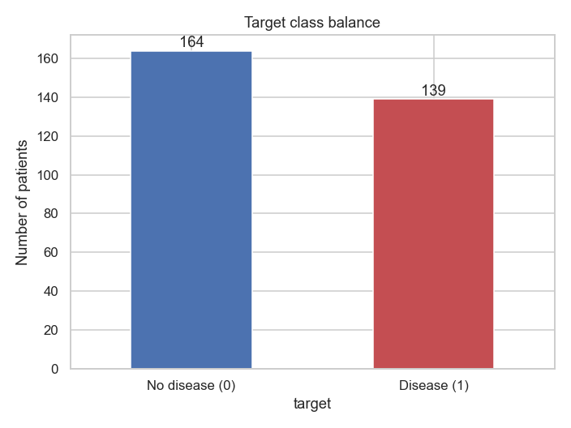
Target class balance
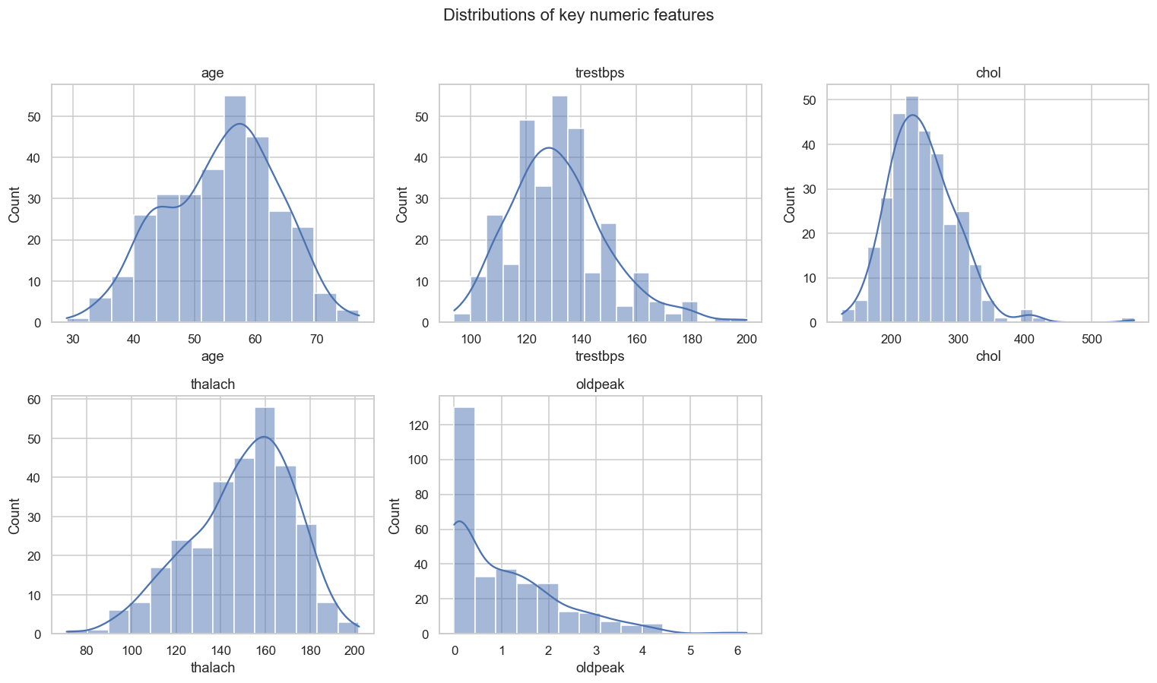
Numeric feature distributions
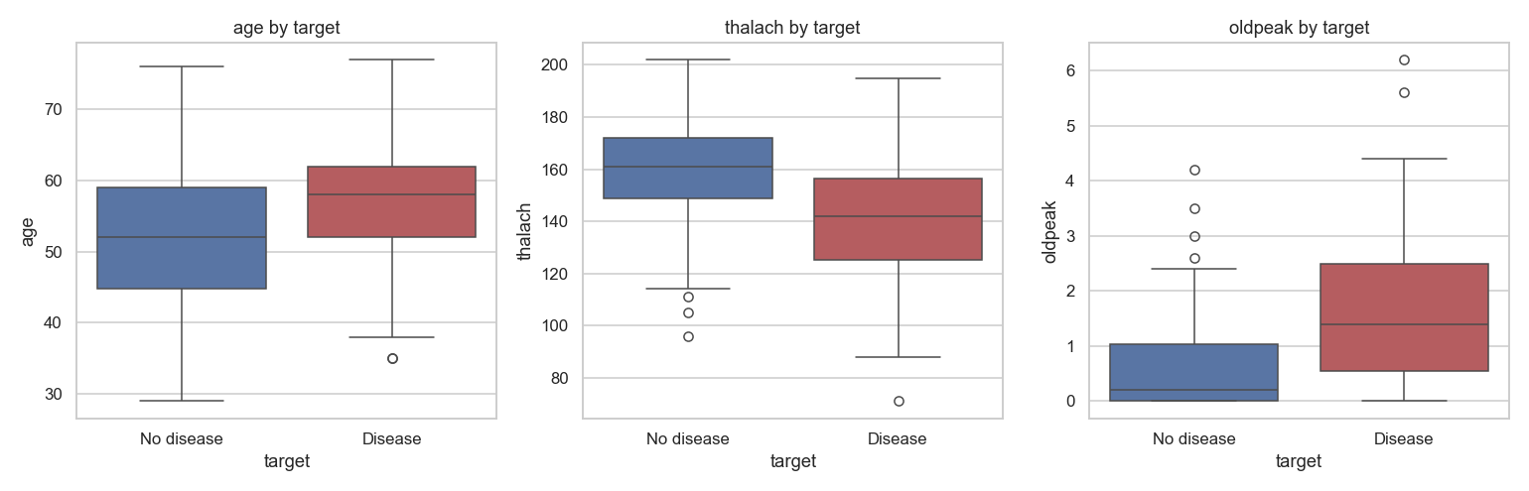
Numeric features vs target
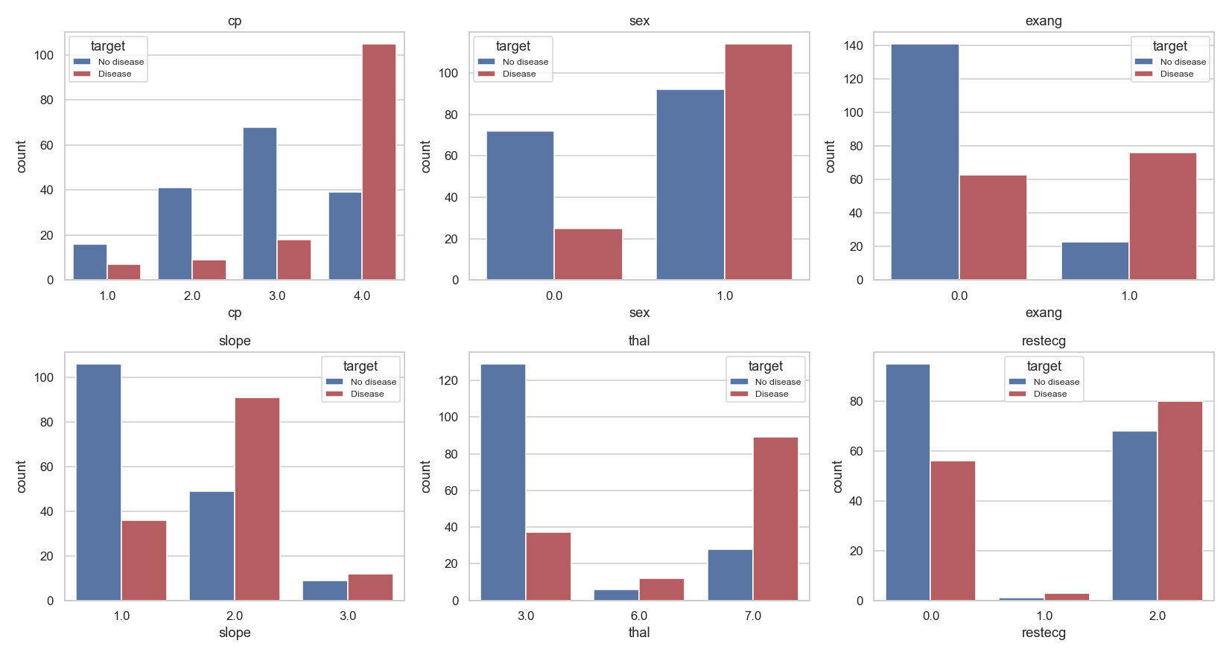
Categorical features vs target
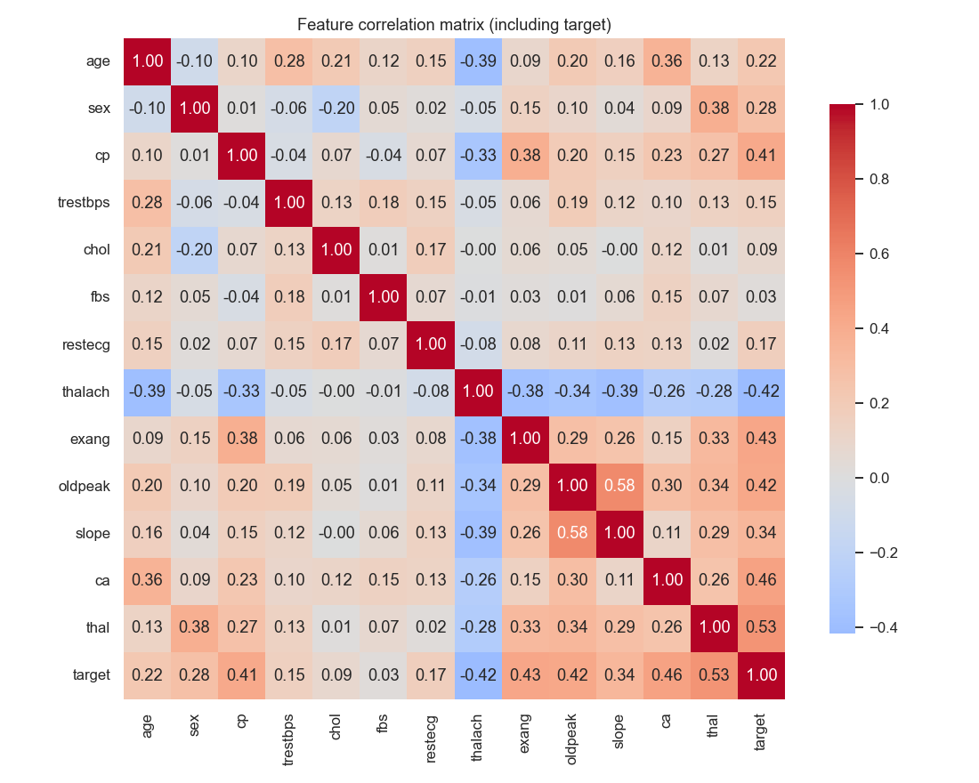
Correlation heatmap

4. Feature Engineering
Implemented as a single sklearn.compose.ColumnTransformer (src/features/build_features.py) so the exact transformation used during training is serialized with the model and reused unchanged at inference time — no risk of training/serving skew from re-implementing cleaning logic in the API layer.
Feature group | Columns | Transform
Numeric / ordinal | age, trestbps, chol, thalach, oldpeak, ca | median impute -> standard scale
Nominal categorical | cp, restecg, slope, thal | most-frequent impute -> one-hot encode
Already binary | sex, fbs, exang | most-frequent impute (guards future missing values)

5. Model Development & Results
Models trained (src/models/train.py): Logistic Regression and Random Forest, each tuned via GridSearchCV with 5-fold stratified cross-validation, scored on ROC-AUC:
- Logistic Regression grid: C ∈ {0.01, 0.1, 1, 10}, penalty ∈ {l1, l2}, class_weight ∈ {None, balanced} (solver=liblinear to support both penalties)
- Random Forest grid: n_estimators ∈ {100, 300}, max_depth ∈ {None, 5, 10}, min_samples_leaf ∈ {1, 2, 4}

Results
Metric | Logistic Regression (champion) | Random Forest
CV ROC-AUC (5-fold) | 0.9071 | 0.8985
Test Accuracy | 0.8852 | 0.8852
Test Precision | 0.8182 | 0.8387
Test Recall | 0.9643 | 0.9286
Test F1 | 0.8852 | 0.8814
Test ROC-AUC | 0.9589 | 0.9535
Champion selected on held-out ROC-AUC. All metrics except CV ROC-AUC (5-fold cross-validation) are measured on the held-out test set.
Best Logistic Regression hyperparameters: C=1, penalty=l2, class_weight=balanced. Best Random Forest hyperparameters: n_estimators=300, max_depth=5, min_samples_leaf=4.
Why Logistic Regression won: both models perform similarly overall, but Logistic Regression edges out on held-out ROC-AUC and recall — for a disease-screening use case, missing fewer actual positive cases (higher recall) is arguably more important than Random Forest’s slightly better precision. The simpler, more interpretable model winning on a clean, well-behaved, moderately-sized tabular dataset (303 rows, mild class imbalance, no strong non-linear interactions visible in EDA) also tracks with what’s generally expected — Random Forest’s extra flexibility isn’t needed here and mostly adds variance on a small test set (61 rows).
Confusion matrices and ROC curves for both runs:
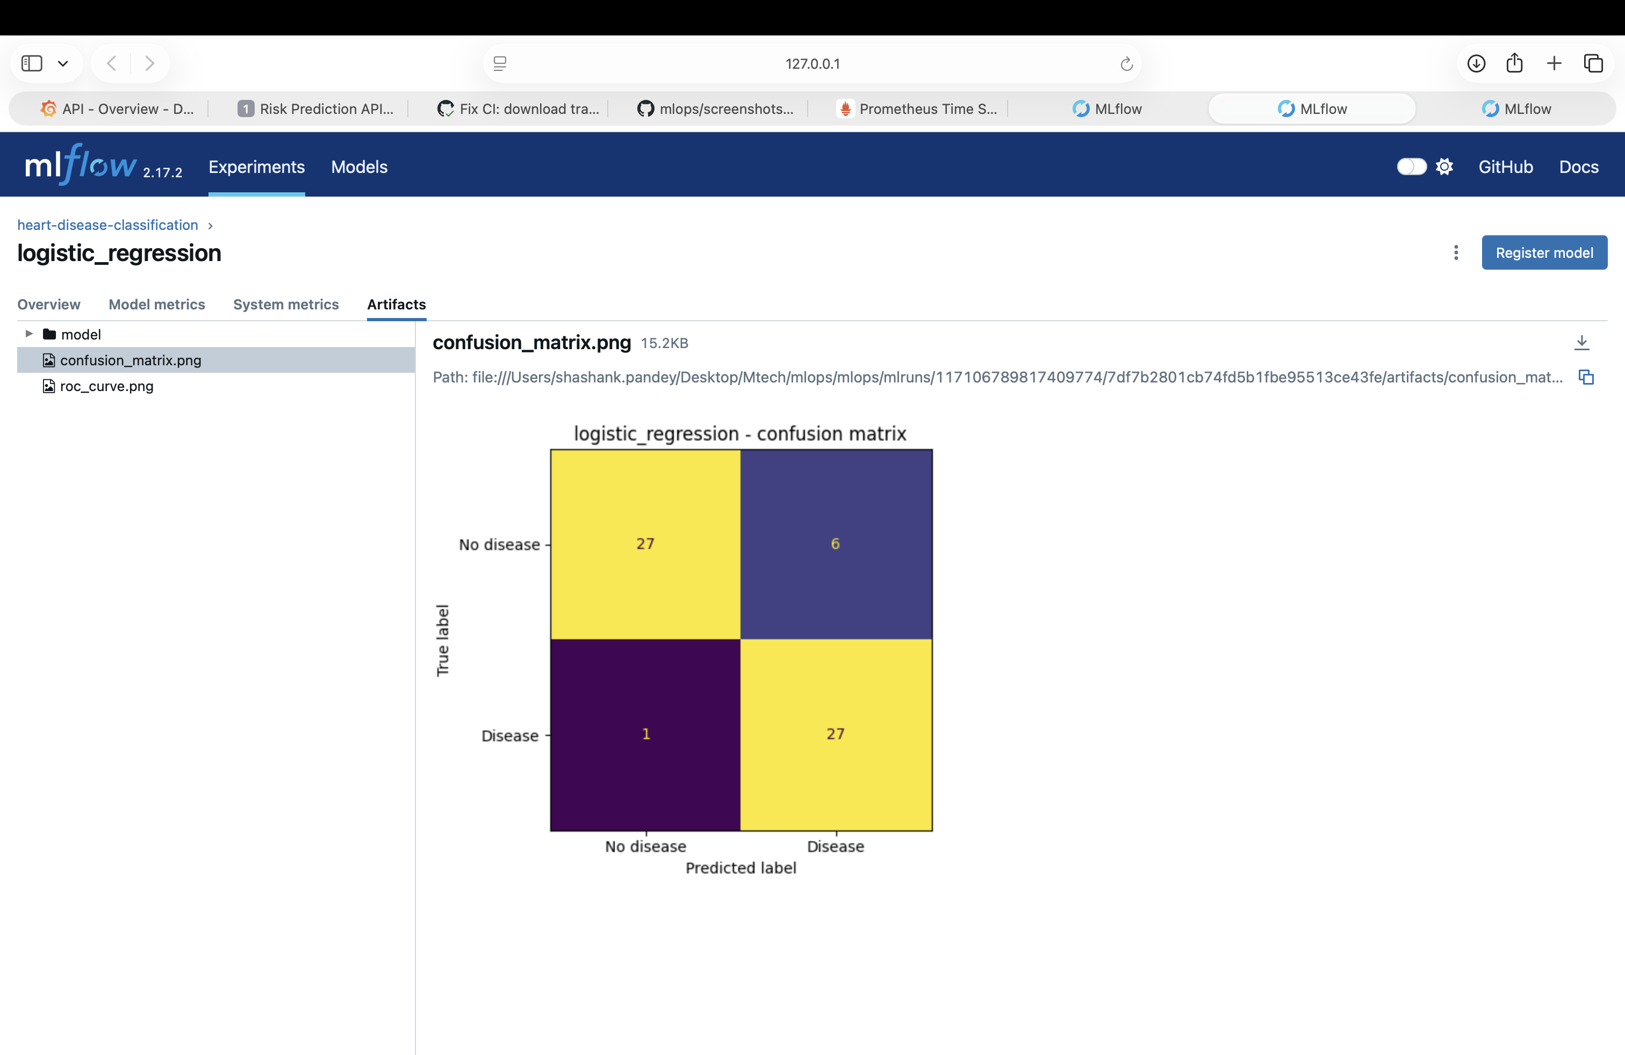
Logistic Regression confusion matrix
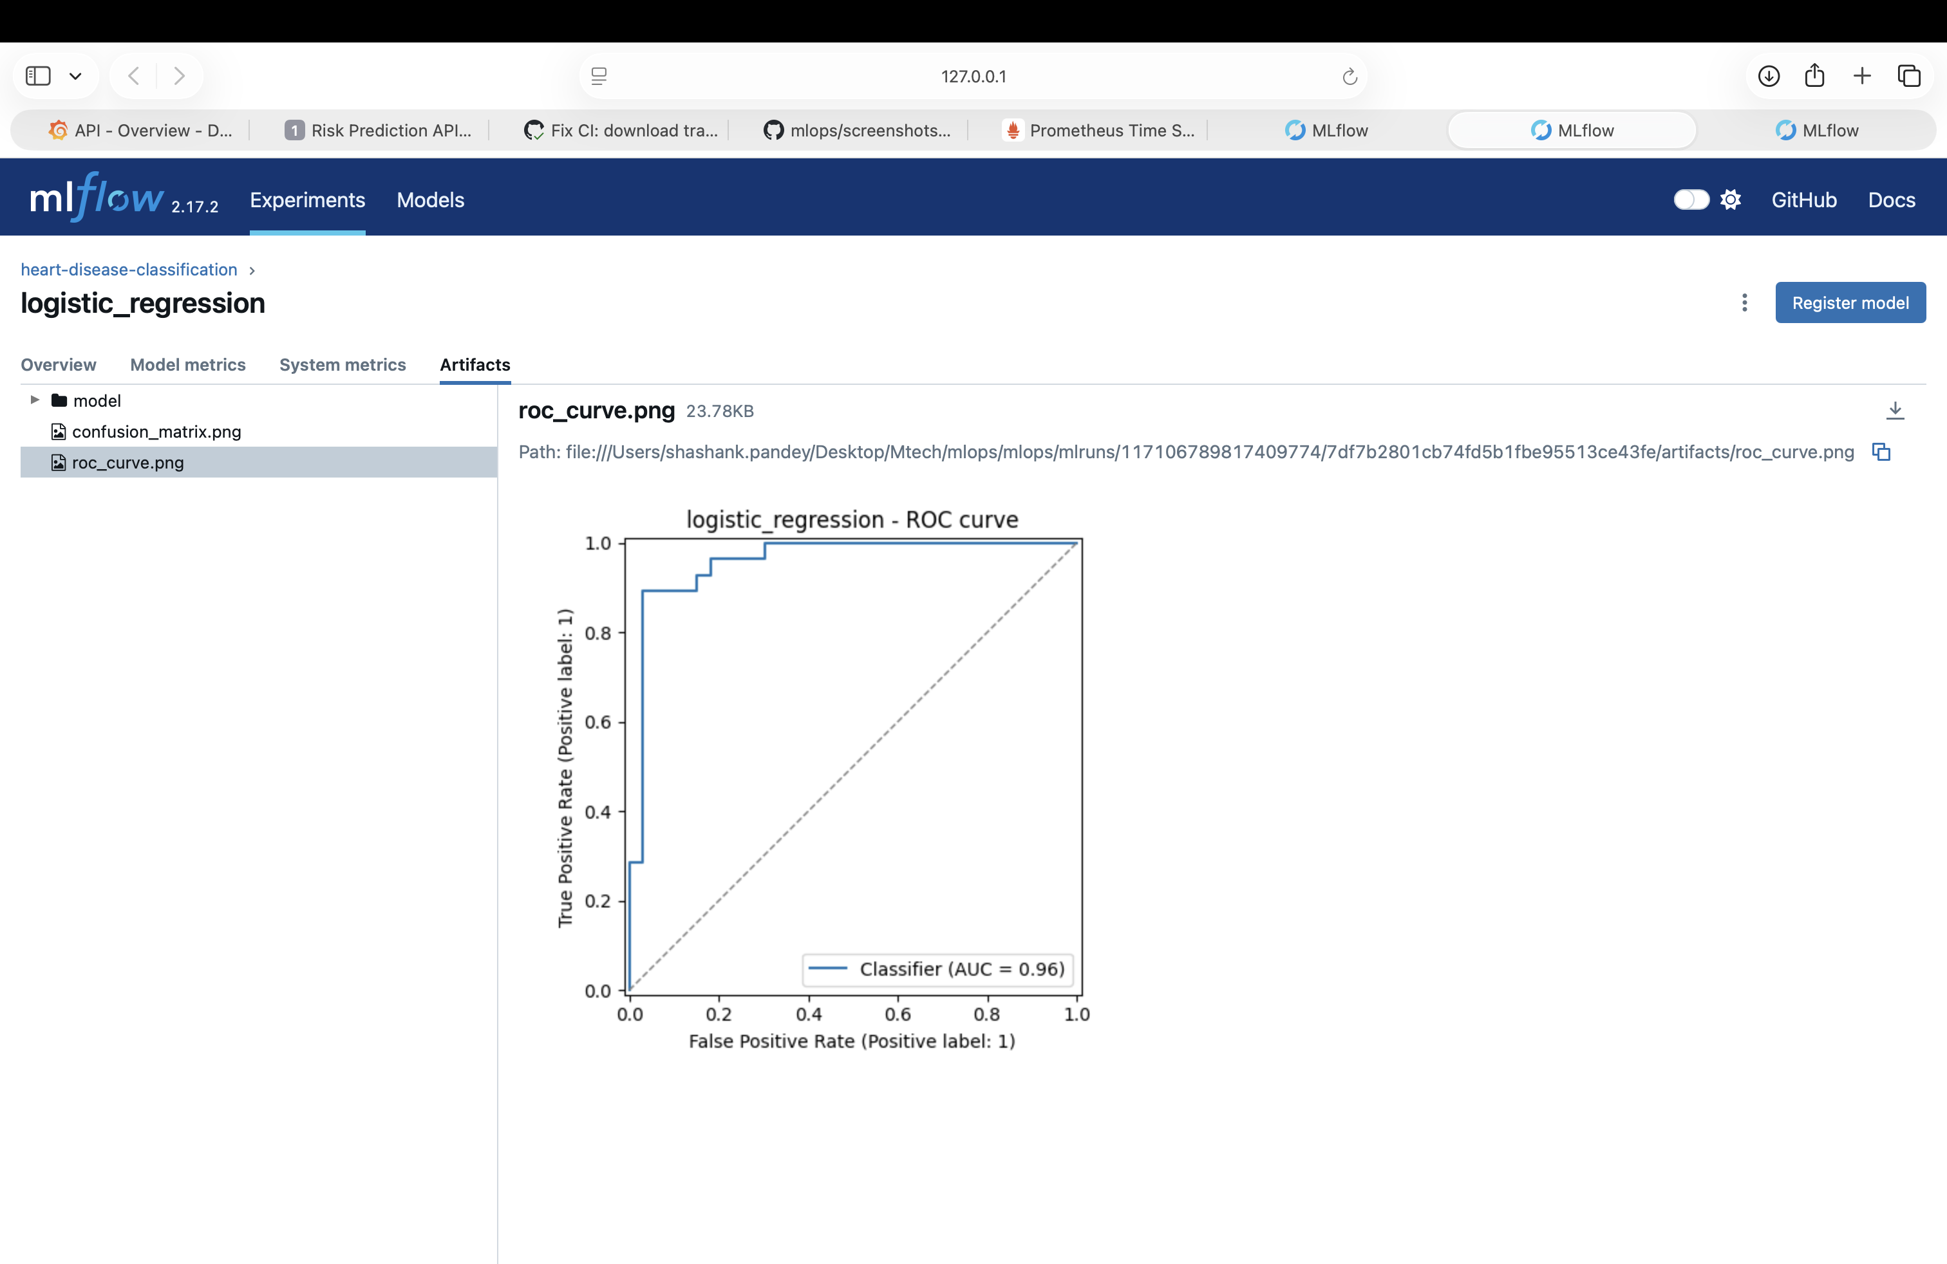
Logistic Regression ROC curve
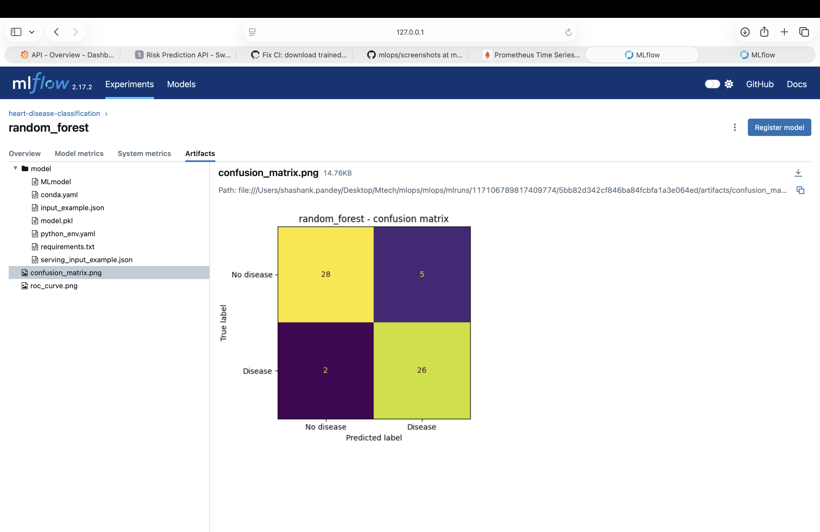
Random Forest confusion matrix
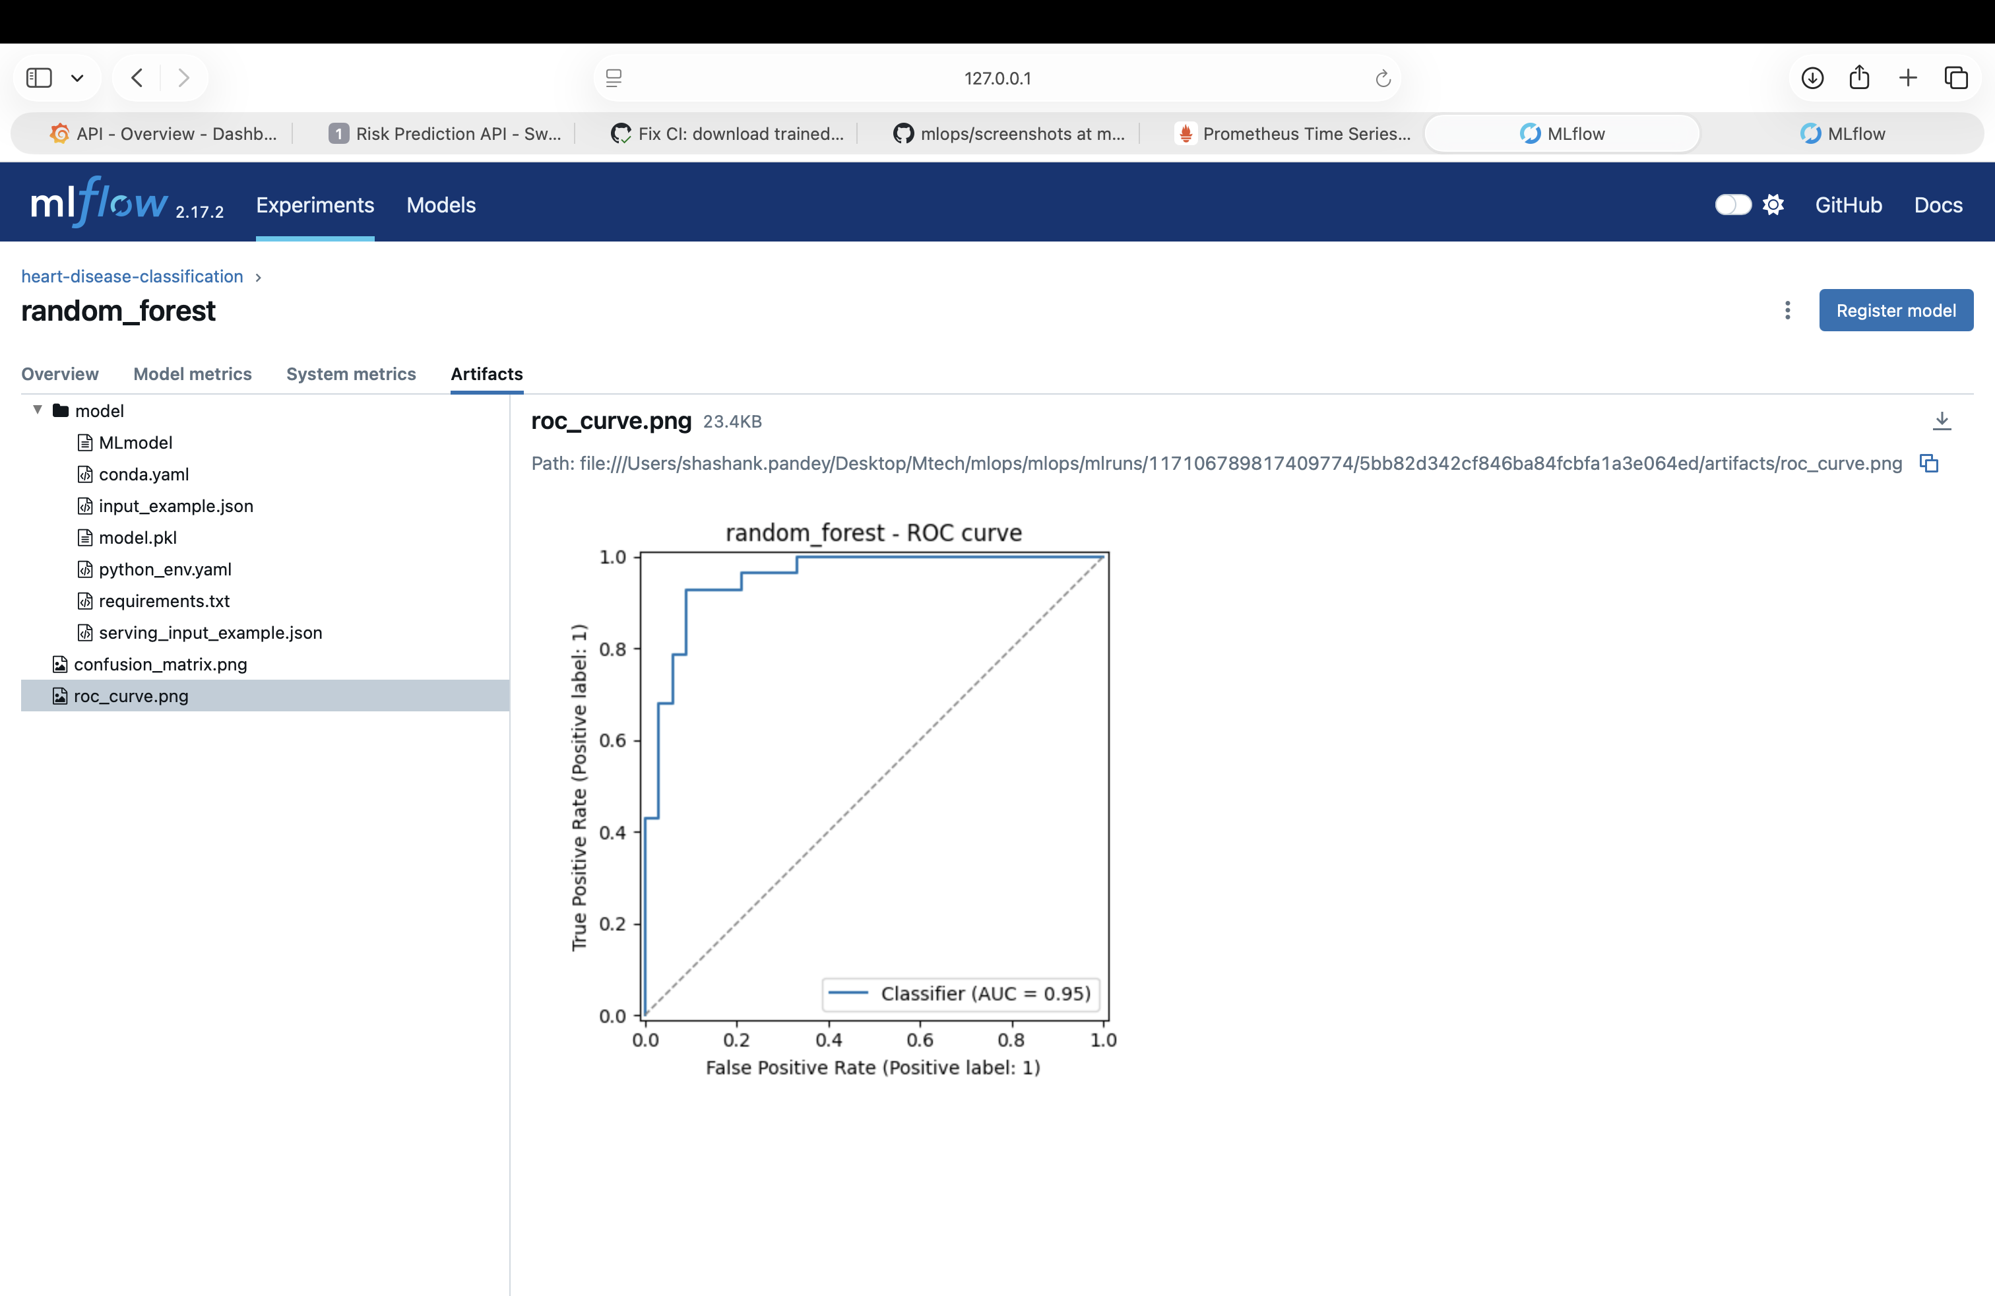
Random Forest ROC curve

6. Experiment Tracking (MLflow)
Every GridSearchCV run is logged as its own MLflow run under the heart-disease-classification experiment, with:
- Params: winning hyperparameters from the grid search, CV fold count
- Metrics: CV ROC-AUC mean, and test accuracy/precision/recall/F1/ROC-AUC
- Artifacts: confusion matrix PNG, ROC curve PNG, the full serialized pipeline (via mlflow.sklearn.log_model, including an inferred input signature)
- Tags: model_family, plus a champion=true tag set retroactively on whichever run wins, so the winner is identifiable straight from the MLflow UI without cross-referencing JSON files
Tracking store: local file-based (file:./mlruns), kept out of git (regenerable by re-running train.py).
Side-by-side run comparison from the MLflow UI (logistic_regression vs. random_forest, matching the results table above exactly):
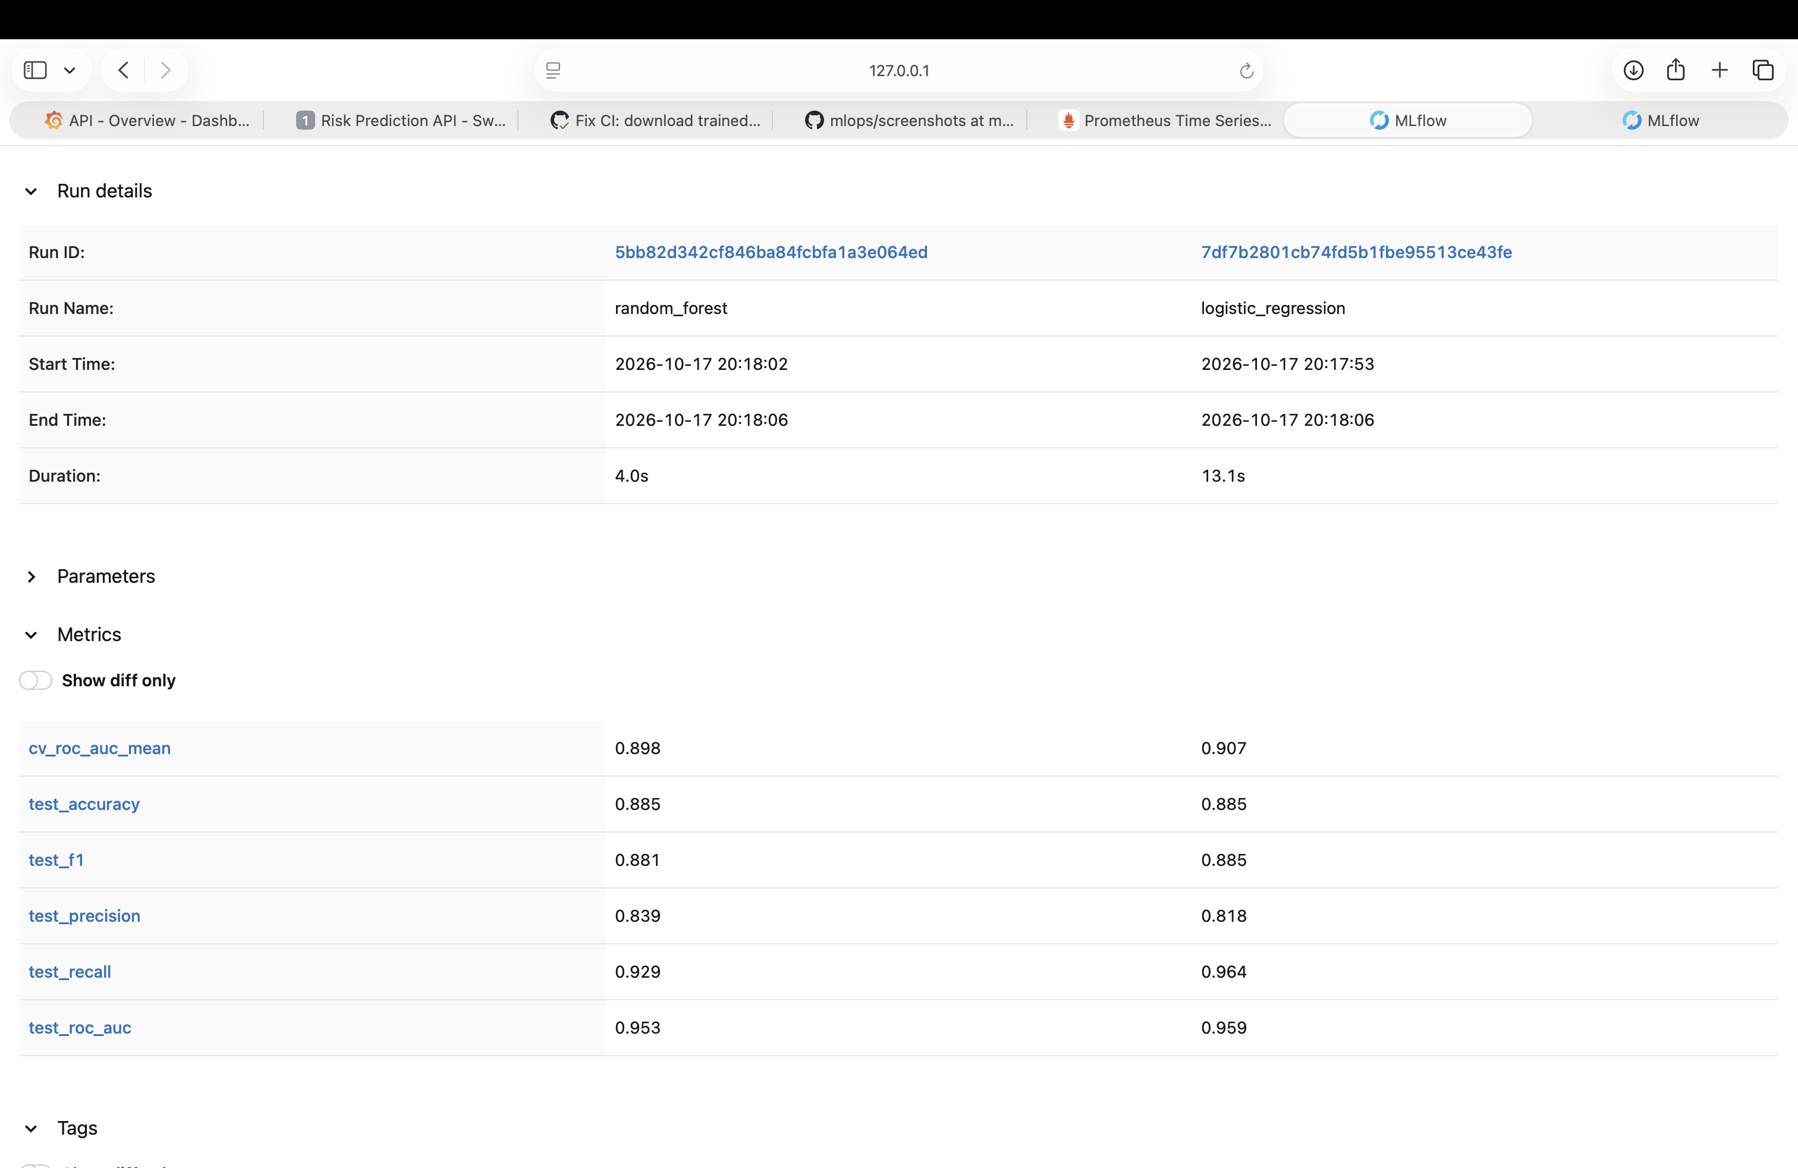
MLflow run comparison

7. Model Packaging & Reproducibility
- The champion’s full pipeline (preprocessing ColumnTransformer + fitted classifier) is pickled as a single artifact: models/model.pkl via joblib.dump. Loading one file is enough to reproduce training-time preprocessing exactly — the API never re-implements imputation/scaling/encoding logic separately.
- models/model_metadata.json records the champion’s name, training timestamp, best hyperparameters, test metrics, the exact feature column order expected, and a summary of all candidates trained (not just the winner) — useful for audit/debugging later.
- Two requirements files, deliberately split:
  - requirements-api.txt — the minimal runtime set (pandas, scikit-learn, FastAPI, uvicorn, prometheus-client, …) baked into the Docker image.
  - requirements.txt — the full dev superset (adds MLflow, matplotlib/ seaborn, pytest, flake8, jupyter) for local development/training. All packages are version-pinned for reproducibility.

8. Automated Testing
Unit tests (tests/, 40 tests, pytest): cover data parsing (download_data.parse_cleveland), preprocessing (split_features_target, stratified splitting), the feature pipeline (no-NaN output, correct one-hot expansion, independent refits), evaluation metric computation (including edge cases like single-class predictions), model packaging/inference (HeartDiseaseModel), the training pipeline’s structural correctness, and the FastAPI layer (valid/invalid payloads, response schema, Prometheus metrics exposure). Deliberately no test depends on the network or on models/model.pkl already existing — a small synthetic fixture dataset (tests/conftest.py) stands in for the real data, so the suite runs identically on a clean checkout before any training has happened.

9. CI/CD Pipeline
.github/workflows/ci.yml runs four sequential jobs, each gated on the previous one succeeding:
- lint — flake8 src tests
- test — pytest with coverage, JUnit + coverage XML uploaded as artifacts
- train — downloads the dataset fresh, runs src.models.train, asserts model_metadata.json was produced, uploads the trained model + full MLflow run directory as artifacts
- docker — downloads the model artifact from the train job, builds the Docker image, runs the container, polls /health until ready, sends a real /predict request and asserts the response shape, then uploads the container logs and response JSON as artifacts
Any failure (lint error, failing test, training crash, or a container that never becomes healthy / returns a bad response) fails the whole pipeline with a non-zero exit code and a readable log, satisfying the “must fail on error with clear logs” production-readiness requirement.
All 4 jobs passing on a live run (main branch):
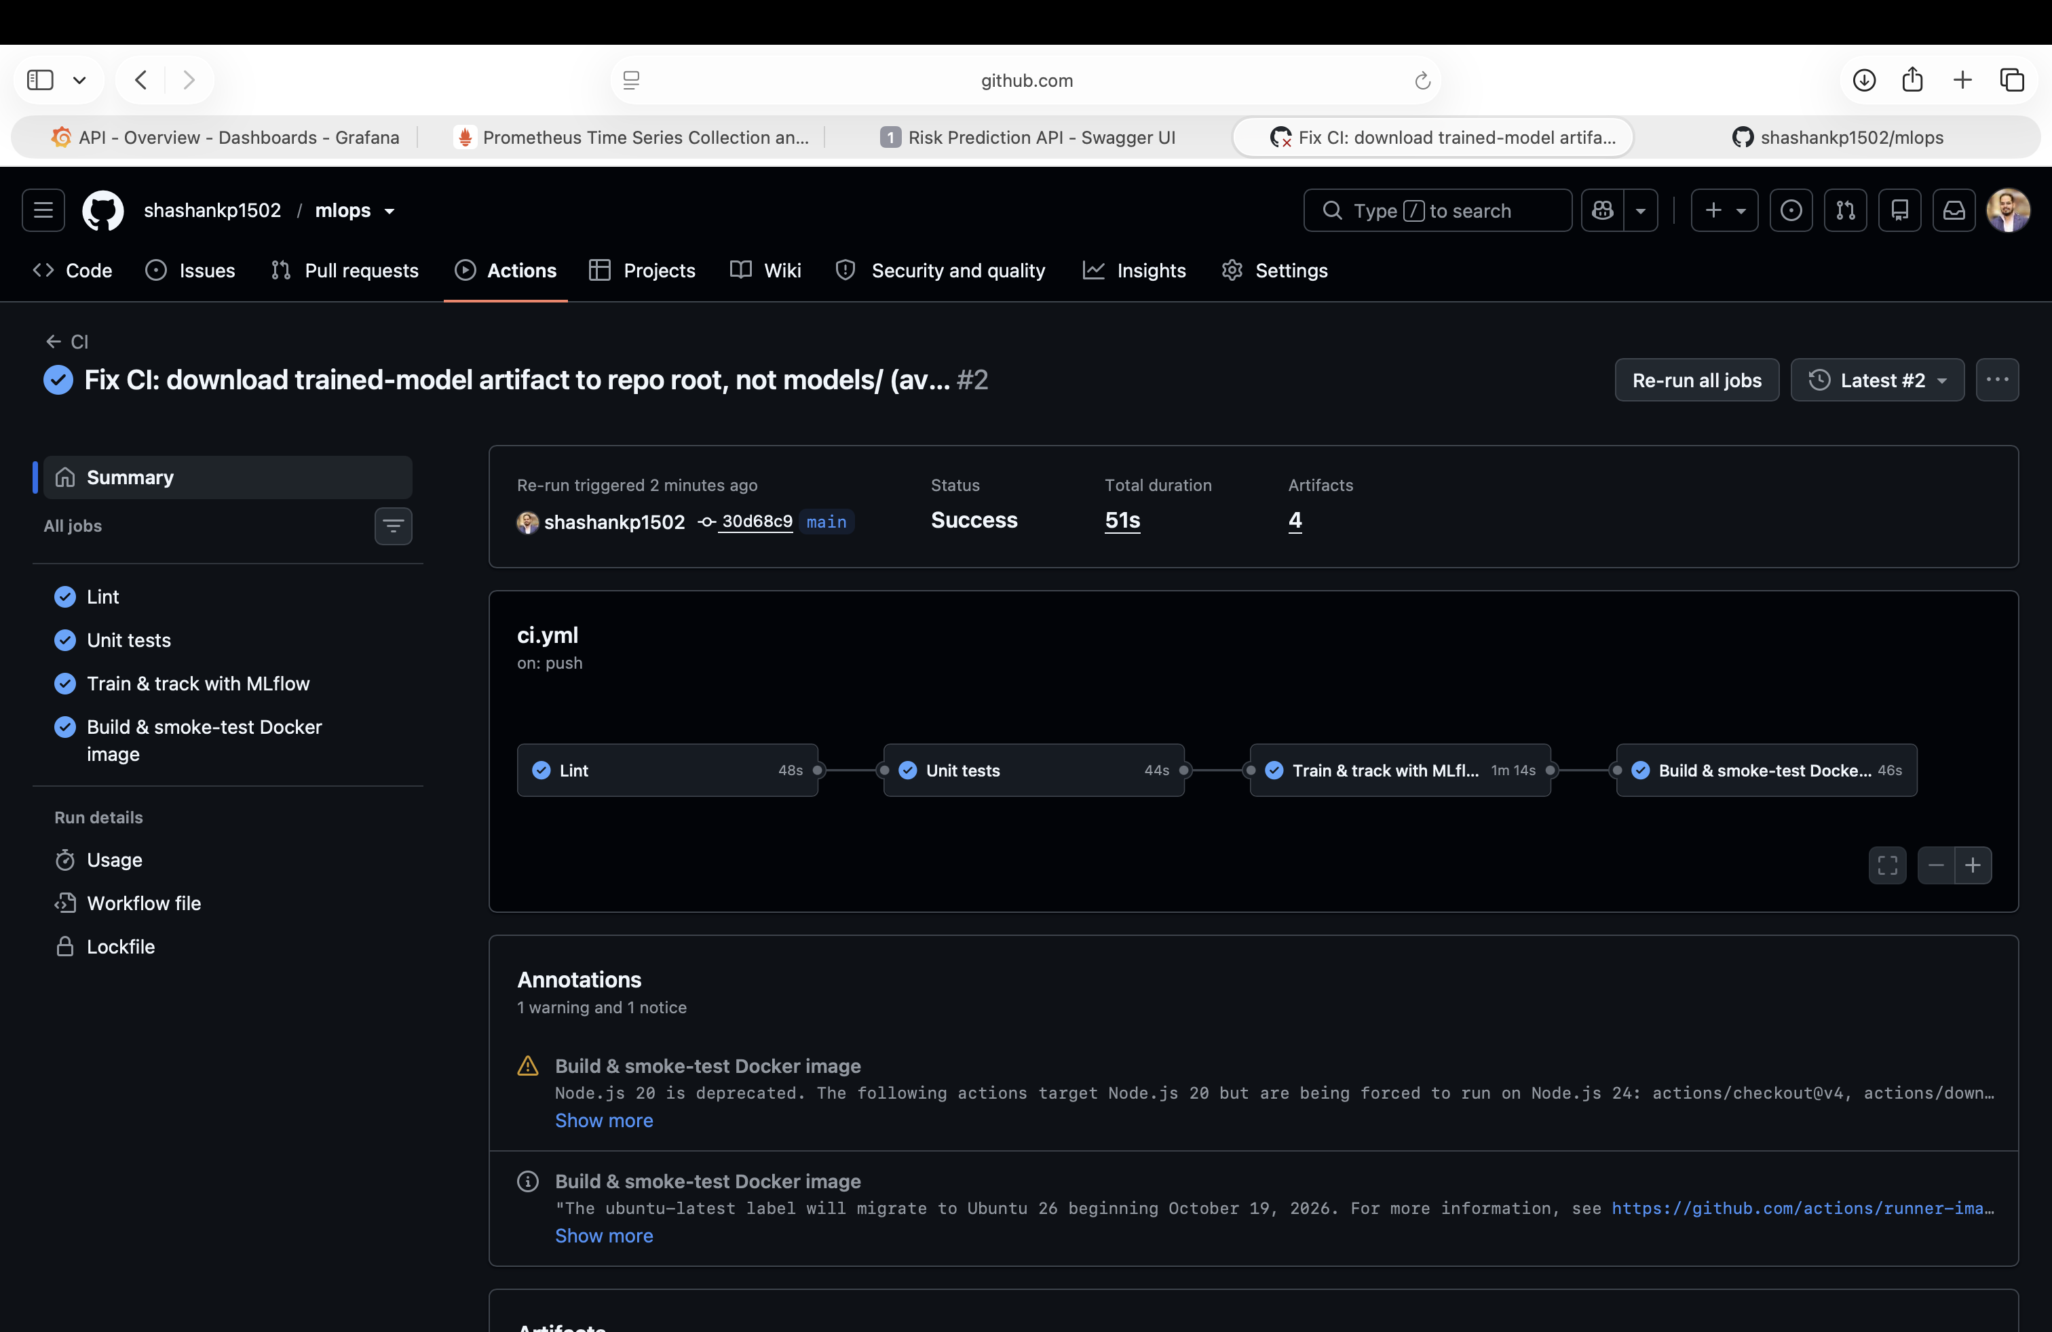
GitHub Actions pipeline - all 4 jobs green
The train job’s own logs, downloading the dataset fresh and showing both models’ metrics (matches the results table in Section 5 exactly):
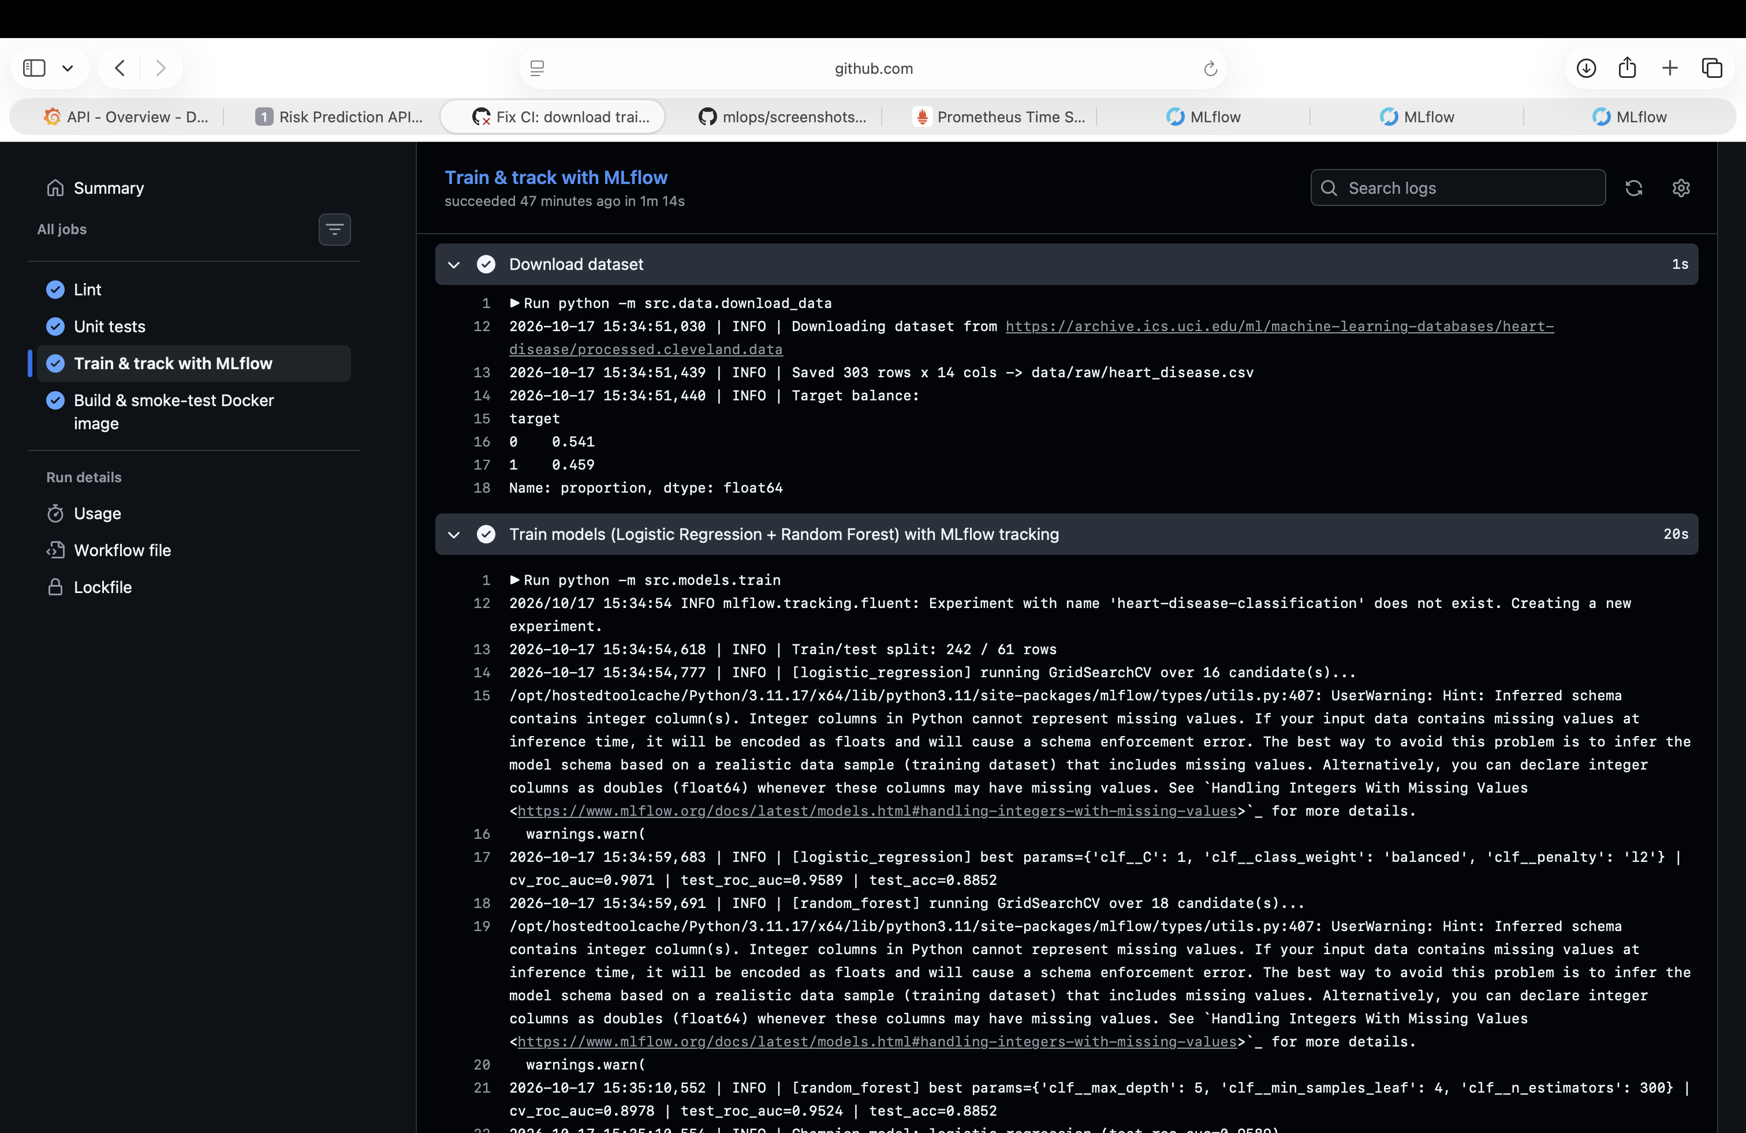
CI train job logs

10. Containerization
docker/Dockerfile — multi-stage build:
- Stage 1 (builder): installs requirements-api.txt into a venv (needs build-essential for a couple of wheels)
- Stage 2 (runtime): python:3.11-slim + the venv copied over, app code, and the two model artifacts — no compiler toolchain in the final image. Runs as a non-root user, exposes port 8000, includes a HEALTHCHECK hitting /health.
Final image size: ~550-770MB (varies slightly by host vs. Minikube’s docker daemon layer caching) — down from ~1.17GB with a naive single-stage build.
Verified locally:
docker build -t heart-disease-api:latest -f docker/Dockerfile .
docker run -d --name heart-disease-api -p 8000:8000 heart-disease-api:latest
curl http://localhost:8000/health
# {"status":"ok","model_loaded":true,"champion_model":"logistic_regression"}
curl -X POST http://localhost:8000/predict -d '{...}'
# {"prediction":0,"label":"no_disease","confidence":0.7764,...}
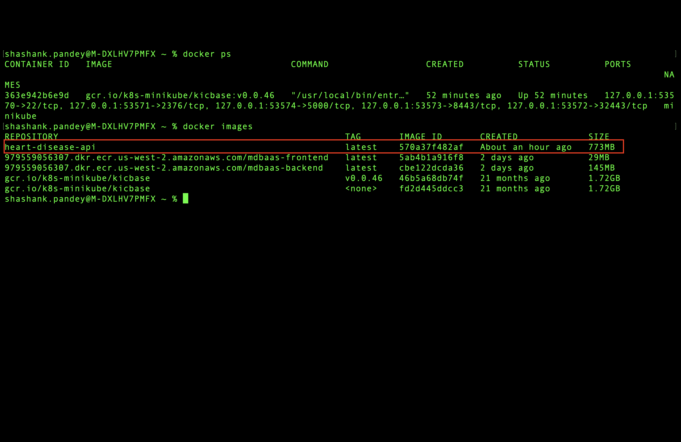
docker images / docker ps
The FastAPI interactive docs (Swagger UI) generated automatically from the Pydantic schemas in src/api/schemas.py:
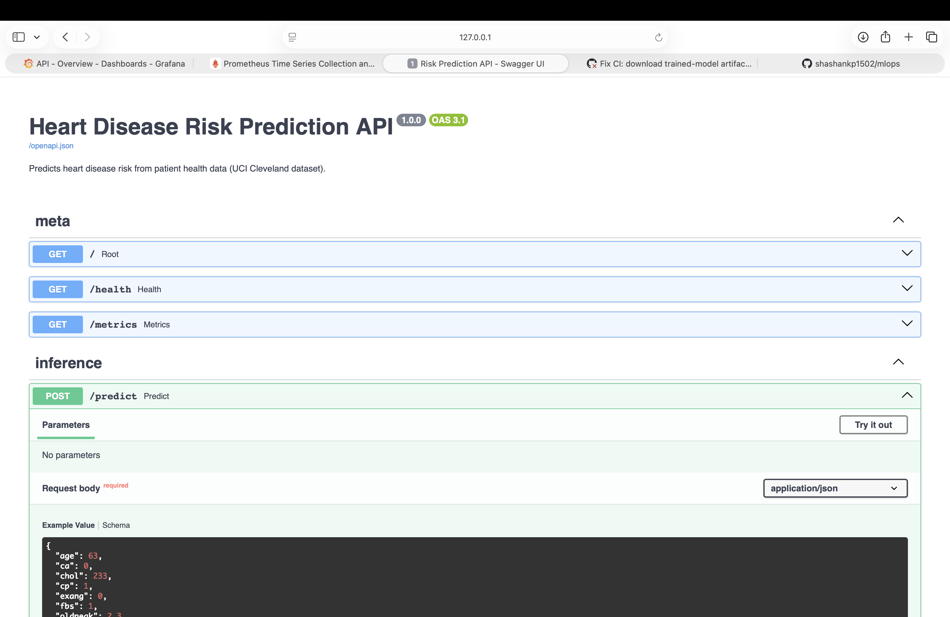
FastAPI Swagger UI

11. Kubernetes Deployment
Deployed to a local Minikube cluster (namespace heart-disease):
- k8s/deployment.yaml — 2 replicas, resource requests/limits (100m/256Mi -> 500m/512Mi), readiness probe (/health, 5s initial delay) and liveness probe (/health, 15s initial delay) so Kubernetes only routes traffic to pods that have actually finished loading the model
- k8s/service.yaml — LoadBalancer type, port 80 -> containerPort 8000 (exposed locally via minikube tunnel / minikube service --url)
Verified end-to-end:
$ kubectl -n heart-disease get deploy
NAME READY UP-TO-DATE AVAILABLE AGE
heart-disease-api 2/2 2 2 80s
$ curl http://<minikube-service-url>/health
{"status":"ok","model_loaded":true,"champion_model":"logistic_regression"}
$ curl -X POST http://<minikube-service-url>/predict -d '{...}'
{"prediction":0,"label":"no_disease","confidence":0.7764,"probability_disease":0.2236,"model_version":"model.pkl"}
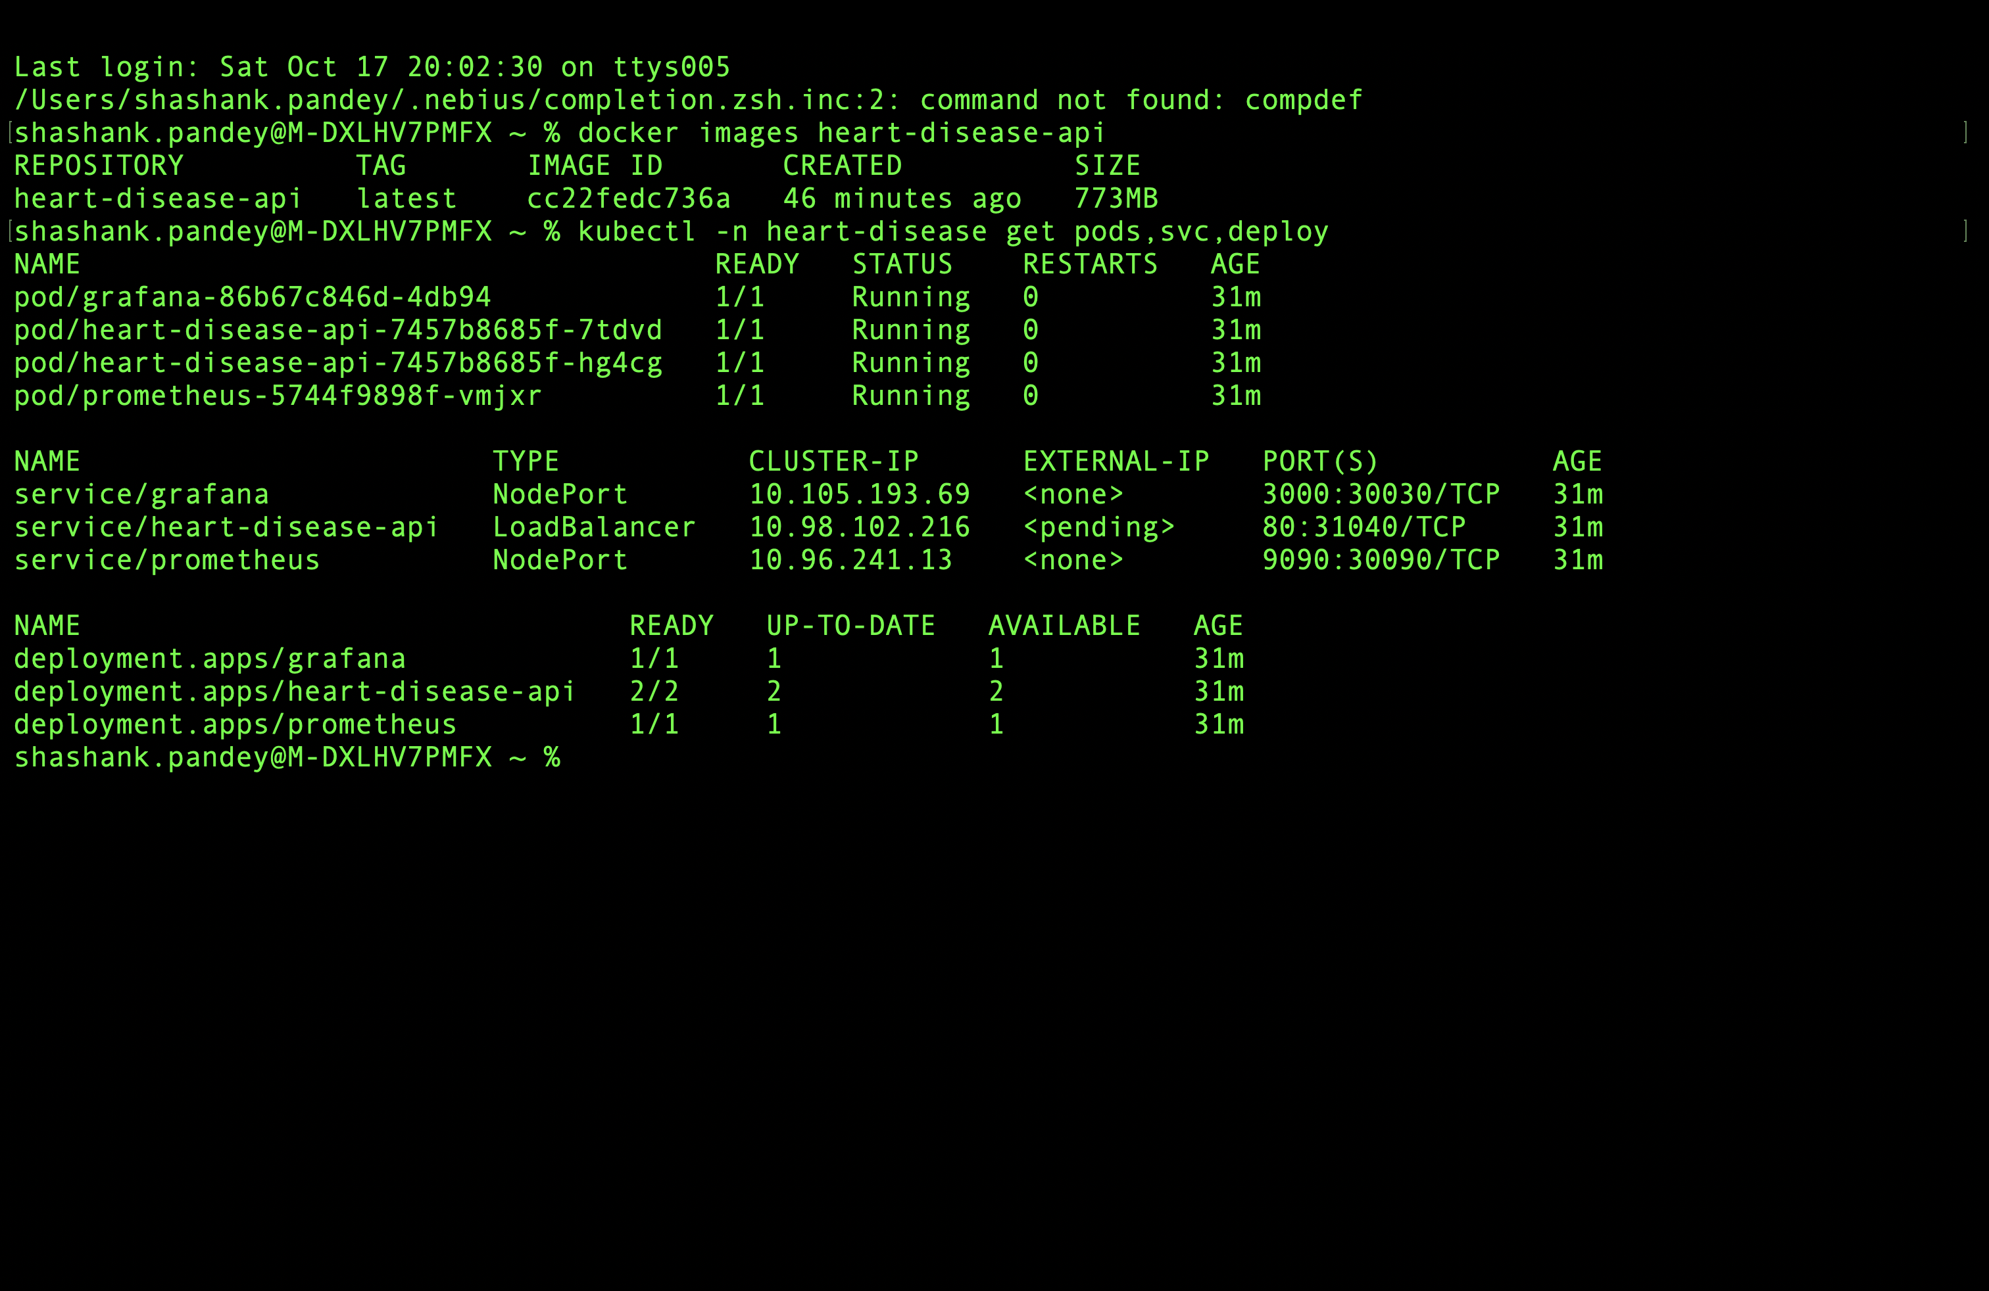
kubectl get pods,svc,deploy -n heart-disease
Both replicas came up healthy and served real predictions through the LoadBalancer service, not just the pod’s own loopback.

12. Monitoring & Observability
Request logging: every API request is logged as a single structured line (request id, method, path, status code, latency in ms) via a FastAPI middleware (src/api/main.py) — written to stdout so it’s captured by Docker/kubectl logs without any extra agent.
Metrics: prometheus_client instrumentation exposes /metrics with:
- api_requests_total{endpoint,method,status_code} — request counts
- model_predictions_total{label} — prediction outcome counts
- api_request_latency_seconds{endpoint} — latency histogram
Deployed stack (k8s/monitoring/):
- Prometheus (prom/prometheus:v2.54.1) scrapes the heart-disease-api Kubernetes Service directly every 10s (static target, no operator/CRDs needed for this scale)
- Grafana (grafana/grafana:11.2.0) auto-provisions the Prometheus datasource and a ready-made “Heart Disease API - Overview” dashboard (request rate by endpoint, predictions by label, p95 latency, HTTP status codes) via ConfigMaps — zero manual dashboard-building
Both were verified live against real traffic generated by scripted /predict calls against the Minikube deployment:
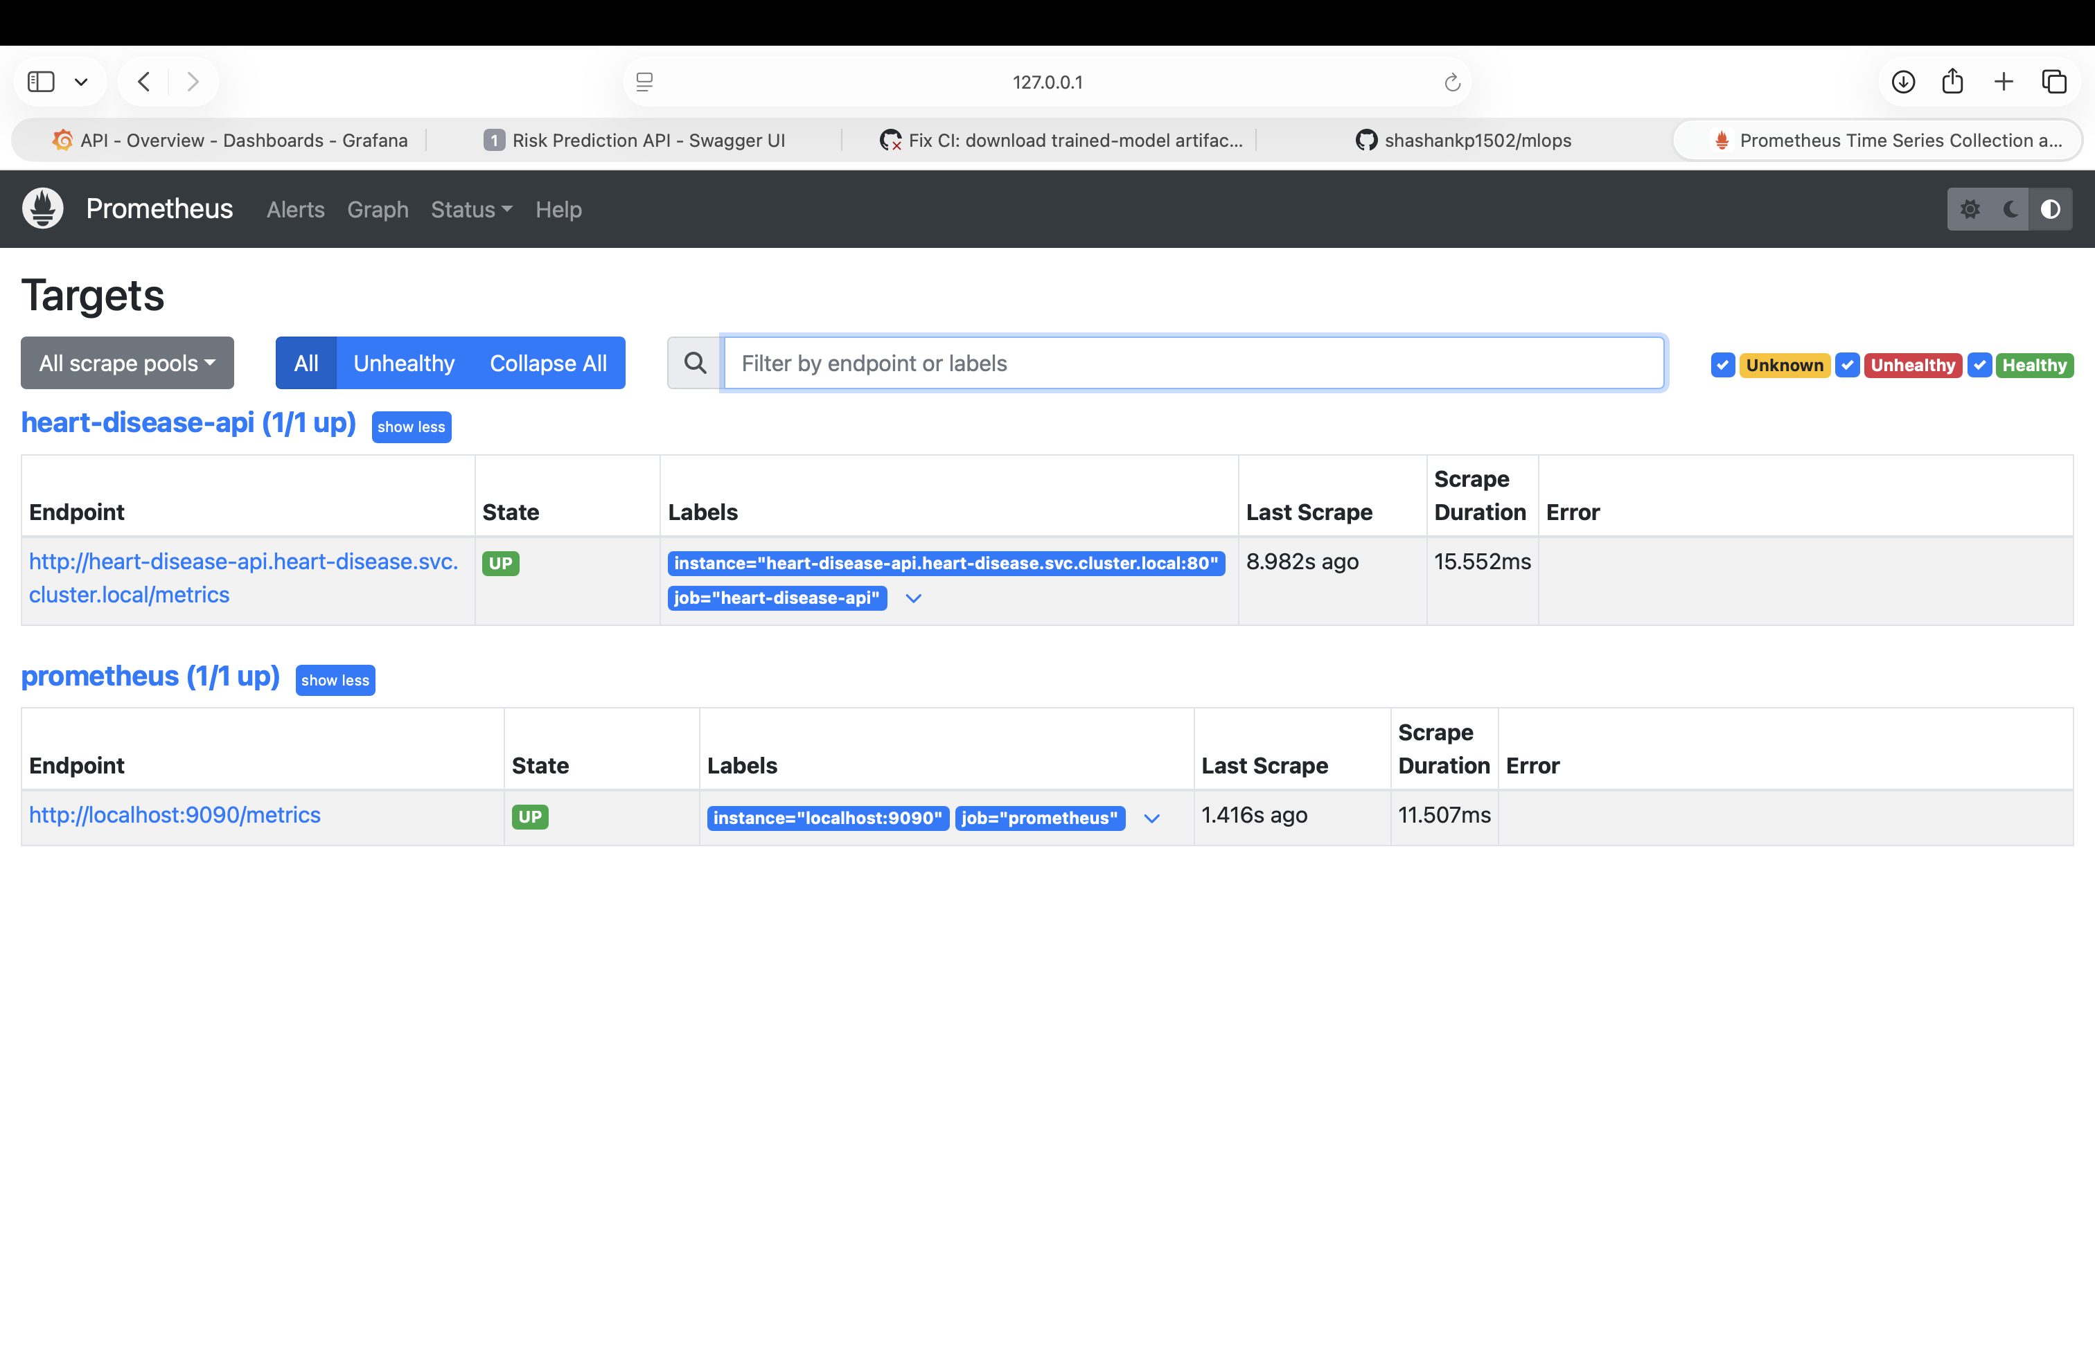
Prometheus targets - heart-disease-api UP
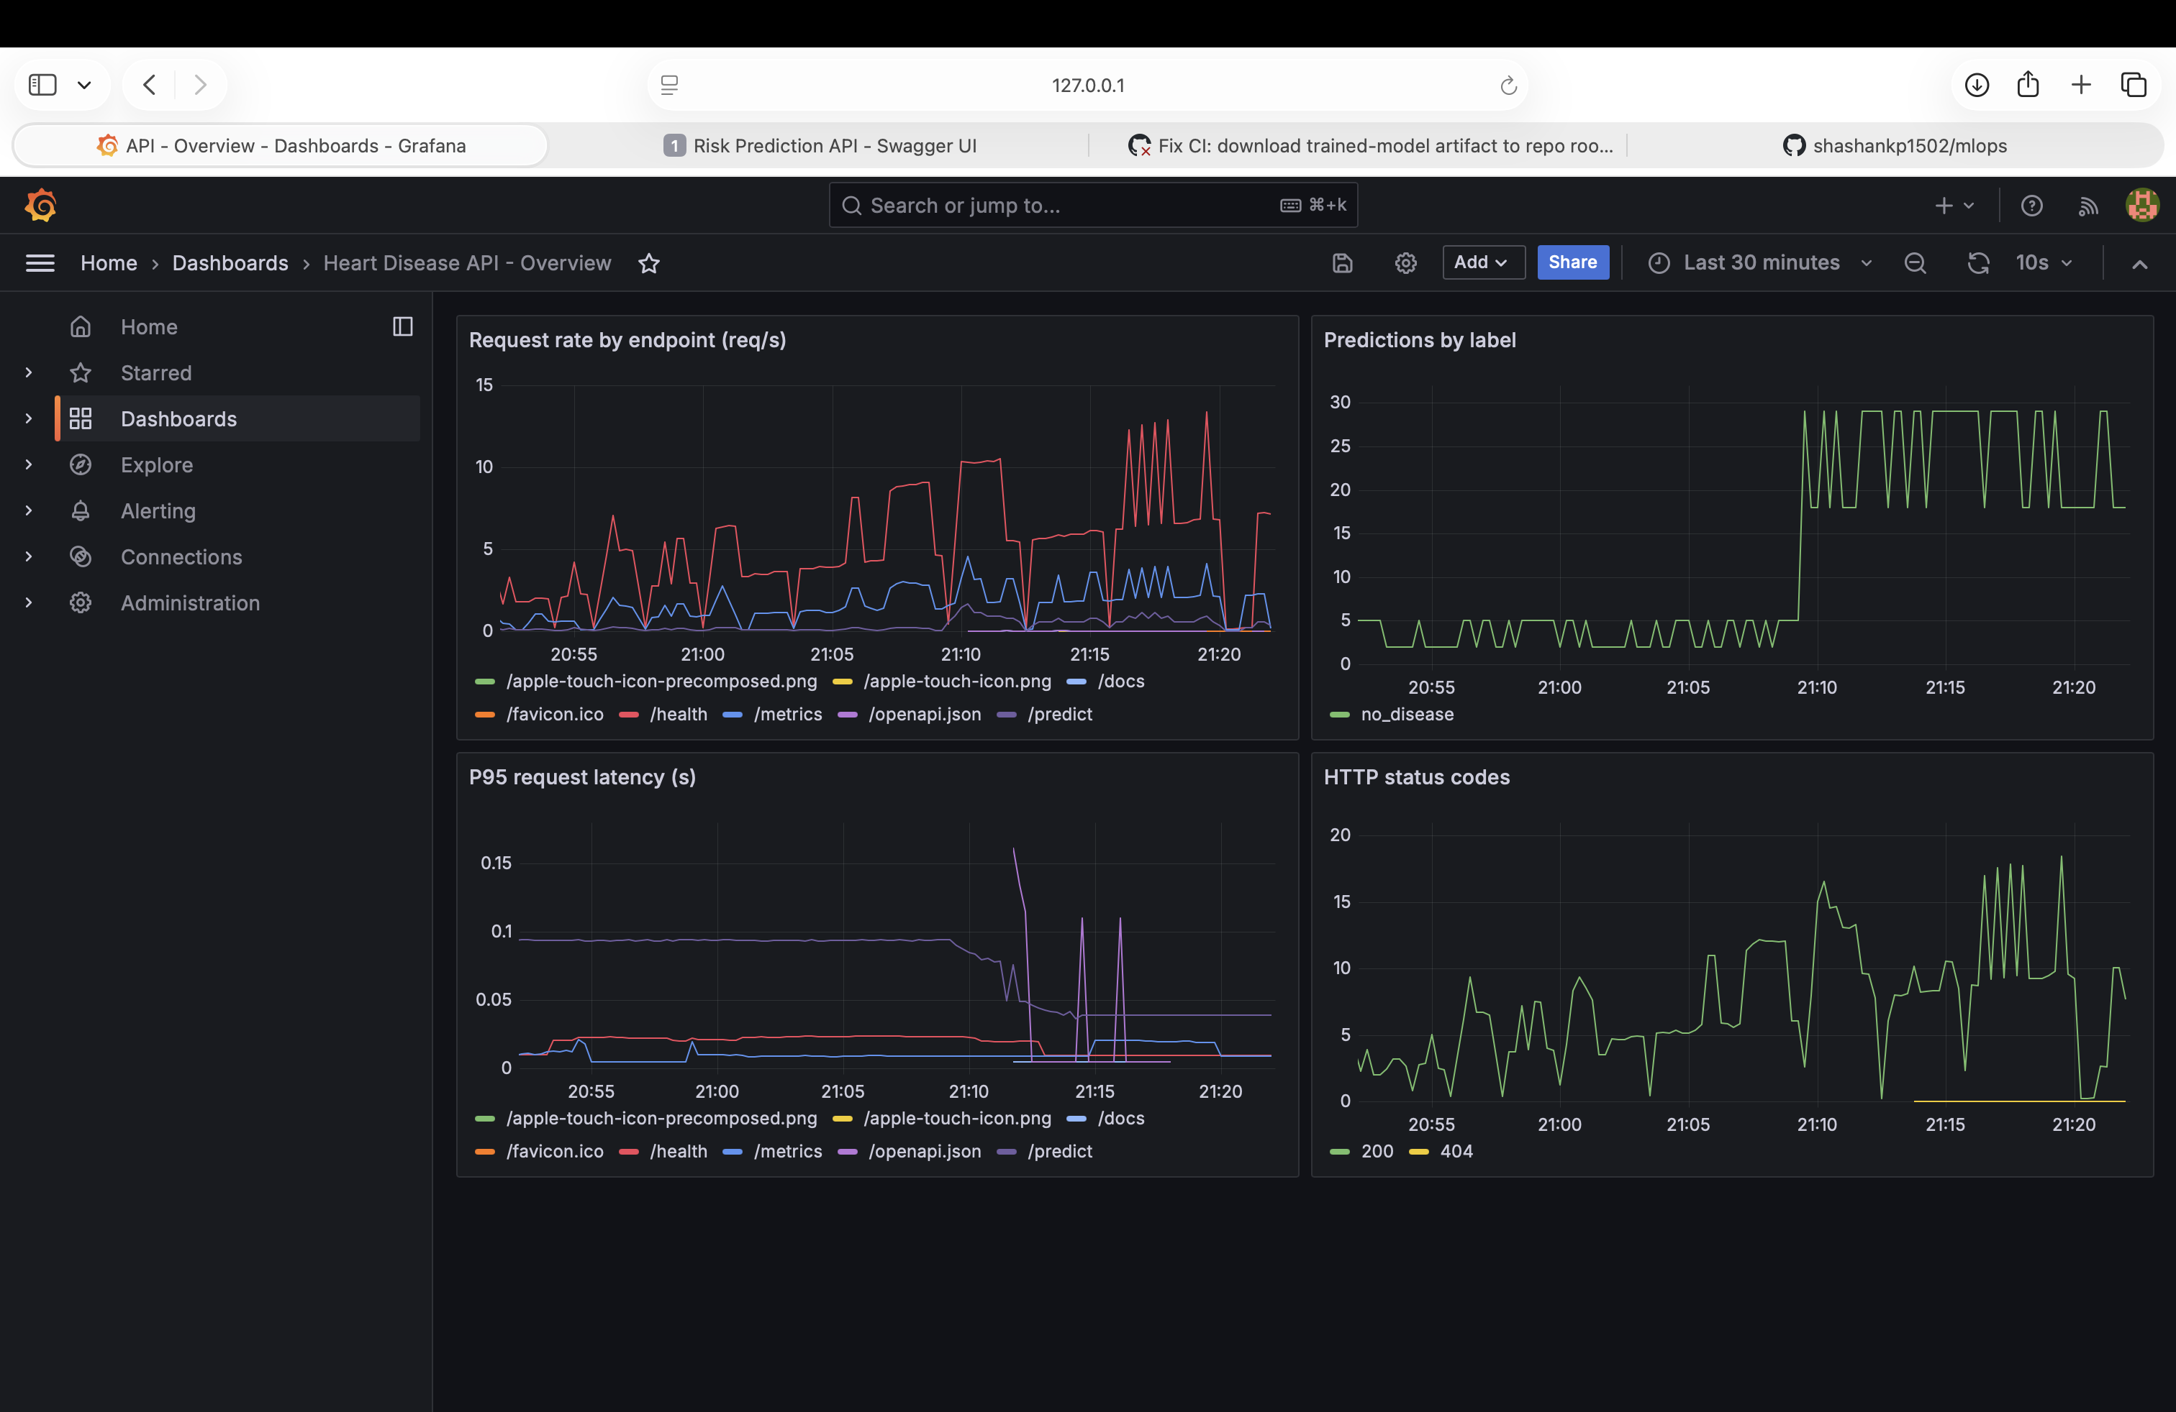
Grafana - Heart Disease API Overview dashboard with live data

13. Getting Started (Setup & Usage Reference)
git clone https://github.com/shashankp1502/mlops.git
cd mlops
python3.11 -m venv .venv
source .venv/bin/activate
pip install -r requirements.txt
python -m src.data.download_data # fetches data/raw/heart_disease.csv from UCI
python -m src.models.train # trains + logs to MLflow, saves models/model.pkl
pytest # 40+ tests, ~1s
uvicorn src.api.main:app --reload # API on http://localhost:8000
Full step-by-step instructions for Docker, Kubernetes, and monitoring are in the project README.md; they’re not repeated verbatim here to keep this report focused on decisions and results rather than command transcripts.

14. Repository & Resources
See the table at the top of this report for the GitHub repository, CI/CD pipeline, and pipeline walkthrough video links.

