Encoded Gossip Application
Prof. Abha Marathe, Shashank Patil
Department of Multidisciplinary Engineering, Vishwakarma Institute of Technology 666, Upper Indiranagar, Bibwewadi, Pune- 411037, India
Abstract— Communication through internet brings teams together. Three main parts of communication are sender, medium and receiver. Now days, transmission of data over internet is not safe without any encryption method. All corporate sectors, banking sectors, government sectors and many other sectors are sharing their data through internet. Hackers always try to attack on the transmitted data and try to recover the data. Various techniques are developed for providing the data security. Cryptography is used for safe transmission of data. In cryptography, Encryption is done at sender side and decryption is done at receiver side. In the encryption technique, Caesar cipher is one of the best example. The analysis of Basic Caesar cipher, Delta formation Caesar cipher and XOR Caesar cipher is done on the basis of many parameters like Avalanche Effect, Frequency Test and Brute force attack
.Keywords— Security, cipher text, encryption, decryption, firebase, gitpod.
I. INTRODUCTION
By sending and receiving messages in real time, a conversation application makes it simple to communicate with individuals all over the world. Nowadays, data privacy is extremely important. Basically, this project is a web application that allows users to safely communicate messages to other users utilising cypher techniques. It addresses a security issue; while there is various chatting software available, this project will be unique in that it will only require one click to protect existing chats.
Cryptography means “hiding data or secret writing”. Hiding data from attacker provides data security. Information security is the prime concern as most of the works are done by the computers. Components of the cryptography are Plaintext and Cipher text, Ciphers, Secret Key, Encryption algorithm and Decryption algorithm. The information that is routed over the network is called as Plain text and after adding number of operations on Plaintext, a Cipher text is obtained.
II. LITERATURE SURVEY
Among others, A.RAJAN (2014) The Caesar cypher is explored using the delta formation method in the article "ADVANCEMENT IN CAESAR CIPHER BY RANDOMIZATION AND DELTA FORMATION." When employing this approach, it gets challenging. The substituted character is generated at random, making it easier for an attacker to crack the encryption. It won't be feasible for an attacker to break it with physical force since new characters have replaced the previous ones in the personality-based delta structure. This method enhances data transport that is more secure. Caesar, the Crypts divided into three separate pieces.
Utilizing the alphabet:
B. Characters may be mixed and matched to make new ones.
C. A delta's development.
Compared to the hill cypher, this cypher uses a reasonable encryption and has a reduced computational complexity. info from ATM cards.
Basic Caesar cypher components are comparable to those in this article, however the authors have added additional operations overall. The factorial function is applied, just like in key creation, and the binary form of the key value is then obtained. Key and plaintext are XORed during the encryption process. This technique's avalanche effect and frequency test equalisation are increased by the addition of these functions. The significance of key length is stated by P. Garg et al. in their study "A Review Paper on Cryptography and Significance of Key Length." The author of this paper describes several algorithms.
These algorithms include the hash function, public key cryptography, and secret key cryptography. Secret key cryptography employs a single key for both encryption and decryption.

III. SOFTWARE REQUIREMENTS
Visual Studio Code / Gitpod
React
GitHub
Html, JavaScript
Tailwind CSS

IV. SYSTEM DESIGN
Landing page
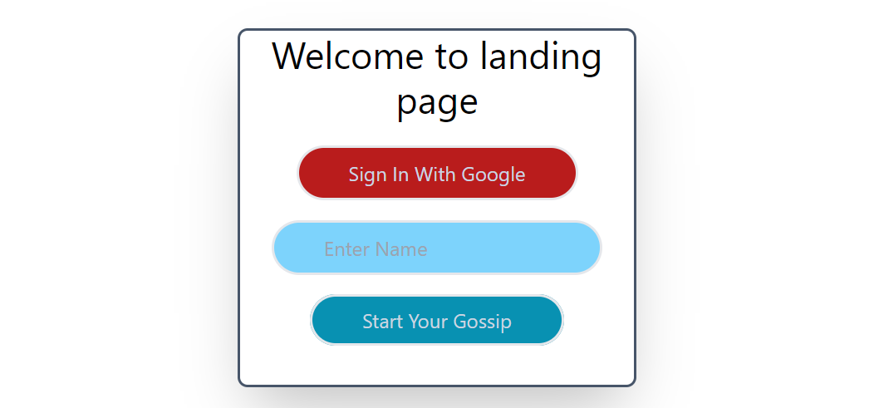
they are concentrated on a single objective or call to action by giving details about a particular offer or item, landing pages convert more visitors. Its simple design and minimal navigation prevent visitors from becoming sidetracked by numerous links that go off the page and away from their intended aim.
At that page we are take details from user like his name, email id or google signin
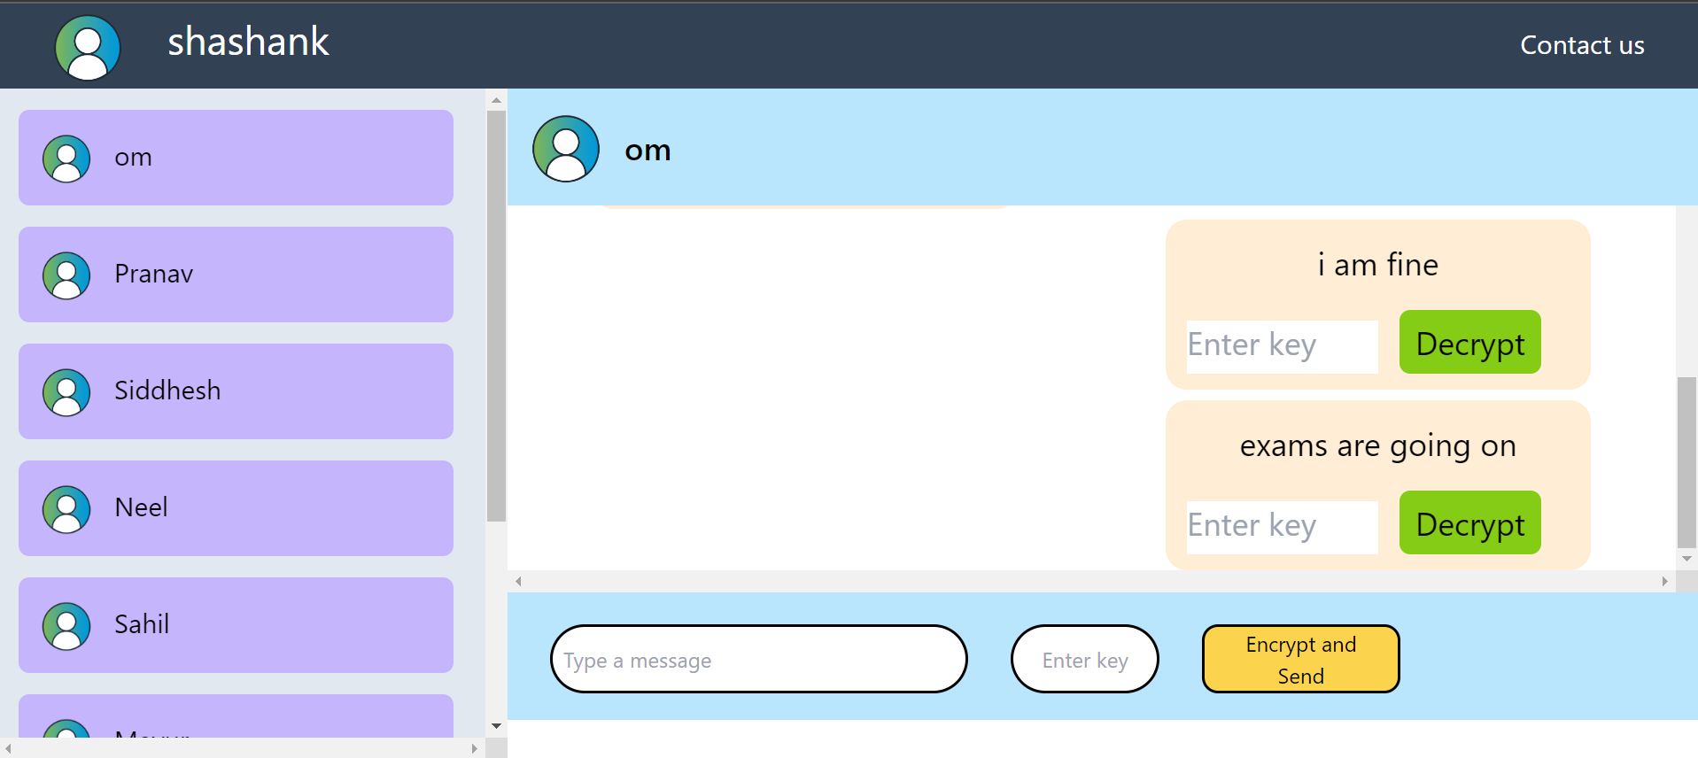
This is the chat window of web application there are content like navbar on navbar there are name and profile pic are displayed as well as the chat channel list is also there it defines the how much are active channels are there. As well as there is chat window is created for displaying the chats of the users and we can type the message and send it then it will displayed on the chat window.
Working of Encryption Algorithem-
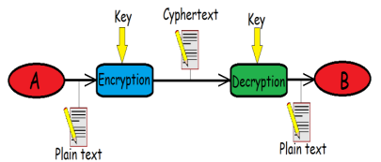
When these elements are used along, they form cipher text. In decryption part, three elements which are required are Cipher text, Rule and Key. Sender shares the secret key only with the receiver so that the information should stay protected [1]. Caesar cipher is also familiar with another name “Shift Cipher”. Caesar cipher is also known as Julius Caesar, by its inventor name. In Caesar cipher, all the characters of the plaintext is interchanged by a character of some mounted variety of locations down the alphabet [2]. When the key value is 2, all the characters of plaintext are encrypted into cipher text by these characters as shown below.
In cryptography, a Caesar cipher, also known as Caesar's cipher, the shift cipher, Caesar's code or Caesar shift, is one of the simplest and most widely known encryption techniques. It is a type of substitution cipher in which each letter in the plaintext is replaced by a letter some fixed number of positions down the alphabet. For example, with a left shift of 3, D would be replaced by A, E would become B, and so on. The method is named after Julius Caesar, who used it in his private correspondence.
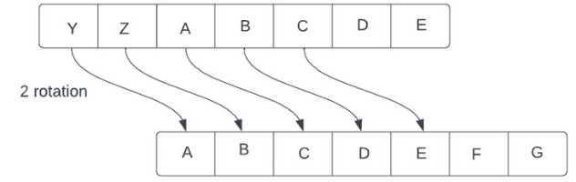
Gitpod:-
Gitpod continuously builds your git branches like a CI server so that you can start coding right away - no more waiting for dependencies to download and builds to finish. Gitpod continuously builds your git branches like a CI server so that you can start coding right away - no more waiting for dependencies to download and builds to finish.
V. CONCLUSIONS AND FUTURE WORK

This application helps us to secured the chats. It will be secured using cipher text. Using encryption and decryption algorithm we can easily secured the text and we can easily cat with other person very secured manner. As well as in future we can implement the firebase for storing the data on database it will much secured platform for storing data.
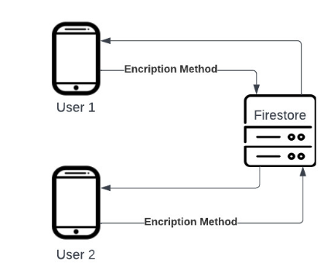

Using that manner, we easily store the data and encrypt and decrypt it easily.
REFERENCES

Ashwini Sheth , Mr. Sachin Bhosale, "RESEARCH PAPER ON CYBER SECURITY", 2021.
Yahia Alemami, Mohamad Afendee Mohamed, Saleh Atiewi, "Research on Various Cryptography Techniques", 2019.
Naveen Kumar. Rohit singh, "Paper on Cryptography of Modified Caesar Cipher", 2018
Teng Lv , Ping Yan, and Weimin He, "Survey on JSON Data Modelling", 2018.
Chunnu Khawas, Pritam Shah, Application of Firebase in Android App Development-A Study, 2018
Dr. Jacek Kopeck´,Mr. Paul Fremantle, A History and Future of Web APIs, 2014
Blog on: React js
Link: https://reactjs.org/
Blog on: firebase
Link: https://www.youtube.com/watch?v=P0x0LmiknJc
blog on: Structure Your Database
Link: https://firebase.google.com/docs/database/web/structure-data

