Prompt 1:

Response:
To determine if a binary pixel mask contains multiple connected components (blobs) and specifically more than 5 blobs, you should use connected component labeling.
If you are already using OpenCV in your pipeline, you can use cv2.connectedComponents:
python
import cv2
import numpy as np

# Ensure your mask is of type uint8
binary_mask_uint8 = pixel_mask.astype(np.uint8)

# OpenCV returns the number of labels including the background
num_labels, labeled_mask = cv2.connectedComponents(binary_mask_uint8)

# Subtract 1 to exclude the background label
num_blobs = num_labels - 1

is_multiple_blobs = num_blobs > 1
is_more_than_five = num_blobs > 5

Prompt 2:
how can I obtain PIL and Python to load image in RGBA and resize it to square keeping same image size?
To obtain Python and Pillow (PIL), you install them via your terminal or command prompt. To expand a rectangular image into a perfect square without shrinking, stretching, or distorting the original visual content, you pad the shorter edges. [1, 2, 3]
Here is the complete setup guide and Python program.
Step 1: Install Python and Pillow
- Download and install Python from the Official Python Website. Make sure to check the box that says "Add Python to PATH" during installation.
- Open your terminal (Mac/Linux) or Command Prompt (Windows) and install the Pillow library by running:
bash
pip install pillow
Use code with caution.
Step 2: The Python Code
This script opens your image in RGBA mode, finds the largest dimension to create a square canvas, and uses the correct alpha channel masking to paste the image perfectly without leaving jagged or dark borders around transparent elements. [1]
python
from PIL import Image
import os

def resize_to_square_keep_scale(image_path, output_path, bg_color=(0, 0, 0, 0)):
"""
Pads an RGBA image into a square without altering the original image content size.
bg_color default is (0, 0, 0, 0) which means transparent.
"""
# 1. Open the image and ensure it's in RGBA mode
img = Image.open(image_path).convert("RGBA")
width, height = img.size

# 2. Determine the size of the square based on the largest side
square_size = max(width, height)

# 3. Create a brand new square canvas (default is transparent RGBA)
new_square_img = Image.new("RGBA", (square_size, square_size), bg_color)

# 4. Calculate centering coordinates
x_offset = (square_size - width) // 2
y_offset = (square_size - height) // 2

# 5. Extract the precise alpha mask for a perfect blend
alpha_mask = img.getchannel('A')

# 6. Paste original image into the center of the square canvas
new_square_img.paste(img, (x_offset, y_offset), mask=alpha_mask)

# 7. Save the final image
new_square_img.save(output_path)
print(f"Successfully saved square image to: {output_path}")

# --- Example Usage ---
# Replace 'example.png' with your file's name
input_file = "example.png"
output_file = "square_output.png"

# Create a dummy image if you don't have one in your folder yet to test
if not os.path.exists(input_file):
test_img = Image.new("RGBA", (800, 400), (255, 0, 0, 255)) # Red rectangle
test_img.save(input_file)

# Run the function (keeps original pixels, adds transparent padding)
resize_to_square_keep_scale(input_file, output_file, bg_color=(0, 0, 0, 0))

Prompt 3: 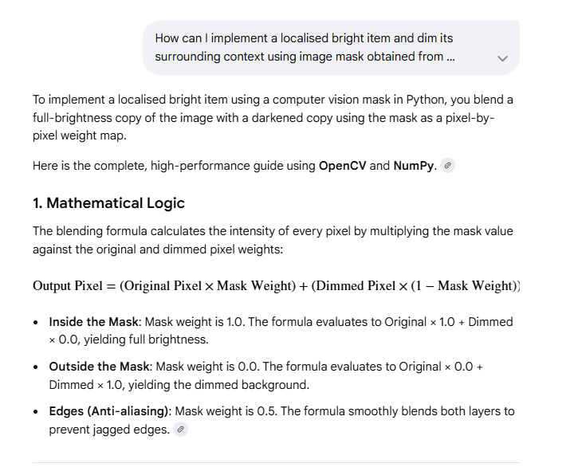
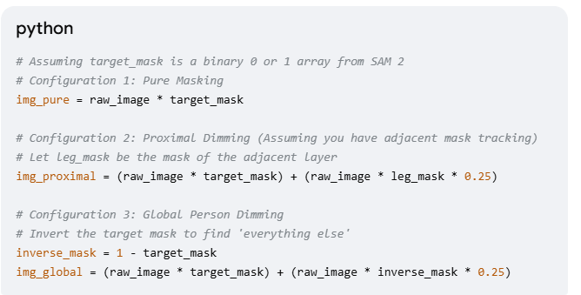

Prompt 4:
How to merge files with same 10 columns and add a key column as filename

