Report
Of
Product Management Job Simulation
Submitted
To
School of Computer Science and Engineering
IILM University, Greater Noida, U.P.
In partial fulfilment of the requirement of degree of
B.Tech CSE

By
Roll Number of Student: [Roll Number]
Name of Student: SHASHANK SHARMA
Batch: 2026-27

CANDIDATE'S DECLARATION
I, Shashank Sharma do hereby declare that the internship report titled "Product Management Job Simulation" has been completed by me to fulfil the requirement for the award of the degree of Bachelor of Technology in CSE. All the references have been quoted and I have not taken as such any material from any other source. I affirm to you that this report is my own and has not been submitted to any other institute for any degree/diploma requirement and further I shall be solely responsible for any kind of copyright violation in this regard.
Signature
Student Name: Shashank Sharma
Roll No.: [Roll Number]

ACKNOWLEDGEMENT
I am using this opportunity to express my gratitude to everyone who supported me throughout the Internship Program. I am thankful for their aspiring guidance, invaluably constructive criticism and friendly advice during this work. I am sincerely grateful to them for sharing their truthful and illuminating views on a number of issues related to this work.
I express my gratitude to my parents for their blessings.
Signature
Student Name: Shashank Sharma
Roll No.: [Roll Number]

TABLE OF CONTENTS
Chapter No. | Chapter Name | Page Nos.
 | Cover Page | -----
1. | Candidate's Declaration | i
2. | Acknowledgement | ii
3. | Internship Completion Certificate | -----
4. | Project Description | 1
 | 4.1 Introduction | 1
 | 4.2 Organization Profile | 1
 | 4.3 Problem Statement | 1
 | 4.4 Project Objectives | 1
 | 4.5 Scope of the Project | 2
 | 4.6 Technologies and Tools Used | 2
 | 4.7 System Architecture | 2
 | 4.8 Methodology | 2
 | 4.9 Expected Outcomes | 3
 | 4.10 Certificates of Completion and Other Proof | 3
5. | Bibliography/References | 4
LIST OF TABLES
Table No. | Title | Page No.
4.1 | Simulation tasks and outputs | 2
4.2 | Skills practiced during the simulation | 3
LIST OF FIGURES
Figure No. | Title | Page No.
4.1 | Analysis-to-presentation workflow | 2

INTERNSHIP COMPLETION CERTIFICATE
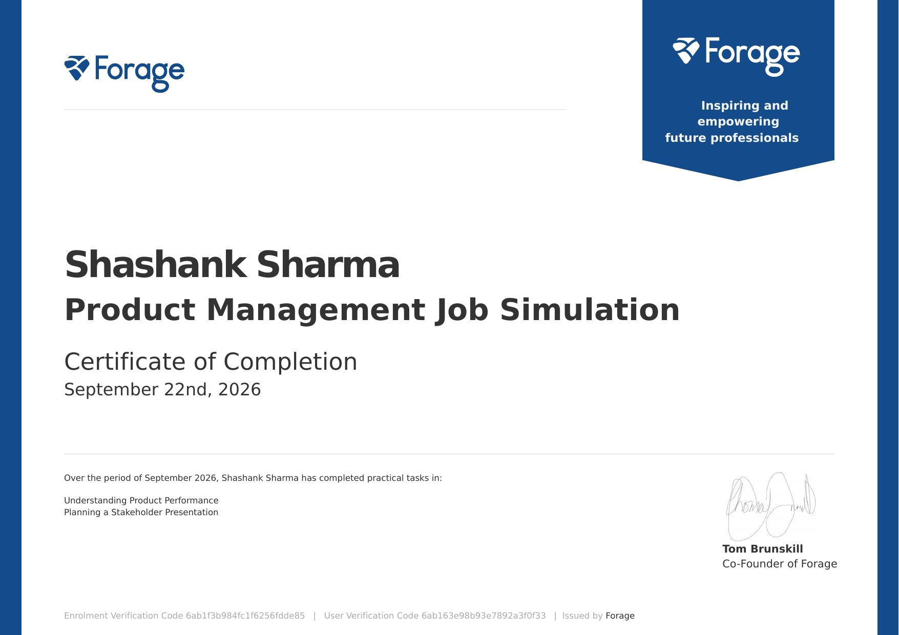
Certificate of Completion issued by Forage, September 22, 2026

4. Project Description

4.1 Introduction
This report describes the internship experience gained through the Product Management Job Simulation, a free, self-paced virtual experience program offered by Forage. In the simulation, participants take the role of a mobile gaming intern, analyze key performance indicators (KPIs) for a mobile game, and present their insights to company leaders. The program reflects the kind of work carried out by product teams at major gaming brands.
The simulation was completed in September 2026, and a Certificate of Completion was issued on September 22, 2026. Two practical tasks were completed: Understanding Product Performance and Planning a Stakeholder Presentation. This is a virtual, educational program and not paid employment.

4.2 Organization Profile
Forage is an online platform that provides virtual job simulations, which let students and early-career professionals try realistic workplace tasks and build career skills. The organization describes its purpose as inspiring and empowering future professionals. The certificate for this program is issued by Forage and signed by Tom Brunskill, Co-Founder of Forage.
The simulation places the participant inside a mobile gaming product team. The work is guided by a structured series of tasks, and the participant plays the role of an intern supporting product decisions with data.

4.3 Problem Statement
A mobile gaming product team collects a large amount of data about how its game is performing. Leaders need to know what the data means for the product, but raw figures alone do not support decisions. The problem addressed in this simulation was twofold: first, to identify which KPIs describe product performance and interpret what they show; second, to communicate the resulting insights to leaders in a clear and convincing way.

4.4 Project Objectives
- To understand the role of a product management intern in a mobile gaming company.
- To identify and interpret KPIs that describe the performance of a mobile game.
- To turn performance data into insights and recommendations.
- To plan a presentation that communicates findings to senior stakeholders.
- To develop professional skills in analysis, structured thinking and communication.

4.5 Scope of the Project
The project covers the two practical tasks of the simulation: analyzing product performance through KPIs and planning a stakeholder presentation. It is limited to the simulated scenario and the data and materials provided by the program. It does not involve live production data, game development or any changes to a real product.

4.6 Technologies and Tools Used
The simulation is an analytical and communication exercise rather than a software development project. The tools used were:
Table 4.1: Simulation tasks and outputs
Task | Focus | Output
Understanding Product Performance | KPI identification and data interpretation | Performance insights
Planning a Stakeholder Presentation | Audience-focused communication | Presentation plan and recommendations

- Forage virtual experience platform for task instructions and materials.
- Spreadsheet or data-analysis software for reviewing KPI data.
- Presentation software for planning the stakeholder presentation.

4.7 System Architecture
As the project is an analytical workflow rather than a software system, its architecture is described as the flow of work from data to decision. Product performance data is reviewed, relevant KPIs are selected, trends are analyzed, insights and recommendations are drawn, and these are organized into a plan for presenting to stakeholders (Figure 4.1).
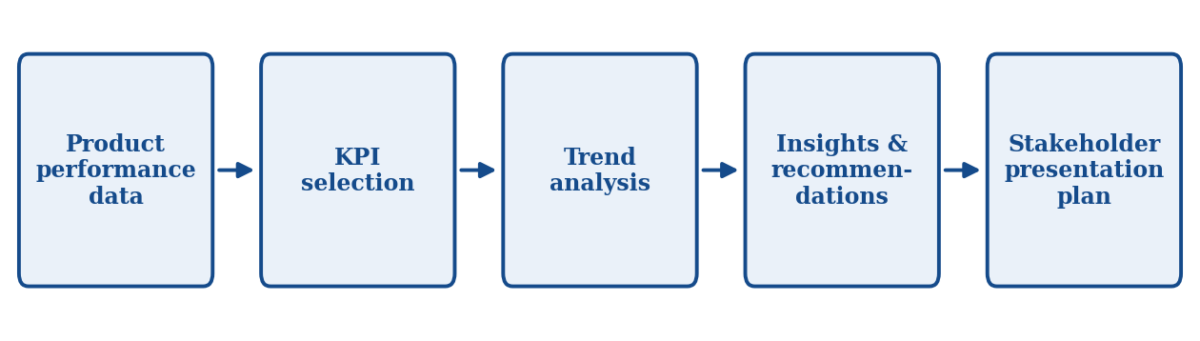
Figure 4.1: Analysis-to-presentation workflow

4.8 Methodology
Task 1: Understanding Product Performance. The first task focused on understanding how the mobile game was performing. The approach was to review the available product data, decide which KPIs best describe product health, examine how they change over time, and interpret what these trends mean for players and for the product.
Task 2: Planning a Stakeholder Presentation. The second task focused on communicating the analysis. The approach was to consider the audience and their priorities, lead with the most important insight, support it with relevant evidence, and end with clear recommendations, keeping the message simple enough for a non-technical, senior audience.
Table 4.2: Skills practiced during the simulation
Skill | Description
Data and KPI analysis | Reading metrics and drawing conclusions from them
Product thinking | Connecting player behaviour to product decisions
Stakeholder communication | Presenting insights to leadership
Structured storytelling | Organizing findings into a clear narrative

4.9 Expected Outcomes
- A practical understanding of how KPIs are used to assess a mobile game.
- The ability to convert data into insights and actionable recommendations.
- Experience in planning and structuring a presentation for senior stakeholders.
- Greater awareness of the product management role and its link with data and communication.
- A Certificate of Completion from Forage as proof of participation.

4.10 Certificates of Completion and Other Communication Mail Proof
The Certificate of Completion for the Product Management Job Simulation, issued by Forage on September 22, 2026, is attached in this report after the Table of Contents (Internship Completion Certificate). The verification details printed on the certificate are given below.
- Enrolment Verification Code: 6ab1f3b984fc1f6256fdde85
- User Verification Code: 6ab163e98b93e7892a3f0f33

5. Bibliography/References
[1] Forage, "Product Management Job Simulation," Forage Virtual Experience Program, September 2026. [Online]. Available: https://www.theforage.com
[2] Forage, "Certificate of Completion: Product Management Job Simulation," issued to Shashank Sharma, September 22, 2026.

