Orchestrator API — Architecture Documentation
Project: SAP S/4HANA Localization Requirements Orchestrator
Platform: SAP AI Core (Generative AI Hub)
Author: Shashank Shekhar
Date: [fill in]
Status: [e.g., Phase 3 complete — 7 agents implemented, Austria validated]

1. Purpose
This service automates the generation of SAP S/4HANA localization requirement documents for a given country. It replaces a manual, consultant-driven research process with an LLM-based pipeline that produces a structured, multi-sheet Excel workbook containing legal/business requirements, SAP configuration steps, master data needs, statutory reports, implementation sequencing, and test scenarios.
The central design constraint: legal and compliance content must not be hallucinated. The entire architecture is built around minimizing and catching LLM errors before they reach the output file.

2. High-Level Architecture
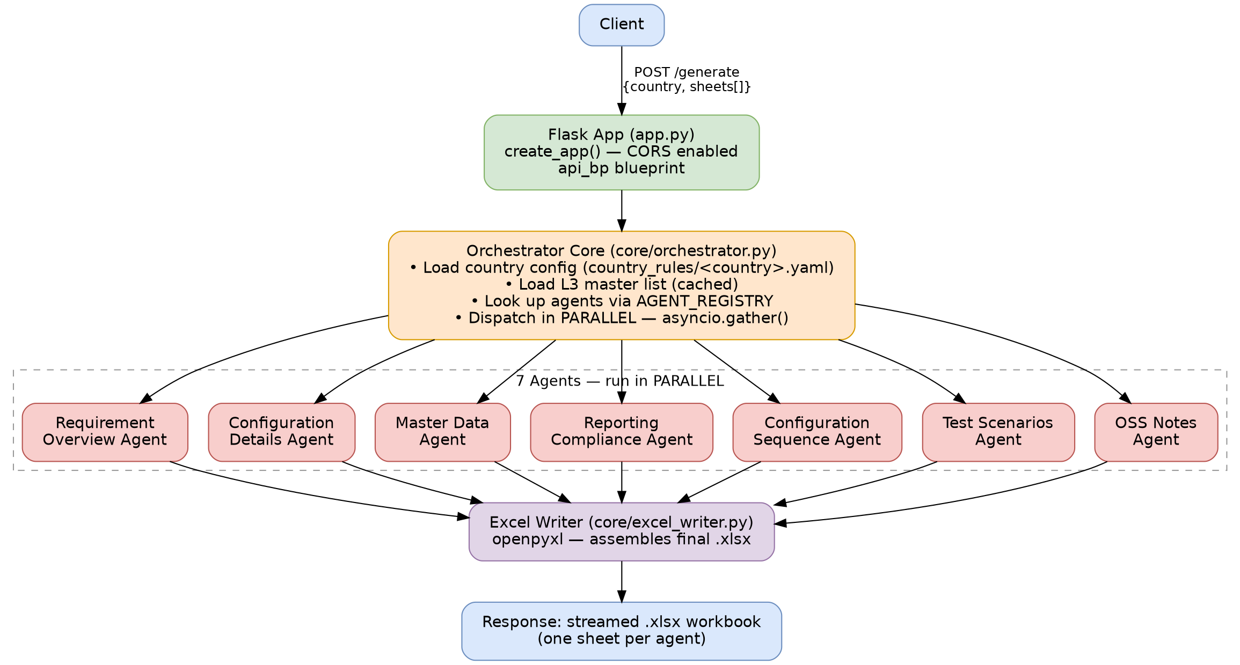
Text summary:
Client
|
v
POST /generate { "country": "Austria", "sheets": [...] }
|
v
Flask App (app.py -> create_app(), api/routes.py -- api_bp blueprint, CORS enabled)
|
v
Orchestrator Core (core/orchestrator.py)
- Load country config (country_rules/<country>.yaml)
- Load L3 master process list (cached, l3_loader.py)
- Dispatch selected sheet agents in PARALLEL -- asyncio.gather()
|
+--> Requirement Overview Agent
+--> Configuration Details Agent
+--> Master Data Agent
+--> Reporting Compliance Agent
+--> Configuration Sequence Agent
+--> Test Scenarios Agent
+--> OSS Notes Agent
|
v
Excel Writer (core/excel_writer.py, openpyxl)
|
v
Response: streamed .xlsx workbook (one sheet per agent)

3. Per-Agent Pipeline — the "no-hallucination" design
Every agent runs the same pipeline (defined once in agents/base_agent.py, inherited by all 7 agent subclasses): 3 LLM stages, followed by 1 deterministic (non-LLM) validation step.
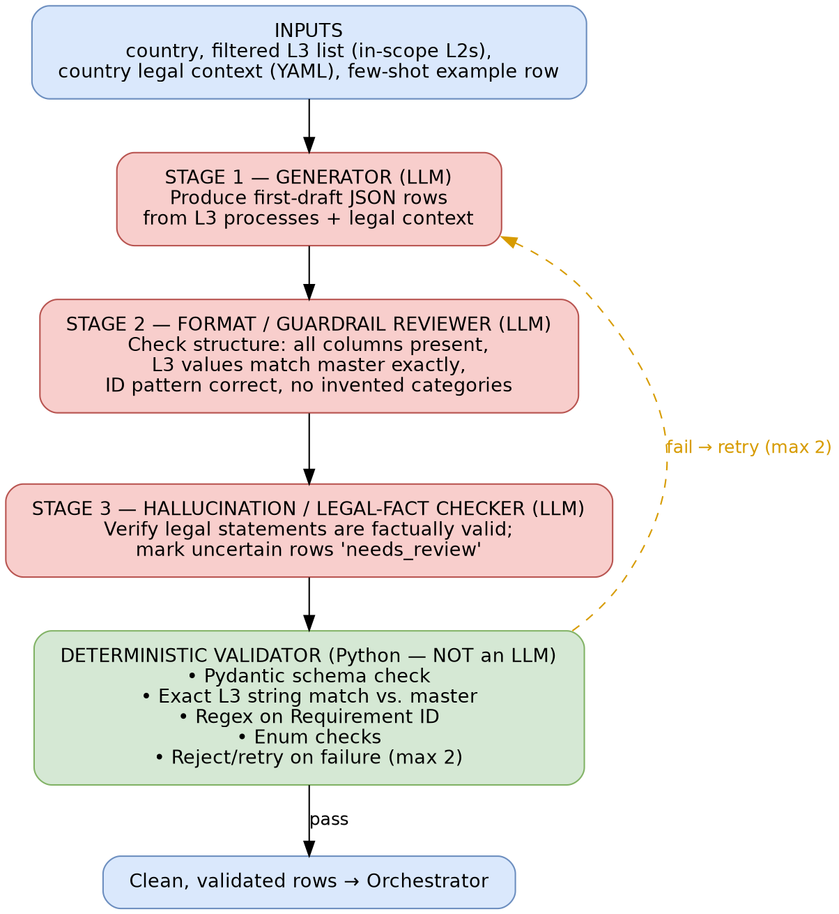
Stage | Role | Type
1. Generator | Produces a first-draft JSON array of rows from the L3 process list + country legal context | LLM
2. Format / Guardrail Reviewer | Verifies structure: all required columns present, L3 values match the master file exactly, IDs follow the required pattern, no invented categories | LLM
3. Hallucination / Legal-Fact Checker | Verifies the content is factually correct for the country; marks uncertain claims "needs_review" instead of guessing | LLM
Deterministic Validator | Pydantic schema check, exact string match against L3 master, regex on IDs, enum checks; rejects and retries (max 2) on failure | Python (no LLM)

Why this shape: each stage has a narrow, checkable job. Structural correctness is verified before factual correctness, and the final gate is pure code — which cannot hallucinate. This also allows using a cheaper model for Stage 1 and a stronger model for Stage 3, since the stages have different reliability requirements.
Source of truth: the LLM is not relied on to "know" country legal rules from training data. Two data sources are injected into every prompt:
- L3 Master file (inputs/L3_Master.xlsx) — the canonical list of valid SAP business processes; loaded once per request and cached across all parallel agents.
- Country YAML (country_rules/<country>.yaml) — hand-authored legal/tax facts (VAT rates, ID prefix pattern, in-scope process areas, statutory retention rules, etc.).
The LLM's role is to apply and format this given data, not to invent it.

4. Agents Implemented
Agent | Output Sheet | ID Pattern | Status
requirement_overview_agent.py | Requirement Overview | AT-LOC-### | Validated (Austria)
configuration_details_agent.py | Configuration Details | — | Validated
master_data_agent.py | Master Data | — | Validated
reporting_compliance_agent.py | Reporting Compliance | AT-RPT-### | Validated
configuration_sequence_agent.py | Configuration Sequence | — (ordered steps 1–12) | Validated
test_scenarios_agent.py | Test Scenarios | AT-TC-### | Validated
oss_notes_agent.py | OSS Notes | — | [confirm status]

All agents share the same base class and prompt-file structure (llm/prompts/<sheet_name>/stage1_generate.txt, stage2_format_review.txt, stage3_legal_check.txt), differing only in prompt content, output schema, and ID pattern.

5. Concurrency Model
- Agents run in parallel across sheets: asyncio.gather(agent.run() for agent in selected_agents) in the orchestrator.
- Within a single agent, the 3 LLM stages + deterministic validator run sequentially, since each depends on the previous step's output.
- LLM call rate-limiting is handled via a semaphore in llm/client.py.
- The L3 master file is loaded once per request and shared (read-only) across all dispatched agents to avoid redundant I/O.

6. Project Structure
orchestrator_api/
├── app.py # Flask entrypoint (create_app factory)
├── api/
│ └── routes.py # /generate, /health, /countries, /sheets, /models
├── core/
│ ├── config.py # settings, LLM keys, model names
│ ├── orchestrator.py # parallel agent dispatcher, sheet->agent registry
│ └── excel_writer.py # assembles final .xlsx via openpyxl
├── agents/
│ ├── base_agent.py # abstract 3-stage LLM pipeline + validator
│ ├── requirement_overview_agent.py
│ ├── configuration_details_agent.py
│ ├── configuration_sequence_agent.py
│ ├── master_data_agent.py
│ ├── oss_notes_agent.py
│ ├── reporting_compliance_agent.py
│ └── test_scenarios_agent.py
├── llm/
│ ├── client.py # unified LLM client (SAP AI Core / ai-core-sdk)
│ └── prompts/
│ └── <sheet_name>/
│ ├── stage1_generate.txt
│ ├── stage2_format_review.txt
│ └── stage3_legal_check.txt
├── l3_loader.py # reads L3 master xlsx -> dict, cached
├── country_rules/
│ ├── austria.yaml # legal prompts, VAT rates, in-scope L2s
│ └── <other countries>.yaml
├── schemas/
│ ├── request.py # Pydantic input schema
│ └── <sheet>.py # Pydantic output row schema per sheet
├── validators/
│ └── row_validator.py # format + hallucination guards (Stage 4)
├── inputs/
│ └── L3_Master.xlsx
├── outputs/ # generated Excel files land here
├── requirements.txt
└── README.md

7. Platform / Integration
- Runtime: Python 3.12 (note: Python 3.14 currently breaks pandas==2.2.3 install — no prebuilt wheel yet; 3.12 confirmed working)
- LLM Provider: SAP AI Core / Generative AI Hub (ai-core-sdk, ai-api-client-sdk)
- Credentials: loaded via .env locally (python-dotenv, optional) — AICORE_AUTH_URL, AICORE_CLIENT_ID, AICORE_CLIENT_SECRET, AICORE_RESOURCE_GROUP, AICORE_BASE_URL. In production, these are injected directly by Cloud Foundry.
- Excel generation: openpyxl
- Framework: Flask (app.py — create_app() factory pattern, flask_cors enabled, routes via api_bp blueprint)
- Deployment target: SAP BTP Cloud Foundry (CF_PORT read from main/config/settings.py)

8. Input / Output Contract

Routes (Flask blueprint api_bp)
Route | Method | Returns
/health | GET | {"status": "ok"}
/countries | GET | {"countries": [...]} via list_supported_countries()
/sheets | GET | {"sheets": [...]} — from AGENT_REGISTRY.keys()
/models | GET | supported LLM model names
/generate | POST | streamed .xlsx workbook

Agent Registry: main/agents/__init__.py exposes AGENT_REGISTRY, a sheet-name → agent-class mapping. The orchestrator and the /sheets endpoint both read from this registry — agent dispatch is registry-driven, not hardcoded conditional logic.
Error handling: dedicated exception types — OrchestratorError (core/orchestrator.py) and CountryConfigError (data/country_loader.py) — distinguish orchestration failures from invalid/missing country configuration.

Sample Request
POST /generate
{
"country": "Austria",
"sheets": ["requirement_overview", "configuration_details",
"master_data", "reporting_compliance",
"configuration_sequence", "test_scenarios"]
}
Response: streamed .xlsx file — one sheet per requested agent, styled to match the reference "golden file" format.

9. Sample Output Summary (Austria)
Sheet | Row Example
Requirement Overview | AT-LOC-004 — VAT Tax Codes — L3: 1.4.1 GL Reporting Tax Reports
Configuration Details | AT-LOC-004 — Configure VAT codes and accounts — T-codes: FTXP, OBYZ, OB40
Master Data | Tax Code — VAT rate, EU transaction code, reverse charge indicator
Reporting Compliance | AT-RPT-001 — Preliminary VAT Return UVA/U30 — High complexity
Configuration Sequence | Step 3 — VAT — Configure 20/13/10% rates — Owner: Tax Lead
Test Scenarios | AT-TC-002 — Post transaction with Austrian VAT rates

Cross-sheet traceability was verified: the same underlying requirement (e.g., VAT Tax Codes) is represented consistently across all six sheets with matching context, confirming the shared L3 master and country config are applied coherently across all agents.

10. Known Gaps / Next Phases
Phase | Status
Phase 1 — Austria, Requirement Overview only | Complete
Phase 2 — Configuration Details + Master Data agents | Complete
Phase 3 — Remaining sheets (Reporting, Test Scenarios, OSS Notes) | Complete (confirm OSS Notes)
Phase 4 — Add France, UK, Italy country configs | Not started
Phase 5 — Persistence (job queue/DB), auth, monitoring | Not started

11. Open Questions for Handover
☐ Is OSS Notes agent tested end-to-end, or only scaffolded?
☐ Are Stage 2/3 guardrails tested against intentionally malformed input (missing L3 entries, ambiguous legal facts)?
☐ What is the retry/failure behavior surfaced to the API caller if Stage 4 validation fails twice?
☐ Are there rate-limit/cost figures per agent run (LLM calls x stages x sheets) to budget for scale-out to more countries?

