# Project Report

Title of Project: BondLocal

Name of the Innovator: Shashank Shekhar

Start Date: 26/10/2025

End Date: 31/10/2025

## Day 1: Empathize & Define

### Step 1: Understanding the Need

Which problem am I trying to solve?

I am solving the problem of weak community connections and low volunteering participation at the local level. People often want to help or be involved in their neighborhoods but don’t know where to start or how to find local initiatives. BondLocal bridges this gap by helping residents discover, join, and organize nearby community events that make a real impact.

Who is affected by this problem?

Urban residents, students, NGOs, civic groups, and small organizations that struggle to find volunteers for meaningful initiatives.

How did I find out about this?

☑ Interviews  
☑ Observation  
☑ Online Research  
☑ AI Tools

### Step 2: What is the problem?

Modern life has led to growing social isolation and low civic participation. Although there are people willing to contribute, they lack a simple digital platform to discover local volunteering drives or to create their own. BondLocal solves this by making local volunteering accessible, visible, and rewarding.

Why is this problem important to solve?

Strong communities are built when people engage locally. Volunteering helps build empathy, reduce loneliness, and strengthen civic responsibility. BondLocal encourages people to participate in local causes, creating stronger, safer, and happier neighborhoods.

### Take-home task

Ask 2–3 people what they think about the project:

1. College Student:  
“BondLocal sounds amazing. It’s hard to find nearby volunteering events unless they’re shared on random WhatsApp groups. This would make it easy.”  
  
2. NGO Organizer:  
“We always need volunteers for cleanup and donation drives. If BondLocal lists our events publicly, it would save us so much outreach time.”  
  
3. Resident:  
“I’d love to know when my neighbors are planning something like a park cleaning or food drive. It brings people together.”

### AI Tools used:

1. ChatGPT – for brainstorming social impact ideas, generating app structure, and writing meaningful content.  
2. Claude AI – for refining feature flows and creating emotional appeal in the design.  
3. Canva AI – for mockup and presentation design of the app interface.

## Day 2: Ideate

### Step 3: Brainstorming Solutions

1. Community bulletin board for nearby events.  
2. Local volunteer-matching app.  
3. Digital wall for community stories and appreciation.  
4. Gamified volunteer reward system.  
5. Neighborhood collaboration hub.

### Step 4: My favourite solution

My favorite solution is BondLocal — a full-featured web app that helps individuals discover, join, and organize local volunteering events. It connects people with community groups, encourages participation through badges and recognition, and uses technology to strengthen social bonds.

### Step 5: Why am I choosing this solution?

BondLocal stands out because it focuses on human connection and community empowerment. It’s not just an app — it’s a movement toward stronger, kinder neighborhoods.

### AI Tools used for Step 3–5:

1. ChatGPT – for brainstorming and ideation.  
2. Claude AI – for project structuring and emotional storytelling.  
3. Figma AI – for creating UI mockups of the interface.  
4. Canva AI – for presentation and poster design.

## Day 3: Prototype & Test

### Step 6: Prototype – Building my first version

The prototype was built as a web app using Next.js, TailwindCSS, and Firebase. The design features a map-based event feed, event creation form, and user profiles with badges.

AI Tools Used:  
• ChatGPT – for writing copy and dummy event data.  
• Claude – for feature refinement.  
• Figma AI – for UI prototype.  
• Canva – for presentation design.

### Step 7: Test – Getting Feedback

I shared BondLocal with students, volunteers, and NGO coordinators. Most users found it easy to navigate and inspiring.

Pros:  
• Simple interface and emotional appeal.  
• Encourages people to act locally.  
• Gamification motivates participation.  
  
Cons:  
• Needs real-time map integration.  
• Some filters and location services need improvement.

My Response:  
These issues will be solved in future updates using real-time databases and geolocation APIs.

## Day 4: Showcase

### Step 8: Presenting my Innovation

BondLocal is a web-based platform for discovering and organizing local volunteering events. It empowers communities by making participation easy, fun, and visible.  
Features include:  
• Map-based nearby events  
• Event posting and joining system  
• Community wall for stories  
• Volunteer profiles and badges

Impact: BondLocal strengthens social ties, builds empathy, and promotes civic engagement.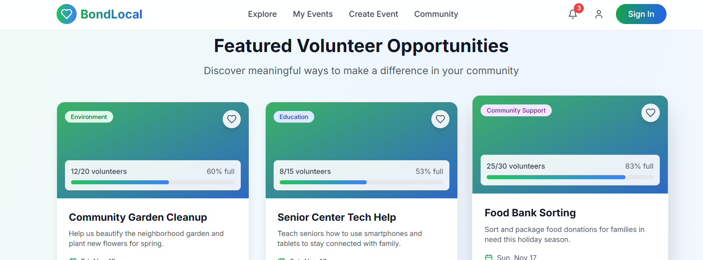

### Step 9: Reflection

I enjoyed designing a solution that creates real social impact. It was inspiring to imagine how small actions could build stronger communities.

The main challenge was ensuring scalability and maintaining real-time updates for events and maps, but it encouraged me to learn about better database integrations.

Tool Link: https://bondlocal.vercel.app