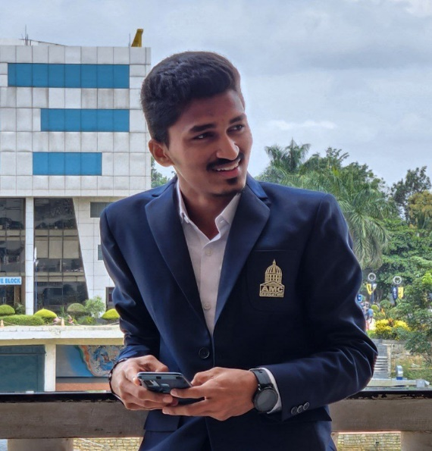****

**Varcons technologies, Full stack web development**

**Pvt Ltd**

**MG road, Banglore**

## Design Thinking for innovation

University of virginia. Apr 8,2022

***ABOUT ME***

***HOBBIES***

PCM with computer science

Viveka junior college Kota, kundapura

**2021 – 2025 BACHLOR DEGREE**

* ENGILISH
* HINDI
* KANNADA
* TULU

**LinkedIn**:

<https://www.linkedin.com/in/shashank-shetty-49a80b22b>

**Instagram:** https://www.instagram.com/shashank.shetty_07

**2022**

* TEAM WORK
* COMMUNICATION
* LEADERSHIP
* CREATIVITY

***WORK EXPERIENCES***

BE Computer science engineering

AMC engineering college, Banglore

Date of birth: June 6,2003

Age: 20

Gender: Male

**2019 – 2021 PRE-UNIVERSITY COLLEGE**

***CERTIFICATION***

***LANGUAGES***

***SKILLS***

6361128305

[***Shettyshashank089@gmail.com***](mailto:Shettyshashank089@gmail.com)

**Udupi, Karnataka**

***CAREER OBJECTIVE***

Coursera

***INTERNSHIPS***

A computer science engineer who is seeking to find the opportunity to work in a fun and challenging working environment that will encourage him to improve and learn new and necessary skills as well as to be motivated by the company to do his best for the sake of helping himself and the company.

***ACADEMIC BACKGROUND***

**Computer science Engineer**

SHASHANK.SHETTY

***HOBBIES***