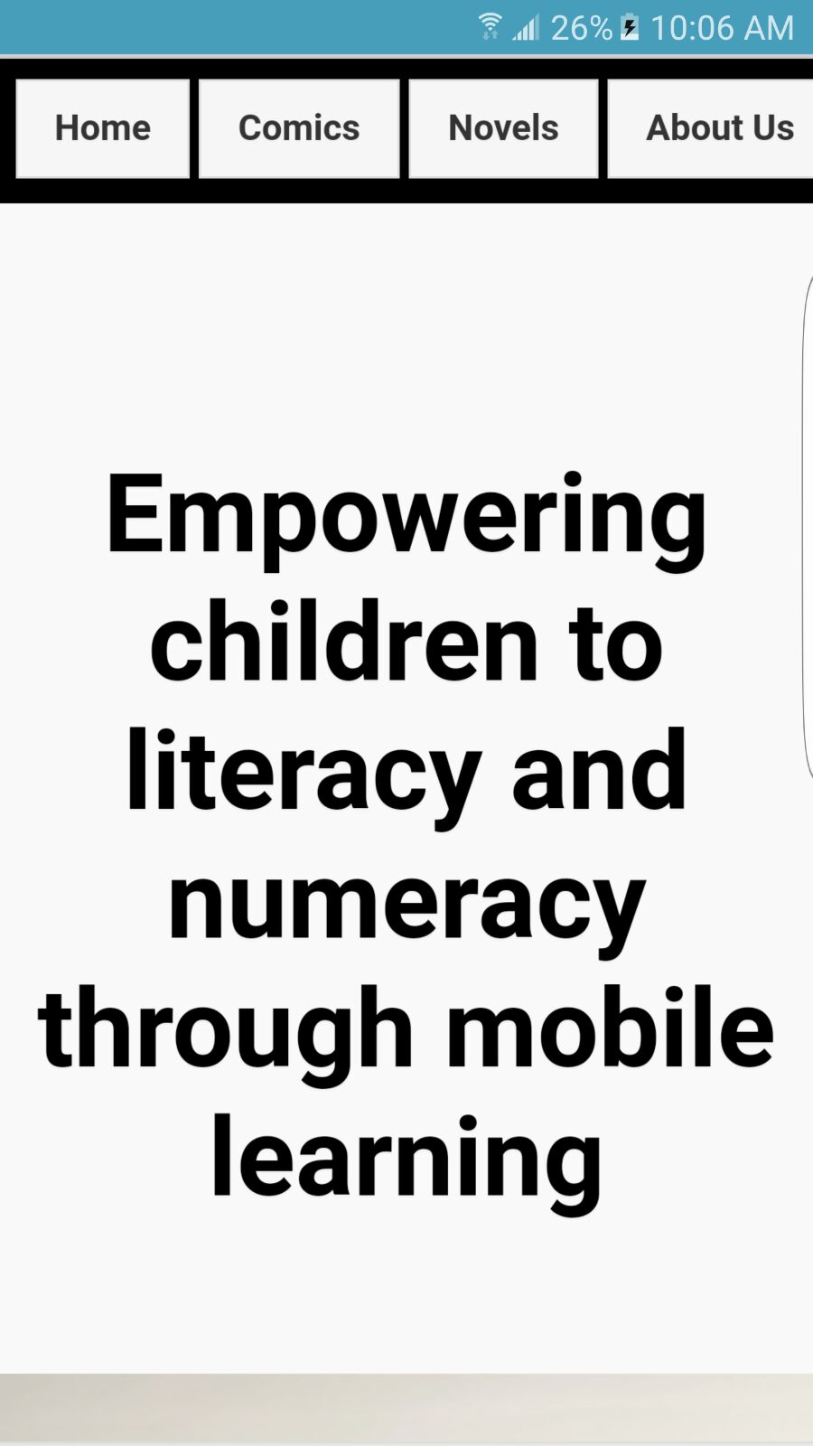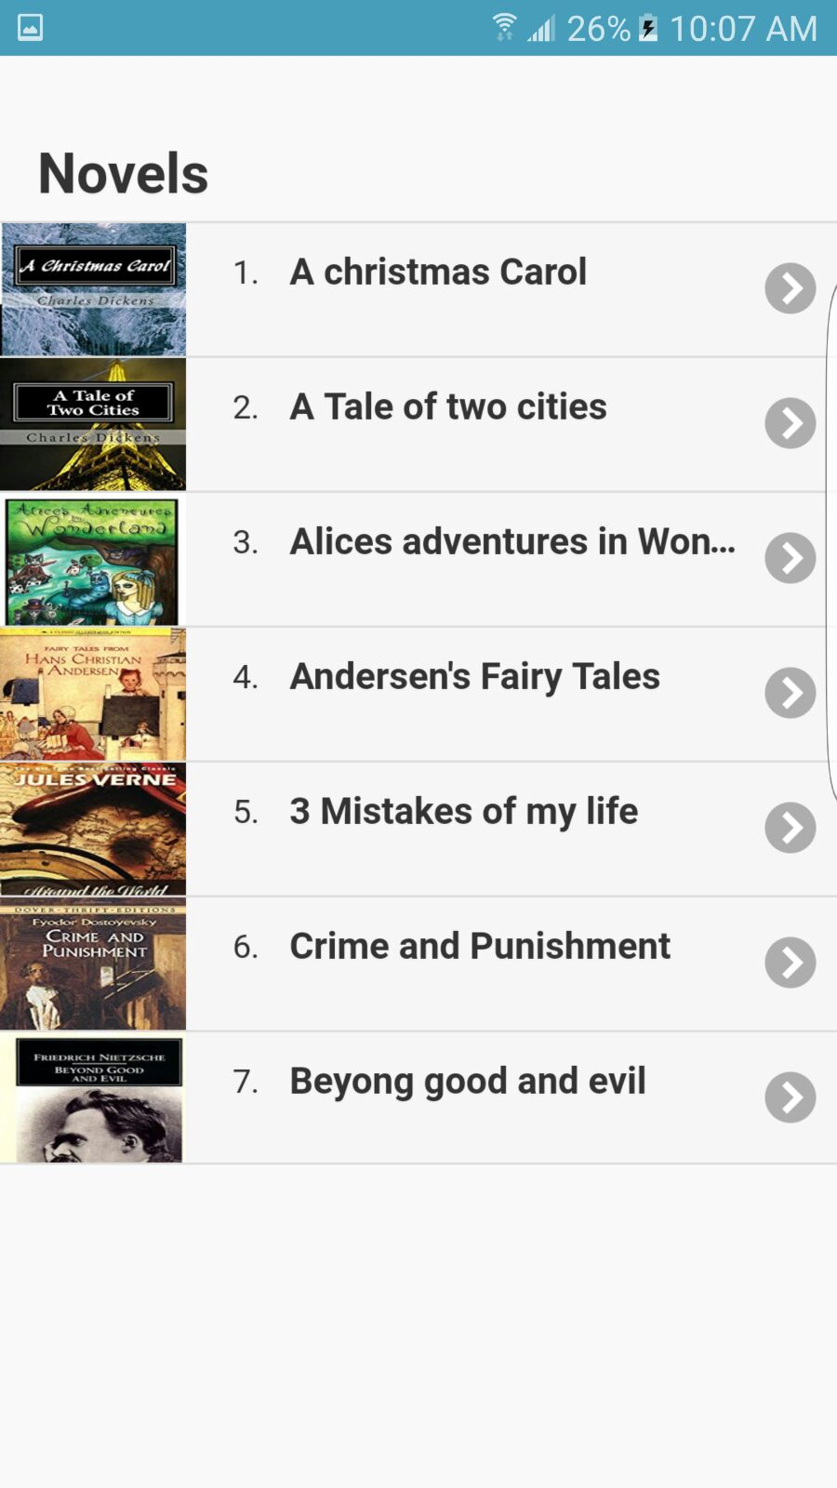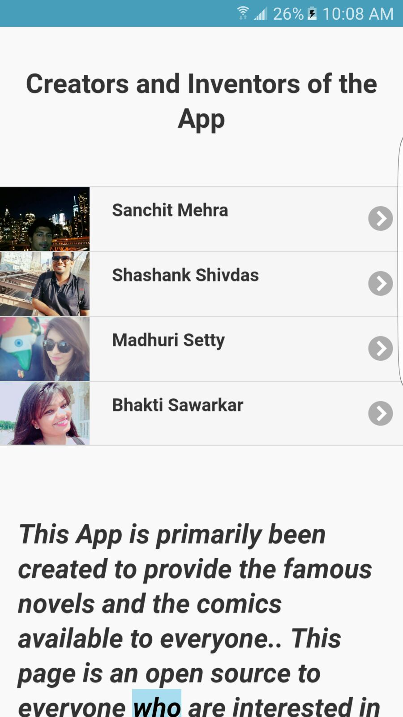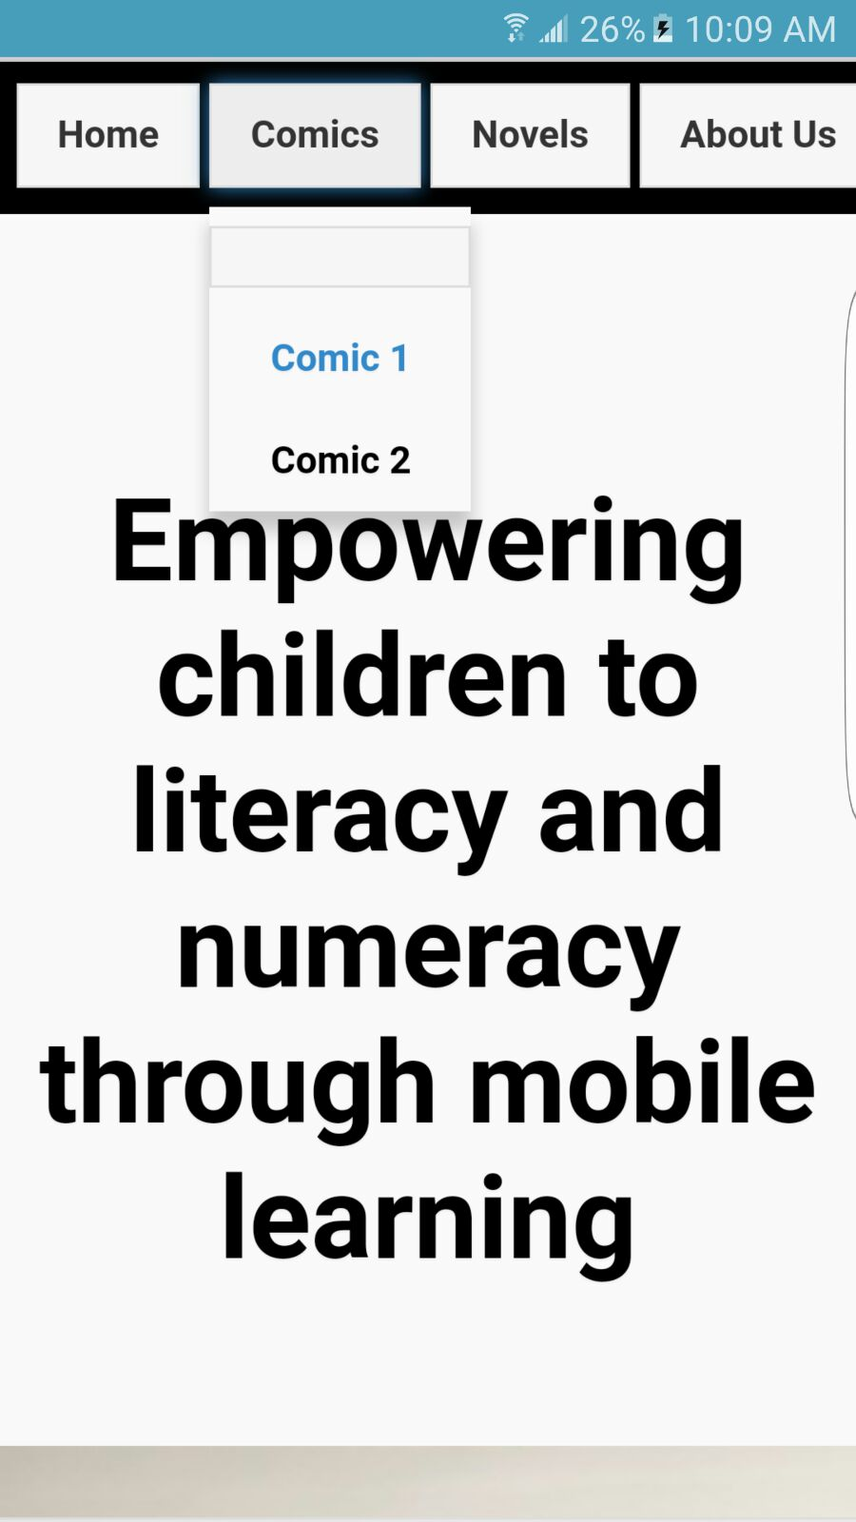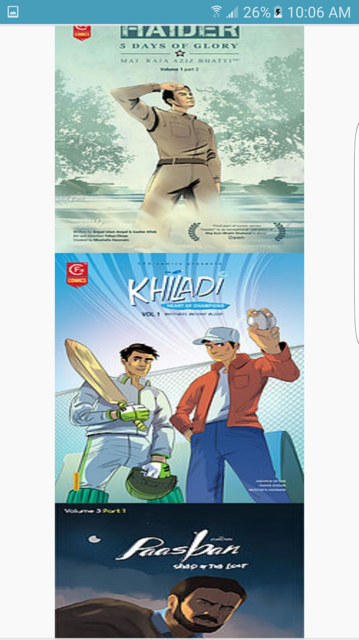The first screenshot is the homepage of our app. The header consists of Home, comics, novels and about us page. In this page, we have given a general description of our app and what it does.

The second screen shot is the novels page which shows the different novels available on our app. To read a novel, user can just go to the novels page and click on a particular novel.

The third screenshot is the contact us page where user can contact us regarding any query. By clicking on a name, it will direct the user to our facebook contact page where he/she can leave a query.

The fourth and fifth screenshot shows the images of different comics available on our app. User can go to the comics page to download it.