

Dining at Hotel Augusto
A vegetarian meal at the hotel. A quiet meal in your room. Plan what works for your day in Varanasi.
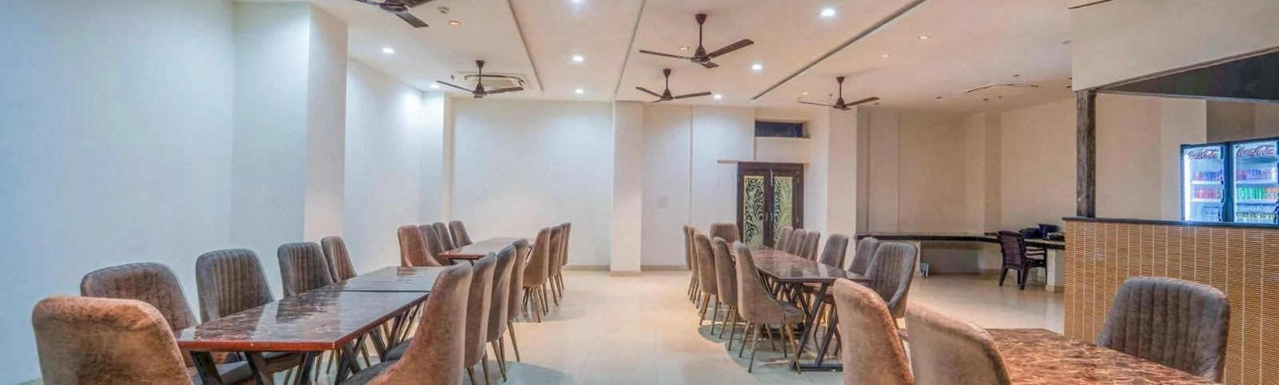

At the restaurant
Vegetarian dining is available on site. Ask the team for the current menu, prices and serving times.

In your room
Room service is another option. Ask what can be ordered, when it is available and any applicable charges.

Before you enquire
- Share your preferred date, time and the number of people in your party.
- Check which meals your room plan includes, especially breakfast.
- Tell the hotel about dietary requirements before you order.

Talk to the hotel
+91 80817 09146 · Enquire on WhatsApp
D 36/1, August Kunda Road, Godowlia, Jangambari, Varanasi 221001 · Opposite State Bank of India
The hotel will confirm your dining arrangements, menu, serving times and charges.
Planning information checked 20 October 2026. Sources: Google hotel profile · MakeMyTrip property listing

