Superstore Sales Analysis Report

Project Overview
This project analyzes Superstore sales data to evaluate sales performance across regions, product categories, products, and time. The objective is to identify business trends, top-performing products, weak-performing products, and opportunities for sales improvement.

Dataset Information
Dataset: Superstore Sales Dataset
Records: 9,800 rows
Features: 20 columns including Order_ID, Order_Date, Region, Category, Product_Name, and Sales.

Data Preparation
The dataset was cleaned and prepared using Python and Pandas. Date fields were standardized, duplicate records were checked, and Year and Month features were created for trend analysis.

Key Performance Indicators (KPIs)
Total Revenue: $2,261,536.7
Total Orders: 4,922
Average Order Value (AOV): $459.48

Regional Performance
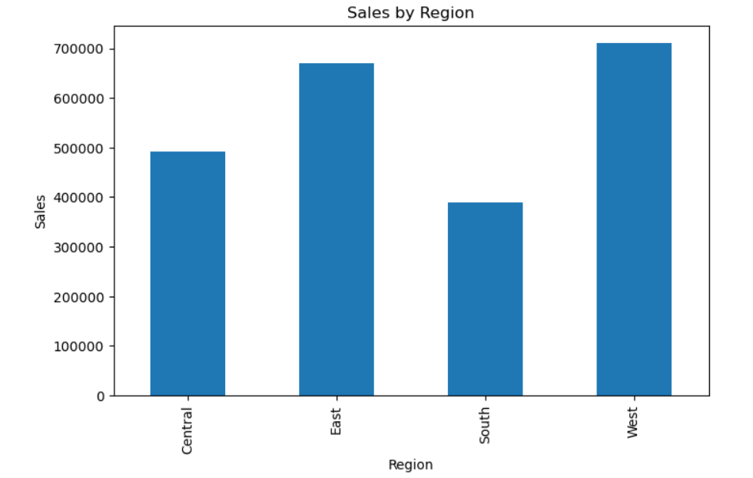
West region generated the highest sales ($710,219.68), followed by East ($669,518.73). South recorded the lowest sales ($389,151.46), indicating potential opportunities for targeted growth initiatives.

Category Performance
Technology was the best-performing category with sales of $827,455.87. Furniture generated $728,658.58 and Office Supplies generated $705,422.33.
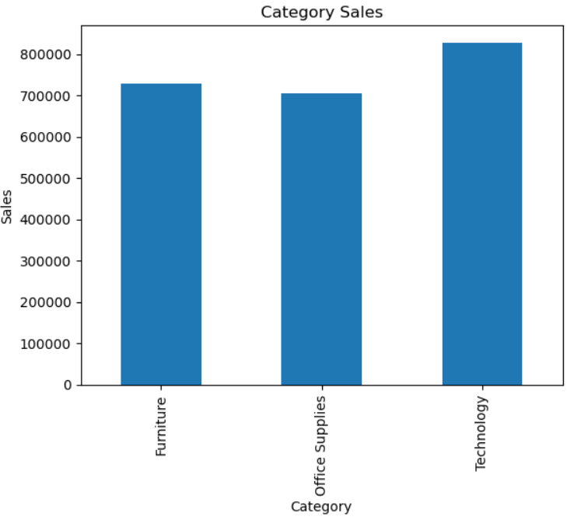

Top Performing Products
- Canon imageCLASS 2200 Advanced Copier ($61,599.82)
- Fellowes PB500 Electric Punch Plastic Comb Binding Machine ($27,453.38)
- Cisco TelePresence System EX90 Videoconferencing Unit ($22,638.48)
- HON 5400 Series Task Chairs for Big and Tall ($21,870.58)
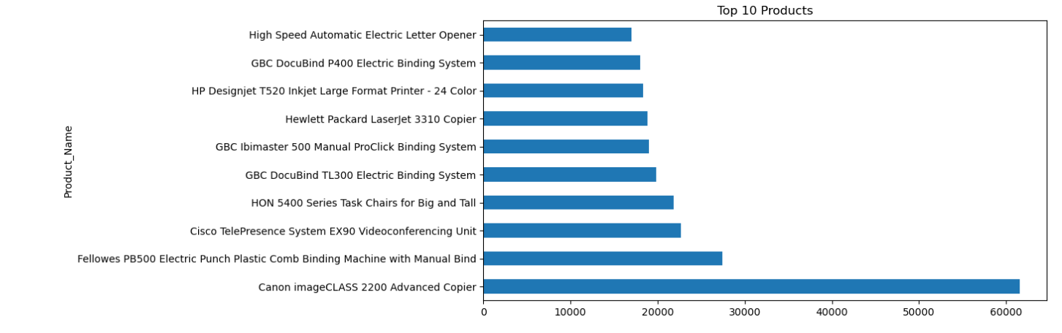
- GBC DocuBind TL300 Electric Binding System ($19,823.48)

Lowest Performing Products
Examples of low-selling products include Eureka Disposable Bags for Sanitaire Vibra Groomer I Upright Vac, Avery 5, Xerox 20, Grip Seal Envelopes, and Acme Serrated Blade Letter Opener.

Seasonality Analysis
Monthly and yearly trend analysis was performed to identify seasonal sales patterns and peak demand periods. These insights can support inventory planning and promotional strategies
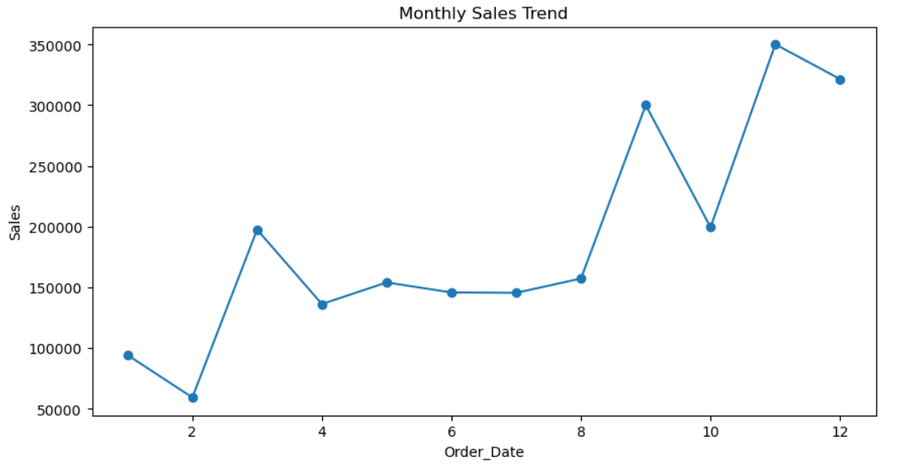

Key Findings
- Revenue exceeded $2.26 million.
- Technology was the strongest product category.
- West region generated the highest revenue.
- Several products contributed disproportionately to total sales.
- Sales data reveals opportunities for regional and product-level optimization.

Recommendations for InternSpark
- Increase focus on high-performing Technology products.
- Expand marketing efforts in lower-performing regions.
- Bundle or promote low-performing products.
- Use seasonal trends to optimize inventory levels.
- Prioritize top-selling products in advertising and sales campaigns

Conclusion
The analysis highlights strong performance in Technology products and the West region. By leveraging product, category, and regional insights, InternSpark can improve revenue growth and sales efficiency.

.

