Website Traffic Analysis Report

Executive Summary
This report analyzes website clickstream data to identify traffic patterns, geographic engagement, popular artists, albums, tracks, and link performance. The objective is to derive actionable insights for improving user engagement and conversions.

Project Objectives
- Analyze website traffic data.
- Identify top-performing countries, cities, artists, albums, tracks and links.
- Explore traffic trends.
- Provide business recommendations.

Dataset Overview
Dataset Source: Kaggle Website Traffic Analysis. The dataset contains 226,278 click records across 9 columns: event, date, country, city, artist, album, track, isrc, and linkid.

Data Preparation
The dataset was reviewed for missing values, duplicate records, and inconsistent formatting. Date fields were standardized and categorical values prepared for analysis.

Exploratory Data Analysis
The analysis focuses on:
- Total click events
- Country-wise traffic
- City-wise traffic
- Top artists
- Top albums
- Top tracks
- Most-clicked links
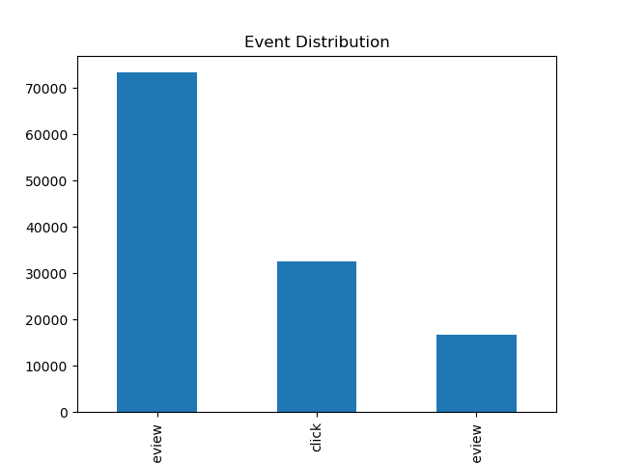
- Daily traffic trends

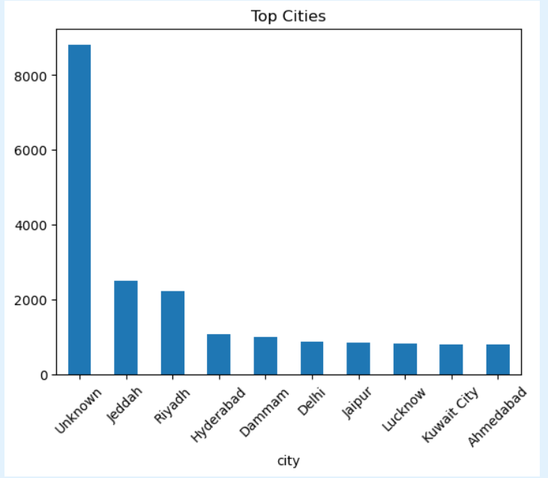

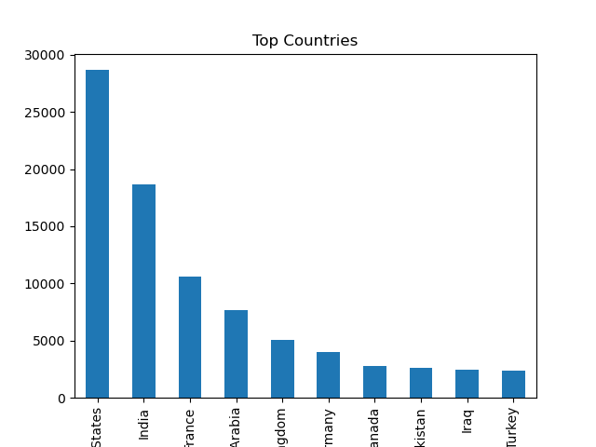

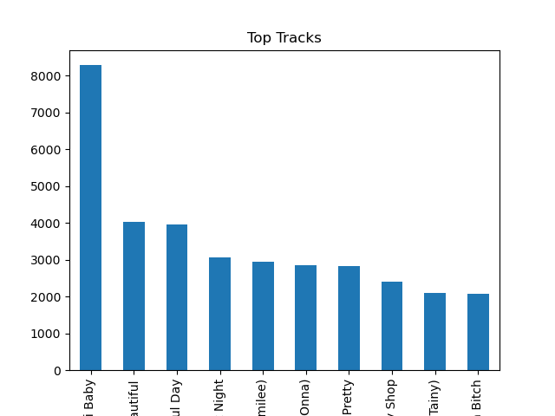

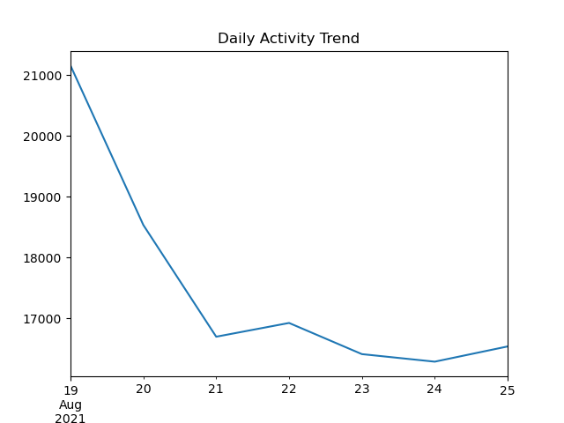

Key Insights
- Traffic is concentrated in a limited number of countries and cities.
- A small number of artists and tracks generate the majority of clicks.
- Popular links contribute a significant share of engagement.
- Geographic insights can support targeted marketing campaigns.

Dataset Limitation
The provided dataset contains click-event records rather than complete web session logs. Therefore, metrics such as bounce rate, average session duration, landing pages, exit pages, and user journeys cannot be calculated directly because session identifiers and navigation history are unavailable.

Recommendations for InternSpark

Prioritize marketing in high-performing regions.
- Promote top-performing artists and content.
- Optimize low-performing links and campaigns.
- Use geographic insights for localized promotions.
- Monitor click trends regularly to improve engagement and conversions.

Conclusion
The analysis provides valuable insights into user engagement using the available clickstream data. Although session-based metrics are unavailable, the findings support data-driven decisions for improving content performance and marketing effectiveness.

