**CHAT APPLICATION**

**GUI Interface :**

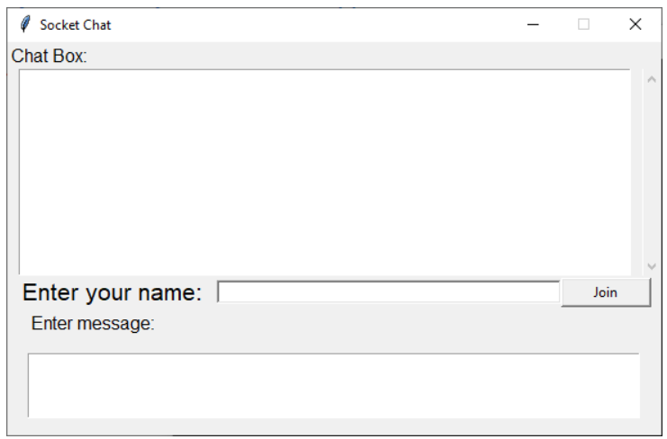

**HOW TO USE :**

1. **Run server file python server.py**

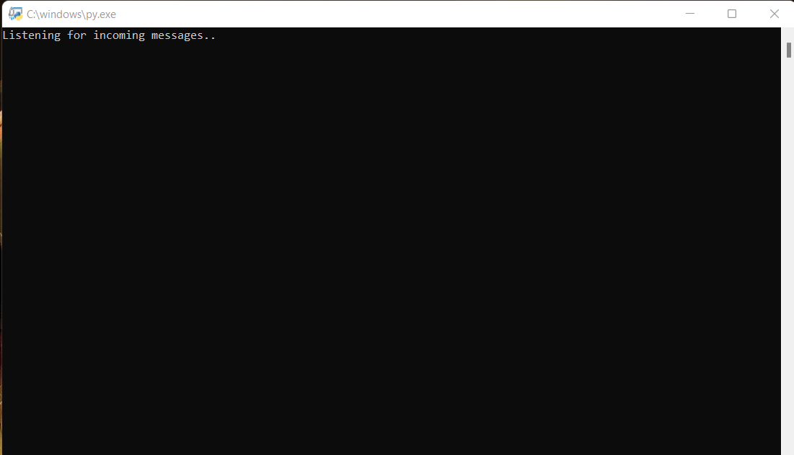

1. **Run client file python client.py you can run it as much as clients you want**

