Student Name: Shashank Dubey
Student Id: 11709998
Email Id: Shashankssm@outlook.com
GitHub link: https://github.com/shashankssm

Description
Write a program to implement priority scheduling algorithm with context switching time. Prompt to user to enter the number of processes and then enter their priority, burst time and arrival time also. Now whenever operating system preempts a process and shifts CPU’s control to some another process of higher priority assume that it takes 2 seconds for context switching (dispatcher latency). Form a scenario, where we can give the processes are assigned with priority where the lower integer number is higher priority and then context switch. as the process waits the priority of the process increase at rate of one per 2-time units of wait.
Calculate waiting time and turnaround time for each process.

Algorithm

Step 1: Taking Input ‘n’ for no. of processes
Step 2: Run LOOP till (I<N)
Taking Input ‘atime’,’btime’,’priority’ for Arrival time, Burst time and Priority of the Processes.
[END LOOP]
Step 3: Run LOOP till (I<N)
Set PTR=I;
Run LOOP till (J<N) from J=I+1
IF(Priority[I]<Priority[PTR])
Do PTR=J;
[ END Internal LOOP]
SET Temp=Priority[I];
SET Priority[I]=Priority[PTR];
SET Priority[PTR]=Temp;

SET Temp=BTime[I];
SET BTime[I]=BTime[PTR];
SET BTime[PTR]=Temp;

SET Temp=PNo[I];
SET PNo[I]=PNo[PTR];
SET PNo[PTR]=Temp;

[END LOOP]
Step 4: SET WTime[0]=0
Run LOOP till (I<N)
SET WTime[I]=0;

Run LOOP till(J<I)
SET WTime[I] = WTime[I] + BTime[J];
[END LOOP]

SET Sum=Sum+WTime[I];
[END LOOP]

Step 5: SET AvgWaitTime= Sum/N;
Step 6: Run LOOP till(I<N)
SET TurnAroundTime[I]=BTime[I]+WTime[I]
SET Sum1=Sum1+TurnAroundTime[I];
[END LOOP]

Step 7: SET AvgTurnAroundTime=Sum1/n;

[EXIT]

Code Snippet

/* NOTE : IF THE BELOW CODE IS NOT GIVING DESIERED OUTPUT THEN, REMOVE THE COMMENT MARK FROM fflush(stdin) BEFORE EVERY SCANF FUNCTION TO REMOVE BUFFER */

/* NOTE : SYSTEM(COLOR 00) and SYSTEM("CLS") FUNCTION IS USED FOR BETTER USER INTERFACE EXPERIENCE,
KINDLY REMOVE OR MARK THEM AS A COMMENT WHILE EXECUTING IT ON LINUX BASED OS*/

#include<stdio.h>
int main()
{
char ch;
int n,i,j,ptr,c,z,sum=0,avgtime;
int atime[10],btime[10],wtime[10],priority[10],pn[10],tatime[10];

system("COLOR E0");
printf("__________________________________\n");
printf("Enter the the no. of processes : ");
scanf("%03d",&n);
printf("__________________________________\n");
system("cls");

for (i=0;i<n;i++)
{
system("COLOR FC");
printf("\n\nprocess [%03d] \n",i+1);
printf("************************\n");
printf("Enter arrival time : ");
scanf("%03d ",&atime[i]);
printf("************************\n");

printf("Enter Burst time : ");
//fflush(stdin);
scanf("%03d ",&btime[i]);
printf("************************\n");

printf("Enter Priority : ");
//fflush(stdin);
scanf("%03d ",&priority[i]);
printf("************************\n");
pn[i]=i+1;
system("cls");

}

for (i=0;i<n;i++)
{
ptr=i;

for (j=i+1;j<n;j++)
{
if(priority[j]<priority[ptr])
{
ptr=j;
}
}

c=priority[i];
priority[i]=priority[ptr];
priority[ptr]=c;

c=btime[i];
btime[i]=btime[ptr];
btime[ptr]=c;

c=pn[i];
pn[i]=pn[ptr];
pn[ptr]=c;

}
wtime[0]=0;
for(i=1;i<n;i++)
{
wtime[i]=0;
for(j=0;j<i;j++)
{
wtime[i] = wtime[i]+btime[j];
}

z = z+wtime[i];

}

avgtime=z/n;
system("COLOR F0");
fflush(stdin);
printf("__________________________________________________________________________________________________\n");
printf("| PROCESS | ARRAIVAL TIME | BURST TIME | WAITING TIME | PRIORITY | TURN AROUND TIME | \n");

for (i=0;i<n;i++)
{
tatime[i]=btime[i]+wtime[i];
printf("| %03d | %03d | %03d | %03d | %03d | %03d | \n",pn[i],atime[i],btime[i],wtime,pn[i],tatime[i]);
sum= sum+tatime[i];

}
printf("__________________________________________________________________________________________________\n");
int avgtatime= sum/n;
printf("____________________________________");
printf("\n| AVERAGE WAIT TIME : %03d |",avgtime);
printf("\n| AVERAGE TURNAROUND TIME : %03d |",avgtatime);
printf("\n____________________________________");

}

//FOR FURTHER ASSISTANCE CONTACT DEVELOPER: SHASHANKSSM@OUTLOOK.COM

Boundary Condition

- User cannot pass process value greater than 10.
- Arrival time value is bounded for 10 processes.
- Burst time value is bounded for 10 processes.
- Priority of processes cannot exceed the limit 10.
- SYSTEM(COLOR 00) function only suitable with windows based environment.
- SYSTEM(“cls’) function is also compatible with windows environment only.
- Buffer memory may exist, to rectify it fflush(stdin) function is used.

Test Cases

Test case 1: When User Pass the value of processes = 0

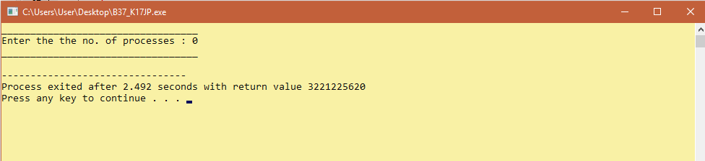

Status : Test Case Passed

Test case 2: When User Pass the value of processes < 0
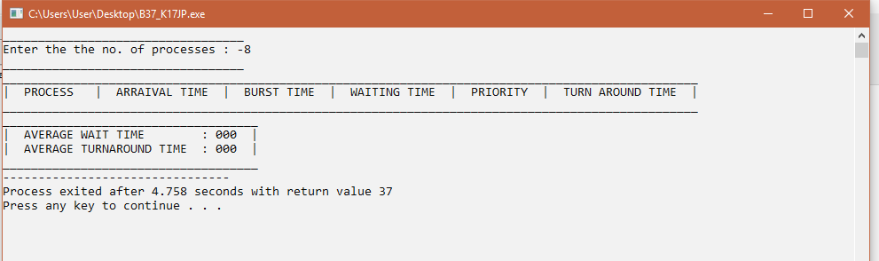
Status: Partially Passed

Test case 3: When User pass the value of processes > 0

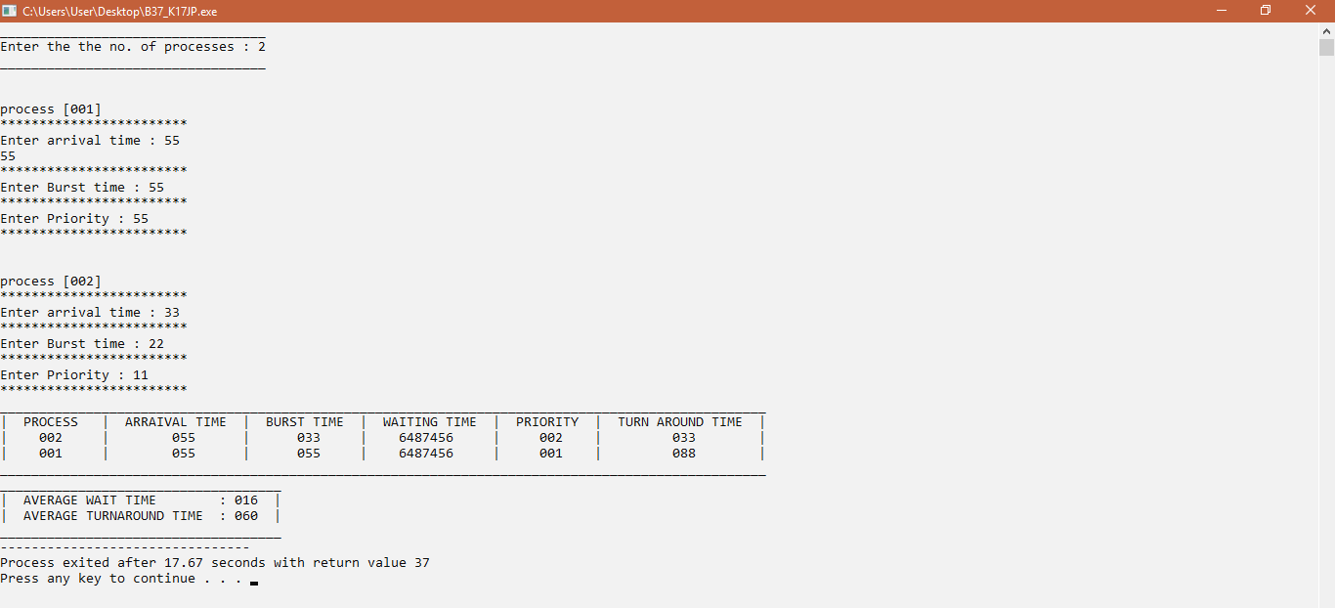

Status: Test case passed

Test case 4: When User give input = 0, for arrival time, burst time and priority.
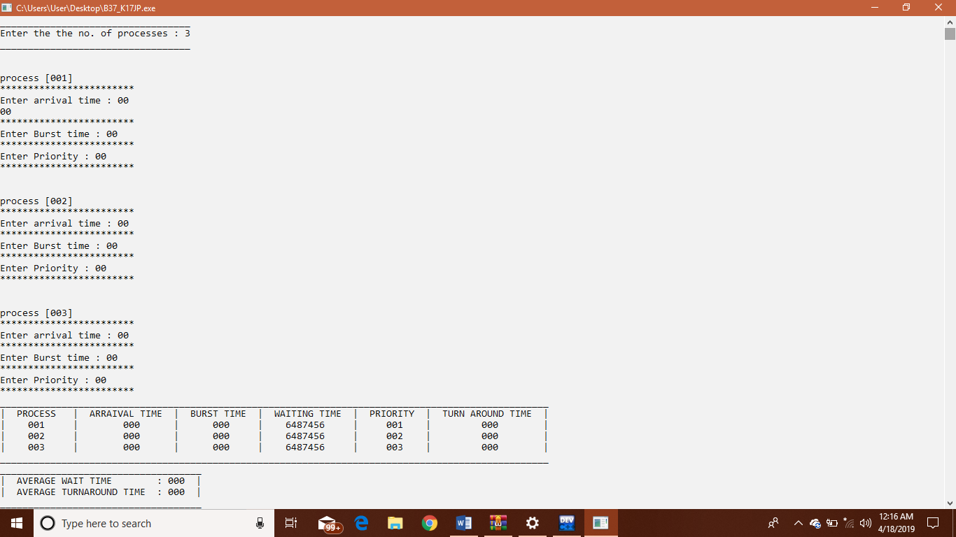

Status: Test case Passed with all desired output, i.e=0

Test case 5: When user gives the process value > 10 i.e bounded length for input
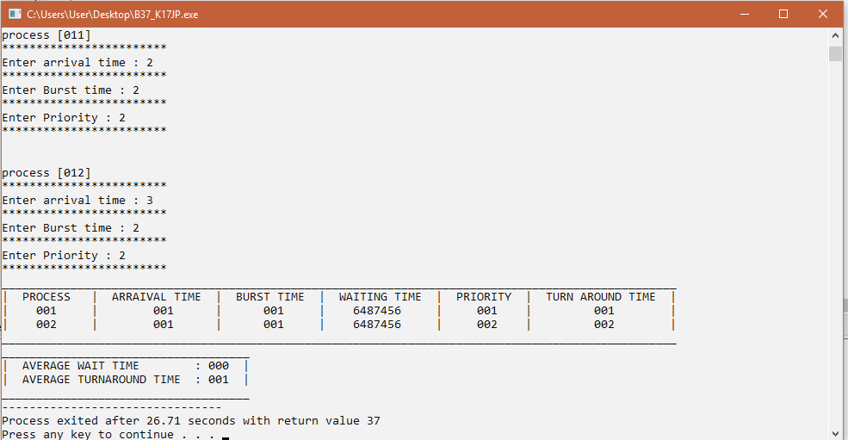
Status: exceed the input boundary limit, giving output for only two processes with garbage values. (Passed)

Test case 6: When user gives all the desired input. i.e no. of process > 0, burst time>0, arrival time>0, priority >=0;
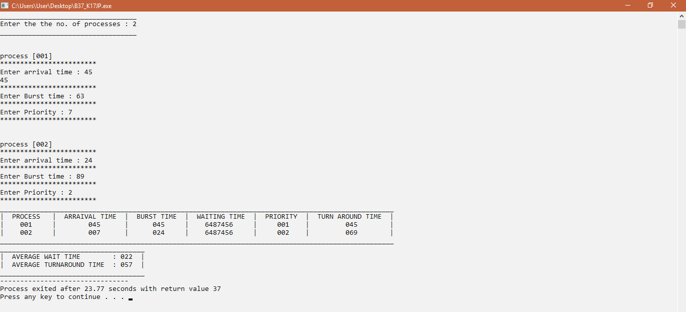
Status: all test case Passed

