**CHAPTER 1**

**INTRODUCTION**

* 1. **Prelude**

This document serves as a comprehensive record of the development, execution, and critical reflection of my Final Major Project—a culmination of my academic and creative journey throughout this course. It stands as both a personal and professional milestone, capturing the intersection of conceptual exploration, practical application, and artistic growth. Over the course of this project, I have engaged deeply with both the theoretical and practical dimensions of creative practice, refining not only my technical skills but also my critical thinking, decision-making, and creative confidence.

The project began with a conscious effort to select a theme that held both personal resonance and wider relevance. I aimed to create work that could engage an audience meaningfully while also offering a platform for me to explore ideas that matter to me. Through extensive research—spanning cultural, social, artistic, and historical sources—I began shaping a concept that was rooted in thoughtful inquiry. This phase was crucial, as it provided the intellectual foundation for the project, encouraging me to question, interpret, and reflect on the world around me and the role of design within it.

As the concept began to take shape, I moved into a period of experimentation and creative development. Here, I explored various mediums, techniques, and visual strategies that could best communicate my ideas. This phase was iterative and often unpredictable, requiring flexibility and resilience. Some approaches failed, others revealed unexpected insights, and through each step, I learned to refine my practice and deepen my understanding of my creative direction. I made a conscious effort to document my process thoroughly, capturing both the successes and the setbacks, as these reflections played a vital role in shaping the final outcome.

One of the most significant aspects of this project was the balance between creativity and critical thinking. While artistic intuition and visual experimentation drove much of the practical work, I continuously engaged in reflective analysis, asking why certain choices were made and how they contributed to the overarching narrative of the project. This reflective practice helped me maintain a clear conceptual thread throughout the process and ensured that the final piece was not only aesthetically compelling but also meaningful and coherent in its intent.

Collaboration and feedback also played an essential role. Engaging with peers, tutors, and even individuals outside the creative field helped me see my work from multiple perspectives. These interactions often challenged my assumptions and introduced me to new ideas or interpretations that enriched the project. I found value in both formal critiques and informal conversations, as they sharpened my ability to articulate my ideas and defend our creative decisions.

The final outcome is a synthesis of this multifaceted journey. It is not just a standalone piece of design or artwork but the result of sustained effort, critical engagement, and creative exploration. It reflects my growth as a designer—technically, conceptually, and professionally. I have learned how to take an idea from a vague notion to a fully realised project, how to adapt to unexpected challenges, and how to remain true to a vision while being open to evolution and change.

* 1. **Importance of Smart Floor Cleaning System in Modern Era**

In today's fast-paced, technology-driven world, smart floor cleaning systems have revolutionized hygiene management in homes and businesses. These intelligent devices—from robotic vacuums to industrial-grade autonomous scrubbers—offer superior efficiency, technological sophistication, and health and environmental benefits. As urban living intensifies and time becomes increasingly valuable, these systems provide an effective, automated alternative to traditional, labour-intensive cleaning methods. Using AI, machine learning, IoT, and sensor mapping, they navigate complex environments, adjust to various surfaces, and optimize cleaning routes over time, delivering consistent results with minimal human input.

Integrated into smart home or building ecosystems, users can control them remotely via smartphones or voice assistants, enabling seamless cleaning even in their absence. In a post-pandemic era, their relevance has grown due to their ability to reduce allergens, dust, and harmful particles. Many feature HEPA filters and even disinfection technologies such as UV-C light, vital for healthcare and elderly care environments where hygiene is critical. These systems reduce human exposure to contaminants and cleaning chemicals while ensuring consistent sanitation—especially in high-traffic or fatigue-prone areas.

Environmentally, smart cleaners are designed for sustainability. They optimize water and chemical use, some recycle cleaning water, and many operate efficiently with improved battery life. These features align with global efforts toward eco-friendly practices, helping businesses meet environmental regulations and CSR goals. In commercial and industrial settings—malls, airports, warehouses—autonomous machines reduce labor costs and increase productivity, operating during off-hours and gathering performance data for smarter facility management.

Despite their benefits, smart cleaning systems face challenges such as high upfront costs, maintenance needs, and data privacy concerns. However, falling prices, new financing models, and advances in cybersecurity are addressing these issues. Though they may struggle in cluttered or uneven areas, ongoing innovations in AI and navigation are enhancing adaptability.

Ultimately, smart floor cleaning systems embody the shift toward automation, sustainability, and intelligent living. They offer convenience and independence in homes, boost hygiene and efficiency in public and commercial spaces, and represent a crucial tool for meeting modern cleanliness standards. As innovation continues, these systems are set to become indispensable in creating cleaner, safer, and smarter environments.

* 1. **Block Diagram**

The block diagram shown in Figure 1.1 illustrates the architecture of a smart floor cleaning system that is designed to perform both wet and dry cleaning tasks with automation and remote control capabilities. At the heart of the system lies the Arduino Uno, which functions as the central processing unit responsible for coordinating the operations of various components. The system begins with a power supply that provides the required voltage and current to operate all modules, including sensors, actuators, and the Arduino itself. One of the critical input devices connected to the Arduino is the Bluetooth module (HC-05), which allows wireless communication between the user and the cleaning robot. Through a smartphone or Bluetooth-enabled device, the user can send commands to control the movement and cleaning modes of the system. Once the Arduino receives the user's input, it determines whether to activate the wet or dry cleaning mechanism. This decision is executed via a 2-channel relay module, which switches on either the pump (used for wet cleaning by spraying water or cleaning liquid) or the dry cleaning system (typically involving brushes or vacuum mechanisms). The relay acts as an electronic switch, ensuring 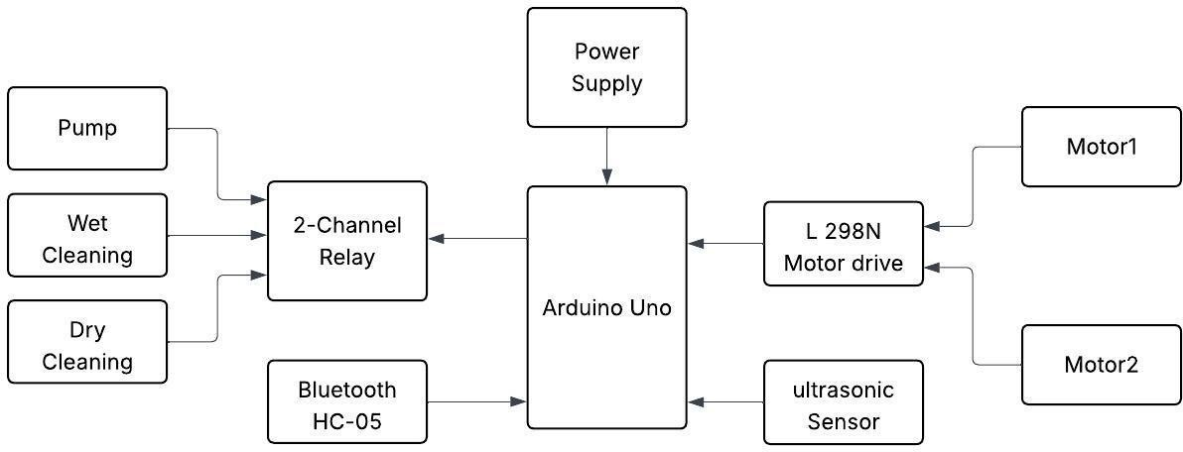that only one cleaning mode is active at a time depending on the user's instruction.

**Figure 1:Block Diagram Of Smart Floor Cleaning System**

* 1. **Motivation**

The motivation behind developing a Smart Floor Cleaning System stems from the increasing need for efficient, hygienic, and time-saving cleaning solutions in today’s fast-paced world. With modern lifestyles becoming more demanding, individuals often struggle to maintain clean environments, and traditional cleaning methods prove time-consuming, inconsistent, and labor-intensive. This system offers a smart, automated alternative that reduces human effort while ensuring consistent cleanliness. Equipped with technologies like sensors, microcontrollers, and motor control, the Smart Floor Cleaning System can navigate spaces autonomously, detect dirt or obstacles, and clean floors systematically. It is especially beneficial for elderly individuals, people with disabilities, and those with busy schedules who need reliable, hands-free cleaning.

In commercial and institutional environments—such as hospitals, schools, and offices—where hygiene is crucial, smart cleaning systems provide continuous, high-quality cleaning without the limitations of manual labor. The COVID-19 pandemic has further emphasized the importance of surface sanitation, boosting the relevance of automated cleaning technologies. Additionally, these systems promote sustainability by optimizing the use of water, electricity, and cleaning agents, reducing environmental impact. From a technical and educational perspective, building such a system fosters innovation and interdisciplinary learning. Overall, the Smart Floor Cleaning System addresses key challenges of modern living through automation, convenience, and environmental responsibility.

* 1. **Objective of the Project**

The Floor Cleaning Robot project faces significant challenges that impact its design, functionality, and real-world usability. One major issue is the accuracy and reliability of sensors, such as infrared and ultrasonic, which struggle with obstacles like shiny surfaces or low-profile objects, resulting in missed spots or collisions. Navigation is further complicated by varying floor types and cluttered environments. Power management is another hurdle, as the robot's battery often depletes mid-operation, leading to interrupted cleaning. The robot's mechanical design must balance compactness with functionality, as poor designs may compromise suction power or debris capacity. Wet cleaning adds complexity, requiring durable, integrated systems that resist leakage or electrical damage. Software limitations also exist, as basic robots lack efficient movement algorithms, while advanced features like SLAM and AI require expensive hardware. Cost is a barrier, as quality components drive up manufacturing expenses, limiting affordability. Environmental constraints such as uneven floors or cables hinder effectiveness, and regular maintenance remains necessary. Additionally, user interface challenges, scalability, and sustainability issues pose further concerns. Overcoming these challenges will require ongoing research, innovation, and careful design trade-offs.

* Sensors often struggle with detecting shiny, transparent, or low-profile obstacles, affecting navigation and cleaning efficiency.
* Cluttered spaces and varying floor types complicate navigation, while battery life limitations require frequent recharging mid-operation.
* Balancing compact design with adequate cleaning components is challenging, especially for wet cleaning systems that risk leakage or electrical damage.
* Basic software algorithms result in inefficient cleaning paths, and high-quality components drive up manufacturing costs, making robots less affordable.
* Environmental challenges like uneven floors, cables, and debris reduce effectiveness, while regular maintenance is still necessary for emptying bins and refilling water tanks.
* Complex controls, app integration issues, and limited customization hinder user experience, and scalability remains a concern with one-size-fits-all designs.
* Sustainability issues arise from battery replacements, non-recyclable parts, and synthetic cleaning agents, contributing to environmental impact.
  1. **Issues of the Floor Cleaning Robot Project**

The development of autonomous floor cleaning robots offers clear benefits but faces numerous challenges affecting performance, usability, and cost. Sensor limitations, such as difficulty detecting shiny or transparent surfaces, can lead to poor navigation and incomplete cleaning. Battery life is another issue, as high power demands from motors and cleaning systems often result in limited operation time and require frequent recharging. Mechanical design must balance compactness with effective cleaning, yet components like brushes and bins can wear down or be inefficient. Advanced software like SLAM enhances coverage but requires significant processing power, raising costs and complexity. Budget models often compromise on performance, while high-end units remain costly and inaccessible for many. Environmental factors like clutter or spills can impair functionality, and regular maintenance is essential but often neglected. User interfaces may lack customization or ease of use, especially for non-tech users. Addressing these issues requires integrated engineering, intelligent design, and ongoing innovation.

* 1. **Tools Used**

**1.7.1 Hardware Tools**

* 1. **Applications**
* **Residential Cleaning**: The robot can automatically clean floors in homes, reducing manual effort and maintaining hygiene, especially in urban households with busy lifestyles.
* **Office and Commercial Spaces**: It can be used in offices, shops, and commercial buildings for routine cleaning of floors during non-working hours without human intervention.
* **Hospitals and Clinics**: In medical environments, the robot helps maintain cleanliness and reduces contamination risk, especially by automating wet mopping with disinfectants.
* **Educational Institutions**: Schools, colleges, and universities can utilize the robot to keep classrooms, labs, and corridors clean efficiently and consistently.
* **Hotels and Hospitality**: It ensures clean and presentable floors in hotel lobbies, hallways, and guest rooms, improving guest satisfaction and reducing labor costs.
* **Airports and Railway Stations**: The robot can contribute to maintaining hygiene in high-footfall public areas like terminals, waiting halls, and lounges.
* **Factories and Warehouses**: In industrial environments, it can help in cleaning dust and debris from smooth concrete floors, supporting workplace safety.
* **Smart Homes and IoT Integration**: When integrated with smart home systems, the robot enhances automation and remote control through mobile apps or voice assistants.
* **Elderly and Disabled Assistance**: It is especially useful for people with limited mobility who may find manual cleaning difficult or impossible.