CAPSTONE PROJECT REPORT

On
3D PRINTED PROSTHETIC ARM

Submitted in partial fulfilment of the requirement for the

Bachelor of Engineering
in

Mechatronics Engineering

Submitted by: Kartikeya Paul – 102009041 Kulraj Singh - 102009030
Shashank singh - 102003010

Under the Guidance of Dr. Ashish Purohit Assistant Professor


Mechanical Engineering Department
THAPAR INSTITUTE OF ENGINEERING & TECHNOLOGY, PATIALA
Session: 2023-24

DECLARATION

I hereby declare that work done in the Capstone Project Report entitled "3D Printed Prosthetic Arm " submitted towards partial fulfilment of the requirement for the Bachelor of Engineering in Mechanical Engineering is an authentic record of work carried out by me under the supervision and guidance of Dr. Ashish Purohit, Assistant Professor of Mechanical Engineering Department, Thapar Institute of Engineering and Technology, Patiala. This is the original work done by our team at no part of the matter embodied in this report has been submitted to any other university or institute.

Kartikeya Paul – 102009041 Kulraj Singh - 102009030
Shashank singh - 102003010

This is to certify that the above declaration made by the student concerned is correct to the best of my/our knowledge and belief.

Dr. Ashish Purohit
Assistant Professor, MED, TIET Patiala

Countersigned by:

Head of Mechanical Engineering Department
THAPAR INSTITUTE OF ENGINEERING & TECHNOLOGY, PATIALA

ACKNOWLEDGEMENT:

We would like to express our thanks to our mentor Dr. Ashish Purohit. He has been of great help in our venture, and an indispensable resource of technical knowledge. He is truly an amazing mentor to have. We are also thankful to the entire faculty and staff of Mechanical Engineering Department, and our friends who devoted their valuable time and helped us in all possible ways towards successful completion of this project.
We thank all those who have contributed either directly or indirectly towards this project. Lastly, we would also like to thank our families for their unyielding love and encouragement. They always wanted the best for us and we admire their determination and sacrifice.
Date: 25-01-2023

Roll No | Name | Signature
102003010 | Shashank singh
102009030 | Kulraj Singh
1020090 | Kartikeya Paul

ABSTRACT

Throughout this comprehensive report, the project has been approached with full-time dedication. Manufacturing, assembly, and testing were carried out at Thapar University, Patiala, during the day, while research, design, and documentation were managed in the evenings.
The report introduces a 3D printable design for a myoelectric prosthetic arm, which operates through electronic actuation controlled by the user's muscle flexing. This innovative bionic arm shows promise for use by amputees or individuals born without limbs, addressing a crucial need in the field of prosthetic technology. While such technology exists, its high cost and limited availability in developing countries highlight the importance of affordable and accessible solutions.
The rapid growth and advancement of the 3D printing industry have empowered individuals to become small-scale manufacturers, fostering innovation and accessibility in various fields, including prosthetics. While acknowledging the limitations of 3D printing, ongoing growth and development in the field promise continuous improvements over time, making these technologies more viable and effective.
This report topic encompasses a broad spectrum of engineering disciplines, focusing on an innovative mechanical design for a 3D printed prosthetic arm. The integration of modern electronic actuators and circuitry enables sophisticated control schemes, enhancing the functionality and usability of the prosthetic device. The aim is for this work to contribute significantly to the advancement of prosthetic technology and benefit a diverse audience, including those in need of affordable and effective prosthetic solutions.

List of Figures
Figure 1 Prosthetic leather found on a mummy 1
Figure 2 Body Powered Hook 2
Figure 3 Advanced DARPA Myoelectric prosthetic arm 2
Figure 4 Direct brain connection 3
Figure 5: Survey form and responses (a) 5
Figure 6: Survey form and responses(b) 6
Figure 7: Survey form and responses(c) 7
Figure 8: Survey form and responses(d) 8
Figure 9 Major bones in human hand 11
Figure 10 Degree of freedom at single point 12
Figure 11 Various grips by bebionic 3 14
Figure 12 Examples of amputations suitable for the iLimb Digits 15
Figure 13 iLimb Digits attached to an amputee four fingers and the thumb but palm still intact 16
Figure 14 Gripper design 20
Figure 15 3-finger hand design 20
Figure 16 Hand Design 21
Figure 17 Finger Design 27
Figure 18 Thumb Design 27
Figure 19 Palm Design 28
Figure 20 Wrist Adjustment 28
Figure 21 Finger and motor connection 29
Figure 22 Index Finger Tip 32
Figure 23 Index Finger Middle 32
Figure 24 Palm 32
Figure 25 Signal Flow 33
Figure 26 Circuit Design 36
Figure 27 BOM of 3d Printed Parts 37
Table 4 Buy and build decisionFigure 27 BOM of 3d Printed Parts.. Error! Bookmark not defined.
Figure 28 3d printing of parts 37
Figure 28 3d printing of parts Error! Bookmark not defined.
Figure 29 Circuit Schematic 37
Figure 29 Circuit Schematic Error! Bookmark not defined.
Figure 30 Assembly of arm 37
Figure 30 Assembly of arm Error! Bookmark not defined.
Figure 31 Light flex output 37
Figure 31 Light flex output Error! Bookmark not defined.
Figure 32 Strong flex output 37
Figure 32 Strong flex output Error! Bookmark not defined.
Figure 33 EMG signals(black) with ADC samples(blue) 37
Figure 33 EMG signals(black) with ADC samples(blue) Error! Bookmark not defined.
Figure 34 Broken finger 37
Figure 34 Broken finger Error! Bookmark not defined.

List of Tables

Table 1 MAY//MUST have features 10
Table 2 Weighted Matrix Analysis 22
Table 3 Morphological Table 23
Table 4 Buy and build decisionFigure 27 BOM of 3d Printed Parts.. Error! Bookmark not defined.
Table 4 Buy and build decision 37
Table 5 Buy and build decision 37
Table 4 Buy and build decision 37
Table 5 Buy and build decision 37

List of Standards Used

Details of the Standard | Page No.
Design Standard
File Format Standard
Testing Standard

Table of Contents

DECLARATION |  | i
ACKNOWLEDGEMENT |  | ii
ABSTRACT |  | iii
NOMENCLATURE |  | iv
LIST OF FIGURES |  | v
LIST OF TABLES |  | vi
Chapter 1 | Introduction
1.1 | Introduction
1.2 | Problem Definition
Chapter 2 | Need Analysis
2.1 | Need Analysis
2.2 | Customer Requirements
2.3 | Design Constraints
Chapter 3 | Literature Survey
3.1 | Relevant Research
3.2 | Product Survey
3.3 | Patent Survey
3.4 | Summary
Chapter 4 | Design Concepts
4.1 | Design Concept – 1
4.2 | Design Concept – 2
4.3 | Design Concept - 3
4.4 | Weighted Matrix Analysis
4.5 | Development of Morphological Table
Chapter 5 | Detailed Design
5.1 | Theoretical Design
5.2 | CAD

5.3 | CAE Analysis
5.4 | Design Iterations and optimization
5.5 | Production Drawings
5.6 | BOM
Chapter 6 | Prototype development
6.1 | Manufacturing plan.
6.2 | Prototype building
6.3 | Prototype Testing
6.4 | Reflection
Chapter 7 | Conclusion & Future Scope of work
 | References
 | Final Picture of the product
 | Plagiarism Check report

Chapter 1: Introduction

Introduction
The essence of human existence arguably resides in the body, making it among the most prized possessions. The endeavor to replace a lost human limb, particularly a hand, underscores the profound intricacies of the human anatomy. Throughout history, innovators have pursued the challenge of substituting lost limbs with artificial counterparts, showcasing the enduring evolution of prosthetic technology across ancient civilizations. Despite this historical progression, the development of prosthetic limbs has traditionally advanced at a sluggish pace. Early iterations, like the wooden leg, epitomize simplistic prosthetic solutions. These prostheses, for a considerable period, remained passive implements, offering limited control and mobility.

However, advancements gradually emerged, with enhancements in materials and the incorporation of mechanical mechanisms such as hinges and pulleys. These innovations birthed rudimentary body-powered devices, like metal hooks, which respond to the user's movements, such as bending the elbow. In recent times, there has been a seismic shift towards monumental advancements in prosthetic technology. The focus has expanded beyond mere physicality to encompass sophisticated control and biofeedback systems. This trajectory hints at an eventual convergence of human and machine, possibly yielding prosthetic devices that surpass biological limbs in speed, strength, and even health.

  - Types of Prosthetic Limbs
Prosthetic devices span several categories, primarily delineated by their control mechanisms:
    - Passive prosthetics, exemplified by non-moving devices like the simple wooden peg leg, primarily focus on restoring basic functionality and cosmetic appearance to amputees. Historical artifacts, such as prosthetic toes found on ancient Egyptian mummies, underscore the antiquity of such solutions.
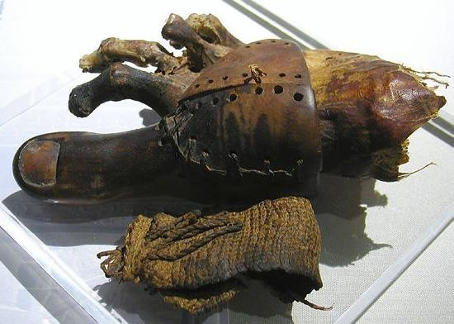
Figure 1 Prosthetic leather found on a mummy

    - Mechanical/Body Control Prostheses -
Body-powered prosthetics, controlled via harnesses linked to the user, typically comprise straightforward mechanisms like mechanical hooks activated by elbow or shoulder movements. Despite their simplicity, these devices remain prevalent today.
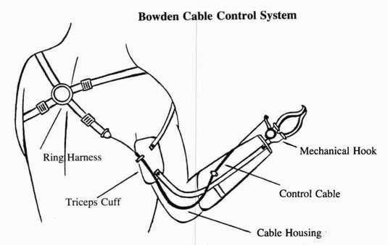
Figure 2 Body Powered Hook
    - Myoelectric Controlled Prostheses
Myoelectric prostheses harness electromyography (EMG) signals generated by muscle contractions near the residual limb. These signals, detected via electrodes on the skin or embedded within muscles, are amplified and transmitted to a microcontroller for analysis, offering enhanced control compared to mechanical counterparts.

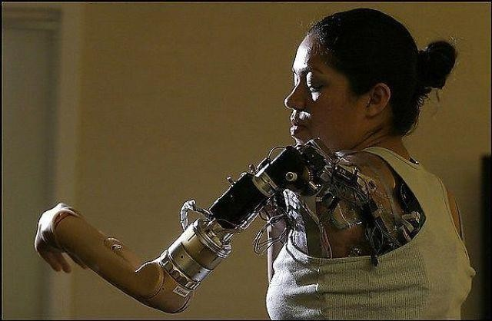

Figure 3 Advanced DARPA Myoelectric prosthetic arm

    - Direct Brain Interface
At the forefront of innovation lies direct brain neural interfaces, wherein electrode arrays placed on the brain's surface enable users to control robotic arms through their

thoughts. Although nascent, this technology has shown promise in empowering disabled individuals to operate bionic devices through mental commands alone.
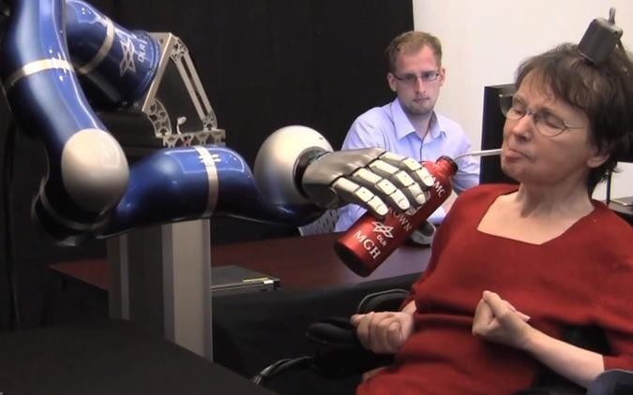

Figure 4 Direct brain connection

Problem Definition

The endeavor to develop a functional prosthetic arm presents myriad design and manufacturing challenges. Notably, this work spans multiple engineering disciplines, necessitating comprehensive discourse to integrate various aspects into a cohesive, functional system.

Major areas addressed are:
    - Physical Design: The intricacy of mechanical and electrical systems dictates the arm's resemblance to the human limb and its dexterity.
    - Control Scheme: Optimal control mechanisms prioritize ease and naturalness of operation, ensuring practical utility for users.
    - Practicality: The device must offer tangible benefits to amputees, emphasizing usability and functional efficacy.
    - Affordability: Material costs are kept minimal, with a target substantially lower than that of commercial myoelectric prosthetic arms.
    - Each challenge, particularly in physical design and control systems, will be thoroughly examined throughout this thesis.

Our mission is to empower individuals with limb loss by restoring maximal functionality through the development of an innovative prosthetic arm. With the ultimate aspiration of achieving a perfect limb replacement, our project aims to harness cutting-edge technology to create a prosthetic solution that seamlessly integrates with the user's body and daily activities. Leveraging modern advancements in 3D printing technology, we endeavour to overcome traditional limitations and deliver a prosthetic arm that not only meets but exceeds the expectations of our users.

Central to our approach is the utilization of 3D printing technology, which offers unparalleled advantages in terms of rapid prototyping and customization. Unlike conventional manufacturing methods, 3D printing allows for the fabrication of intricate mechanical components with precision and efficiency, making it the ideal choice for our project's timeframe and objectives. By harnessing the capabilities of 3D printing, we can explore innovative design concepts and iterate quickly to refine our prototype, ensuring optimal performance and usability.
In designing our prosthetic arm, we prioritize functionality, comfort, and user control. Our goal is to create a device that seamlessly integrates into the user's daily life, providing natural and intuitive movement through muscular contractions detected via surface electrodes. By enabling users to control the prosthetic arm with their own muscle signals, we aim to restore a sense of autonomy and independence, empowering individuals to perform tasks with confidence and ease.
When it comes to actuation, we have carefully considered two main approaches:
    - Implementation of an Artificial Tendon Network: Inspired by the natural tendon system found in the human body, this approach offers a cost-effective and straightforward solution for controlling finger movements. By simulating the function of tendons through mechanical linkages, we can achieve precise and responsive articulation of the prosthetic fingers. This approach is commonly used in robotic hands and provides a practical and efficient method for achieving lifelike movement.
    - Design of a Rigid Joint-Linked System: While prevalent in commercial prosthetic arms, this approach presents challenges when applied to 3D printing. Creating intricate gear linkage systems from fragile components poses durability and functionality concerns with 3D printing technology. As such, we have determined that this approach is not suitable for our project objectives and timeframe.
Throughout the development process, we remain committed to upholding the highest standards of safety, reliability, and user satisfaction. We conduct rigorous testing and validation to ensure that our prosthetic arm meets or exceeds industry standards and regulatory requirements. Additionally, we actively seek feedback from users, healthcare professionals, and experts in the field to inform iterative improvements and refinements to our design.
In conclusion, our project represents a pioneering effort to revolutionize prosthetic technology and improve the quality of life for individuals with limb loss. Through the integration of advanced 3D printing technology, innovative design concepts, and user-centered approaches, we aim to deliver a prosthetic arm that not only restores functionality but also inspires confidence and independence in its users. By pushing the boundaries of what is possible, we strive to make a meaningful and lasting impact on the lives of individuals with limb loss around the world.

Chapter 2: Need Analysis

: Design of survey form

A comprehensive design survey was undertaken to solicit input from a diverse array of participants regarding the desirable features for a myoelectric arm. Subsequently, a thorough analysis was conducted on the accumulated dataset, comprising 273 responses, to extract meaningful insights and inform the design process.
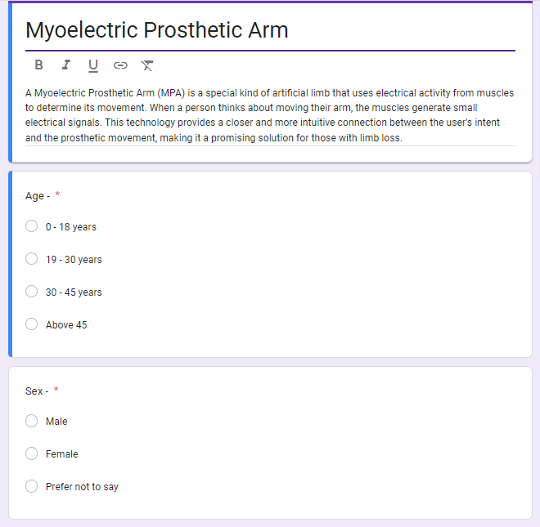
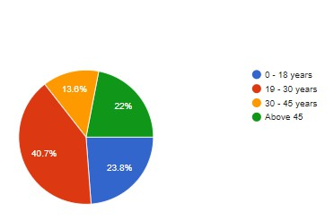
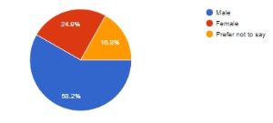
Figure 5: Survey form and responses (a)

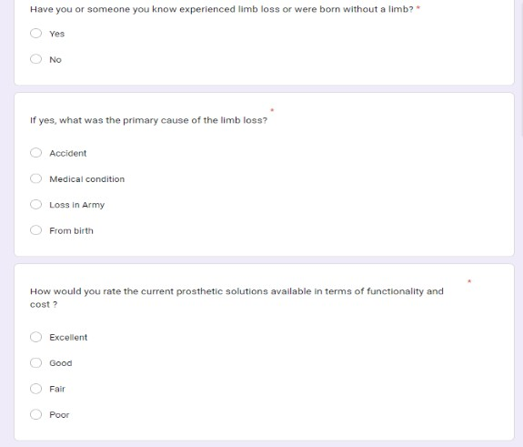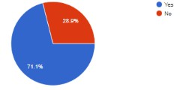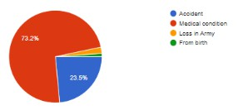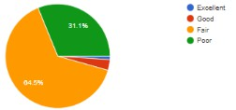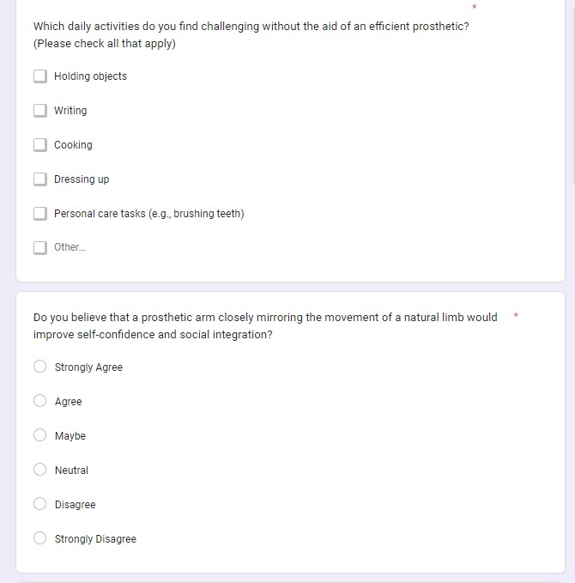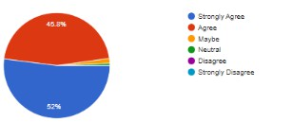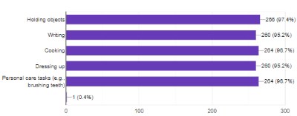

Figure 6: Survey form and responses(b)

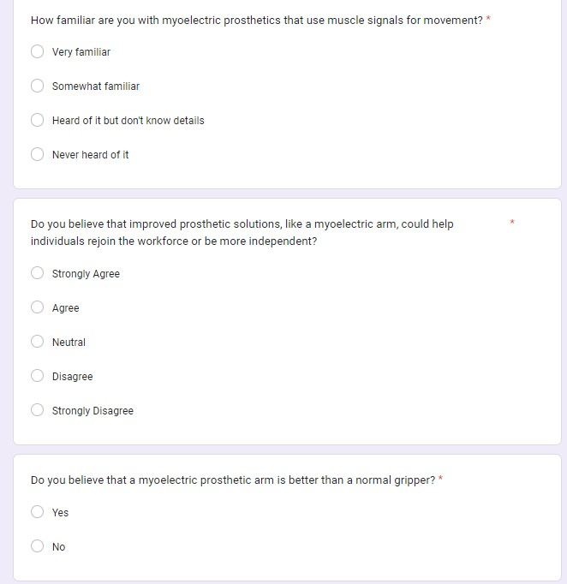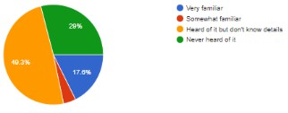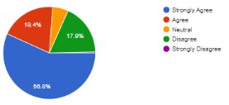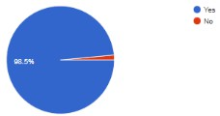

Figure 7: Survey form and responses(c)

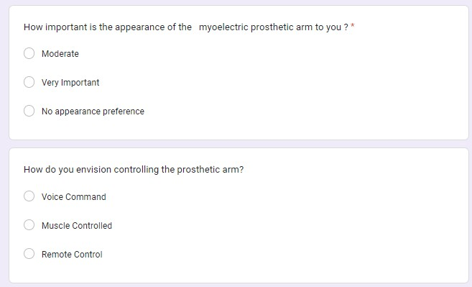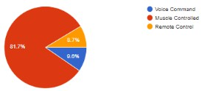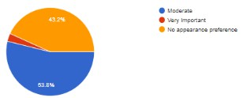

Figure 8: Survey form and responses(d)

Customer requirements based on surveys from the customers
Based on the feedback gathered from our Google Form, we have identified several pivotal requirements that are of utmost importance to our customers. These requirements include:

    - Should be able to hold or assisting in holding everyday essential items
    - Should have the aesthetics of a normal human hand
    - Should be able to balance approximately 500gms of weight
    - Should be controlled by muscles of the human arm
    - Should have a decent battery life of 4-5 hours

Design constraints and the “must have” and “may have” criteria
In this section, we delve into the critical aspect of design constraints and criteria, which serve as guiding principles in shaping the development of our prosthetic arm prototype.

Customer Requirements Integration: The foundation of our design constraints is rooted in the comprehensive understanding of customer requirements obtained through surveys and feedback. By synthesizing and analyzing the collected information, we gain valuable insights into the specific needs, preferences, and challenges faced by users of prosthetic arms.

Must-Have Criteria: These represent the non-negotiable aspects of our design, essential for meeting the fundamental needs and expectations of users. These criteria are derived directly from customer requirements and serve as the cornerstone of our design process

May-Have Criteria: In addition to the must-have criteria, we also consider the inclusion of features and functionalities that enhance the user experience and satisfaction. These criteria, while not essential, contribute to the overall effectiveness and appeal of the prosthetic arm prototype. Examples may include advanced customization options, aesthetic appeal, and compatibility with smart devices.

Functional and Performance Standards: Our design constraints also encompass adherence to established functional and performance standards governing prosthetic devices. Compliance with industry regulations and standards ensures the safety, reliability, and effectiveness of our prototype in real-world applications.

Material and Manufacturing Constraints: Another crucial aspect of our design constraints relates to the selection of materials and manufacturing processes. Factors such as biocompatibility, durability, and cost-effectiveness guide our choices, ensuring the optimal balance between performance and feasibility.

Usability and Accessibility: Design constraints also address usability and accessibility considerations, ensuring that the prosthetic arm is intuitive to use and accessible to users of diverse abilities. Features such as adjustable fit, easy maintenance, and compatibility with assistive technologies are prioritized to enhance usability and inclusivity.

Integration of Feedback and Iterative Refinement: Throughout the design process, feedback from stakeholders and iterative refinement play a pivotal role in shaping and updating design constraints. By soliciting input from users, healthcare professionals, and experts in the field, we ensure that our design constraints remain relevant, responsive, and aligned with evolving needs and expectations.

Table 1 MAY//MUST have features

Must have | May have
5-6 hours battery life | Pressure sensor feedback
Fast response time of less than 1 sec | Haptics
Lift a total weight of 500gms | Customization option
Aesthetically pleasing | Compatible with smart devices

Chapter 3: Literature Survey

Relevant research
    - Modern Prosthetic Arms Various commercially available robotic arms, such as the Bebionic 3 and iLimb, offer myoelectric control and are accessible to the public. In contrast, research laboratories worldwide are continuously developing prototypes of prosthetic arms to explore cutting-edge designs and concepts. These research prosthetics typically feature advanced mechanical designs and sophisticated control and monitoring systems. However, they often fall short in practicality, affordability, and durability compared to their commercially available counterparts.

    - The Human Hand The human hand is a complex structure composed of approximately 27 bones (the exact number can vary among individuals), over 30 individual muscles, and more than 100 named ligaments, nerves, and arteries [3]. Prosthetic devices strive to emulate the capabilities of the human body and restore functionality to individuals with missing limbs. However, none of the prosthetic solutions currently available can fully replicate the intricate dexterity, flexibility, and fluidity exhibited by the human hand.

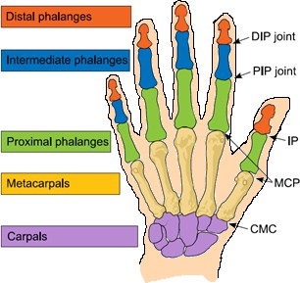
Figure 9 Major bones in human hand

Before any further discussion, briefly explain the meaning of a degree of freedom (DOF) for a reader with a non-engineering background

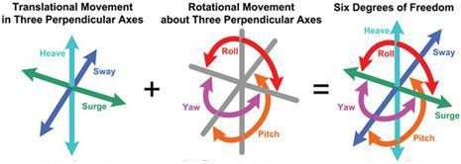

Figure 10 Degree of freedom at single point

Looking at the above image, imagine a point in space. From this point we can translate (move) along 3 different axes, i.e. we can move forward/backward, up/down and left and right. At the same point we can also rotate around 3 different axes. The human neck for example has 3 degrees of rotational freedom – we can look left/right, up/down and tilt our head sideways. So in total a single point can have a maximum of 6 degrees of freedom (3 translational, 3 rotational) The human finger in total has 4 degrees of freedom. Three of these are the rotations of each joint (DIP, PIP, MCP) which combine to control flexion and extension of the finger. The knuckle (MCP joint) also allows for abduction/adduction (wiggling the finger from side to side).

2.3 Capabilities of Prosthetic hands
Dexterity in the human hand stems from its numerous degrees of freedom. The precise control individuals exert over each finger joint enables them to perform a wide range of intricate tasks. In contrast, commercial prosthetic devices often lack this level of fine control, limiting them to simpler activities. For instance, tasks such as knitting, sewing, or playing musical instruments like the guitar would prove exceedingly challenging, if not impossible, with modern commercial prosthetics
Another crucial consideration in the design of commercial prostheses is durability. The typical user wears a myoelectric prosthetic hand for more than 8 hours daily . As such, commercially available prosthetic arms must be sturdy, lightweight, and integrated into a closed system that can be easily attached to an amputee. The mechanical complexity of these devices dictates the degrees of freedom they offer. However, there's often a trade-off, as increased complexity can

result in larger device sizes and decreased robustness and durability. The capabilities of a prosthetic hand have evolved significantly in recent years, thanks to advancements in technology and materials. Modern prosthetic hands are designed to closely mimic the natural movements and functionality of a biological hand, empowering individuals with limb loss to perform a wide range of tasks with confidence and ease. Here are some of the key capabilities of today's prosthetic hands:

- Dexterity and Precision: Prosthetic hands are equipped with multiple articulating joints and fingers, allowing for a high degree of dexterity and precision. Users can perform intricate tasks such as grasping small objects, typing on a keyboard, and manipulating tools with remarkable accuracy.
- Grip Strength: Many prosthetic hands feature adjustable grip strength settings, enabling users to exert varying levels of force when grasping objects. This versatility allows users to handle delicate items with care or exert more force when needed for tasks requiring strength.
- Customization: Prosthetic hands can be customized to meet the unique needs and preferences of individual users. From the size and shape of the fingers to the color and texture of the covering material, customization options allow users to personalize their prosthetic hands to suit their aesthetic preferences and functional requirements.
- Intuitive Control: Advances in myoelectric technology enable prosthetic hands to be controlled through muscular contractions detected via surface electrodes placed on the skin. This intuitive control mechanism allows users to manipulate their prosthetic hands with natural, intuitive movements, enhancing their sense of agency and control.
- Multi-Functional: Many modern prosthetic hands are designed to be multi-functional, capable of performing a wide range of tasks encountered in daily life. Users can switch between different grip patterns, such as pinch grip, power grip, and precision grip, to adapt to various activities and environments.
- Feedback Mechanisms: Some prosthetic hands are equipped with sensory feedback mechanisms that provide users with tactile sensations, such as pressure or temperature, when grasping objects. This feedback helps users better understand their environment and improve their ability to interact with objects.
- Durability and Reliability: Prosthetic hands are engineered to withstand the rigors of daily use, offering durability and reliability even in challenging conditions. High-

quality materials and robust construction ensure that prosthetic hands remain functional and dependable over time.
- Waterproof and Dustproof: Many prosthetic hands are designed to be waterproof and dustproof, allowing users to wear them in various environments, including wet or dusty conditions. This versatility ensures that users can maintain their independence and functionality in a wide range of situations.

Product survey
    - Bebionic 3
The Bebionic 3 stands out as a leading commercial myoelectric arm globally. Similar to its counterparts, it employs a predetermined grip system. Through muscle activity in the upper forearm, users can choose from a selection of 14 distinct grip patterns [5]. However, users don't have direct control over individual finger movements. Instead, they can choose a grip pattern and then use muscle activity to trigger the movements associated with that particular grip. Four of the fourteen grips of the Bebionic 3 are shown below.

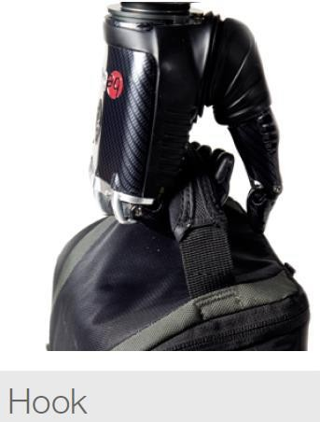
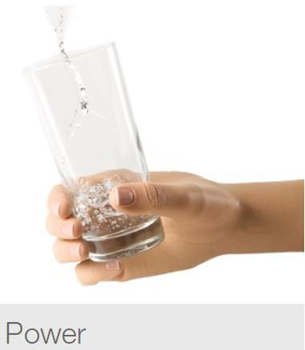
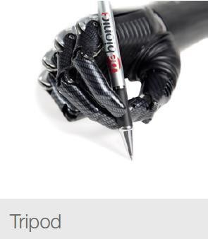
Figure 11 Various grips by bebionic 3

The problem with a predefined grip system is that the user cannot finely control finger positions in order to grip a specific object or complete a task. Rather, a user must choose a grip pattern that best suits the job at hand and then actuature that grip pattern.

Furthermore, the user must cycle through a number of grip patterns before they get to their desired choice. For example, unzipping a bag, picking up a heavy object, placing it in that bag and then zipping the bag up could require a number of grip changes. As a result certain simple tasks like this could actually take quite some time to complete and can become tedious and frustrating.
    - iLimb digits
A significant challenge in prosthetic arm development stems from the fact that amputation can occur at any point along the arm, with each case being unique. For instance, the Bebionic 3 arm, which we discussed earlier, utilizes electric motors within the palm to control the fingers. Consequently, individuals who have lost several fingers while retaining their palm would find the Bebionic arm unsuitable. However, the iLimb digits, developed by Touch Bionics, address this issue by integrating electric motors directly into the prosthetic fingers. This design allows the palm area to fit into a socket connection, attaching the prosthetic fingers to the hand. The diagram below illustrates potential amputation scenarios where the iLimb digits would be suitable for use.

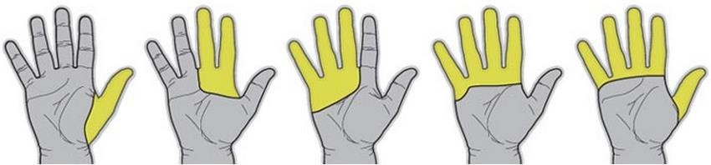

Figure 12 Examples of amputations suitable for the iLimb Digits

Like the Bebionic 3, the iLimb digits are controlled through EMG electrodes, which are placed over muscle regions in the palm. A small package must be worn around the user’s wrist which contains the battery and controller for the system A disadvantage of this system is that relatively small motors have to be used to be able to fit inside the fingers. This leads to digits which move slower and are weaker than those in other commercial prostheses.

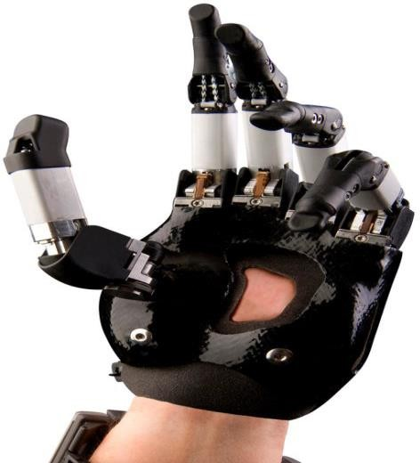

Figure 13 iLimb Digits attached to an amputee four fingers and the thumb but palm still intact

Patent Survey
    - Under-actuated prosthetic hand capable of reproducing hand grasping function Publication Date: 2015-03-04
Patent no- CN104382674A
By- HUAZHONG UNIV OF SCI & TECH
The invention discloses an under-actuated prosthetic hand capable of reproducing a hand grasping function; the under-actuated prosthetic hand is provided with an interphalangeal drive mechanism and a thumb drive mechanism in a palm; finger bodies take pulleys as main parts, and transmission mechanisms arranged in fingers are sequentially and alternately wound on all the pulleys of the fingers by steel wire ropes; joints in the fingers are in flexible coupling by elastic components; the interphalangeal drive mechanism adopts two motors to drive four fingers and multiple degrees of freedom of the fingers in a synergetic way; a thumb body takes a pulley as a main part, the transmission mechanisms in the finger bodies take transmission ropes as transmission mediums, the interphalangeal drive mechanism adopts a gear component for transmission matching, and the four degrees of freedom of the thumb can be controlled by two motors.

    - Multi-Grasp Prosthetic Hand Publication Date: 2017-02-23

Patent no- US20170049583A1 By- YALE UNIV
The present invention provides a prosthetic hand capable of multiple grasp types. The prosthetic finger units are underactuated both within and between the finger units using a differential mechanism arrangement. The locking movement of the prosthetic thumb unit is coupled to the differential mechanism. As the user repositions the prosthetic thumb unit, the differential mechanism is affected as to alter both the initial positions and force distribution of the prosthetic finger units. The present invention further provides an additive manufacturing molding method for making the same.

  - Research Summary
Shortcomings in modern prosthetic arms include limitations in dexterity and fine motor control, particularly in comparison to the human hand. Commercial prosthetics often struggle with replicating the intricate movements of individual fingers, hindering tasks requiring precision such as playing musical instruments or typing. Additionally, the design of prosthetic arms may not accommodate the varying degrees of amputation, leading to limited functionality for users with non-standard amputations. Durability is another concern, as prosthetic arms must withstand daily wear and tear, yet mechanical complexity can sometimes compromise robustness. Finally, cost remains a significant barrier, with advanced prosthetic technologies often inaccessible to those who need them due to their high price.
Scope of improvement of our proposed project can potentially offer-
- The fingers and arm components of the prosthetic were manufactured using 3D printing technology, ensuring precision and customization.
- Streamlined manufacturing processes were employed to optimize production efficiency and reduce lead times.
- Design considerations were made to facilitate easy assembly of the prosthetic arm, with components designed to seamlessly fit together.
- Screw and hinge mechanisms were integrated into the design, allowing for straightforward assembly and disassembly of the prosthetic arm.
- The modular design approach enables flexibility in customization and maintenance, as components can be easily replaced or upgraded as needed.

- Emphasis was placed on user-friendliness and accessibility, with intuitive assembly features to enhance usability for both users and technicians.

Chapter 4 – Design Concepts
  - Mechanical Design
To create a useful myoelectric prosthesis, it is necessary to have a well-designed mechanical system which mimics the functionality of the human arm as best as possible. Among many other things mechanical design involves how joints are actuated and the types of forces present in the system. The bionic arm design presented in this section can be entirely manufactured with a 3D printer and basic tools.

Early Ideas & Concept Drawings
After researching several actuation methods for prosthetic arms an artificial tendon design was chosen. The tendons can be any high strength line which does not stretch when tensioned. These lines connect to the fingers and are tensioned by motors in the forearm. Pulling on the tendons cause the fingers to open and close.
The electric motors driving these tendons must be completely housed inside the device in order to make it portable and attachable to an amputee. Ideally, we would like these motors placed as closely to the fingers as possible, however due to their relatively large size we cannot house the motors used inside the palm section. Instead, the motors housed within the forearm.
Shown on the following page are some early concept sketches outlining several key starting ideas.

    - Gripper Design
      - A normal mechanical gripper, used mainly to pick and place objects only.
      - Strong, as well as durable as it is easy to maintain.
      - The gripper should be capable of adaptive grasping to accommodate a variety of object shapes and sizes.
      - Implement a mechanism that allows the gripper to adjust its grip based on the object's dimensions
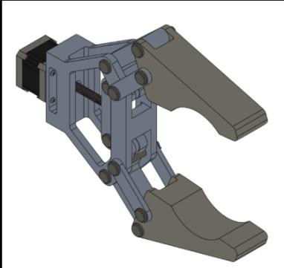
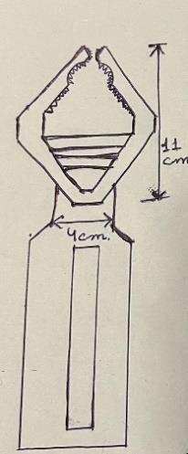
Figure 14 Gripper design

    - 3-finger hand design
      - Adaptive Grasping: Three-finger design enables adaptive grasping, accommodating a variety of object shapes and sizes.
      - Natural Articulation: Mimics the natural articulation of the human hand, providing lifelike movements and gestures.
      - Customizable Grip Patterns: Allows users to customize grip patterns for different tasks and preferences.
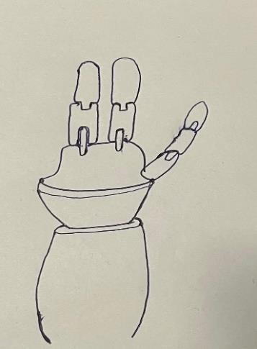
Figure 15 3-finger hand design

    - Hand design
      - Intuitive Myoelectric Control: Responsive control system utilizing muscle signals for natural and intuitive movement.
      - Multi-Grip Functionality: Supports multiple grip patterns, enhancing versatility for various daily tasks.
      - Precision Grasping: Enables precise object manipulation with fine motor control for delicate tasks.
      - Cosmetically Appealing: Aesthetic design with cosmetic options for a visually appealing and confidence-boosting appearance.

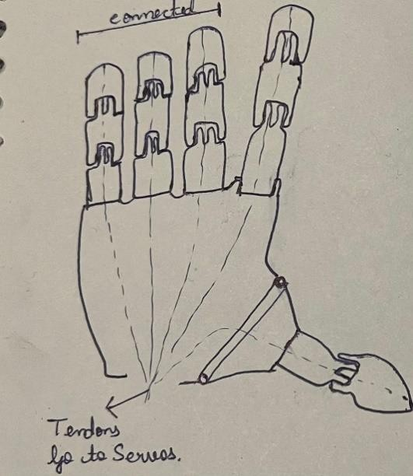
Figure 16 Hand Design

4.4 Weighted Matrix Analysis

Table 2 Weighted Matrix Analysis
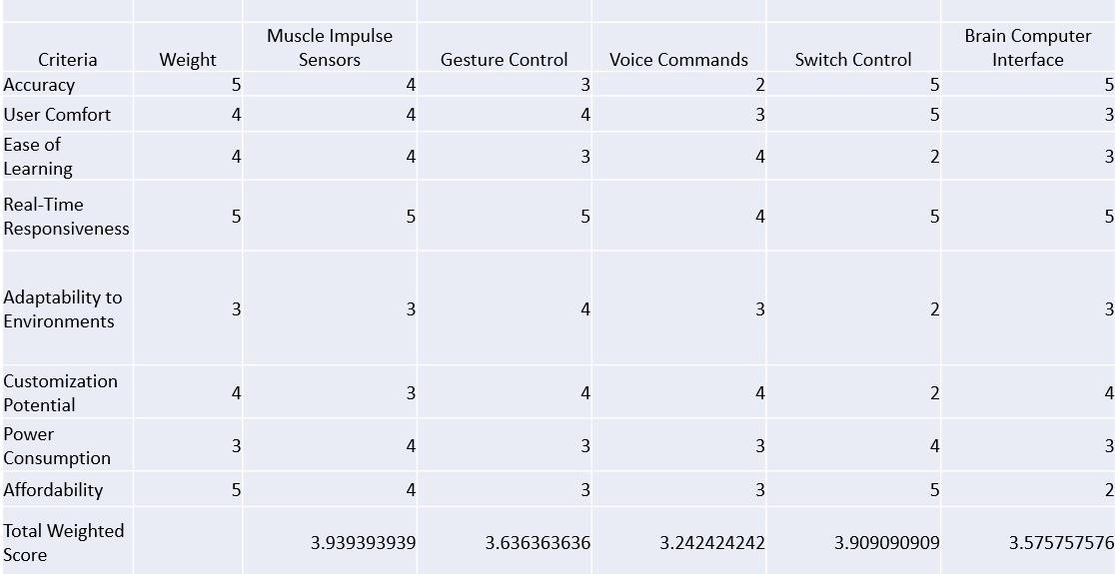

It is a table that shows average scores of different criteria for various assistive technology interfaces. The criteria include accuracy, user comfort, ease of learning, real-time responsiveness, adaptability to environments, customization potential, power consumption, and affordability. Each criterion is weighted, with a weight of 5 being the most important and 1 being the least important. The table shows that brain computer interfaces scored the highest (3.94) while gesture control scored the lowest (3.24).
Here is a breakdown of the table by category:
- Accuracy: Brain computer interfaces and switch control interfaces scored the highest (5) in accuracy.
- User Comfort: Both brain computer interfaces and switch control interfaces scored the highest (5) in user comfort.
- Ease of Learning: Muscle impulse interfaces and gesture control interfaces scored the highest (4) in ease of learning.
- Real-Time Responsiveness: Brain computer interfaces, switch control interfaces, and muscle impulse interfaces all scored the highest (5) for real-time responsiveness.
- Adaptability to Environments: Gesture control interfaces scored the highest
(4) in adaptability to environments.
- Customization Potential: Brain computer interfaces and switch control interfaces tied for the highest score (4) in customization potential.
- Power Consumption: Brain computer interfaces and switch control interfaces tied for the lowest score (4) in power consumption.

- Affordability is weighted most heavily and switch control interfaces scored the highest (5) while brain computer interfaces scored the lowest (2).
Overall, switch control interfaces scored the highest (3.91) followed by brain computer interfaces (3.58) based on the weighted criteria.

4.5 Development of Morphological Table

Table 3 Morphological Table
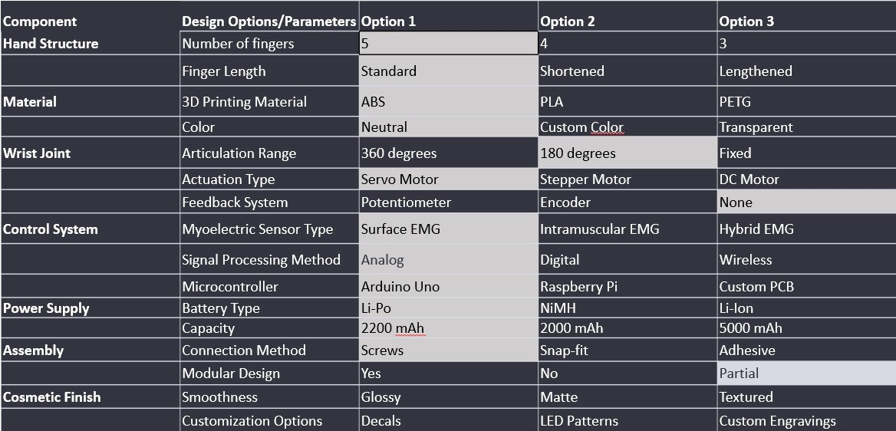

It is a table that compares three different designs for prosthetic hands. Let's go through each section of the table:

Hand Structure
- This section refers to the number and length of fingers on the prosthetic hand. There are three options:
  - Option 1: A hand with five fingers of standard length
  - Option 2: A hand with four fingers of shortened length
  - Option 3: A hand with three fingers of lengthened length
Material
- This section specifies the material used to 3D print the hand. There are three options:
  - Option 1: ABS (acrylonitrile butadiene styrene) - a common and versatile thermoplastic
  - Option 2: PLA (polylactic acid) - a biodegradable and biocompatible thermoplastic derived from renewable resources
  - Option 3: PETG (polyethylene terephthalate glycol) - a durable and chemical-resistant thermoplastic

Wrist Joint
- This section details the wrist joint's range of articulation and actuation type. Actuation refers to the mechanism that creates movement. There are three options:
  - Option 1: A wrist joint with 360 degrees of rotation actuated by a servo motor. Servo motors are ideal for precise positioning.
  - Option 2: A wrist joint with 180 degrees of rotation actuated by a stepper motor. Stepper motors are good for controlled, incremental movements.
  - Option 3: A fixed wrist joint with no motor
- The table also details the feedback system, which refers to how the prosthetic hand transmits information about its position and movement back to the user. There are three options:
  - Option 1: A potentiometer, which is a variable resistor that translates rotary position into electrical signal.
  - Option 2: An encoder, which is a rotary sensor that translates shaft position or rotation into digital or analog signals.
  - Option 3: No feedback system Control System
- This section refers to the type of myoelectric sensor, signal processing method, microcontroller, and power supply used in the prosthetic hand. Myoelectric control uses electrical signals generated by muscle contractions to control the prosthetic limb.
- There are three options for the type of myoelectric sensor:
  - Option 1: Surface EMG (electromyography) - electrodes placed on the surface of the skin to detect muscle signals.
  - Option 2: Intramuscular EMG - electrodes implanted into the muscle to detect muscle signals.
  - Option 3: Hybrid EMG - a combination of surface and intramuscular electrodes.
- Signal processing refers to how the electrical signals from the muscles are converted into usable control signals for the prosthetic hand. There are three options:
  - Option 1: Analog signal processing - converting the EMG signal into a continuous electrical signal.
  - Option 2: Digital signal processing - converting the EMG signal into a series of discrete digital codes.
  - Option 3: Wireless signal processing - transmitting the EMG signal wirelessly to a separate controller.
- The microcontroller is a small computer that controls the prosthetic hand based on the signals it receives. There are three options:
  - Option 1: Arduino Uno - a popular open-source microcontroller board
  - Option 2: Raspberry Pi - a credit card-sized computer that can be used for general-purpose computing
  - Option 3: Custom PCB (printed circuit board) - a custom-designed circuit board for improved performance or miniaturization
- Finally, the power supply refers to the battery that provides power to the prosthetic hand. There are three options:
  - Option 1: Lithium-polymer (Li-Po) battery - lightweight and rechargeable battery with high energy density

Assembly
- Option 2: Nickel-metal hydride (NiMH) battery - rechargeable battery with good capacity and performance at low temperatures
- Option 3: Lithium-ion (Li-ion) battery - lightweight, rechargeable battery with high energy density

  - This section covers how the different parts of the prosthetic hand are assembled. There are three options:
    - Option 1: Using screws for a secure and permanent assembly
    - Option 2: Using snap-fit connections for easy assembly and disassembly without tools
    - Option 3: Using adhesive for a permanent but potentially less serviceable assembly
  - The table also mentions whether the prosthetic hand has a modular design. A modular design allows for easy swapping of components to customize the hand for different needs.
Cosmetic Finish
  - This section refers to the appearance of the prosthetic hand. There are three options for the smoothness of the finish:
    - Option 1: Glossy finish
    - Option 2: Matte finish
    - Option 3: Textured finish
  - The table also mentions that there are customization options available, such as decals, LED patterns.

Chapter 5: Detailed Design

Theoretical Design
Creating a functional myoelectric prosthesis requires a meticulously designed mechanical system that closely replicates the functions of the human arm. This includes aspects such as joint actuation and the forces at play within the system. The bionic arm design outlined in this segment can be completely fabricated using a 3D printer and simple tools, showcasing the accessibility and feasibility of the manufacturing process.

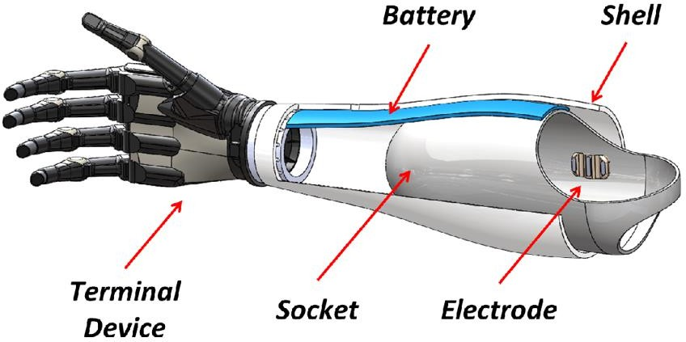

Computer Aided Design
SolidWorks is a computer-aided design (CAD) software package designed specifically for modeling solid mechanical components and assemblies. Widely utilized in the engineering industry, SolidWorks has gained significant popularity for its extensive capabilities in designing and analyzing mechanical components with precision and efficiency.

Fingers
Every finger comprises three separate printed components interconnected by polypropylene pins. A crucial feature is the artificial tendon looping around the inner tip of the finger, creating a locking point for the tendon.

This locking point plays a vital role: when the tendon is under tension, it pulls the finger's tip, initiating the rotation of all joints. To open the finger from a closed position, tension is applied to the opposite end of the tendon.
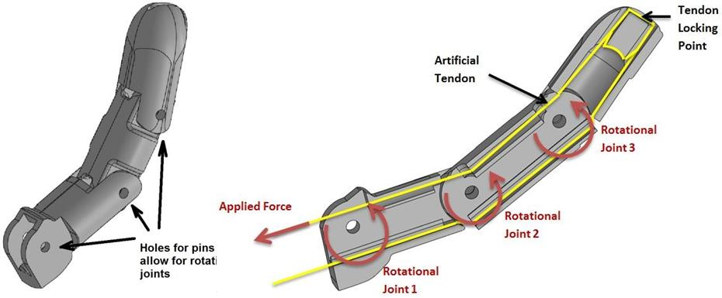
Figure 17 Finger Design

Thumb
The thumb is designed following a similar approach. While many commercial and research-based prosthetic hands typically offer a minimum of two degrees of freedom in the thumb, this particular design provides only a single degree of freedom. As a result, it can only perform a single open/close motion.
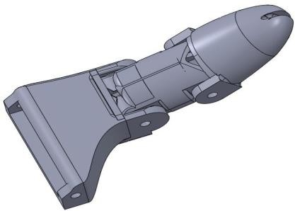

Figure 18 Thumb Design

Palm
Each finger is connected to the palm using small aluminium rods. The bottom of the palm incorporates part of wrist rotation.
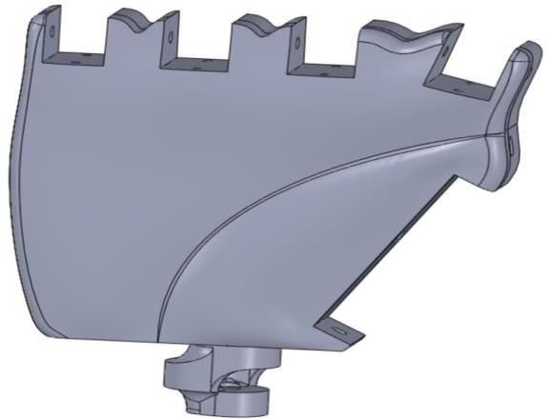

Wrist
Figure 19 Palm Design

A passage traversing the pivot point of this joint enables the tendons to move from the fingers through to the forearm. This setup permits ± 90 degrees of rotation around the wrist and resolves the challenge of angular position control.

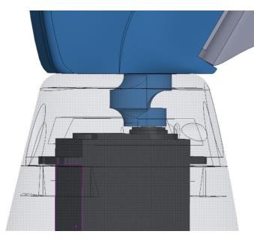
Figure 20 Wrist Adjustment

However, a significant challenge with this design lies in ensuring sufficient strength. To accommodate the tendons passing through as the wrist rotates through 180 degrees, a large opening

had to be incorporated around the base cylinder. This design choice, while facilitating tendon movement, concentrates stress around the small cross-sectional area near the base of the palm.

The hole allows the tendons to travel from the fingers down to the servos in the forearm. The wrist model depicted in the images on the previous page experienced a fracture during testing due to its weakness. The latest model, operating on the same principle, now includes additional material around the base to enhance component strength and prevent fractures at this critical juncture. Additionally, a small horizontal ridge around the outer edge of the small cylinder aids in transferring lateral loads to the outer shell of the forearm, enhancing overall stability.

- Drive System
The tendons are wrapped around custom 3D printed servo horns, forming a closed loop as depicted below. When the servo motor rotates in one direction, it exerts tension on the tendon, resulting in the closure of the finger. Conversely, rotating the motor in the opposite direction causes the finger to open.
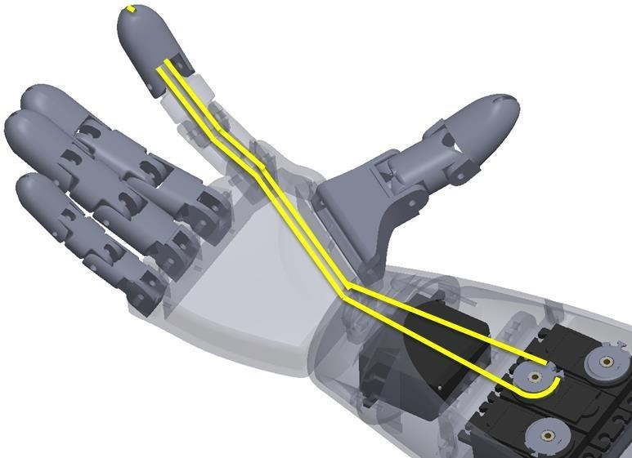
Figure 21 Finger and motor connection

The thumb, index and middle fingers are connected to individual servo motors. Because the interior space of the arm is limited the ring and pinky fingers have both been tied to the same servo, meaning they open and close in tandem.

- Forearm
Even though the forearm section doesn't contain any moving parts, its design remains quite challenging due to the need to accommodate five servo motors, a lithium polymer (LiPo) battery, and allow for assembly.
The complete forearm section had to undergo a design process that involved splitting it into separate components, which could then be assembled using screws. This approach was necessary because if the forearm were 3D printed as a single large component, there would be no feasible way to install and assemble the motors and tendons inside.

Since 3D printed ABS plastic can be relatively weak and prone to splitting when subjected to screw insertion, precautions were taken to minimize the risk of cracks. Guide holes for the screws were integrated into the design, and careful consideration was given to ensuring that there is sufficient material to provide strong support for the screws.

CAE Analysis
Force analysis was done on the all of the parts of the arm. Analysis was done using software called Solid works.

- Component Selection:
The critical components selected for FEA include the fingers, wrist joint, and any other components identified as prone to stress or failure during use.

- Constraints:
Fixed Constraints: The base of the prosthetic arm is fixed to simulate its attachment to the user's body, preventing any translation or rotation at this point.

Contact Constraints: Contact between different components of the prosthetic arm, such as between the fingers and the palm, is modeled to accurately capture interaction forces and prevent interference.

- Loads:
Grasping Loads: Simulated loads representing the forces exerted on the prosthetic hand when grasping objects of varying weights and shapes.
Static Loads: External forces applied to the prosthetic arm during everyday activities, such as lifting, pushing, or pulling objects.

- CAE Parameters:
Element Type: Linear tetrahedral elements are chosen for their balance between accuracy and computational efficiency.
Mesh Size: A finer mesh is employed in regions of high stress or deformation, ensuring accurate representation of critical areas while maintaining a reasonable computational cost.
Material Properties: Mechanical properties of PLA plastic, including modulus of elasticity, Poisson's ratio, and yield strength, are input into the software based on material testing or literature data.
Solver Settings: The FEA software's solver settings are configured to ensure convergence and accuracy of results within a reasonable computational time.
Boundary Conditions: Boundary conditions are carefully specified to accurately represent real-world constraints and loading conditions, ensuring realistic simulation results.

- Optimizer:
An optimization algorithm may be employed to improve the design of critical components by minimizing weight, maximizing strength, or optimizing other performance criteria.

By selecting appropriate parameters and conducting FEA with a thorough understanding of the prosthetic arm's mechanical behavior, we aim to identify potential failure modes, optimize design parameters, and ensure the safety and functionality of the device for users.

Stress Analysis –
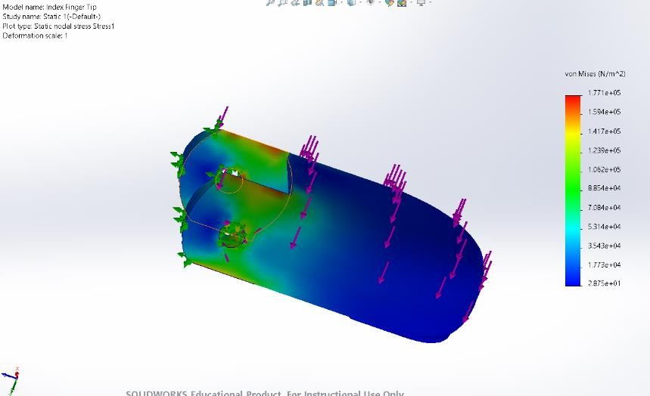
Figure 22 Index Finger Tip

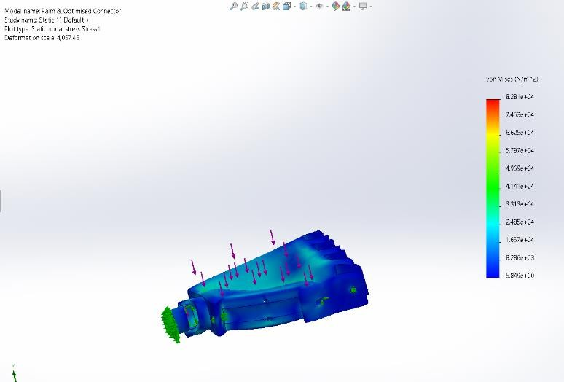
Figure 24 Palm

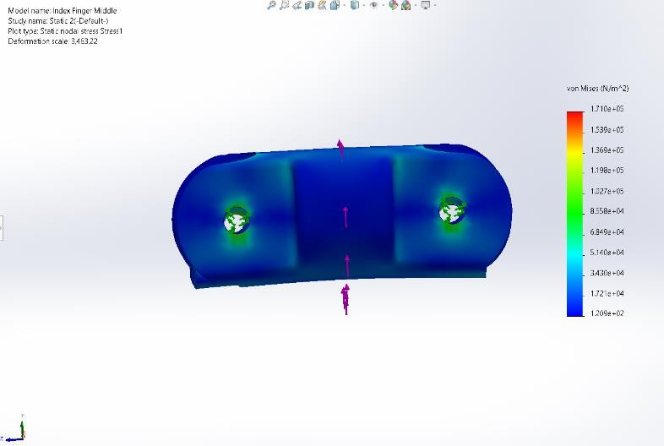
Figure 23 Index Finger Middle

Design Iteration and Optimization

Signal Flow Overview:
The signal flow overview begins with a user flexing, generating an analog signal. This signal is then amplified, rectified, and smoothed by the EMG sensor board. The microcontroller utilizes this analog signal to produce a pulse-width modulated signal. This signal drives the servo motors, which in turn tension the tendons, resulting in the curling up of the fingers.
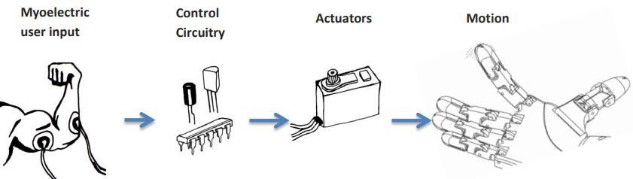
Figure 25 Signal Flow

Actuation
As mentioned earlier, the actuators employed in this system are standard servo motors. These motors can be directed to rotate to angular positions within a range of ± 90 degrees from their rest position. Given that the artificial tendons move minimally to open and close each finger, the angular accuracy of each servo motor impacts the precision of finger control to some extent. To keep costs low, relatively affordable servo motors were chosen for this system. Opting for higher-quality servos would undoubtedly enhance finger strength and precision but would also come with a substantial increase in cost.

Micro Controller
An Arduino Uno board has been utilized as the central computing unit for this system. While the Arduino Uno has certain computational limitations, it proves to be more than sufficient for the requirements of this design. To program the device, an appropriate debugger/programmer, such as the Pickit3, connects to the Arduino Uno circuitry. Data is then transferred to a PC via a USB connection for programming and debugging purposes.
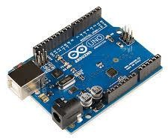

Electromyography Sensing
Single-channel EMG sensor boards, known for their user-friendly interface, have been employed to detect and quantify muscle activity. This kit includes a compact PCB and three surface electrodes. Two of these electrodes gauge the voltage potential across a muscle, while the third serves as a ground reference point positioned on a bony
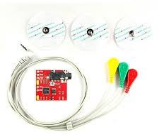
structure.

Single-channel EMG sensor boards, known for their user-friendly interface, have been employed to detect and quantify muscle activity. This kit comprises a compact PCB along with three surface electrodes.
Among these electrodes, two are dedicated to measuring the voltage potential across a muscle, while the third serves as a ground reference point positioned on a bony feature.

Power Supply
Ensuring portability and reliance on internal power sources is crucial for this system. While using a wall power supply is suitable for testing and debugging purposes, a prosthetic arm must be powered by a source that an amputee can conveniently carry.
Servo motors consume a considerable amount of current during operation. Using disposable batteries wouldn't be practical as they would drain power rapidly, necessitating frequent replacements. In contrast, Lithium Polymer (LiPo) batteries offer a high energy density and are rechargeable, making them an ideal choice.
However, there's a trade-off between battery life and size. Ideally, we aim for the arm to run for several hours without needing a recharge. Nevertheless, achieving this goal may require a larger battery size that could be challenging to house within the device. Finding the right balance between battery capacity and device size is crucial to ensure optimal functionality and user convenience.

The muscle sensor kits operate on minimal power consumption compared to the Servos and microcontroller, which demand a substantial amount of power. These kits necessitate two power sources to establish a positive and negative voltage reference. Due to their sensitivity to input voltage spikes, they rely on a stable power supply to produce high-quality signals.
To meet these requirements, the EMG sensing boards are powered by two separate 9V batteries. This setup ensures a reliable and consistent power supply, allowing the sensors to function optimally and generate accurate readings. Moreover, using disposable batteries ensures a prolonged operational lifespan, and when depleted, they can be easily replaced at a low cost.
Alternatively, a more advanced electrical system could integrate all components into a unified power source. Techniques could be implemented to generate a negative voltage specifically for the EMG sensors, streamlining the power supply system and reducing size, weight, and overall clutter. Such an approach would enhance the system's efficiency and convenience while maintaining reliability and performance.

Circuit Design
The following schematic outlines the circuitry of the system.

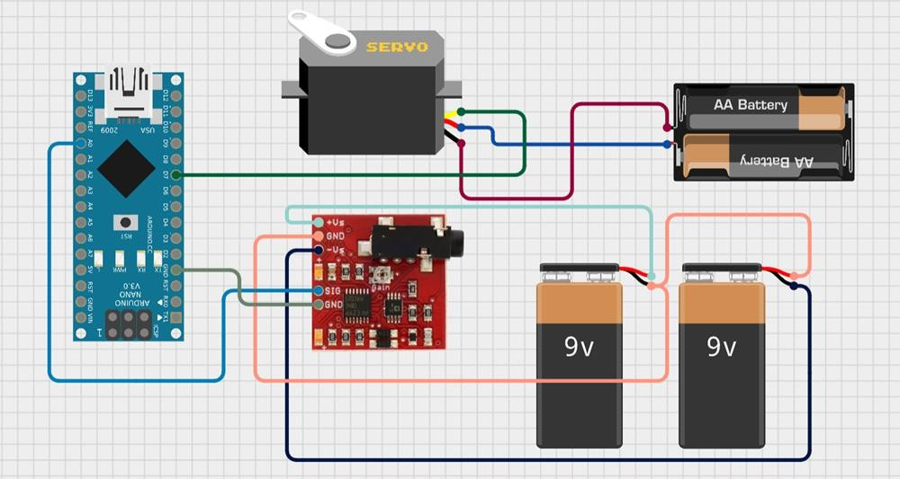
Figure 26 Circuit Design

Two separate sets of 9V batteries are utilized to power the EMG sensor and the servo motor, ensuring distinct power sources for each component. It's important to note that the circuit diagram provided here offers a simplified representation for clarity.
The EMG sensor, being sensitive to voltage fluctuations, benefits from a dedicated power supply to maintain stability and precision in signal processing. On the other hand, the servo motor requires a robust power source to drive its mechanical movements effectively.
This dual-battery setup not only optimizes performance by preventing interference between the EMG sensor and servo motor but also enhances overall system reliability. By providing independent power sources, potential issues such as voltage drops or spikes affecting one component's operation are mitigated, ensuring consistent and accurate functionality.

5.6 BOM
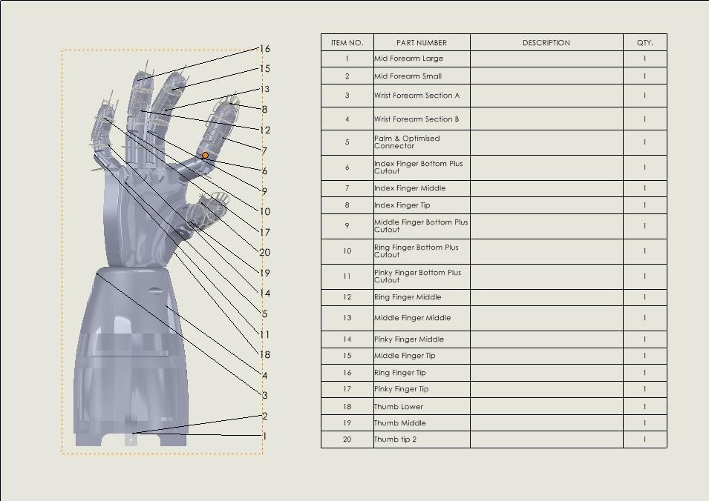
Figure 27 BOM of 3d Printed Parts

Chapter 6: Prototype development

Manufacturing Plan
In this pivotal phase of our project journey, the manufacturing plan for the prosthetic arm prototype is meticulously crafted, embodying a fusion of strategic decision-making, cost estimation, and meticulous material requirement planning.
Buy/Build Decision: The decision-making process regarding whether to procure pre-manufactured components or to embark on an in-house fabrication journey is an intricate dance between various factors. The considerations span across cost-effectiveness, time constraints, and the extent of customization required to align with the project's unique specifications. After a comprehensive analysis, a judicious decision was reached to opt for an in-house fabrication approach. This choice affords us unparalleled control over the manufacturing process, enabling us to tailor each component precisely to our design requirements.
Table 4 Buy and build decision
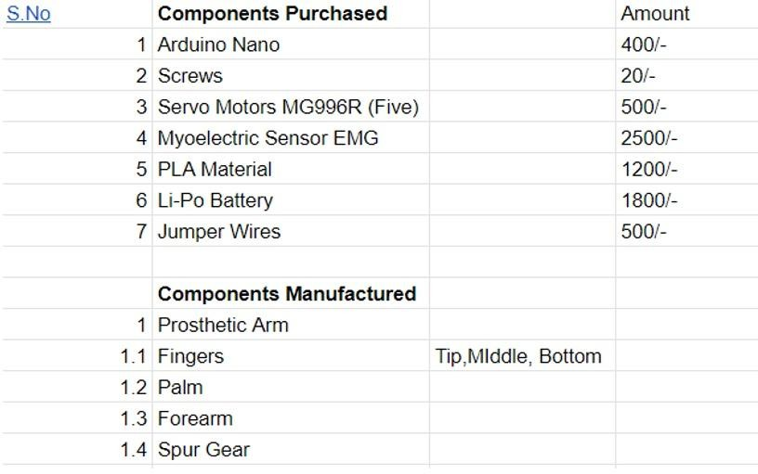

Here are the main components included in the BOM: Purchased components:
- Arduino Nano

- Screws
- Servo Motors MG996R (Five)
- Myoelectric Sensor EMG
- PLA Material
- Li-Po Battery
- Jumper Wires Manufactured components:
- Prosthetic Arm including
- Fingers (Tip, Middle, Bottom)
- Palm
- Forearm
- Spur Gear

Based on this information, the following points can be considered while developing a manufacturing plan:
Buy vs Build Decision
The BOM lists several components that need to be purchased including the Arduino Nano, servo motors, sensors, battery and basic materials like screws and jumper wires. These are commercially available components and purchasing them might be more economical than setting up manufacturing for small quantities.
On the other hand, the BOM also includes a prosthetic arm with parts like fingers, palm, forearm and spur gear. These components are listed as manufactured. This suggests that 3D printing or other manufacturing methods might be used to create a customized prosthetic arm.
Cost Estimation/Material Requirement Planning: A cornerstone of any manufacturing endeavor is a meticulous cost estimation and material requirement planning. The intricate dance between cost and quality, coupled with the judicious allocation of resources, sets the stage for the successful realization of our prototype. Through rigorous analysis and forecasting, we meticulously ascertain the financial outlay required for each component, ensuring that our endeavor remains within the bounds of fiscal prudence. Simultaneously, a detailed material requirement plan is meticulously crafted, delineating the precise materials needed for the fabrication process. This meticulous

planning ensures seamless procurement and availability of materials, preventing any disruptions in the manufacturing timeline.

Prototype Building
The process of fabricating and assembling the prototype of our prosthetic arm is a meticulous endeavor that involves a series of intricate steps. Each step is carefully executed to transform the conceptual design into a tangible reality, ensuring precision, functionality, and reliability.
Fabrication Steps:
Design Preparation: The journey commences with the meticulous preparation of Computer-Aided Design (CAD) files for the various components of the prosthetic arm. These CAD files serve as the blueprint for the entire manufacturing process, providing detailed specifications regarding dimensions, geometries, and structural integrity. Our team of skilled designers and engineers collaboratively refine and iterate upon the design, ensuring optimal performance and usability.
3D Printing: With the CAD files finalized, the focus shifts to the actual fabrication of the components using state-of-the-art 3D printing technology. Fused Deposition Modeling (FDM) emerges as the preferred technique due to its versatility, precision, and efficiency. Each component is meticulously crafted layer by layer, utilizing high-quality PLA filament as the primary printing material. PLA's favorable mechanical properties, affordability, and eco-friendliness make it an
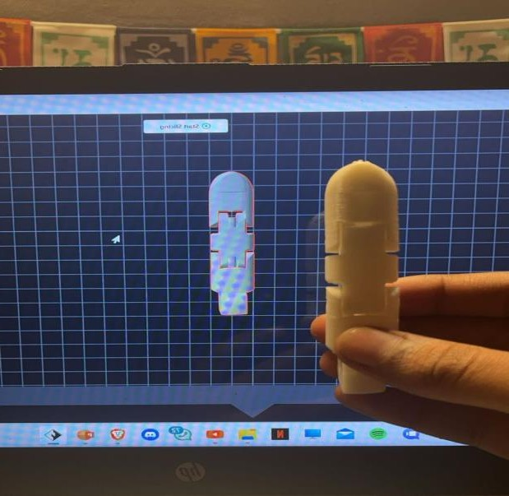
Figure 28 3d printing of parts

ideal choice for our prototype. The 3D printing process not only allows for the realization of intricate geometries but also facilitates rapid prototyping, enabling us to iterate and refine designs with unparalleled ease and agility.
Electronic Assembly: Concurrently, the electronic components essential for the functionality of the prosthetic arm are sourced, meticulously assembled, and integrated. This assembly process entails soldering, wiring, and integration of components such as servo motors, Arduino Uno microcontroller, EMG muscle sensor, and rechargeable LiPo battery. Each electronic module is carefully selected for its reliability, performance, and compatibility with our design specifications.Attention to detail is paramount as the electronic assembly forms the backbone of the prosthetic arm's control and operation.
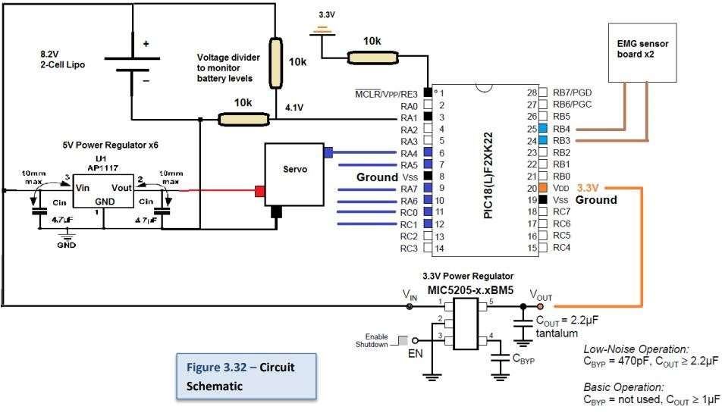

Figure 29 Circuit Schematic

Mechanical Assembly: As the 3D printed parts and electronic components near completion, the focus shifts to mechanical assembly, where the disparate elements converge to form the cohesive structure of the prosthetic arm. This phase involves fitting the printed components together, integrating the electronic modules into the assembly, and ensuring proper alignment and functionality of all parts. Meticulous attention is paid to detail, with every component meticulously inspected and calibrated to ensure seamless integration and optimal performance.

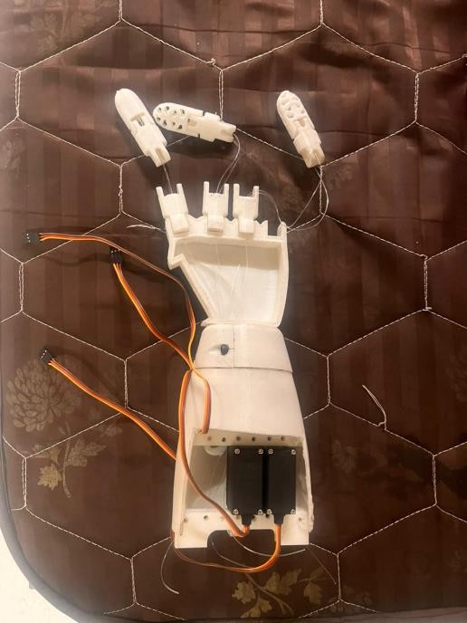
Figure 30 Assembly of arm

Quality Check: Throughout the fabrication process, stringent quality checks are conducted at every stage to uphold the highest standards of precision, functionality, and reliability. Visual inspection, dimensional measurements, functional testing, and iterative refinement are employed to identify and address any discrepancies or inconsistencies. Each component and assembly step undergoes meticulous scrutiny, with deviations promptly rectified to ensure adherence to design specifications and user requirements.
Continuous Improvement: Beyond the initial fabrication process, our commitment to excellence extends to ongoing refinement and optimization. Feedback from testing and user trials informs iterative improvements, allowing us to enhance functionality, usability, and performance iteratively. By embracing a culture of continuous improvement, we strive to deliver a prosthetic arm prototype that exceeds expectations and empowers users with unparalleled mobility and functionality.

Prototype Testing
The final system is a bionic arm offering six degrees of freedom and the ability to be controlled through myoelectric signals. The total design consists of thirty-six individual 3D

printed components.
Several features of the prosthetic arm have been tested and measured to improve the performance and characteristics of the system

    - System Specifications
The thumb, index and middle fingers each move independently and the ring finger and small finger move in tandem. The wrist allows for 180 degrees of rotation and the elbow allows for 110 degrees of bending. A user can control the motion of the arm through a set of EMG electrodes placed on their forearm and/or bicep. At this stage two electrode sets allow for rudimentary control of the arms range of motions. The device is completely portable and has a battery life of more than 3 hours

    - Component Strength

In our project, all components have been 3D printed using PLA plastic, a material renowned for its versatility and ease of use in the 3D printing process. PLA (Polylactic Acid) is a biodegradable thermoplastic derived from renewable resources such as cornstarch or sugarcane, making it an environmentally friendly choice for manufacturing.

One of the primary reasons for selecting PLA over ABS (Acrylonitrile Butadiene Styrene) is its lower melting point and favorable properties. While ABS is known for its toughness and impact resistance, PLA offers advantages such as minimal warping during printing and improved dimensional accuracy. This is particularly crucial for intricate components of the prosthetic arm, where precision and reliability are paramount.

Additionally, PLA is less brittle compared to ABS, making it better suited for applications where shock absorption is necessary. While ABS may be stronger in terms of impact resistance, PLA's superior dimensional stability and printing characteristics make it a more suitable choice for our project's requirements.

Despite the inherent weaknesses of 3D printed components, such as lower tensile strength compared to injection-molded counterparts, PLA offers sufficient mechanical properties for the prosthetic arm's intended use. To further enhance the strength and durability of PLA components, post-processing techniques such as acetone coating can be employed.

Acetone coating involves applying a thin layer of acetone to the surface of 3D printed PLA parts. This process helps to smooth out imperfections between layers and improve adhesion, resulting in stronger and more resilient components. Additionally, suspending components in an evaporating stream of acetone gas can further bond layers together and enhance the overall strength of the parts.

While PLA may not match the strength of ABS formed by injection molding, its benefits in terms of ease of printing, dimensional accuracy, and environmental sustainability make it a preferred choice for our project. By leveraging the unique properties of PLA and employing post-processing techniques, we can ensure that our prosthetic arm meets the necessary mechanical requirements while remaining cost-effective and accessible.

    - Fluidity
The fingers move in a relatively smooth and natural manner. The fluidity of finger movements are dependent on several factors including friction between moving plastic components, servo control and also how well the tendons are tensioned.
The middle finger opens and closes exceptionally well. The ring and small finger do not move as smoothly and do not completely close. This is because both ring and small finger tendons are tied to the same servo which has to work to move both fingers in tandem. Since the
small finger is a 0.8 scale of the ring finger it means its tendons do not have to move as far to open and close the finger. Neither tendon is actuated in an optimal manner which reduces
the fluidity of the ring and small fingers. Strength
Testing using small kitchen scales indicates the fingers can provide at least 300g of force each. Indeed, the servo motors could be rotated more to further increase the tension on the tendons. This would effectively increase the closing force of each finger. The limiting factor in finger force is not the torque of the servo motors but rather the strength of the printed ABS components. If we kept increasing the tension applied by the servos either a finger component would break or a fracture would occur at the wrist.
The only sure way of determining the absolute maximum finger force would be to test to destruction. Unfortunately tests to destruction could not be carried out – otherwise there would be no working system to present

    - Control
The basic Boolean EMG control allowed for different states to be cycled through and actuated. One state allowed for wrist rotation and another state allowed for finger actuation. It was possible to instruct the hand to close, rotate to a certain position, rotate back and then reopen. Such a movement could be used to grasp and pour a liquid from a bottle. However having to switch between the two states made the task slow and tedious

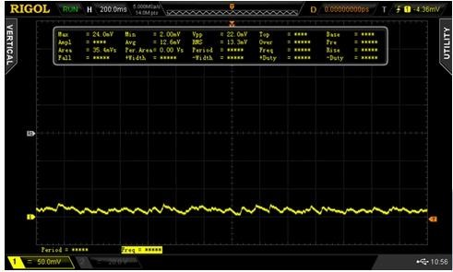
using this basic EMG control.
Figure 31 Light flex output

Proportional control of the fingers worked fairly well – the harder the user flexed the more the fingers would close. However, this proportional control caused the fingers to start shaking when trying to close – which was due to noisy signals being used to control servo positions.
Initially the EMG signals were sampled every 100ms converting the magnitude of the signal to a decimal value. The servos were also updated every 100ms.
As seen in the oscilloscope images on the next page the EMG signals are quite noisy. This means the signal voltage level can significantly jump or drop in 100ms which results in the servos being instructed to constantly move around to different positions. This is especially bad with high level signals.
As illustrated below the sampled points used for servo control are constantly shifting up and down. A smooth signal is desired which means some filtering should be done to these EMG outputs to improve control characteristics.
Increasing the time between ADC samples and servo updates slows down the shaking of the fingers but does not fix the problem.

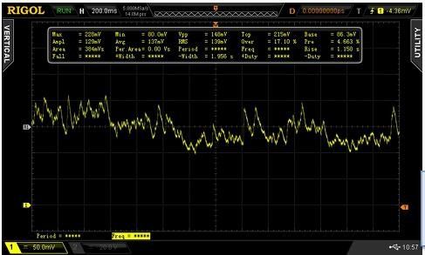
Figure 32 Strong flex output

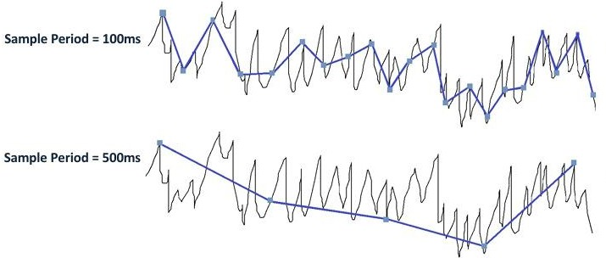

Figure 33 EMG signals(black) with ADC samples(blue).

Sample Period = 100ms Sample Period = 500ms
In order for proportional control to work we need an EMG signal that increases linearly with

flex intensity. To generate the screen shot below the user focused on starting at rest and gradually increasing flex intensity to a maximum and then releasing.
The magnitude of this signal seems to increase linearly with increasing flex intensity. This is required for accurate proportional control.
    - Battery Life
The LiPo battery being used is rated at 1600mAh. The maximum current the system can pull in any circumstance is around 3.1A. This corresponds to an extreme worst case battery life of roughly 30 minutes (1600mAh/3.1A). However, such a scenario would only happen if all the servo motors were continuously pulling at their maximum capacity – which would never happen for an extended amount of time.
A much more realistic estimate is an average current consumption of 75mA by each servo. Incorporating power requirements of the microcontroller and other electronics a reasonable estimate of 550mA required system power gives an estimate of just under 3 hours of battery life.
In practice the battery life is significantly longer lasting up to 6 hours. This is because the majority of the time the joints are at a rest position minimizing the power usage of the motors.

Reflection
During the fabrication of our prosthetic arm prototype, we encountered several challenges that required innovative solutions and thoughtful redesign. One significant issue we faced initially was the choice of printing material. We initially opted for ABS (Acrylonitrile Butadiene Styrene) due to its widespread use in 3D printing. However, we soon realized that ABS posed several limitations that impeded the quality and functionality of our prototype.

Problem: ABS proved to be unsuitable for our application due to its inadequate strength and lack of detail. Components printed with ABS exhibited a tendency to break under stress, compromising the structural integrity of the prosthetic arm. Additionally, ABS lacked the precision and accuracy required to reproduce intricate details, resulting in suboptimal performance and functionality.

Remedies/Redesign: To address these issues, we conducted thorough research and experimentation to identify a more suitable alternative. Our investigation led us to PLA (Polylactic Acid), a biodegradable thermoplastic known for its superior strength, precision, and printability. By switching to PLA, we were able to overcome the shortcomings associated with ABS and significantly enhance the quality and performance of our prototype.
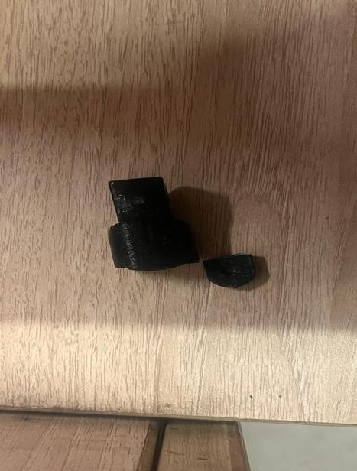
Figure 34 Broken finger

Superior Strength: PLA exhibited superior mechanical properties, providing the necessary strength and durability to withstand the rigors of daily use. Components printed with PLA demonstrated enhanced resilience and resistance to breakage, ensuring the longevity and reliability of the prosthetic arm.

Enhanced Precision: One of the most notable advantages of PLA was its exceptional precision and detail reproduction. The inherent properties of PLA facilitated the creation of intricate geometries and fine details with unparalleled accuracy, resulting in a prosthetic arm prototype of superior quality and functionality.

Improved Performance: With PLA as our printing material of choice, we observed a marked improvement in the overall performance and functionality of the prosthetic arm. The enhanced

strength, precision, and durability afforded by PLA translated into a more robust and reliable prototype, capable of meeting the diverse needs and requirements of users.

By recognizing the limitations of ABS and proactively seeking a viable alternative in PLA, we were able to overcome a significant obstacle in the fabrication process and propel our prototype development efforts forward. This experience underscored the importance of thorough material selection and informed decision-making in achieving optimal results in 3D printing applications. Through continuous learning, adaptation, and innovation, we remain committed to delivering a prosthetic arm prototype of uncompromising quality and functionality.

Chapter 7: Conclusion and Future Scope of work

Conclusion
Overall Performance of the project:
The prosthetic arm functions fully with an EMG sensor and Arduino Uno. All 3D printed parts are of remarkable quality and seamlessly interact with each other. The overall system delivers relatively good performance and possesses the qualities of a well-made 3D printed prosthetic arm. The major drawback of this project is its inability to control fingers individually. The EMG sensor used lacked the capacity to detect signals from individual fingers in the forearm. This limitation has been extensively discussed in the future scope of work.
In terms of aesthetics and build quality, the prosthetic arm has commendable features. All parts are seamlessly integrated and maneuver smoothly. It was designed with the concept of being the most affordable 3D printed prosthetic arm.
The project's objectives were initially unclear and underwent changes over time. The main goal was to develop a 3D-printed prosthetic arm. Our team worked diligently towards completing this task and is proud to announce that we have successfully achieved all of our objectives.

Future Scope of Work
The current iteration of the presented prosthetic arm falls short of being usable for amputees; instead, it primarily serves as an affordable bionic arm prototype. To bridge this gap, focusing on designing a customized socket connection is crucial. This customization could open doors for collaboration between the University and medical institutions, enabling thorough testing and real-world usage by amputees.
The potential collaboration with a medical institute holds significant promise. It could involve conducting comprehensive tests to evaluate the prosthetic arm's functionality, comfort, and practicality in daily activities. Feedback from amputee users during these trials would offer invaluable insights into improving the arm's design, ergonomics, and overall performance.
Moreover, such collaborative efforts could lead to the development of standardized protocols and guidelines for integrating innovative prosthetic technologies into clinical practice. This not only benefits current users but also lays a foundation for future advancements in the field of prosthetics,

ensuring that individuals with limb differences have access to cutting-edge and functional solutions.
Given below are the future scope of work points:
    - Enhancing the material used in 3D printing would significantly bolster the arm's circuitry safety while also enhancing its overall strength and stability.
    - Calibrating the EMG sensor for individual finger control would greatly enhance the functionality of the bionic arm, making it more versatile and user-friendly.
    - Implementing suitable physical enhancements can minimize the risk of bionic arm failures, ensuring reliable and consistent performance.
    - Incorporating features like easy battery replacement and extending battery life would enhance the arm's usability and reduce downtime for users.

Safety & Environmental Factors
Safety Factors –
    - Biocompatibility: Ensured all materials like PLA used are skin-friendly and won't cause irritation or allergic reactions.
    - Electrical Safety: Choosing components that meet safety standards, preventing risks like short circuits or electrical shocks. Moreover we also installed a barrier between the user and the battery and the other electrical connections so that user doesn’t get any electrical shock.
Environmental Factors –
    - Material Selection: We prioritized the use of environmentally sustainable materials in the construction of the prosthetic arm. This involved selecting biodegradable or recyclable materials wherever possible, such as PLA (Polylactic Acid), which is derived from renewable resources like corn starch or sugarcane, for 3D printing components.
    - Reduced Waste Generation: By adopting additive manufacturing techniques such as 3D printing, we aimed to minimize material waste during the manufacturing process. Additive manufacturing allows for precise material deposition, reducing excess material usage and minimizing the generation of waste compared to traditional subtractive manufacturing methods.

References

Belter, Joseph T,M.S., B.S., J. L. Segil, Dollar, Aaron M, PhD,S.M., B.S. and R. F. Weir PhD. Mechanical design and performance specifications of anthropomorphic prosthetic hands: A review. Journal of Rehabilitation Research and Development 50(5), pp. 599-618. 2013. Available:

Europen Commission community research, Cognitive Robotic Systems. DEXMART. DEXterous and autonomous dual-arm/hand robotic manipulation with sMART sensory-motor skills: A bridge from natural to artificial cognition. February 2, 2009

Tim Taylor. Muscles of the Hand and Wrist. Inner Body org. http://www.innerbody.com/image_skel13/ligm27.html#full-description

Hands Facts and Tivia. The electronic textbook of hand surgery. http://www.eatonhand.com/hw/facts.htm

RSL Steeper. Bebionic 3 Technical Information. 2014. http://bebionic.com/

Touch Bionics. i-limb Digits Clinician User Manual. 2014. http://www.touchbionics.com/

George ElKoura, Karan Singh. Handrix: Animating the Human Hand. Department of Computer Science, University of Toronto, Toronto, Canada Side Effects Software, Inc., Toronto, Canada. Eurographics/SIGGRAPH Symposium on Computer Animation (2003)

Lillian Y. Chang and Yoky Matsuoka. A Kinematic Thumb Model for the ACT Hand. The Robotics Institute, Carnegie Mellon University. Proceedings of the 2006 IEEE International Conference on Robotics and Automation.

Christian Pylatiuk, Stefan Schulz and Leonhard Döderlein. Results of an Internet survey of myoelectric prosthetic hand users. Prosthetics and Orthotics International, Sage Publications Dec1, 2007

Myoelectric Bebionic 3 bionic hand. CNET, November 2012.
https://www.youtube.com/watch?v=KCIpbRSMfGM

Tuomas E. Wiste, Skyler A. Dalley, Thomas J. Withrow Member, IEEE and Michael Goldfarb, Member, IEEE. Design of a Multifunctional Anthropomorphic Prosthetic Hand with Extrinsic Actuation. 2009 IEEE 11th International Conference on Rehabilitation Robotics, Kyoto International Conference Center, Japan, June 23-26, 2009.

Claudio Melchiorri, Gianluca Palli, Giovanni Berselli, and Gabriele Vassura. Development of the UB hand IV. Bologna University, Overview of Design Solutions and Enabling Technologies, September 2013.

Frank R¨othling, Robert Haschke, Jochen J. Steil, and Helge Ritter Neuroinformatics Group, Faculty of Technology, Bielefeld University. Platform Portable Anthropomorphic Grasping with the Bielefeld 20-DOF Shadow and 9-DOF TUM Hand. Proceedings of the 2007 IEEE/RSJ International Conference on Intelligent Robots and Systems San Diego, CA, USA, Oct 29 - Nov 2, 2007.

Weir, R., Mitchell, M., Clark, S., Puchhammer, G., Haslinger, M., Grausenburger, R., Kumar, N., 2-A Hofbauer, R., Kushnigg, P., Cornelius, V., Eder, M., Eaton, H3 Wenstrand, D.THE INTRINSIC HAND – A 22 DEGREE-OF-FREEDOM ARTIFICIAL HAND-WRIST
REPLACEMENT. Measuring Success in Upper Limb Prosthetics,” Proceedings of the 2008 MyoElectric Controls/Powered Prosthetics Symposium, held in Fredericton, New Brunswick, Canada, August 13–15, 2008.

Erkan Kaplanoglu. Design of Shape Memory Alloy-Based and Tendon-Driven Actuated Fingers Towards a Hybrid Anthropomorphic Prosthetic Hand. International Journal of Advanced Robotic Systems, July 2012.

Patrick Maudsley. Shape Memory Alloy (SMA) Robotic Hand -University ofUtah Mechanical Engineering. May, 2009. https://www.youtube.com/watch?v=zQih9tLbEzo [

Chris Lake. Chapter 14: Partial Hand Amputation: Prosthetic Management. American Academy of Orthopaedic Surgeons.

