Project Assignment 2

Research Project Dataset Selection and Research Questions

**Food Price Outlook**

Shashank Yelagandula

syelagan@gmu.edu

**Data Set:**

Food Price Outlook Table:

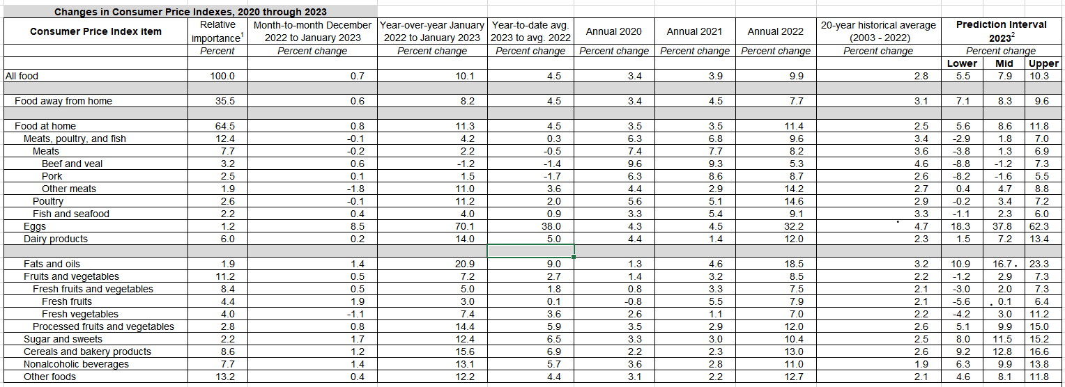

This dataset can be used to study how consumer behavior is impacted by food price changes. With the use of this dataset, we can examine how variations in food prices impact both customer demand for various food items as well as consumer spending habits. (Food price outlook, 2023)

We can create predictive models to estimate future food costs using the monthly changes in food prices supplied by this dataset. This will allow merchants and food producers to better plan their pricing strategies. For example, we may use this dataset to forecast which food items would likely see a spike in demand as a result of higher costs and change our inventory as necessary. Also, we can use this dataset to examine how various socioeconomic characteristics, such as income and education, influence food-related consumer behavior.

In addition, this dataset can be used by policymakers to help them make decisions about food and agricultural policies. The dataset, for instance, can help with developing policies to manage food insecurity and provide light on how changes in food prices affect vulnerable groups like low-income households.

Overall, this dataset is useful for understanding how consumer behavior is affected by food costs, as well as for informing decisions about the food and agricultural sector and food security policies.

**Research Questions:**

1. What is the annual change in the consumer price index for all food items and how does it compare to the historical average over the previous 20 years?
2. What is the prediction interval for 2023 and how has the consumer price index for eggs changed from 2021 to 2022 and the annual average of 2020?
3. How has the consumer price index for fresh fruits and vegetables changed from month to month from 2022 to 2023, and how does that compare to the overall average?
4. What is the consumer price index for meats, poultry, and fish changing year over year, and what is the projected range for 2023?

**Importance of Dataset:**

The table provides information on the changes in consumer price indexes for several different product categories, like meat, dairy, fruits, and vegetables. Many advantages could result from studying this dataset, Like:

* Monitoring inflation: To keep track of changes in the costs of all types of food over time, the Consumer Price Index (CPI), a measure of inflation, is used. Economists and decision-makers can examine trends and choose the best course of action for monetary policy by examining the data in this table.
* Understanding consumer behavior: The table gives information on the relative importance of several product categories to consumers, such as food at home versus food away from home, to help us better understand consumer behavior. Businesses can better understand consumer behavior and adapt their tactics by studying this data.
* Identifying market trends: To find market trends the table contains information on pricing changes for numerous categories of commodities during the past year. Businesses can spot possibilities and alter their pricing strategy to stay competitive by examining these trends.
* Making educated decisions: The table contains information on the historical average prices for a variety of items, which can assist companies and decision-makers in deciding on pricing and regulatory changes.

Overall, analyzing this dataset can offer insightful information on consumer behavior, market trends, and inflation, assisting businesses and decision-makers in making wise choices.

**Reference of Dataset:**

*Food price outlook*. USDA ERS - Food Price Outlook. (n.d.). Retrieved from https://www.ers.usda.gov/data-products/food-price-outlook.aspx.