Project Assignment#4 – AIT580

Data Analytics Research Project

**Food Price Outlook**

Shashank Yelagandula

syelagan@gmu.edu

**Abstract:**

Food Price Outlook Table:

This dataset can be used to research how changes in food prices affect consumer behavior. With the use of this dataset, we can investigate how changes in food prices affect both consumer spending patterns and the demand for specific food items. (Food price outlook, 2023)

The monthly variations in food prices provided by this dataset can be used to build predictive models that can be used to calculate future food expenditures. Producers of food and retailers will be able to better plan their price strategies as a result. For instance, we could estimate which food items would likely experience a surge in demand because of higher prices using this dataset, and then adjust our inventory as necessary. Additionally, we may utilize this dataset to investigate how different socioeconomic factors, such income and education, affect consumer behavior linked to food.

In addition, policymakers can utilize this dataset to inform their choices regarding food and agricultural policies. The dataset, for instance, can aid in formulating strategies to address food insecurity and provide light on how vulnerably situated groups, such as low-income households, are impacted by price fluctuations in the food supply.

Overall, this dataset is helpful for understanding how the price of food affects consumer behavior as well as for informing policies relating to the food and agricultural industries and food security.

**Introduction:**

The table gives details on how consumer price indices have changed for a variety of various food categories, including meat, dairy, fruits, and vegetables. Numerous benefits could come from researching this dataset, including:

* Monitoring inflation: The Consumer Price Index (CPI), a gauge of inflation, is used to track variations in the price of all types of food over time. The information in this table can be used by economists and decision-makers to analyze trends and choose the best course of action for monetary policy.
* Understanding consumer behavior: To better understand consumer behavior, the table provides data on the relative importance of various product categories to customers, such as food consumed at home versus food consumed away from home. By analyzing this data, businesses can enhance their understanding of consumer behavior and modify their strategies.
* Identifying market trends: To discover market trends The table provides details on how commodity prices have changed over the past year for several different categories. By looking at these trends, businesses can identify opportunities and adjust their pricing approach to remain competitive.
* Making educated decisions: The table includes data on the average prices paid historically for a range of goods, which can help businesses and decision-makers determine pricing and regulatory adjustments.

In conclusion, the analysis of this dataset can provide informative data on consumer behavior, market trends, and inflation, supporting businesses and decision-makers in making informed decisions. (Food price outlook, 2023)

**Research Questions:**

1. What is the annual change in the consumer price index for all food items and how does it compare to the historical average over the previous 20 years?
2. What is the prediction interval for 2023 and how has the consumer price index for eggs changed from 2021 to 2022 and the annual average of 2020?
3. How has the consumer price index for fresh fruits and vegetables changed from month to month from 2022 to 2023, and how does that compare to the overall average?
4. How did the consumer price index for meats, poultry, and fish changing year over year, and what is the projected range for 2023?

**Methodology:**

There are numerous crucial phases in the methodology used to evaluate the food price outlook dataset from the USDA using R Programming. To begin with, data cleaning is done to look for missing data, fix mistakes, and deal with outliers. The distribution, trends, and interactions between the variables are then understood using exploratory data analysis (EDA). The insights generated via EDA are then visualized using data to produce visuals that aid in communication. Using machine learning methods like regression, time series analysis, or clustering, predictive modeling is used to predict or anticipate future food prices. The effectiveness of the model is assessed using suitable metrics like MAE, RMSE, or accuracy.

**Literature Review:**

Related research reports literature review:

1. **Research Report by U.S. Bureau of labor Statistics on Consumer Price Index Summary**

This document, titled "Consumer Price Index - February 2023," was released by the U.S. Bureau of Labor Statistics (BLS) in March 2023. The Consumer Price Index (CPI) for All Urban Consumers in the United States for February 2023 is discussed in length, including monthly changes and yearly increases. (Consumer price index summary - 2023 M02 results, 2023)

According to the article, the all-items index increased by 0.4 percent on a seasonally adjusted basis in February 2023 after rising by 0.5 percent in January 2023. It is also emphasized that the monthly increase in all goods was driven mostly by the index for shelter, accounting for more than 70% of the increase. The page includes more details on the CPI's numerous components, such as food, energy, and health care.

The food index increased by 0.4 percent in February, the article claims, with increases noted in five of the major grocery store food group indexes. It also notes that the index for meats, poultry, fish, and eggs declined by 0.1 percent throughout the month, the first decrease in that index since December 2021.

The article provides in-depth information on the rises in the CPI for several different categories, including housing, leisure, household goods and services, travel, and used cars and trucks. The all-items index increased by 6.0 percent for the year ending in February 2023, while the all-items index excluding food and energy rose by 5.5 percent.

The article provides a full description of both adjustments from the prior year and the February 2023 revisions to the CPI for All Urban Consumers in the United States. The facts in this post can help everyone better understand how inflation is now affecting the United States, including economists, decision-makers, and the public.

1. **Vegetables and Pulses Data Analysis report by Economic Research service U. S**

Various statistics on the production, trade, consumption, and prices of vegetables and pulses in the United States are available on the Vegetables and Pulses Data page of the USDA's Economic Research Service website. The page, which is routinely updated with new data releases, contains crucial information that policymakers, researchers, and industry participants in the agriculture sector can use. (Wilma V. Davis, 2023)

The data on the website is displayed in easily readable and comprehendible tables, charts, and maps. The data includes a variety of vegetables and pulses, including beans, broccoli, carrots, cauliflower, celery, cucumbers, eggplant, lettuce, onions, peas, peppers, spinach, squash, sweet corn, and tomatoes.

One of the key features of the website is the grouping of the data by region, state, and crop, which makes it easy to compare and assess data across multiple places and crops. Due to the data's added presentation as a time-series, users may track trends and changes in output, trade, consumption, and prices over time.

The website also provides data analysis, including reports on topics like the impact of trade agreements on the export of pulses and vegetables, the influence of weather on pulse production, and the changing trends in pulse and vegetable consumption in the United States.

The Vegetables and Pulses Data page on the USDA's Economic Research Service website is generally helpful to anyone interested in the production, trade, consumption, and prices of vegetables and pulses in the United States. The information is complete, up to date, and easy to get, and it may be used to learn more about the current state of the American agriculture business as well as its potential future advancements.

1. **Fruit and Tree Nuts Yearbook Tables by U.S Department of agriculture**

The USDA's Fruit and Tree Nuts Data and Yearbook Tables provide comprehensive information on the production, consumption, trade, and pricing of a wide variety of fruits and tree nuts in the United States. Various organizations, including governmental ones, commercial organizations, and market research firms, are used to compile the data. (Weber, 2022)

The annual tables offer in-depth details on a range of subjects related to fruit and tree nuts, such as the production and consumption of fresh and processed fruits, the production and disposal of tree nuts, and the international trade in these goods.

The data is presented in tables and charts, which makes it easy to comprehend and assess past trends.

One of the major benefits of the yearbook tables is their capacity to offer data on a variety of fruits and tree nuts, including both common and uncommon types. As a result, the data may be used by policymakers, farmers, and other business stakeholders who need to understand market trends and patterns.

The Fruit and Tree Nuts Statistics and Yearbook Tables should generally be consulted by anyone who is interested in the production and consumption of fruits and tree nuts in the United States. They can aid in directing decisions connected to the agriculture and food industries and provide invaluable information on market trends.

**Summary of related literature review:**

In conclusion, while the other research reports mainly concentrated on a specific category or a specific time, the report I chose concentrated on both all categories and historical time periods, allowing users to gain knowledge about consumer behavior. However, if we want to gain insight into a specific category or time, we can choose from other research reports. Most of them provide responses to my research questions. This is my report on the literature that is pertinent to my study data.

**Results**:

Answers for the research questions presented:

1. **What is the annual change in the consumer price index for all food items and how does it compare to the historical average over the previous 20 years?**

We can observe that the annual index changes have a mean of 5.17% and a range of 0.1% to 9.9%. This demonstrates that most yearly changes lie between the range of 2.8% and 9.9%.

This graph demonstrates the huge variation in annual CPI changes for all food categories from year to year. The CPI for all food products increased by 9.9% in 2022, which was the biggest yearly change. This was significantly greater than the 2.8% 20-year historical average. It is crucial to remember that this increase might have been impacted by outside variables like the COVID-19 epidemic. The graph demonstrates that, with some volatility, the annual changes in the CPI for all food products have been rising overall over time. (Food price outlook, 2023)

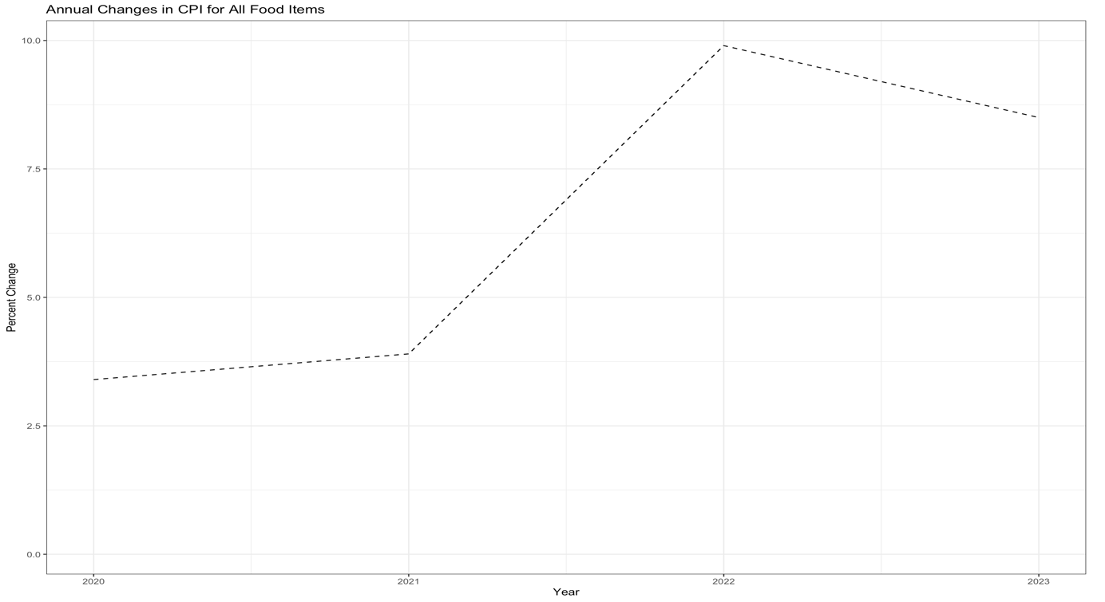

1. **What is the prediction interval for 2023 and how has the consumer price index for eggs changed from 2021 to 2022 and the annual average of 2020?**

With a 95% degree of confidence, we can state that the CPI for eggs in 2023 is predicted to be between 5.1 and 32.9, with a mid-point estimate of 17.8. This indicates that the actual CPI for eggs in 2023 could fall anywhere within the range of uncertainty surrounding the forecast value.

According to the correlation matrix, the consumer price index for eggs has a strong correlation with the change in the consumer price index from year to year (r = 0.88), a weak correlation with the change in the index for 2020, and a weak correlation with the change in index for 2021. This suggests that factors such as the overall inflation rate and others that affect the pricing of food items generally have a significant impact on the price of eggs. (Food price outlook, 2023)

In the period from March 2022 to March 2023 and for the year-to-date average of 2023 compared to 2022, the consumer price index for eggs has seen significantly higher year-over-year changes than the consumer price index for all foods, as shown by the bar chart.

1. **How has the consumer price index for fresh fruits and vegetables changed from month to month from 2022 to 2023, and how does that compare to the overall average?**

The statistic shows that between February 2023 and March 2023, the consumer price index (CPI) for fresh fruits and vegetables dropped by 1.5%. The CPI for fresh fruits and vegetables increased by 2.5% from March 2022 to March 2023. Fresh fruits and vegetables saw a 2.3% increase in the CPI for the year-to-date average from 2023 to 2022. (Food price outlook, 2023)

Comparatively, the CPI for all food climbed by 0.1% between February and March 2023 and by 8.5% between March and March of the previous year. The CPI for all food increased by 4.8% from 2023 to 2022 for the year-to-date average. Fresh fruits and vegetables have a 20-year historical average CPI of 2.2%, while other foods have a 2.8% historical average CPI.

These modifications imply that the CPI for fresh fruits and vegetables has recently been increasing at a slower rate than the CPI for total food, and that the decline in March 2023 may be a brief blip.

1. **How did the consumer price index for meats, poultry, and fish changing year over year, and what is the projected range for 2023?**

The data set shows that, in contrast to the 20-year historical average of 3.4%, the Consumer Price Index (CPI) for meats, poultry, and fish had climbed by 9.6% yearly in 2022. The CPI for meats, poultry, and fish grew by 2.4% from March 2022 to March 2023 when compared year over year. However, it only increased by 0.5% in the year-to-date average from average 2022 to average 2023. (Food price outlook, 2023)

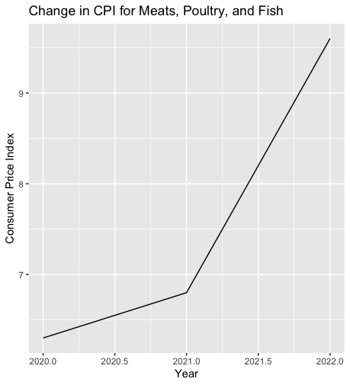

The expected range for all foods in 2023 is smaller than the range for meats, poultry, and fish in that year. While the expected range for total food is between 4.9% and 8.2%, it is between -2.1% and 4.9% for meats, poultry, and fish. This implies that the price increase for meats, poultry, and fish will be less overall in 2023 than the price increase for total food.

**Limitations:**

There are various restrictions on the study of the USDA's food price outlook dataset that should be considered. These include the dataset's restricted granularity, which makes it difficult to pinpoint precise patterns and reasons of price swings since it only gives information on food prices at a high-level category level. Furthermore, the statistical lag of the dataset might not always reflect the most recent data on food costs. Additionally, because the information depends on USDA estimates and predictions, there may be biases or inaccuracies in data collection, interpretation, or forecasting.

There are a few things that can be done to overcome these restrictions. First off, it is possible to employ more precise data sources to complement the USDA dataset and provide a more in-depth knowledge of changes in food prices. Data from wholesalers, retailers, or customer surveys may be included in this. Second, employing real-time data or more regular updates might lessen the influence of data latency on the study. In order to identify and correct any potential biases or inaccuracies in the data, it is crucial to evaluate and cross-check the USDA estimates and projections with other data sources and professional judgment.

**Summary**:

The food price projection dataset from the USDA offers information on the expected changes in food prices in the US. According to the data, the price of food has generally increased during the past ten years, with sporadic variations brought on by supply and demand, the weather, and international trade patterns. pricing for meat and poultry items have increased in response to rising consumer demand, while changes in milk production and international commerce have had an impact on dairy pricing. Despite seasonal changes, fresh product prices have also tended to rise over time.

Looking ahead, several economic, environmental, and geopolitical variables, including the COVID-19 pandemic's effects, are predicted to cause food costs to keep rising. The epidemic has affected the world's supply chains, increasing the cost of logistics and shipping while also altering customer behavior. Furthermore, weather-related occurrences like droughts or floods can have a big impact on crop output and change prices.

It is crucial to remember that the USDA's dataset of food price forecasts contains some restrictions. It can be difficult to pinpoint particular patterns and reasons for price fluctuations within each category because the data only gives information on food costs at a broad category level. Additionally, due to a statistical lag, the dataset might not always reflect the most recent data on food costs. In addition, there could be biases or mistakes in the data collecting, analysis, or forecasting processes.

Overall, the USDA's food price projection dataset is a useful tool for figuring out patterns and shifts in food costs in the US, but its limitations should be taken into consideration while using it.

**References:**

1. Matthew MacLachlan, & Megan Sweitzer. (2023, April 25). *Food price outlook*. USDA ERS - Food Price Outlook. Retrieved from https://www.ers.usda.gov/data-products/food-price-outlook.aspx

1. U.S. Bureau of Labor Statistics. (2023, March 14). *Consumer price index news release - 2023 M02 results*. U.S. Bureau of Labor Statistics. Retrieved from https://www.bls.gov/news.release/archives/cpi_03142023.htm
2. Wilma V. Davis, Gary Lucier, & Catharine Weber. (2023, April 19). *Vegetables and pulses data*. USDA ERS - Vegetables and Pulses Data. Retrieved from https://www.ers.usda.gov/data-products/vegetables-and-pulses-data/
3. Catharine Weber. (2022, November 15). *Fruit and tree nuts yearbook tables*. USDA ERS - Fruit and Tree Nuts Yearbook Tables. Retrieved from https://www.ers.usda.gov/data-products/fruit-and-tree-nuts-data/fruit-and-tree-nuts-yearbook-tables/