“Linux Deadlock Detection and Resource Management System”
A Project Report Submitted in the partial fulfillment of the requirements for the award of the degree of

BACHELOR OF TECHNOLOGY
In

DEPARTMENT OF COMPUTER SCIENCE ENGINNERING

By

M SHASHANTH 2520090129

M ANTHONY AKSHAY 2520090065

G NANDHA KISHORE 2520080050

Under the Esteemed Guidance of

Dr. K. Anusha
Assistant Professor
Department of Computer Science and Engineering




K L (Deemed to be) University DEPARTMENT OF COMPUTER SCIENCE ENGINEERING
&

DEPARTMENT OF COMPUTER SCIENCE AND INFORMATION TECHNOL

Declaration

The Project Report entitled “Linux Deadlock Detection and Resource Management System” is a record of Bonafide work of M SHASHANTH - 2520090129, M ANTHONY AKSHAY - 2520090065, G NANDHA KISHORE - 2520080050 submitted in
partial fulfillment for the award of B. Tech in Computer Science and Engineering (or) Computer Science and Information Technology to the K L University. The results embodied in this report have not been copied from any other departments/University/Institute.

M SHASHANTH 2520090129

M ANTHONY AKSHAY 2520090065

G NANDHA KISHORE 2520080050

K L (Deemed to be) University

DEPARTMENT OF COMPUTER SCIENCE ENGINEERING

CERTIFICATE

This is to certify that the mini project based report entitled “Linux Deadlock Detection and Resource Management System” is a bonafide work done and submitted by M SHASHANTH – 2520090129, M ANTHONY AKSHAY – 2520090065, G NANDHA KISHORE – 2520080050,
in partial fulfillment of the requirements for the award of the degree of BACHELOR OF TECHNOLOGY in Department of Computer Science Engineering, K L (Deemed to be University), during the academic year 2026-2027.

Signature of the Guide

Signature of the Course Coordinator Signature of the HOD

ACKNOWLEDGEMENT
The success in this project would not have been possible but for the timely help and guidance rendered by many people. Our wish to express my sincere thanks to all those who has assisted us in one way or the other for the completion of my project.

Our greatest appreciation to my Course Coordinator Dr. K. Anusha, and my guide Dr. K. Anusha, Department of Computer Science which cannot be expressed in words for his/her tremendous support, encouragement and guidance for this project.

We express our gratitude to Dr. P Venkateshwara Roa (CSE), Head of the Department for Computer Science Engineering for providing us with adequate facilities, ways and means by which we are able to complete this project-based Lab.

We thank all the members of teaching and non-teaching staff members, and also who have assisted me directly or indirectly for successful completion of this project. Finally, I sincerely thank my parents, friends and classmates for their kind help and cooperation during my work.

M SHASHANTH 2520090129

M ANTHONY AKSHAY 2520090065

G NANDHA KISHORE 2520080050
Abstract

Deadlock is one of the classic problems of operating systems. When several processes compete for a limited pool of system resources, a process may hold one resource while waiting for another, and a group of processes can end up waiting on each other in a closed cycle. None of the processes in the cycle can proceed, and the operating system must be able to notice the situation and recover from it without restarting the whole system. This project, the Linux Deadlock Detection and Resource Management System (OSSP 25CS2104E), addresses that need by modelling processes, resources, requests and releases and by detecting and resolving deadlocks.

The system is organised into six cooperating modules: a Process Manager, a Resource Manager, a Resource Allocation Module, a Deadlock Detection Module, a Deadlock Recovery Module and a user interface. All modules work on a shared Allocation, Request and Available state held by the Resource Manager. Detection uses the standard matrix-based algorithm: a process whose pending request can be satisfied from the Available pool is assumed to finish and return its allocation, and any process that can never finish is reported as deadlocked. The project also includes a Banker's-algorithm safety check that computes the Need matrix and a safe sequence, and a resource allocation graph that draws the wait cycle.

Recovery is performed by terminating a victim process (by default the deadlocked process holding the fewest resources), which releases its resources so that waiting processes can be granted them and the system resumes. The simulator is implemented as an interactive web application (HTML, CSS and JavaScript) that mirrors the Linux process-control calls fork(), waitpid() and kill() in its log, and it was designed for the Linux / Ubuntu environment with C/C++, GCC and POSIX APIs as the target stack. In summary, the project gives a practical, visual and testable demonstration of deadlock detection, safety checking and recovery, and builds a clear understanding of process and resource management in Linux.

Index

S. No. | Chapter | Topics / Subtopics | Page No.
 | Acknowledgement |  | i
 | Abstract |  | ii
1 | Introduction |  | 8–9
 |  | 1.1 Background of the Project | 8
 |  | 1.2 Problem Statement | 8
 |  | 1.3 Scope of the Project | 8
 |  | 1.4 Objectives of the Project | 8
 |  | 1.5 Importance of the Application | 9
 |  | 1.6 Target Users / Audience | 9
2 | OS Concepts and Background Study |  | 10–11
 |  | 2.1 Operating System Concepts Related to the Project | 10
 |  | 2.2 Existing Methods / Algorithms | 11
 |  | 2.3 Proposed Approach | 11
 |  | 2.4 Advantages of the Proposed Approach | 11
3 | System Requirements |  | 12
 |  | 3.1 Hardware Requirements | 12
 |  | 3.2 Software Requirements | 12
 |  | 3.3 Operating System Environment – Ubuntu / WSL | 12
 |  | 3.4 Development Tools and Compilers | 12
4 | Technology and Tools Used |  | 13–14
 |  | 4.1 C / C++ and JavaScript Programming | 13
 |  | 4.2 GCC Compiler | 13
 |  | 4.3 Linux System Calls | 13
 |  | 4.4 POSIX Threads / Synchronization | 13
 |  | 4.5 Linux Commands and Utilities | 14
 |  | 4.6 Other Tools / Libraries Used | 14
5 | System Architecture and Design |  | 15–17
 |  | 5.1 Overall System Architecture | 15
 |  | 5.2 System Workflow | 15
 |  | 5.3 Flowchart / Data Flow | 16
 |  | 5.4 Module Description | 16
 |  | 5.5 Input and Output Design | 17
6 | Implementation |  | 18–20
 |  | 6.1 Module-wise Implementation | 18
 |  | 6.2 Algorithm / Pseudocode | 18
 |  | 6.3 Core Implementation (JavaScript Simulator) | 19
 |  | 6.4 Linux System Calls / APIs Used | 19
 |  | 6.5 Process Model Implementation | 20
 |  | 6.6 IPC / Synchronization Implementation | 20
 |  | 6.7 State and Memory Management | 20
 |  | 6.8 Optional User Interface Implementation | 20
7 | Execution and Demonstration |  | 21–26
 |  | 7.1 Compilation in Ubuntu | 21
 |  | 7.2 Execution Commands | 21
 |  | 7.3 Sample Inputs and Outputs | 21
 |  | 7.4 Screenshots of Execution | 22
 |  | 7.5 Demonstration of OS Concepts | 26
8 | Conclusion |  | 27–28
 |  | 8.1 Summary of the Project | 27
 |  | 8.2 Objectives Achieved | 27
 |  | 8.3 Results Achieved | 27
 |  | 8.4 Skills and Learning Outcomes | 27
9 | References |  | 29
 |  | 9.1 Books | 29
 |  | 9.2 Research Papers | 29
 |  | 9.3 Linux / GNU Documentation | 29
 |  | 9.4 Online Resources | 29

CHAPTER 1
INTRODUCTION
1.1 Background of the Project
An operating system is the layer of software that shares the machine's limited resources among many programs that run at the same time. A process is a program in execution: an independent unit of work with its own memory, state and resource needs. A system resource is anything a process needs to run, such as CPU time, memory, files, printers and I/O devices, and such resources are often limited in number.
Because many processes run concurrently while resources are finite, the operating system has to allocate and share them fairly. This competition creates a risk. When processes hold resources while waiting on each other in a cycle, none of them can proceed, and the system reaches a state called deadlock. Deadlock handling (prevention, avoidance, detection and recovery) is therefore a core topic of the Operating Systems and Systems Programming course (OSSP, course code 25CS2104E).
This project, the Linux Deadlock Detection and Resource Management System, models that competition. It lets the user create processes and resources, make requests and releases, see when the system has deadlocked, find out which processes are involved, and recover by terminating a victim process.
1.2 Problem Statement
Multiple processes compete for a limited pool of system resources. A process may hold one resource while waiting to acquire another, and this mutual waiting can form a circular chain among processes. Deadlocked processes stop making progress and cannot continue normally. A system is therefore needed to detect and manage deadlock conditions so that the operating system can identify the affected processes and recover without a full restart.
1.3 Scope of the Project
• Simulation of any number of processes (P0, P1, …) and resource types (R0, R1, …) with multiple units per resource type.
• Handling of resource request, allocation, blocking, release and re-allocation to waiting processes.
• Deadlock detection using the Available / Allocation / Request matrices, with identification of the deadlocked processes and a resource allocation graph.
• A Banker's-algorithm safety check (Need = Max − Allocation) that reports a safe sequence or an unsafe state.
• Recovery by process termination (automatic victim selection or manual choice) and re-evaluation of the new state.
• Out of scope: killing real operating-system processes. The system works on a simulated model of processes and resources and logs the equivalent Linux calls (fork, waitpid, kill).
1.4 Objectives of the Project
1. Simulate competing processes: model multiple processes competing for a limited set of system resources.
2. Detect deadlock conditions: apply a suitable algorithm to identify when the system has entered a deadlocked state.
3. Identify involved entities: pinpoint exactly which processes and resources are part of the deadlock cycle.
4. Enable recovery: provide resource management and basic recovery mechanisms to restore progress.
1.5 Importance of the Application
Deadlocks are hard to reproduce on a real machine and are usually seen only as a program that “hangs”. A simulator makes the four necessary conditions visible and repeatable: mutual exclusion, hold and wait, no preemption and circular wait. Students can create the situation on demand, watch the resource allocation graph form a cycle, and see how removing one process breaks the cycle. The same ideas apply to database lock managers, multi-threaded programs using mutexes, and distributed systems, so the concepts transfer directly to real software.
1.6 Target Users / Audience
• Students and faculty of the Operating Systems and Systems Programming course who need a hands-on demonstration of deadlock.
• Beginners in systems programming who want to understand process and resource management on Linux.
• Developers who want a small reference implementation of the detection algorithm and the Banker's safety check.

CHAPTER 2
OS CONCEPTS AND BACKGROUND STUDY
2.1 Operating System Concepts Related to the Project
2.1.1 Processes and resources
Each simulated process moves through the usual life-cycle states: ready, running, blocked and terminated. A process whose request cannot be satisfied is placed in the blocked state and its request stays pending. A process that is killed is terminated, and its allocated resources are returned to the system.
2.1.2 The four necessary conditions for deadlock
Table 2.1 Necessary conditions for deadlock
Condition | Meaning
Mutual Exclusion | Only one process may use a unit of a resource at a time.
Hold and Wait | A process holds one resource while requesting another.
No Preemption | A resource cannot be forcibly taken from a process; it is released only voluntarily.
Circular Wait | Each process waits for a resource held by the next, forming a closed cycle.

Deadlock can occur only when all four conditions hold at the same time. Breaking any one of them prevents deadlock.
2.1.3 Resource allocation graph
The resource allocation graph (RAG) is a directed graph with process nodes (circles) and resource nodes (squares). An edge from a resource to a process means the resource is assigned to that process; an edge from a process to a resource means the process is waiting for it. With single-unit resources, a cycle in the graph means deadlock. With multi-unit resources a cycle is necessary but not sufficient, so the matrix-based algorithm is used for detection.
2.1.4 Linux process-control APIs
Table 2.2 Linux / OS concepts and APIs
Concept / API | Purpose in the project | Status
Deadlock Detection | Core algorithm that analyzes allocation/request state to find deadlocks. | CORE
Resource Allocation | Assigns and tracks resources granted to each process. | CORE
Resource Allocation Graph | Models processes and resources as nodes to visualize wait cycles. | CORE
Banker's Algorithm / Safety Check | Evaluates whether a state is safe. | OPTIONAL (implemented as a safety check)
fork() | Creates a new process to represent a simulated process entity. | PLANNED (modelled by “Add process”)
wait() / waitpid() | Lets a parent wait for a child process to finish. | PLANNED (modelled in the log)
kill() | Sends a signal to terminate a process during recovery. | PLANNED (modelled by recovery)

2.2 Existing Methods / Algorithms
• Deadlock prevention: design the system so that at least one of the four conditions can never hold (for example, requesting all resources at once, or a global lock ordering). It is safe but can lower resource utilisation.
• Deadlock avoidance (Banker's algorithm): each process declares its maximum claim in advance, and a request is granted only if the system stays in a safe state (Dijkstra, 1965).
• Deadlock detection and recovery: resources are granted freely, the system periodically checks for deadlock, and recovery is triggered when one is found (Coffman et al., 1971; Holt, 1972).
• Ignoring the problem (ostrich approach): used by general-purpose systems such as Linux and UNIX for user-level resources, since deadlocks are rare and the cost of avoidance is high.
2.3 Proposed Approach
The proposed system follows the detection and recovery approach and adds the Banker's safety check as a conceptual reference. The system keeps three states: Available, Allocated and Requested resources. The detection algorithm works as follows:
1. Track the Available, Allocated and Requested state.
2. For each process, check whether its request can be satisfied by the currently available resources.
3. If a process can complete, assume it finishes and release its allocated resources back to Available.
4. Repeat the check for the remaining processes with the updated Available pool.
5. Any process that can never complete is marked as deadlocked.
Recovery then terminates one deadlocked process (the victim). Its resources are freed and given to waiting processes, and the system checks the updated state again.
2.4 Advantages of the Proposed Approach
• Resources are never refused unnecessarily, so utilisation stays high (unlike prevention).
• Processes do not need to declare maximum claims for detection to work.
• The detection is exact: it reports exactly which processes are deadlocked, not just that “something is wrong”.
• Recovery is simple and fast: one victim is terminated and the state is re-checked.
• The Banker's check and the allocation graph give both a numerical and a visual explanation of the state.

CHAPTER 3
SYSTEM REQUIREMENTS
3.1 Hardware Requirements
Table 3.1 Hardware requirements
Component | Minimum | Recommended
Processor | Dual-core, 1.6 GHz | Quad-core, 2.5 GHz or better
RAM | 2 GB | 4 GB or more
Disk space | 200 MB free | 1 GB free
Display | 1024 × 768 | 1920 × 1080
Input | Keyboard and mouse | Keyboard and mouse

3.2 Software Requirements
Table 3.2 Software requirements
Software | Purpose
Linux / Ubuntu (native or WSL) | Target operating system for the Linux implementation
Web browser (Chrome, Firefox, Edge) | Runs the Deadlock Lab simulator
VS Code with Live Server extension | Editing and serving the project
Python 3 (optional) | python3 -m http.server for a local web server
Node.js and npm (optional) | npm start (npx serve) for a local web server
GCC / G++ and POSIX headers | Target toolchain for the C/C++ Linux port
Git and GitHub | Version control and repository hosting

3.3 Operating System Environment – Ubuntu / WSL
The project is designed as a Linux-based system and is developed on Ubuntu (or Ubuntu under Windows Subsystem for Linux). Ubuntu provides the Linux terminal, the GCC toolchain and the POSIX interfaces (fork, waitpid, kill and signals) that the system models. The web simulator itself needs no build step and runs on any modern browser, so it also runs unchanged on Ubuntu, WSL, Windows and macOS.
3.4 Development Tools and Compilers
• VS Code for editing HTML, CSS and JavaScript, with the Live Server extension for instant reload.
• GCC / G++ as the compiler for the C/C++ Linux implementation of the same algorithm.
• Linux terminal for running the local server and for Git commands.
• Git and GitHub for version control and sharing of the source code.

CHAPTER 4
TECHNOLOGY AND TOOLS USED
4.1 C / C++ and JavaScript Programming
The system is designed around C/C++ for the Linux implementation, because deadlock handling is a systems-programming topic and C/C++ gives direct access to POSIX calls. The interactive simulator delivered with this project is written in JavaScript (with HTML and CSS) so that the algorithm can be shown visually in a browser. The detection, safety and recovery logic is written as small pure functions over arrays, and the same logic maps directly to C/C++ arrays and loops.
Table 4.1 Project files
File | Role
index.html | Page structure: Simulator, Banker's algorithm and Syllabus map tabs
style.css | Styling, light/dark theme variables, tables, status banners and the graph
script.js | State, deadlock detection, Banker's safety check, recovery and graph drawing
package.json | npm start script that serves the folder on port 3000
README.md | How to run the project in VS Code

4.2 GCC Compiler
GCC (GNU Compiler Collection) is the standard compiler on Linux. For the C/C++ implementation, a program is compiled with a command such as g++ -Wall -o deadlock deadlock.cpp. GCC supports the POSIX headers (unistd.h, sys/wait.h, signal.h) used for process control.
4.3 Linux System Calls
Table 4.2 System calls and their role
System call | Use in this system
fork() | Creates a new process to represent a simulated process (modelled by Add process; logged as “fork created Pn”).
wait() / waitpid() | Lets the parent reap a finished child; the log shows “waitpid(Pn): reaped” after termination.
kill() | Sends SIGTERM or SIGKILL to the victim during recovery; the log shows “kill(Pn, SIGKILL)”.

4.4 POSIX Threads / Synchronization
Real deadlocks commonly appear when threads lock several mutexes in different orders (pthread_mutex_lock). The simulator's resources behave like such locks: a unit held by one process cannot be used by another, and a request that cannot be met makes the process wait. The same Allocation / Request model can be applied to a set of POSIX threads, which is a natural extension of this work.
4.5 Linux Commands and Utilities
Table 4.3 Commands used
Command | Purpose
python3 -m http.server 3000 | Serve the project folder on http://localhost:3000
npm start | Run npx --yes serve . -l 3000 from package.json
git init / add / commit / push | Version control and publishing to GitHub
g++ -Wall -o deadlock deadlock.cpp | Compile the C/C++ version

4.6 Other Tools / Libraries Used
• Inline SVG to draw the resource allocation graph (circles for processes, squares for resources, arrow markers for edges).
• IBM Plex Sans / Mono web fonts for the interface.
• Git, GitHub and VS Code for development. No external JavaScript framework or library is used.

CHAPTER 5
SYSTEM ARCHITECTURE AND DESIGN
5.1 Overall System Architecture
The system has six modules. All modules communicate through the Resource Manager, which maintains the live allocation state used by detection and recovery.
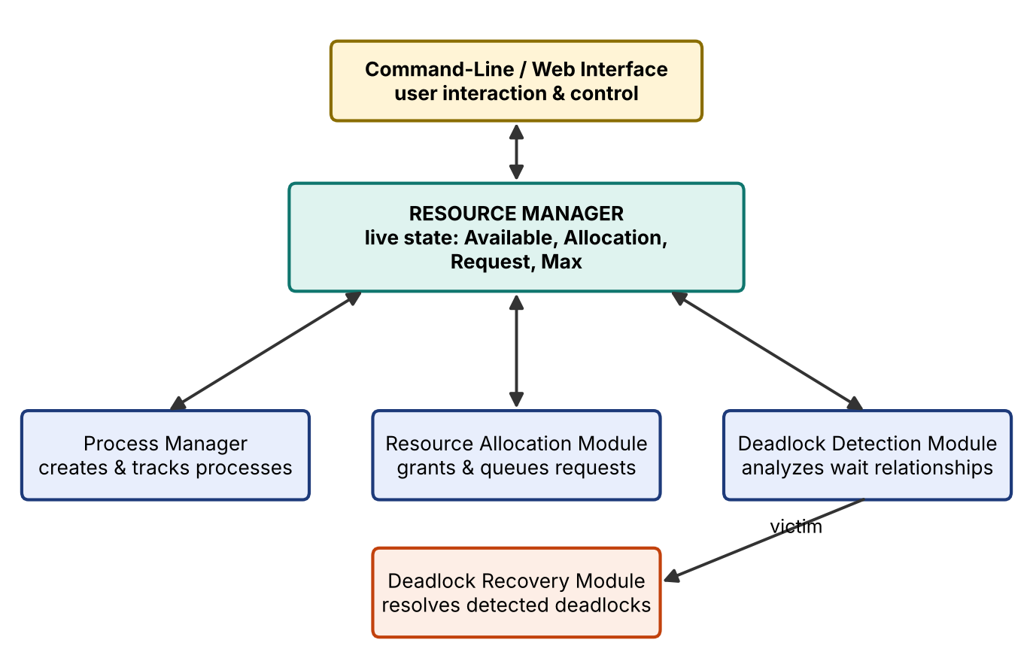
Fig. 5.1 Proposed system architecture
5.2 System Workflow
1. Initialize the resources (type count and total units).
2. Create the processes.
3. Allocate resources to processes.
4. Process resource requests: grant if available, otherwise leave the request pending and block the process.
5. Check the resource state (Available = Total − Σ Allocation).
6. Run deadlock detection.
7. If no deadlock is found, continue execution. If a deadlock is found, identify the involved processes and trigger recovery.
8. After recovery, re-check the updated resource state. The cycle repeats continuously, so new requests are always evaluated against the latest allocation state.
5.3 Flowchart / Data Flow
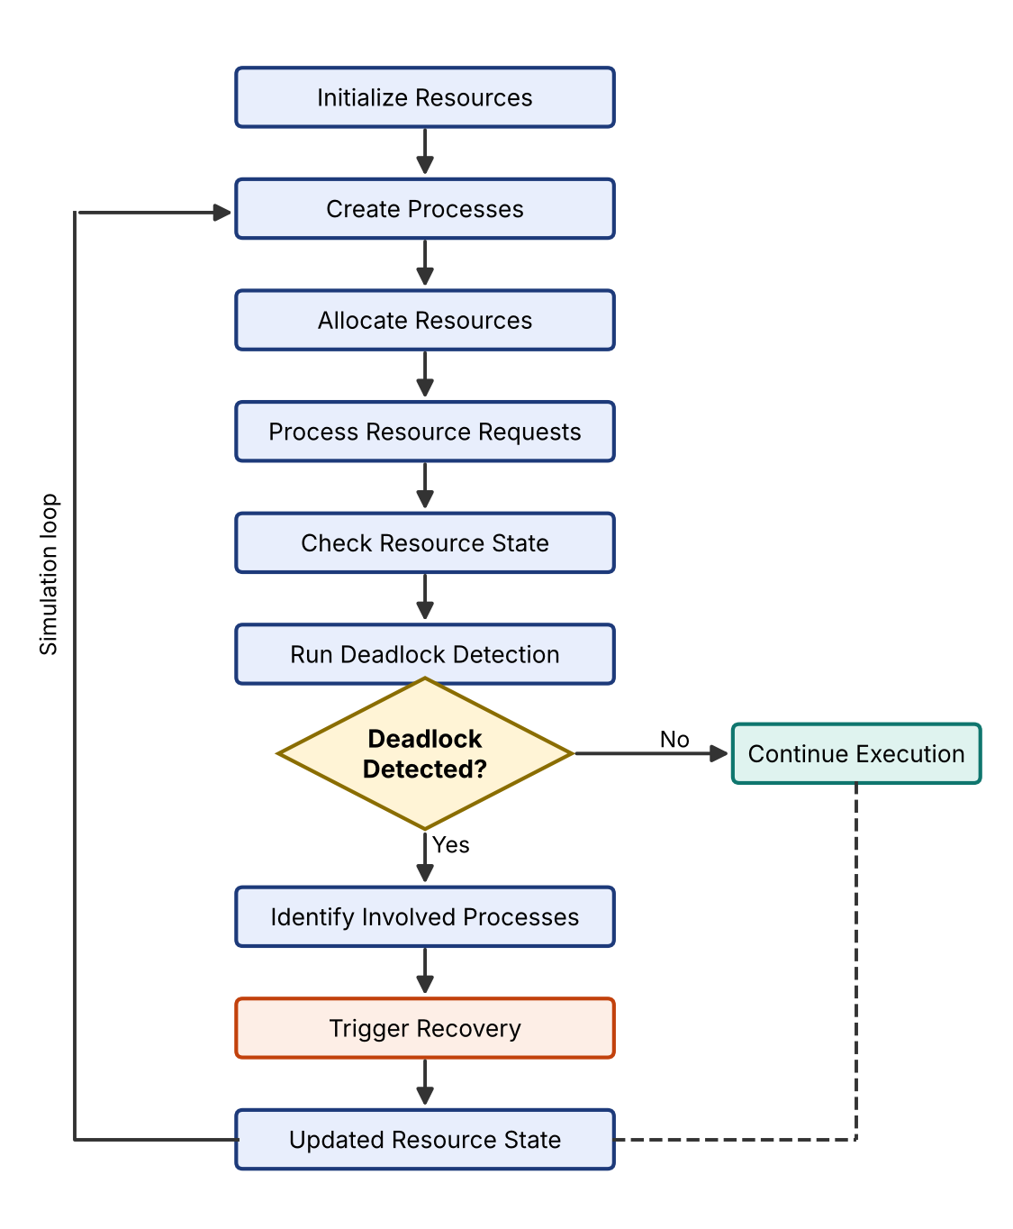
Fig. 5.2 Working / process flow of the system
The main data flows are: user actions (request, release, add, kill) go to the Resource Manager; the Resource Manager updates the Allocation, Request and Available state; the Detection Module reads that state and returns the list of deadlocked processes; the Recovery Module takes that list, chooses a victim and asks the Resource Manager to release the victim's resources.
5.4 Module Description
Table 5.1 Modules and their implementation
Module | Responsibility | Function(s) in script.js
Process Manager | Creates and tracks processes and their alive / terminated state. | addP handler, S.alive[], kill()
Resource Manager | Stores Total, Allocation, Request and Max matrices; computes Available. | S object, avail()
Resource Allocation Module | Grants requests when units are free, queues them otherwise, and serves waiting requests after a release. | bReq / bRel handlers, grant()
Deadlock Detection Module | Finds processes that can never finish. | detect()
Deadlock Recovery Module | Chooses a victim and terminates it. | victim(), kill(), bAuto handler
User Interface | Tabs, controls, tables, graph, status banner and system log. | render(), graph(), mat(), bankRender(), log()

5.5 Input and Output Design
Table 5.2 Inputs
Input | Description
Scenario buttons | Circular wait (3 processes, 3 single-unit resources) or Safe state (5 processes, resources 10 / 5 / 7).
Add process / Add resource | Adds Pn or Rm to the current scenario.
Request / Release | Process, resource and number of units.
Matrix cells | Allocation, Pending request, Max claim and Total resources are editable.
Terminate victim / kill process | Automatic or manual recovery.

Table 5.3 Outputs
Output | Description
Status banner | “Deadlock detected: P0, P1, P2” with the suggested victim, or “No deadlock” with the Available vector.
Resource allocation graph | Solid grey = assigned, dashed orange = waiting, red circle = deadlocked, dotted outline = terminated.
State tables | Allocation, Request (pending), Max claim and Resources (Total / Free).
Banker's tab | Safe sequence or unsafe state, and the Need matrix.
System log | Time-ordered messages: init, grant, block, free, recover, kill, wait, fork.

CHAPTER 6
IMPLEMENTATION
6.1 Module-wise Implementation
The whole system state is held in one object S with five fields: total (units per resource), alloc (units each process holds), req (pending requests), max (maximum claim) and alive (1 for a running process, 0 for a terminated one). Every module is a function that reads or updates S, followed by render() to redraw the interface.
6.1.1 State and scenarios
const PRE = {
dead: () => ({ total:[1,1,1],
alloc:[[1,0,0],[0,1,0],[0,0,1]],
req: [[0,1,0],[0,0,1],[1,0,0]],
max: [[1,1,0],[0,1,1],[1,0,1]], alive:[1,1,1] }),
safe: () => ({ total:[10,5,7],
alloc:[[0,1,0],[2,0,0],[3,0,2],[2,1,1],[0,0,2]],
req: Z(5,3),
max: [[7,5,3],[3,2,2],[9,0,2],[2,2,2],[4,3,3]], alive:[1,1,1,1,1] })
};
const avail = () => S.total.map((t,j) => t - S.alloc.reduce((a,r) => a + r[j], 0));

The “Circular wait” scenario gives each of three processes one unit of its own resource and a pending request for the next one, which is exactly the circular-wait pattern. The “Safe state” scenario is the classic five-process example with total resources 10, 5 and 7.
6.1.2 Request, release and blocking
$('bReq').onclick = () => {
const i = +$('sp').value, j = +$('sr').value, q = Math.max(1, +$('sn').value || 1);
if (!S.alive[i]) return log(`error P${i} is terminated`);
if (avail()[j] >= q) { S.alloc[i][j] += q; log(`grant P${i} <- ${q}x R${j}`); }
else { S.req[i][j] += q; log(`block P${i} waits for ${q}x R${j} (free: ${avail()[j]})`); }
render();
};
$('bRel').onclick = () => {
...
S.alloc[i][j] -= q; log(`free P${i} released ${q}x R${j}`); grant(); render();
};

A request is granted immediately when enough units are free; otherwise it is stored in the Request matrix and the process is treated as blocked. A release returns units to the pool and calls grant(), which serves waiting requests.
6.2 Algorithm / Pseudocode
6.2.1 Deadlock detection
DETECT(Total, Allocation[n][m], Request[n][m], Alive[n])
Work <- Total - sum(Allocation) // Available
Finish[i] <- true if process i is terminated or holds nothing
repeat
changed <- false
for each process i with Finish[i] = false
if Request[i] <= Work then // its request can be met
Work <- Work + Allocation[i] // it finishes, frees its units
Finish[i] <- true; changed <- true
until changed = false
return { i : Finish[i] = false } // deadlocked processes

6.2.2 Banker's safety check
SAFETY(Total, Allocation, Max)
Need <- Max - Allocation; Work <- Total - sum(Allocation); Seq <- [ ]
repeat
find i not finished with Need[i] <= Work
if found: Work <- Work + Allocation[i]; finished[i] <- true; append i to Seq
until none found
if all finished then return SAFE with sequence Seq else return UNSAFE

6.2.3 Recovery
RECOVER()
D <- DETECT()
if D is empty: log "nothing to recover"; return
v <- process in D holding the fewest units // victim
release all units held by v; clear v's requests; Alive[v] <- 0
GRANT() // serve waiting requests
re-run DETECT()

6.3 Core Implementation (JavaScript Simulator)
The functions below are the core of script.js.
function detect() {
let w = avail(), fin = S.alloc.map((r,i) => !S.alive[i] || r.every(x => x == 0)), ch = true;
while (ch) { ch = false;
for (let i = 0; i < n(); i++)
if (!fin[i] && S.req[i].every((x,j) => x <= w[j])) {
w = w.map((x,j) => x + S.alloc[i][j]); // process i finishes, frees its units
fin[i] = true; ch = true; } }
return fin.map((f,i) => f ? -1 : i).filter(i => i >= 0); // deadlocked processes
}
function safety() {
let w = avail(), fin = S.alive.map(a => !a), seq = [], ch = true;
while (ch) { ch = false;
for (let i = 0; i < n(); i++)
if (!fin[i] && S.max[i].every((x,j) => x - S.alloc[i][j] <= w[j])) {
w = w.map((x,j) => x + S.alloc[i][j]); fin[i] = true; seq.push(i); ch = true; } }
return fin.every(x => x) ? seq : null; // null = unsafe
}
function victim(d) { // deadlocked process holding the fewest resources
return d.reduce((b,i) => S.alloc[i].reduce((a,x) => a+x, 0) < S.alloc[b].reduce((a,x) => a+x, 0) ? i : b, d[0]);
}
function kill(i) {
if (!S.alive[i]) return;
log(`kill kill(P${i}, SIGKILL): released ...`);
S.alive[i] = 0; S.alloc[i] = Array(m()).fill(0); S.req[i] = Array(m()).fill(0);
grant(); log('wait waitpid(P' + i + '): reaped'); render();
}
function grant() { // serve waiting requests after units are freed
let any = true;
while (any) { any = false;
for (let i = 0; i < n(); i++) for (let j = 0; j < m(); j++) {
const q = S.req[i][j];
if (S.alive[i] && q > 0 && avail()[j] >= q) {
S.alloc[i][j] += q; S.req[i][j] = 0; any = true; log(`grant P${i} <- ${q}x R${j} (was waiting)`); } } }
}

Complexity. The detection loop repeats at most n times, and each pass checks n processes over m resource types, so detection takes O(n² · m) time. The same bound applies to the safety check.
6.4 Linux System Calls / APIs Used
The simulator models the Linux process-control interface in user space. Each simulated action corresponds to a real Linux call that the C/C++ implementation would use:
Table 6.1 Mapping of simulator actions to Linux calls
Simulator action | Linux call modelled | Behaviour
Add process | fork() | A new process entity Pn is created with empty Allocation, Request and Max rows.
Terminate victim / kill process | kill(pid, SIGKILL or SIGTERM) | The victim is stopped; its allocation and pending requests are cleared.
After termination | waitpid(pid, …) | The parent reaps the terminated child; logged as “waitpid(Pn): reaped”.

6.5 Process Model Implementation
Each process is a row index in the matrices. A process is running when it has no pending request, blocked when a pending request cannot be met, and terminated when alive[i] is 0. Terminated processes are drawn with a dotted outline in the graph, shown as “(terminated)” in the selectors and struck through in the tables. Deadlocked processes are highlighted in red and listed in the status banner.
6.6 IPC / Synchronization Implementation
In the simulator the Resource Manager is the single owner of the allocation state, and requests and releases reach it as events from the interface. In the Linux implementation these would be messages sent over pipes or FIFOs from each process to the resource manager, and the recovery step would deliver SIGTERM or SIGKILL with kill(). Because all state changes go through one event handler followed by render(), requests are handled one at a time and the shared state is never updated concurrently.
6.7 State and Memory Management
All data is kept in memory in the object S as small two-dimensional arrays (n × m integers). Adding a process appends one row to alloc, req and max; adding a resource appends one column to each and one entry to total. A terminated process keeps its row (so numbering stays stable) but its values are zeroed, which frees its resources without leaking units. The log keeps only the latest 60 messages so that memory use stays bounded.
6.8 Optional User Interface Implementation
The interface has three tabs. Simulator contains the scenario buttons, the action panel, the recovery panel, the status banner, the resource allocation graph, the editable state tables and the system log. Banker's algorithm shows the safe sequence and the Need matrix. Syllabus map links the project to course outcomes CO-1 to CO-6. The page uses CSS variables with light and dark themes, a responsive grid and accessible labels (aria-live on the status banner, aria-label on table inputs).
function graph(d) { // draws the resource allocation graph as inline SVG
// alloc[i][j] > 0 -> solid grey arrow Rj -> Pi (label = units)
// req[i][j] > 0 -> dashed orange arrow Pi -> Rj
// deadlocked Pi -> filled orange circle; terminated Pi -> dotted outline
}

CHAPTER 7
EXECUTION AND DEMONSTRATION
7.1 Compilation in Ubuntu
The simulator is written in HTML, CSS and JavaScript, so it needs no compilation or build step. On Ubuntu, only a browser (and optionally Python or Node.js for a local server) is required. The C/C++ version of the algorithm is compiled with GCC:
$ g++ -Wall -o deadlock deadlock.cpp
$ ./deadlock

7.2 Execution Commands
Option 1 – VS Code Live Server: open the deadlock-lab folder in VS Code, install the Live Server extension, right-click index.html and choose “Open with Live Server”. Option 2 – terminal (Ctrl + ` in VS Code):
$ python3 -m http.server 3000 # then open http://localhost:3000
$ npm start # runs: npx --yes serve . -l 3000

The index.html file can also be opened directly by double-clicking it.
7.3 Sample Inputs and Outputs
Table 7.1 Test cases and observed results
# | Input / action | Output
1 | Load “Circular wait” | Deadlock detected: P0, P1, P2. Suggested victim: P0. Free: R0 = R1 = R2 = 0.
2 | Click “Terminate suggested victim” | Log: kill(P0, SIGKILL): released 1x R0; grant P2 <- 1x R0 (was waiting); waitpid(P0): reaped. Status: No deadlock.
3 | Load “Safe state” | No deadlock. Available: R0 = 3, R1 = 3, R2 = 2.
4 | P1 requests 6 units of R0 (only 3 free) | Log: block P1 waits for 6x R0 (free: 3). P1 is blocked, but no deadlock is declared because other processes can still finish.
5 | Safe state, then open Banker's tab | Safe state. Safe sequence: P1 → P3 → P4 → P0 → P2.
6 | Set P1 Max R0 = 9 and give P0 3 more units of R0 | Unsafe state: no order lets every process finish. A deadlock is possible.
7 | Release 2 units of R0 from P1, then P0 requests 1 unit of R1 | Log: free P1 released 2x R0; grant P0 <- 1x R1.

Worked check of test 5 (Banker's algorithm). Need = Max − Allocation; for P0 the Allocation is (0,1,0) and the Max is (7,5,3), so Need(P0) = (7,4,3). With Available (3,3,2): P1 needs (1,2,2) and can finish, so Work = (5,3,2). P3 needs (0,1,1) and can finish, so Work = (7,4,3). P4 needs (4,3,1) and can finish, so Work = (7,4,5). P0 needs (7,4,3) and can finish, so Work = (7,5,5). P2 needs (6,0,0) and can finish. The sequence P1, P3, P4, P0, P2 is therefore safe.
7.4 Screenshots of Execution
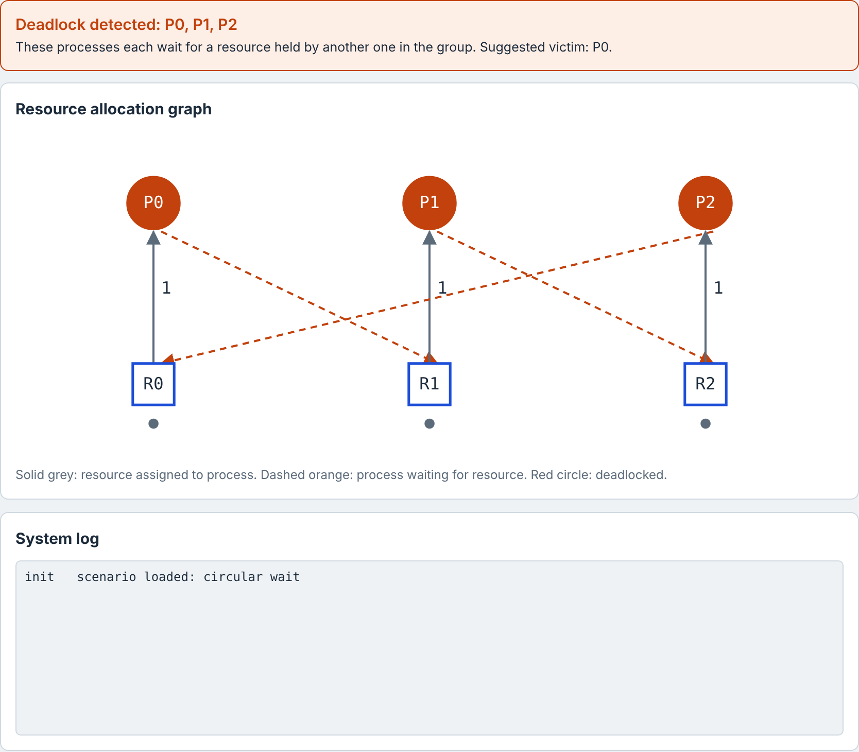
Fig. 7.1 Circular wait scenario: deadlock detected for P0, P1 and P2
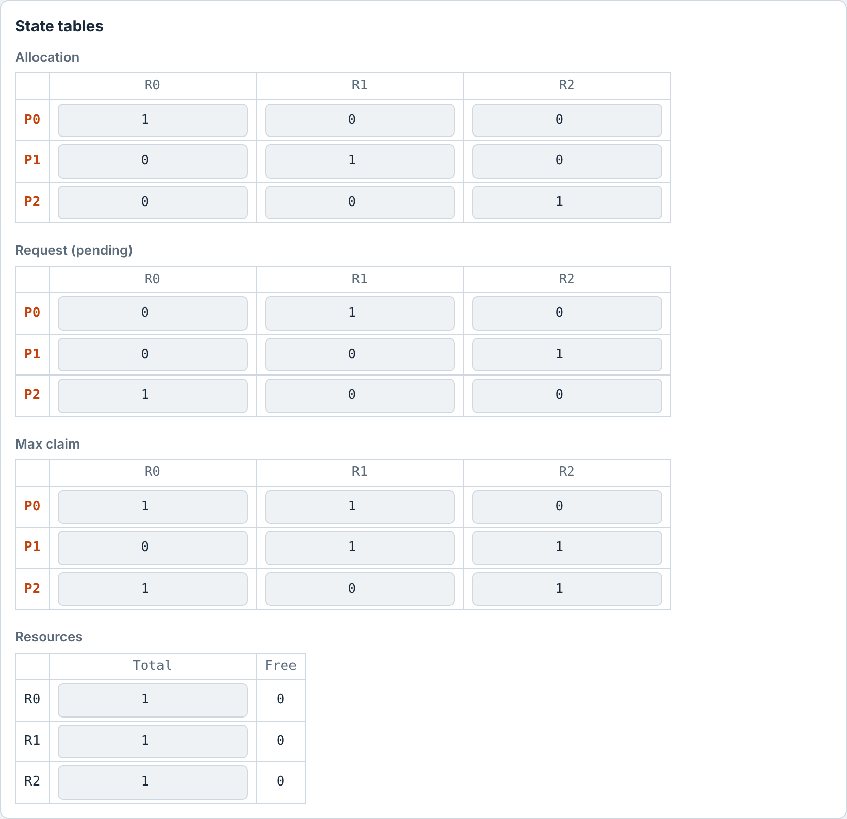
Fig. 7.2 State tables of the circular-wait scenario (Allocation, Request, Max, Resources)
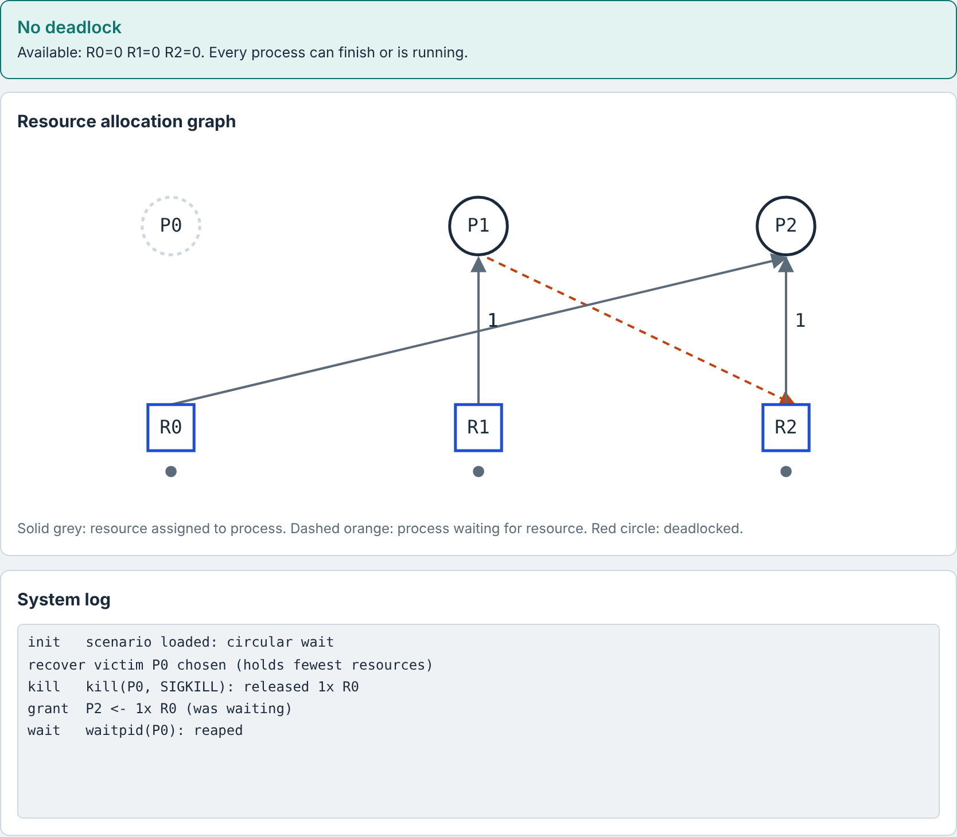
Fig. 7.3 After “Terminate suggested victim”: P0 terminated, R0 granted to P2, no deadlock
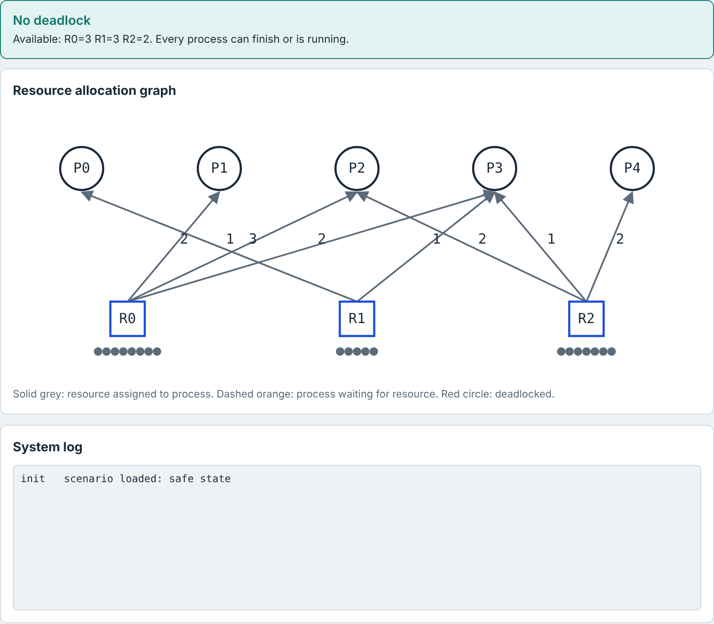
Fig. 7.4 Safe state scenario (5 processes, resources 10 / 5 / 7)
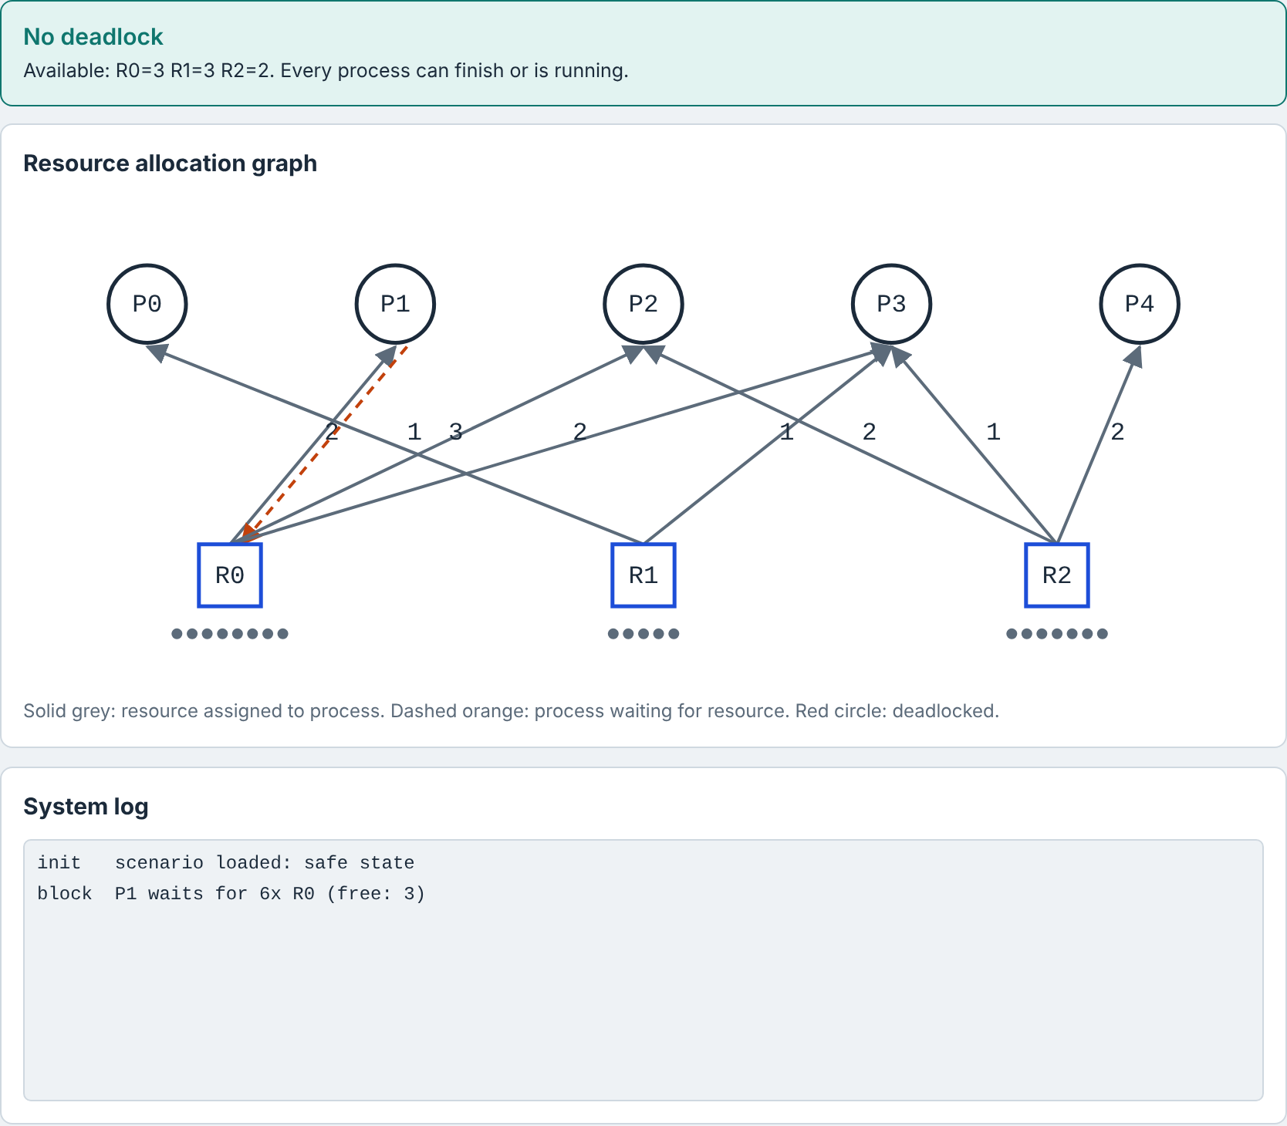
Fig. 7.5 Blocked request: P1 asks for 6 units of R0 while only 3 are free
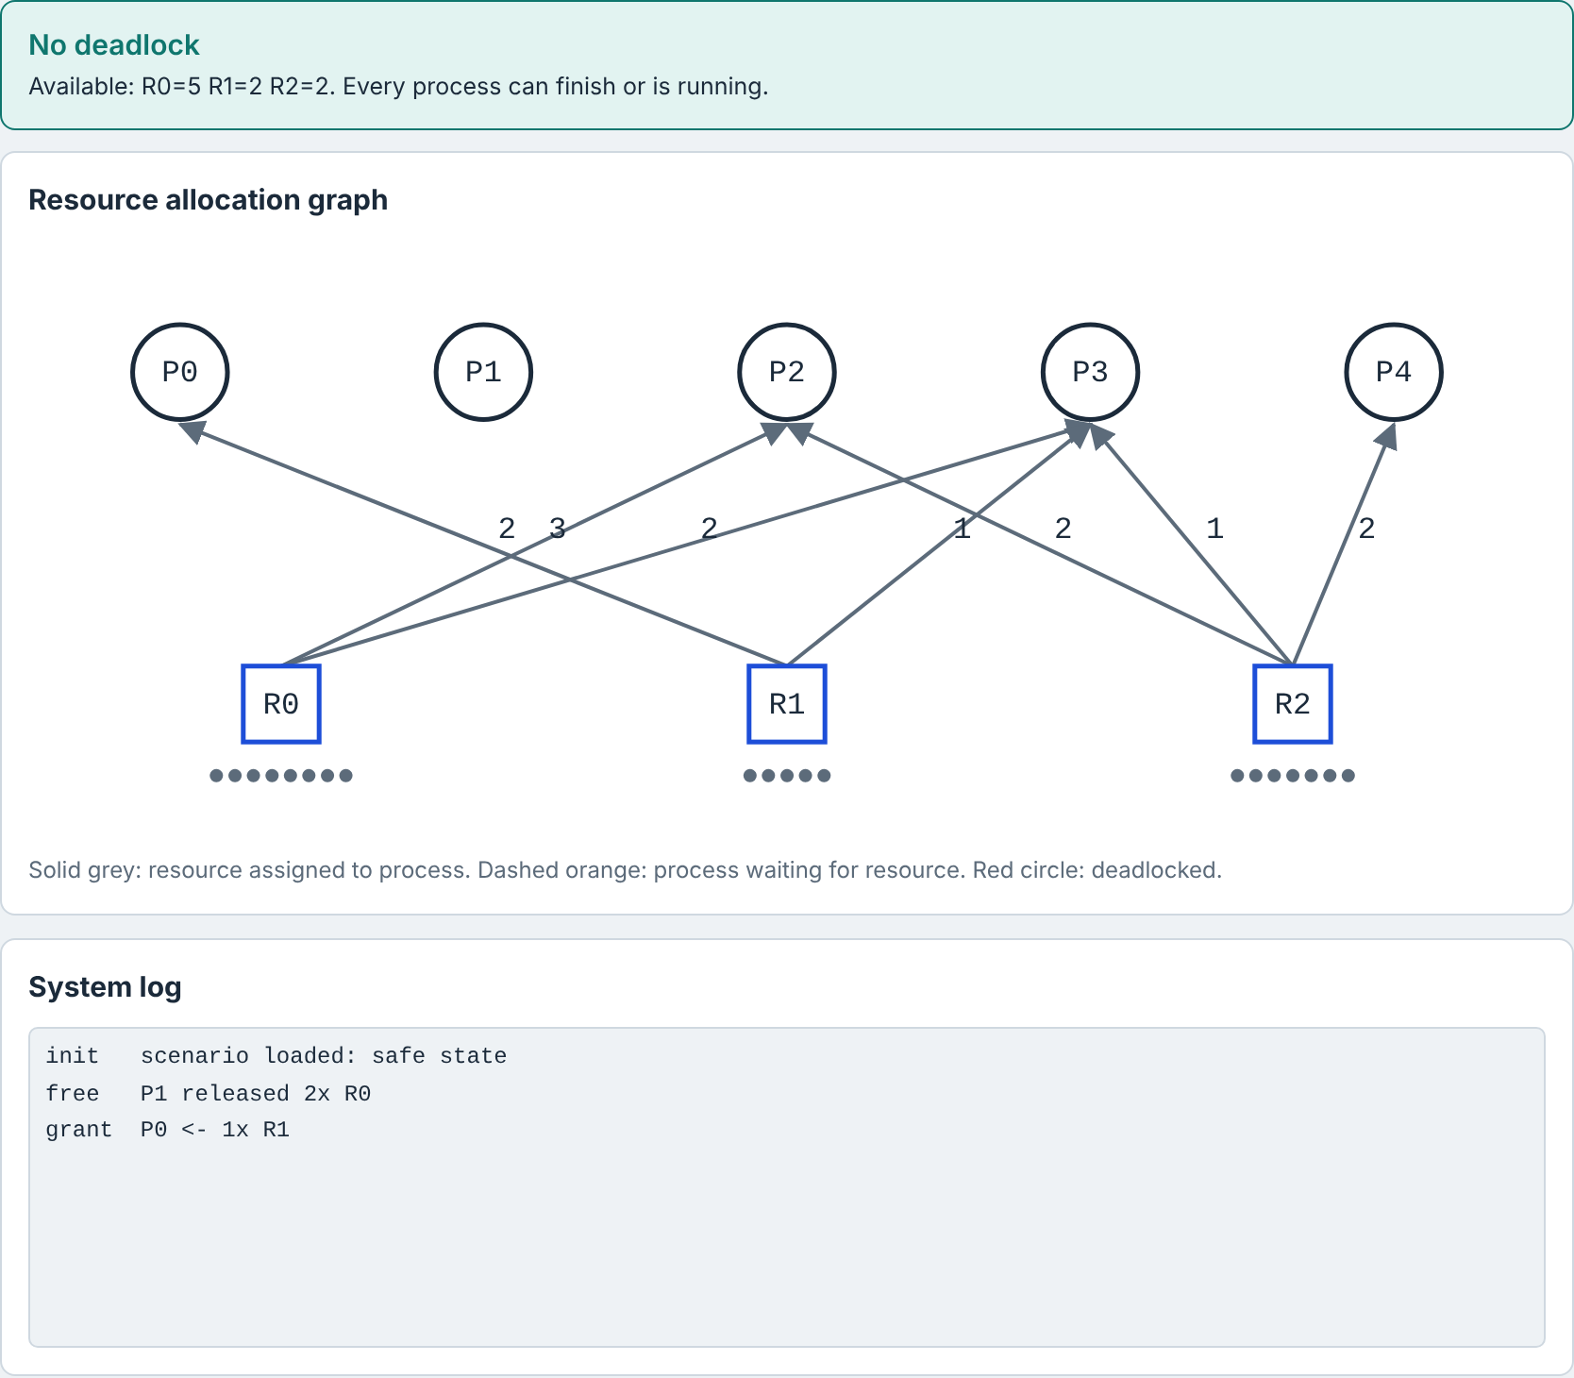
Fig. 7.6 Release and re-allocation: P1 releases 2 units of R0 and P0 is granted R1
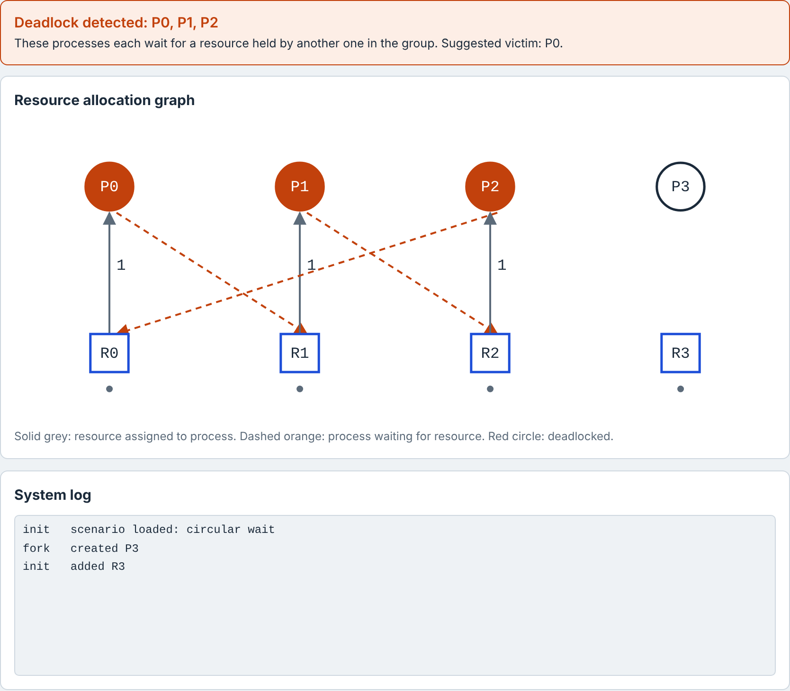
Fig. 7.7 Add process and Add resource: new process P3 and resource R3 added to the circular-wait scenario
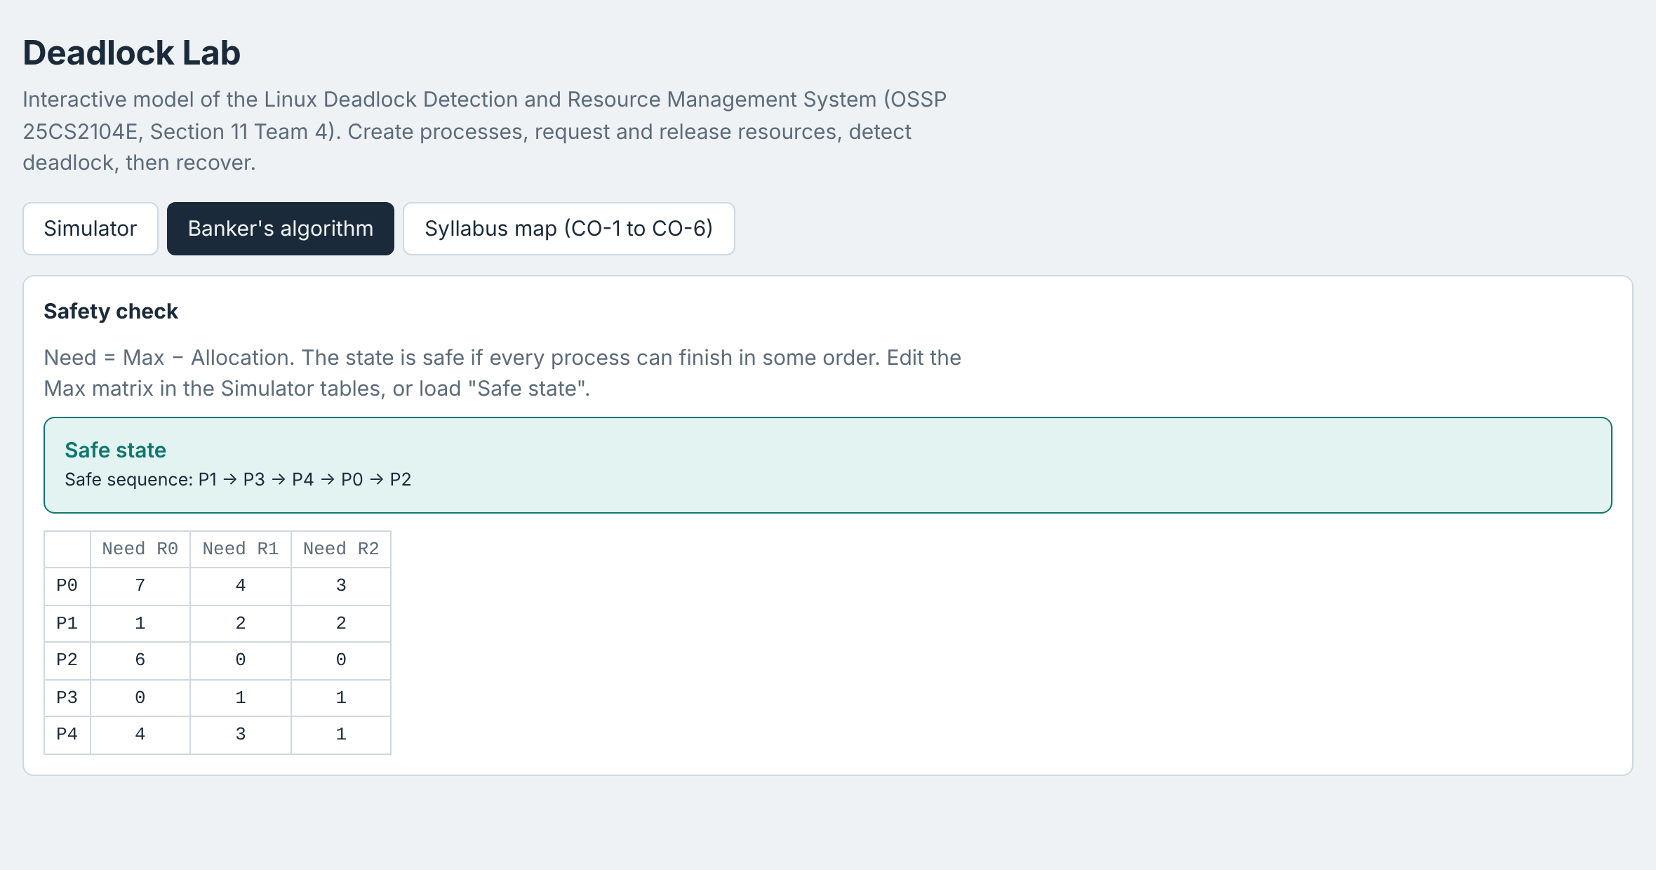
Fig. 7.8 Banker's algorithm: safe state with the safe sequence and Need matrix
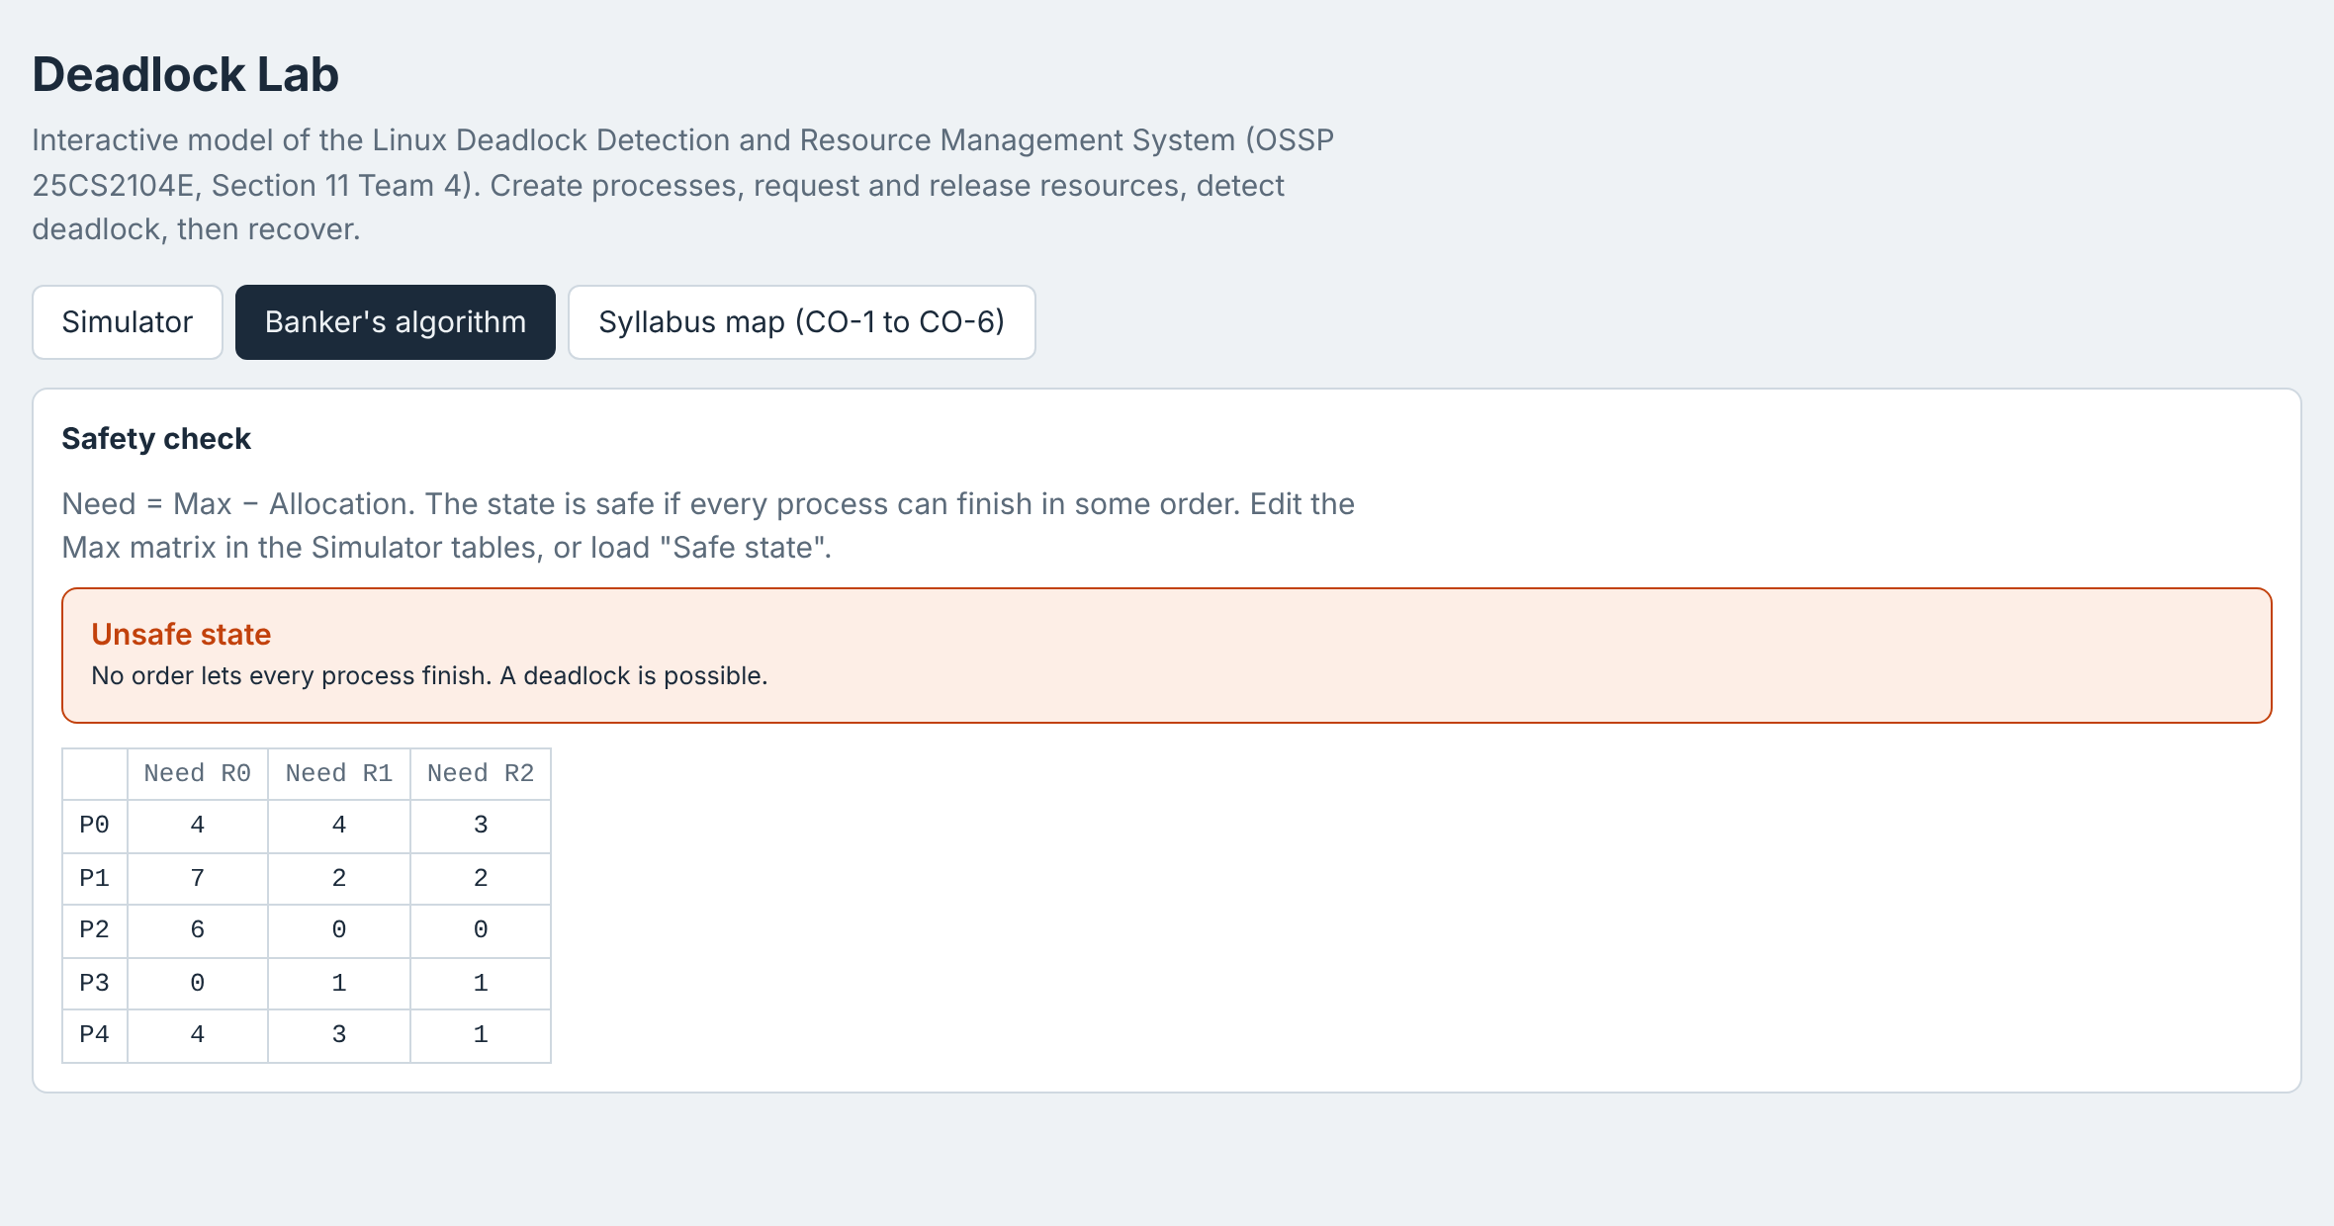
Fig. 7.9 Banker's algorithm: unsafe state after changing the Max claim and the allocation
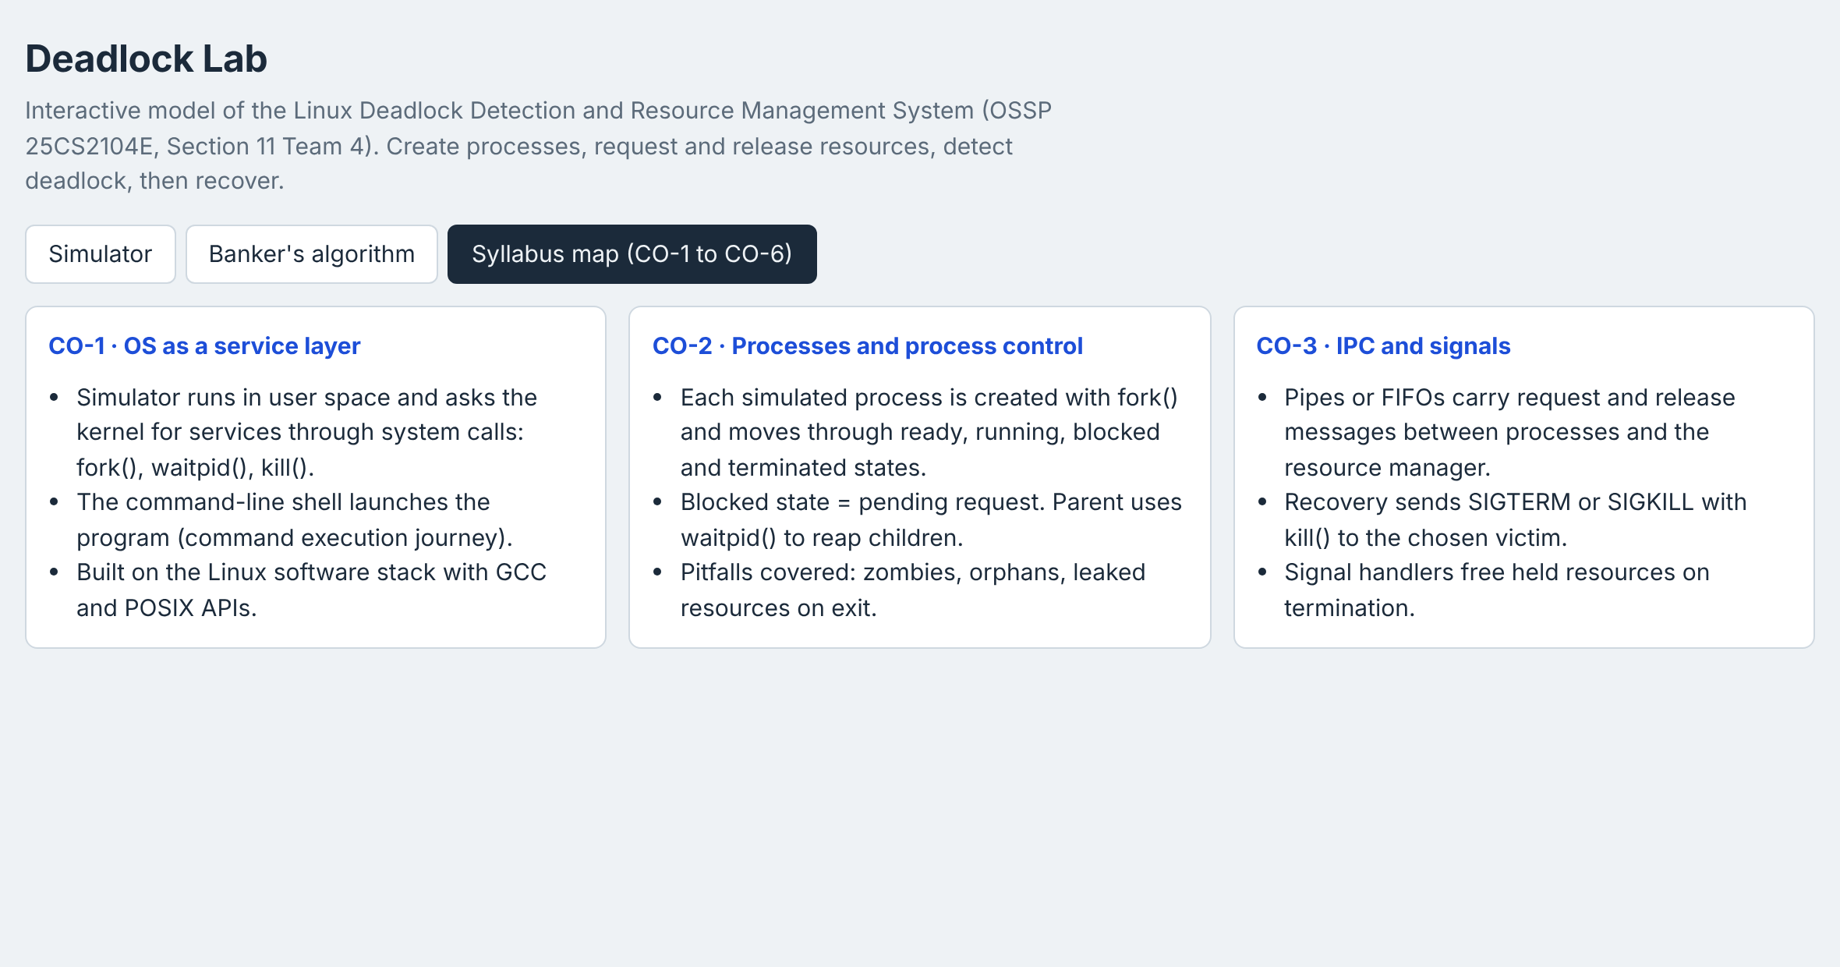
Fig. 7.10 Syllabus map tab linking the project to course outcomes
7.5 Demonstration of OS Concepts
Table 7.2 OS concepts demonstrated
OS concept | Where it is demonstrated
Processes and process states | Add process (fork), blocked / running / terminated states, kill and waitpid in the log.
Resource allocation and blocking | Request and Release buttons; pending requests in the Request matrix; Fig. 7.5.
Four necessary conditions | Circular-wait scenario: each process holds one resource (hold and wait, mutual exclusion) and waits in a cycle.
Deadlock detection | Status banner and red nodes in the graph (Fig. 7.1).
Deadlock recovery by process termination | Fig. 7.3: victim killed, resources released, waiting request granted.
Safe and unsafe states | Banker's tab (Figs. 7.8 and 7.9).
Signals and process control | kill(P, SIGKILL) and waitpid(P) messages in the system log.

CHAPTER 8
CONCLUSION
8.1 Summary of the Project
The Linux Deadlock Detection and Resource Management System simulates multiple processes competing for limited resources, monitors allocation and requests, detects deadlocks with the matrix-based detection algorithm, identifies the deadlocked processes, and recovers by terminating a victim process. A Banker's safety check and a resource allocation graph make the state easy to understand. The simulator is delivered as an interactive web application and follows the system design of six cooperating modules.
8.2 Objectives Achieved
Table 8.1 Objectives and results
Objective | Status | Evidence
Simulate competing processes | Achieved | Add process / Add resource, Request and Release, blocking (Figs. 7.4 – 7.7)
Detect deadlock conditions | Achieved | detect() and the status banner (Fig. 7.1)
Identify involved entities | Achieved | Deadlocked processes listed and drawn in red in the graph (Fig. 7.1)
Enable recovery | Achieved | Terminate suggested victim or chosen process (Fig. 7.3)

8.3 Results Achieved
• The circular-wait scenario is detected correctly and all three deadlocked processes (P0, P1, P2) are reported.
• Terminating the suggested victim P0 releases R0, the waiting request of P2 is granted, and the system returns to a state with no deadlock.
• The Banker's check finds the safe sequence P1 → P3 → P4 → P0 → P2 for the classic example and reports an unsafe state when the claims are changed.
• Pending requests are queued and served automatically as soon as resources are released.
• Detection and safety checks run in O(n² · m) time, which is instant for the sizes used in the lab.
8.4 Skills and Learning Outcomes
• Understanding of processes, resources and the four necessary conditions for deadlock.
• Ability to implement detection, safety-check and recovery algorithms on matrix state.
• Understanding of Linux process control: fork(), waitpid() and kill() with signals.
• Use of the Linux toolchain (Ubuntu, terminal, GCC, Git, GitHub, VS Code).
• Teamwork, documentation and presentation skills.
Limitations and Future Work
• Replace the simulated processes with real Linux processes created with fork(), communicating with the resource manager over pipes or FIFOs and terminated with kill().
• Add more victim-selection policies (lowest priority, least progress, minimum cost) and resource preemption as a second recovery strategy.
• Add a deadlock-avoidance mode that refuses unsafe requests using the Banker's algorithm.
• Extend the model to POSIX threads and mutexes.

CHAPTER 9
REFERENCES
9.1 Books
1. A. Silberschatz, P. B. Galvin and G. Gagne, Operating System Concepts, 10th ed., Wiley, 2018.
2. A. S. Tanenbaum and H. Bos, Modern Operating Systems, 4th ed., Pearson, 2014.
3. W. Stallings, Operating Systems: Internals and Design Principles, 9th ed., Pearson, 2018.
4. M. Kerrisk, The Linux Programming Interface, No Starch Press, 2010.
9.2 Research Papers
1. E. G. Coffman, M. Elphick and A. Shoshani, “System Deadlocks,” ACM Computing Surveys, vol. 3, no. 2, pp. 67–78, 1971.
2. R. C. Holt, “Some Deadlock Properties of Computer Systems,” ACM Computing Surveys, vol. 4, no. 3, pp. 179–196, 1972.
3. E. W. Dijkstra, “Cooperating Sequential Processes,” EWD123, Technische Universiteit Eindhoven, 1965.
9.3 Linux / GNU Documentation
1. Linux man-pages: fork(2), waitpid(2), kill(2), signal(7), https://man7.org/linux/man-pages/
2. GCC, the GNU Compiler Collection – Online Documentation, https://gcc.gnu.org/onlinedocs/
3. Ubuntu Documentation, https://ubuntu.com/server/docs
9.4 Online Resources
1. MDN Web Docs – JavaScript and SVG reference, https://developer.mozilla.org/
2. Visual Studio Code and Live Server extension, https://code.visualstudio.com/
3. Project GitHub repository: [insert repository link here]

