Application Specification Appendix
Water Booster Set - 3 Pumps (N+1)
VSD Control Panel - 3 x 30 kW | IP54 Floor Standing | Cascade PID | Modbus TCP | IEC 62443 Baseline

Version: v1.0 | Date: 2026-02-27

1. Purpose and How to Use
This document is a copy/paste-ready specification appendix intended for Design Firms to include in Concept/FEED and Basic Design packages. It defines a repeatable solution approach for a water booster application and enables early-stage prescription of the complete motor control solution (enclosures, protection, variable speed drives, control, communications, and testing).
This appendix is technology- and outcome-oriented, but references Schneider Electric solution families where applicable. Final product references (exact part numbers) shall be confirmed during detailed design by the System Integrator / Panel Builder according to local catalog, short-circuit levels, environmental conditions, and end-user standards.

2. Application Data Sheet
Application | Water Booster Set - 3 Pumps
Process objective | Maintain discharge pressure at setpoint across variable demand
Motor configuration | 3 pumps x 30 kW each; redundancy N+1 (one pump available as standby)
Starter type | Variable Speed Drive (VSD) for each pump
Control mode | Cascade PID with staging/de-staging and automatic alternation
Enclosure | IP54 floor standing control panel (universal enclosure)
Communications | Modbus TCP (Ethernet) between PLC and drives; optional uplink to SCADA
Cybersecurity | Baseline requirements aligned with IEC 62443 principles (zones, accounts, logging)

3. Reference Architecture
The reference architecture below provides a typical power and control arrangement for a 3-pump booster set with VSD control. It is intended as an early-stage template. The detailed GA, heat dissipation, cable entry, and assembly details shall be provided by the selected panel builder.
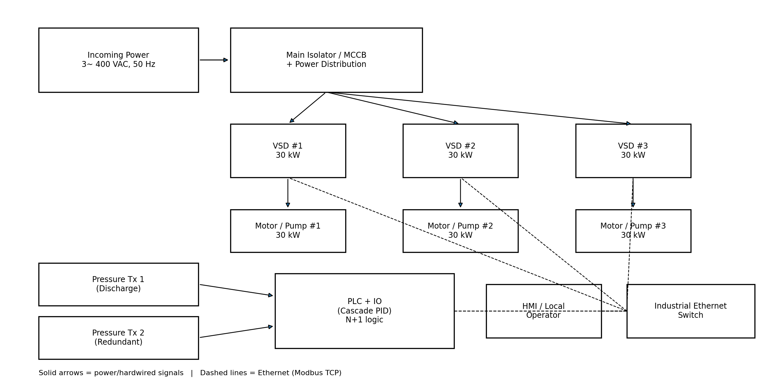
Figure 1 - Reference architecture (power + controls + Modbus TCP).

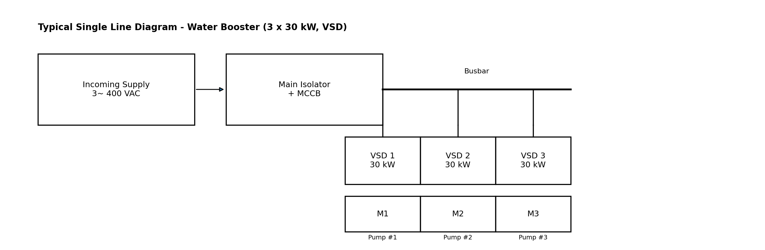
Figure 2 - Typical single line diagram (concept).

4. Panel Scope and Deliverables
The booster control panel assembly shall include, as a minimum:
- Main incoming isolator and/or MCCB sized for the panel maximum demand and fault level.
- Three (3) VSD feeders sized for 30 kW motors, including appropriate upstream protection and isolation as per applicable standards.
- PLC with sufficient Ethernet capability and I/O for pressure feedback, permissives, local controls, and alarms.
- Local operator interface (HMI) and basic local controls (e.g., Auto/Off/Hand selector, Reset, Emergency stop where required).
- Industrial Ethernet switch for Modbus TCP network connectivity (drives + PLC + HMI).
- Panel auxiliaries: 24 VDC power supply, control protection, terminal blocks, labeling, earthing, and service accessories (lighting/heater as required).
- Documentation set: electrical drawings, I/O list, network IP plan, PLC/HMI backups, FAT/SAT records.

5. Electrical Requirements (Copy/Paste Spec Clauses)
5.1 Enclosure and Assembly
- The control panel enclosure shall be floor standing with minimum ingress protection rating IP54 and suitable for indoor technical room installation unless stated otherwise.
- The enclosure shall include a gland plate (or equivalent) for bottom cable entry, earthing bar, and provision for safe maintenance access.
- The panel builder shall provide thermal management (fan/filter or air conditioning as required) to maintain component temperatures within manufacturer limits at site ambient conditions.
- All components shall be clearly labeled; wiring shall be ferruled and identified in accordance with the drawings.
- The assembly shall be designed, manufactured, and tested in accordance with applicable IEC requirements for low-voltage switchgear and controlgear assemblies (e.g., IEC 61439 where applicable).
5.2 VSD Feeders
- Each pump motor shall be controlled by an individual VSD suitable for 30 kW motor duty and the supply network characteristics (voltage, frequency, short-circuit level).
- The VSD shall support network control and monitoring via Modbus TCP and shall expose key operating data (run status, speed reference, current, power, energy, and fault codes).
- The design shall include appropriate upstream protection and isolation for each VSD feeder; additional line/reactor or harmonic mitigation devices shall be included where required by grid code, EMC, or harmonic limits.
- Motor cable length limits and output filtering (e.g., dv/dt filter) shall be addressed during detailed design based on site layout.
5.3 Control Power and Auxiliaries
- The panel shall include a 24 VDC control power supply sized for PLC, HMI, network devices, and field instrumentation loops as required.
- An emergency stop function (if specified by the end user) shall remove run permission from all drives and place the system into a safe state.
- Door interlock and maintenance mode provisions shall be implemented as required by local regulations and end user standards.

6. Control Philosophy - Cascade PID (Booster Set)
The booster set shall maintain discharge pressure at a configurable setpoint using cascade PID control and automatic staging of pumps. The PLC shall coordinate drive start/stop and speed references over Modbus TCP.
Minimum functional requirements:
- PID pressure control using a primary discharge pressure transmitter; automatic fallback to redundant transmitter upon fault/out-of-range.
- Pump staging: start Lead pump on demand; add Lag pumps when pressure cannot be maintained (e.g., Lead speed above high threshold for a time delay).
- Pump de-staging: stop Lag pumps when demand decreases (e.g., average speed below low threshold for a time delay) while maintaining stable pressure control.
- Automatic alternation of Lead/Lag duty to equalize runtime and support N+1 redundancy (one pump available as standby).
- Anti-short-cycle logic: minimum run time and minimum stop time per pump.
- Sleep mode (optional): if no demand (stable pressure at low speed limit) the system may stop all pumps and restart on pressure drop.
- Permissives and interlocks: suction pressure permissive (if provided), valve position permissives (if provided), local emergency stop, drive healthy status.
- Failover: if any pump/drive becomes unavailable, remaining pumps shall continue to control pressure subject to capacity.

7. Communications - Modbus TCP
The PLC shall act as Modbus TCP client/master. Each VSD shall be a Modbus TCP server. The network shall be designed for deterministic control, with segregation from corporate networks.
- Each drive shall have a unique IP address; an IP plan shall be delivered as part of the documentation set.
- Minimum data exchanged per drive: start/stop, speed reference, control mode, run feedback, speed feedback, current, power, energy, fault status, and fault code.
- Loss of communications shall generate an alarm and drive/run commands shall fail to a defined safe state (configurable).

8. Cybersecurity Baseline (IEC 62443-aligned)
This project shall implement baseline cybersecurity controls consistent with IEC 62443 principles. These requirements are written to be achievable for typical water booster deployments while improving security by design.
- Define zones and conduits: (1) Booster Control Panel zone (PLC, drives, HMI, switch); (2) Site Operations zone (SCADA/operations); (3) Corporate zone.
- Unique user accounts on PLC/HMI where supported; role-based access; default passwords shall be changed at commissioning.
- Network segmentation: booster control network shall be separated from corporate networks (VLAN/firewall/industrial DMZ where applicable).
- Disable unused services and ports; maintain an inventory of firmware/software versions.
- Event logging: security-relevant events (login attempts, configuration changes, comms loss) shall be logged and available for export.
- Remote access (if required) shall use secure methods with MFA and audit trail; no direct inbound access to control network from the internet.

9. FAT/SAT - Minimum Acceptance Tests
Factory Acceptance Test (FAT) - minimum scope:
- Visual inspection: wiring, labeling, earthing, component installation, enclosure integrity.
- Electrical tests: continuity, insulation, protective earth verification (per applicable standards).
- Network tests: verify Modbus TCP communications to each VSD; validate data exchange list.
- Functional tests (simulation where necessary): pump staging/de-staging, alternation, permissives, alarms, fallback to redundant pressure transmitter.
- HMI tests: start/stop, setpoint entry, alarm acknowledgement, runtime counters, status screens.
Site Acceptance Test (SAT) - minimum scope:
- Verify field wiring termination and correct motor rotation.
- Verify pressure transmitter calibration and signal scaling.
- Prove PID stability and staging thresholds under representative demand conditions.
- Prove redundancy behavior (simulate one pump/drive unavailable).
- Confirm alarm annunciation to local HMI and (if applicable) SCADA.

Appendix A - Asset Pack Contents
This appendix is intended to be used with the following asset files:
- SpecTextBlocks.txt - copy/paste clauses for tenders
- ApplicationPack.xlsx - I/O list, alarm list, BOM template, network IP plan
- 01_Reference_Architecture.pdf/.png - reference architecture figure
- 02_Single_Line_Diagram.pdf/.png - single line figure

