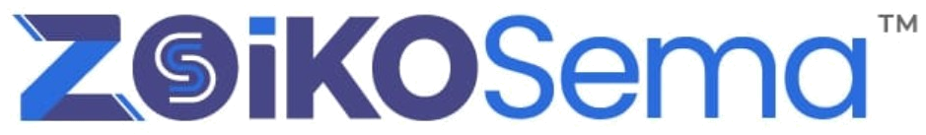
SEMA GUIDE
About Sema Guide
Canonical Detailed Wireframe & Engineering Handoff
Authoritative identity, capability, authority, limitation, governance and human-support disclosure
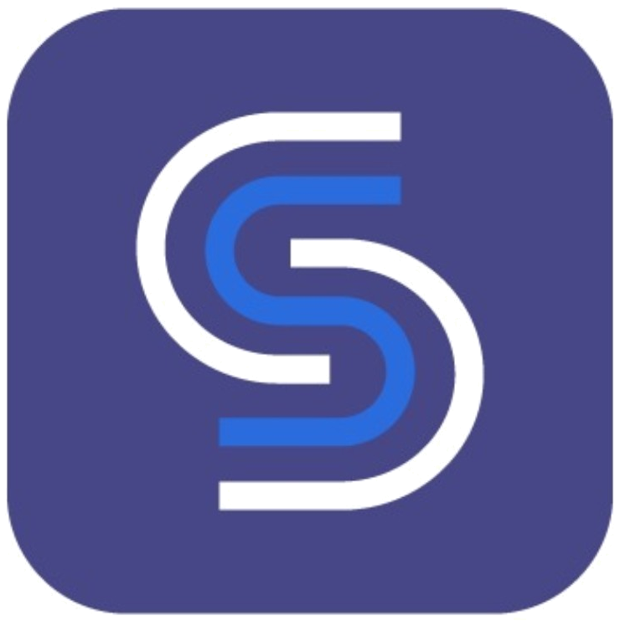
Implementation Baseline
APPROVED DESIGN DIRECTION
American English • July 14, 2026 • Zoiko Group Internal
Document control | Value
Document ID | ZS-SG-ABOUT-01
Version | 1.0
Status | Implementation Baseline
Owner | Zoiko Sema Product and Engineering
Primary consumers | Product, Front-End, Back-End, AI, Support, Security, Privacy, QA, Accessibility
Related specification | ZS-SG-PRIV-01 — Privacy & data
Classification | Zoiko Group Internal — Product and Engineering
Language | American English

1. Executive Lock Statement
CANONICAL DECISION
The overflow-menu item remains About Sema Guide. It opens an in-product, server-authored identity and capability disclosure—not a marketing page, generated biography, model card, or duplicate privacy center.

The surface must allow a user to determine, without leaving the conversation, what Sema Guide is, what it can do now, what information it may use in the current session, which actions it may perform, which limits apply, how it is governed, and how to reach a person.
1.1 Final user-facing identity
Layer | Canonical value
Menu label | About Sema Guide
Screen title | About Sema Guide
Agent name | Sema Guide
Classification | AI support and product guidance agent
Persistent disclosure | AI badge plus explicit text: Sema Guide is an AI system, not a human representative.
Internal surface key | sema_guide_about
Authoritative owner | Sema Guide registry and AI governance services

1.2 Non-negotiable product rules
- All identity, status, capability, access, policy and version values are returned by authoritative services; the language model must not describe itself from memory.
- The screen shows current capability, not the maximum theoretical capability of the platform.
- Privacy & data remains the authoritative detailed privacy surface; About provides summary state and deep links.
- A human-support route is present without requiring failed AI turns.
- Unknown states remain Unknown or Unavailable; they never default to Operational, Allowed, No access or Safe.
- Official Zoiko Sema logo and favicon assets are used without redrawing, recoloring or substitution.
2. Critical Analysis and Refinements Incorporated
Baseline issue | Refinement | Engineering consequence
The earlier design risked becoming a long static description. | Convert it into a live, state-driven disclosure surface with “verified” timestamps. | Client renders an About view model returned by a dedicated API.
Capability language could overstate what is currently enabled. | Use “What Sema Guide can do now” and filter by identity, role, plan, policy, region, flags and tool health. | Capability registry must return allowed, blocked, degraded and unavailable states.
Information-access wording was too generic. | Show current-session access summary and deep-link to Privacy & data → Current session. | Runtime access service is authoritative; no duplicated privacy logic.
Action governance lacked a clear authority ladder. | Adopt Classes A–E: informational, navigational, reversible, consequential and prohibited. | Tool registry declares risk class, confirmation and execution policy.
Version disclosure could expose sensitive infrastructure. | Expose product, experience, policy and knowledge revisions; conceal model routing, prompts and topology. | Response schema separates public version metadata from internal diagnostics.
AI limitations could read as boilerplate. | Connect limitations to source verification, current service state and specialist escalation. | Unverified answers carry explicit labels and a human route.
Governance and privacy content could duplicate each other. | Keep governance summary in About; detailed purposes, retention, training and rights remain in Privacy & data. | Deep links are canonical and context-preserving.
A green dot alone was ambiguous. | Pair every status indicator with text and last-verified metadata. | Accessibility and stale-state requirements are testable.

3. Scope, Users and Non-Goals
3.1 In scope
- Public website, authenticated workspace, desktop app and mobile app.
- Anonymous, authenticated member, workspace administrator, in-meeting help and Confidential Mode variations.
- Agent identity, current capabilities, current access summary, authority boundary, limitations, sources, governance, service information and human support.
- Desktop, tablet and mobile presentation.
- Runtime APIs, authorization, audit, accessibility, failure states, QA and release gates.
3.2 Out of scope
- Detailed processing purposes, retention schedules, deletion and privacy-request workflows; those remain in Privacy & data.
- Full legal terms, privacy notices, security reports or data-processing agreements.
- Agent-administration console design beyond contextual administrator links.
- Human support console design beyond transparent handoff and identity state.
- Marketing claims, personality biography, anthropomorphic backstory or model-vendor promotion.
3.3 Primary user questions
- What is Sema Guide, and am I speaking with AI or a person?
- What can it do for me right now?
- What information can it access in this session?
- Can it make changes, and when must I approve them?
- What should I verify or escalate?
- Which organization and policy control it?
- How do I reach a person?
4. Implementation Doctrine
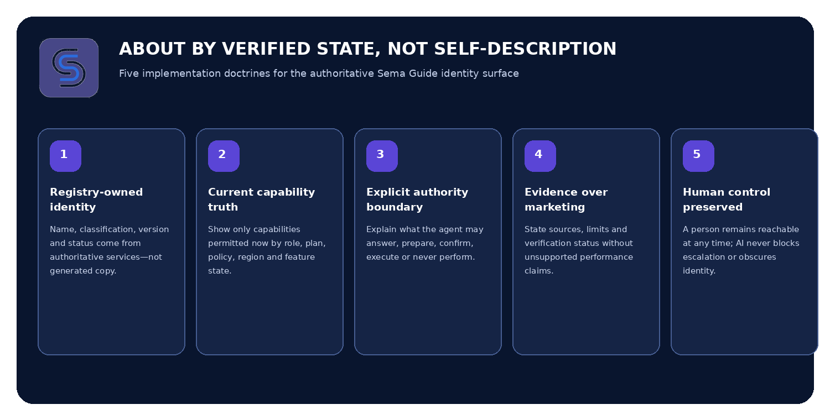
Figure 1. Required implementation doctrine for the About surface
5. Experience Architecture and Navigation
5.1 Navigation model
Control | Behavior | Preserved state
About Sema Guide | Replaces conversation content inside the current Sema Guide shell. | Conversation, composer draft, attachments, tool and handoff state.
Back | Returns to the exact prior conversation position. | Scroll position and pending draft.
Close | Closes the entire Sema Guide panel. | Session remains subject to retention policy; no implied deletion.
Privacy & data | Deep-links to the relevant subsection. | Identity and session context revalidated.
Talk to a person | Starts the governed sharing-and-handoff workflow. | User reviews what will be shared.
Service status | Opens the status surface without ending the conversation. | Current session remains active.

5.2 Information architecture
- Agent identity and current availability.
- What Sema Guide can do now.
- Current-session information access.
- Actions and authorization.
- Important limitations and verification.
- Human support.
- Sources and answer quality.
- Workspace governance.
- Service information and related resources.
5.3 Performance and freshness targets
Metric | Target | Safe fallback
Shell transition | Interactive within 300 ms from local navigation. | Render shell with skeleton state.
About view model | p95 within 900 ms; complete within 1.5 s. | Show Unavailable for unresolved fields after timeout.
Status freshness | Refresh on open, identity change, policy change, tool health change and handoff event. | Show last verified time and stale badge.
Deep-link return | Conversation restored within 200 ms. | Restore at top with preserved draft if exact scroll cannot be recovered.
Human route | Handoff review shown within 500 ms. | Offer support case or Help Center when live handoff is unavailable.

6. Canonical Desktop Wireframe
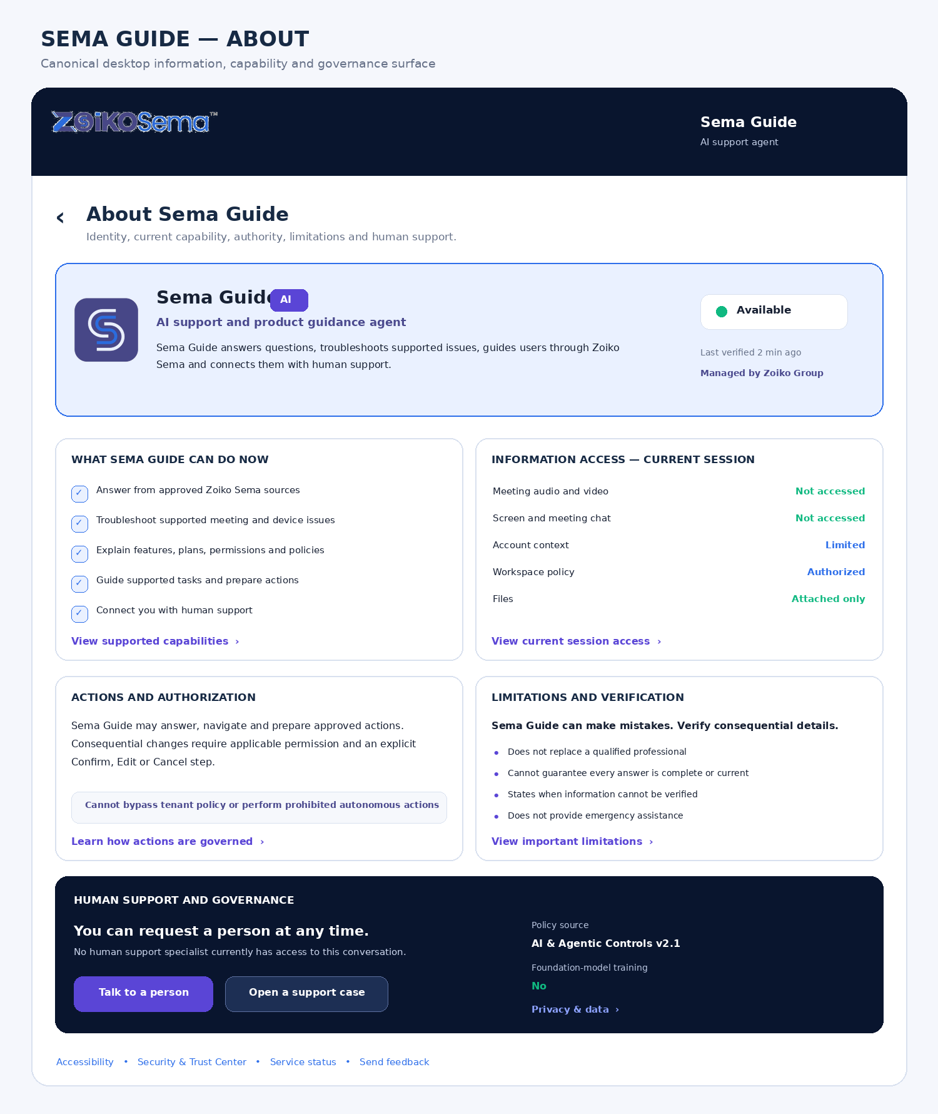
Figure 2. Canonical desktop About Sema Guide surface
6.1 Desktop layout specification
Element | Specification
Panel | 420–480 px in production; single scroll container; responsive inspection views may be wider.
Header | Sticky; back, title, Zoiko Sema subtitle and close.
Identity hero | Official favicon, Sema Guide, AI badge, explicit AI disclosure, availability, last verified and policy owner.
Primary cards | Capability and access presented above action governance and limitations.
Human support | High-visibility section; one-click route; current human-access state.
Footer | Accessibility, Security & Trust Center, service status and feedback; no dense legal link farm.

7. Component-Level UI Specification
7.1 Header
Component | Canonical copy | Behavior
Title | About Sema Guide | Level-one dialog heading; receives focus on open.
Subtitle | Zoiko Sema | Product parent; no duplicate full wordmark inside the secondary screen.
Back | Back to conversation | Preserves conversation state.
Close | Close Sema Guide | Does not delete, clear or end a support request.
Loading | Loading Sema Guide information | Announced once through a polite live region.

7.2 Identity hero card
REQUIRED DISCLOSURE
Sema Guide is an AI system, not a human representative.

Field | Allowed values | Source
Display name | Sema Guide | Agent registry
Classification | AI support and product guidance agent | Agent registry
Availability | Available; Limited; Connecting; Offline; Human specialist connected; Limited by Confidential Mode | Service health + session state
Last verified | Localized timestamp | About aggregation service
Managed by | Verified organization name or General Zoiko Sema policy | Tenant service
Agent version | Product/experience version only | Release registry

Status behavior
- Every colored indicator has a text label.
- Stale state is shown when verification exceeds the configured freshness window.
- Offline does not imply the broader Zoiko Sema service is offline.
- When a human specialist takes over, the human identity becomes primary and Sema Guide moves to background-assist status.
7.3 What Sema Guide can do now
The card displays only capabilities available in the current context. It must not be static marketing copy.
Capability domain | Examples | Display gate
Answers | Approved product, plan, policy and status information. | Approved knowledge source and response policy available.
Troubleshooting | Meeting join, microphone, camera, speaker and supported product issues. | Diagnostic and support flows enabled.
Guidance | Settings, workflows, entitlements and feature restrictions. | User can access the destination.
Action preparation | Draft support case, schedule preview, supported preference change. | Tool enabled and user authorized.
Human support | Live handoff or case creation. | Applicable channel available.
Administration | Roles, policy and audit guidance. | Authorized administrator role only.

Capability states
State | Presentation
Available | Show in primary list.
Available with confirmation | Show with confirmation icon or supporting text.
Managed by organization | Show lock and controlling organization.
Unavailable on plan | Show only when useful, with entitlement explanation; no deceptive CTA.
Blocked by policy | Show when the user attempted or asked about it; explain policy.
Temporarily degraded | Show status and safe alternative.
Unknown | Do not advertise; show capability information unavailable when relevant.

7.4 Current-session information access
ARCHITECTURAL RULE
About displays a concise runtime summary. Privacy & data → Current session is the only detailed access ledger.

Category | Possible values | Rule
Conversation messages | In use; Not retained; Unavailable | Needed to answer current request.
Account context | Not available; Limited; Authorized; Unavailable | Minimum necessary scope.
Workspace policy | Not available; Authorized; Managed; Unavailable | Never infer from email domain alone.
Meeting metadata | Not accessed; Limited; Authorized; Unavailable | State exact metadata class in detailed view.
Meeting audio/video | Not accessed; Authorized feature access; Unavailable | Opening Sema Guide alone never grants access.
Screen/chat/files | Not accessed; Attached only; Explicitly authorized; Unavailable | No implicit capture.
Diagnostics | Not shared; Shared with consent; Expired; Unavailable | Consent record required.
Human access | None; Requested; Waiting; Active; Ended; Unavailable | Unknown never becomes None.

CANONICAL MEETING STATEMENT
Opening Sema Guide does not automatically give it access to meeting audio, video, chat, shared screens, files, transcripts or recordings.

7.5 Actions and authorization
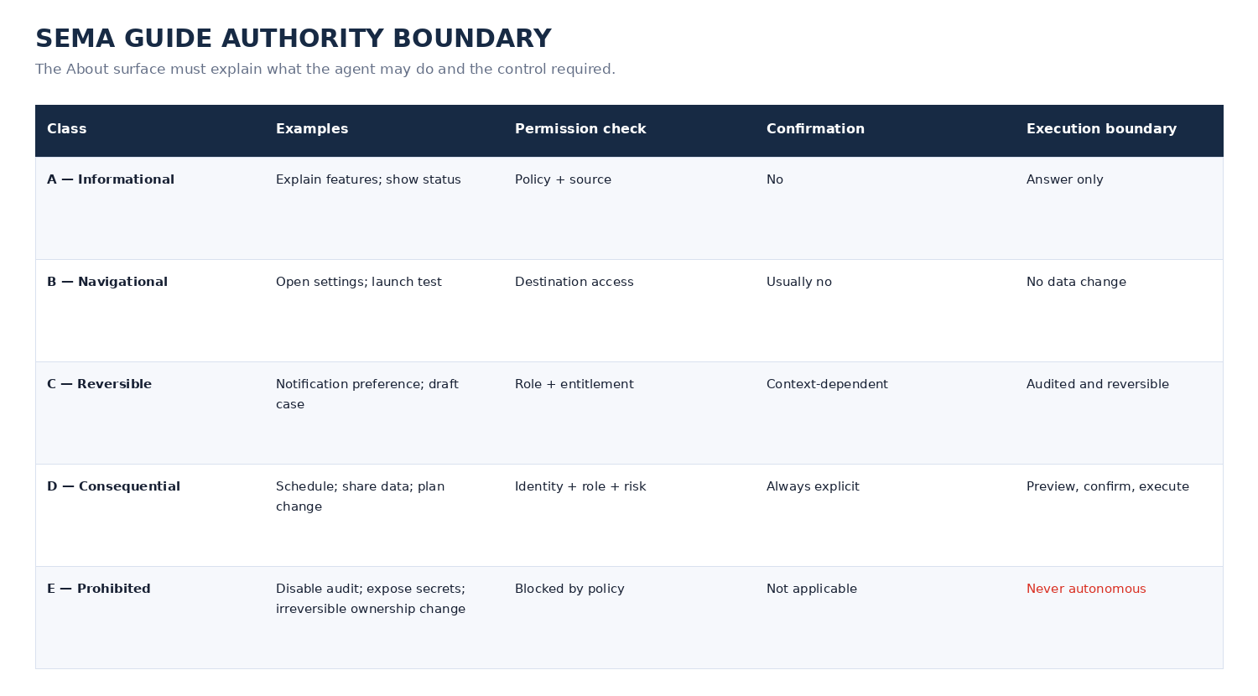
Figure 3. Authority classes and confirmation boundary
Action preview contract
- What will change.
- Which user, account, workspace or meeting is affected.
- Cost, entitlement, privacy or policy impact.
- Information that will be shared.
- Confirmation requirement and reversibility.
- Confirm, Edit and Cancel choices.
Prohibited autonomous actions
- Delete an organization or account.
- Remove the final owner or security administrator.
- Disable audit, retention, identity or security controls.
- Reveal secrets, confidential records or unrelated meeting content.
- Make irreversible financial or legal commitments.
- Override tenant policy, entitlement or deny decisions.
7.6 Limitations and verification
CANONICAL SUMMARY
Sema Guide can make mistakes. Verify consequential details before relying on them.

Limitation | Required behavior
Unverified fact | State Unable to verify; offer sources or human support.
Outdated or conflicting source | Show date and conflict; do not silently choose a favorable source.
Tool unavailable | State that no action occurred; offer retry or manual path.
Professional advice | Provide safe general guidance and route to a qualified specialist; no professional representation.
Emergency | Direct user to appropriate emergency or security channel; do not continue ordinary troubleshooting.
Complex or sensitive matter | Offer human review and explain what context may be shared.

7.7 Human support
The About surface must contain a visible human route and current human-access state.
State | Primary presentation | Actions
No human access | No support specialist currently has access. | Talk to a person; Open a support case.
Handoff review | Choose what will be shared. | Share and connect; Edit; Cancel.
Waiting | Queue and estimated wait where reliable. | Leave a message; Cancel request.
Human connected | Human name, role, organization and connection time. | End human access; View sharing details.
AI background assist | Sema Guide is assisting the human in the background. | View AI role; Pause AI assist where policy permits.
Unavailable | Live support unavailable. | Open support case; Help Center; service hours.

7.8 Sources and answer quality
Source priority | Source class | User-facing label
1 | Active tenant policy | Based on your workspace policy
2 | Authenticated account and entitlement data | Based on your account
3 | Approved Zoiko Sema documentation | Verified from Zoiko Sema
4 | Live service status | Based on current system status
5 | Approved support procedures | Zoiko Sema support guidance
6 | Approved integration documentation | Verified integration guidance
7 | External source, only when enabled | External source — not official Zoiko Sema information

How answers are generated
- Interpret the user request.
- Resolve identity, role, entitlement and policy.
- Retrieve approved knowledge or authorized runtime data.
- Call permitted tools where necessary.
- Compose a response.
- Validate against safety, policy and source requirements.
- Return the answer with verification state and sources when available.
7.9 Governance summary
Field | Example | Rule
Workspace | Zoiko Group | Verified tenant name only.
Policy source | AI and Agentic Controls v2.1 | Deep-link where authorized.
Tool execution | Restricted | Derived from policy and capability registry.
Foundation-model training | No | Summary only; detailed explanation in Privacy & data.
Optional improvement | Off | Display managed state.
Human access | None active | Runtime state.
Retention | 30 days | Summary with deep link; no hard-coded client value.
Processing region | Europe | From residency service.
Confidential Mode | Enforced | Show exact restrictions.

7.10 Service information
Public field | Example | Do not expose
Product version | 1.0 | Internal model or prompt version.
Experience version | 2026.07 | Private deployment pipeline identifiers.
Client version | Web 1.18.4 | Internal API topology.
Knowledge revision | July 14, 2026 | Proprietary evaluation data.
Policy version | SG-POL-1.0 | Private rule IDs.
Service status | Operational | Raw infrastructure health details.
Processing region | Europe | Network location or IP data.
Conversation reference | Masked external reference | Full database identifiers or trace IDs.

8. Responsive and Contextual Variations
8.1 Mobile wireframe
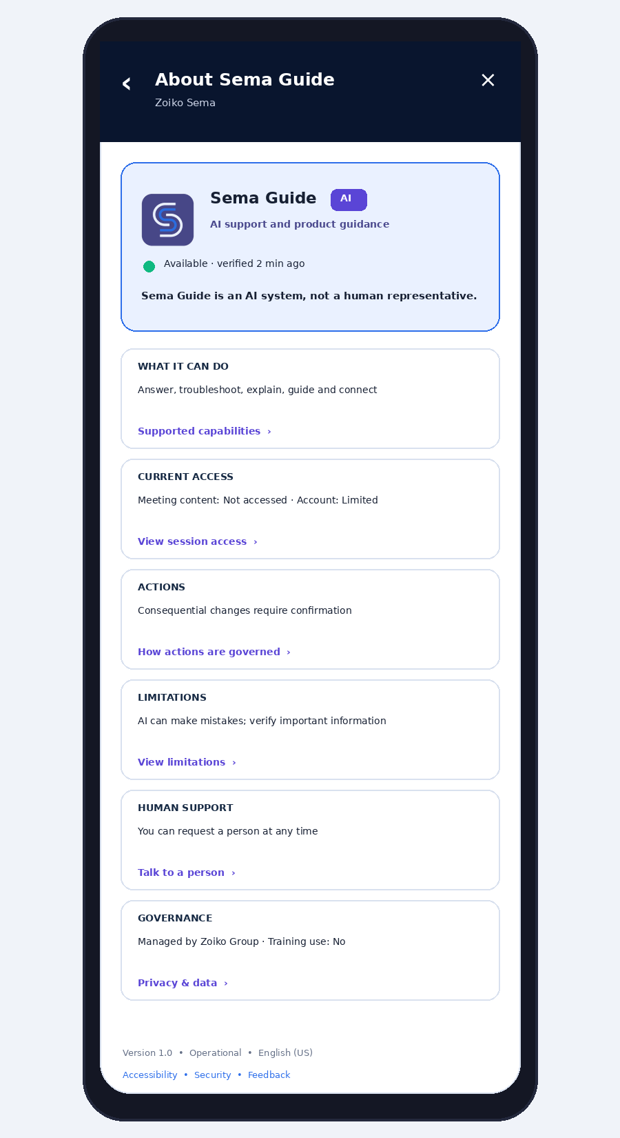
Figure 4. Canonical mobile About Sema Guide screen
Requirement | Mobile behavior
Presentation | Full-screen sheet; never a narrow nested popover.
Header | Sticky with back and close.
Content | Single column; primary cards collapsed to concise summaries.
Detail | Accordions or secondary routes; no dense tables.
Actions | Minimum 44 × 44 px targets; primary human route visible without excessive scrolling.
State return | Native back returns to the prior conversation and preserves draft.
Safe area | Composer and action sheets respect device safe areas.

8.2 Context matrix
Context | Identity/policy | Capability behavior | Access summary | Additional disclosure
Anonymous | General Zoiko Sema policy; no tenant assumption. | General help only; sign-in for account-specific actions. | Account and workspace unavailable. | Session token and general privacy links.
Authenticated member | User + verified workspace. | Plan, role and policy-filtered. | Authorized account/workspace state. | Managed settings and current retention summary.
Workspace administrator | Admin role + tenant policy. | Administrative guidance; tool execution remains governed. | Admin context limited to authorized scope. | Admin links, audit and quality controls.
In-meeting help | Meeting and workspace policy. | Device, connection, control and policy guidance. | No meeting content by default. | Exact meeting metadata scope.
Confidential Mode | Policy locked. | Device and policy help only. | No audio, video, chat, screen, file, transcript or recording access. | Restrictions cannot be overridden.

9. Confidential Mode Specification
REQUIRED BANNER
Confidential Mode active. Sema Guide can help with device settings, connection issues, meeting controls and policy explanations, but cannot access meeting audio, video, chat, shared screens, files, transcripts, recordings or AI-generated meeting content.

- The banner appears immediately after the identity hero.
- The capability list removes or marks unavailable any content-dependent action.
- The access summary is policy-locked and cannot be overridden from Sema Guide.
- No attachment of confidential meeting content through the ordinary composer.
- Human handoff does not include meeting content unless a separate authorized workflow explicitly permits it.
10. Technical Architecture
Client surfaces
→ Sema Guide UI shell
→ About View API / Aggregator
→ Agent Registry
→ Identity + Tenant Service
→ Authorization + Entitlement
→ Capability + Tool Registry
→ Conversation Runtime Access Ledger
→ AI Governance + Policy Engine
→ Support Handoff Service
→ Service Status + Release Registry
→ Knowledge Revision Service
→ Residency Service
→ Policy / Safety Validator
→ About View Model
→ Audit + Telemetry

10.1 Architectural rules
- The UI consumes a single server-composed About view model; it must not assemble legal or governance conclusions from independent client calls.
- The aggregator fails closed for action permissions and fails explicit for display fields.
- No identity, capability or limitation text is generated by the conversational model.
- Capability and access states carry source, verified timestamp and freshness metadata.
- Deep links use opaque routes and revalidate authorization on destination.
- Cached About data is scoped by user, tenant, policy version, locale and client surface.
11. API and Data Contracts
11.1 About view response
{
"surface": "sema_guide_about",
"verified_at": "2026-07-14T14:18:00Z",
"freshness": "current",
"agent": {
"id": "sema-guide",
"display_name": "Sema Guide",
"classification": "ai_support_agent",
"status": "available",
"product_version": "1.0",
"experience_version": "2026.07"
},
"identity_context": {
"state": "authenticated",
"workspace_name": "Zoiko Group",
"role": "workspace_owner",
"plan": "enterprise"
},
"capabilities": [
{"id":"answer_questions","state":"available","authority_class":"A"},
{"id":"schedule_meeting","state":"available_with_confirmation","authority_class":"D"}
],
"current_access": {
"meeting_audio": "not_accessed",
"meeting_video": "not_accessed",
"shared_screen": "not_accessed",
"account_context": "limited",
"workspace_context": "authorized",
"attachments": "attached_only",
"human_access": "none"
},
"governance": {
"policy_name": "AI and Agentic Controls",
"policy_version": "2.1",
"managed_by": "Zoiko Group",
"foundation_model_training": false,
"optional_product_improvement": false,
"confidential_mode": false,
"processing_region": "europe"
},
"links": {
"privacy_current_session": "sema://guide/privacy/current-session",
"human_support": "sema://guide/handoff",
"system_status": "https://status.zoikosema.com"
}
}

11.2 Capability object
Field | Required | Purpose
id | Yes | Stable capability key.
label_key | Yes | Localized UI label.
state | Yes | Available, confirmation, managed, plan-blocked, policy-blocked, degraded or unknown.
authority_class | Yes | A–E execution class.
confirmation_required | Yes | Explicit client behavior.
policy_source | When managed/blocked | Policy name and version.
reason_code | When not available | Machine-readable explanation.
verified_at | Yes | Freshness and audit.
learn_more_route | Optional | Deep link to authoritative explanation.

11.3 Error contract
{
"error_code": "ABOUT_GOVERNANCE_UNAVAILABLE",
"safe_display_state": "unavailable",
"message_key": "about.governance.unavailable",
"retryable": true,
"correlation_id": "corr_...",
"fallback_actions": ["continue_chat", "system_status", "support_case"]
}

12. Security, Privacy and Abuse Controls
Control | Requirement
Authorization | Every deep link and action revalidates identity, role, tenant, entitlement and policy server-side.
Least privilege | About view receives display-safe summaries, not raw account, meeting or security records.
Prompt isolation | No About copy is sourced from the conversation prompt or user-controlled text.
Output encoding | Escape all registry and policy values; no HTML injection from organization names or labels.
Cache isolation | Cache key includes tenant, user/session, role, locale, surface and policy version.
Enumeration protection | Masked references only; no tenant IDs, internal tool names or trace data.
Audit minimization | Audit event names and state transitions; do not duplicate conversation content.
Human identity | Support personnel identity comes from the support directory; never generated.
Failure posture | Unknown governance blocks consequential tools; display remains explicit.
Abuse resistance | Rate limit repeated About and service-status requests without impeding accessibility or human support.

13. Accessibility and Localization
13.1 WCAG 2.2 AA requirements
- Dialog title receives focus on open; focus returns to the overflow trigger on close.
- AI classification is exposed as text, not only a badge or icon.
- Every status dot has a text equivalent and accessible description.
- Cards that open detail have descriptive accessible names, not generic “Learn more.”
- Accordions expose expanded state and remain keyboard operable.
- Information remains usable at 200% zoom and 320 CSS pixels without horizontal scrolling.
- Touch targets are at least 44 × 44 px.
- Dynamic status updates use polite live regions and do not steal focus.
- Color is never the sole indicator of capability, risk, human access or availability.
- Human-support actions remain consistently located and discoverable.
13.2 Localization
- Canonical source copy is maintained in American English.
- All strings use localization keys; no concatenated grammar-sensitive fragments.
- Dates, times and region names are localized.
- Right-to-left layouts mirror navigation and card alignment without mirroring official brand assets.
- Translated legal or policy terms preserve the authoritative policy identifier.
- Unsupported language falls back to English (US) with a visible language label.
14. Telemetry and Audit
14.1 Required audit events
SEMA_GUIDE_ABOUT_OPENED
SEMA_GUIDE_CAPABILITIES_VIEWED
SEMA_GUIDE_SESSION_ACCESS_VIEWED
SEMA_GUIDE_ACTION_GOVERNANCE_VIEWED
SEMA_GUIDE_LIMITATIONS_VIEWED
SEMA_GUIDE_ANSWER_GENERATION_VIEWED
SEMA_GUIDE_HUMAN_SUPPORT_REQUESTED
SEMA_GUIDE_SUPPORT_CASE_STARTED
SEMA_GUIDE_PRIVACY_CENTER_OPENED_FROM_ABOUT
SEMA_GUIDE_SERVICE_STATUS_OPENED
SEMA_GUIDE_FEEDBACK_SUBMITTED_FROM_ABOUT

14.2 Audit payload
Field | Rule
tenant_id | Internal identifier; never exposed in UI.
user_or_session_id | Pseudonymous where possible.
agent_version | Public product/experience version.
policy_version | Version governing displayed state.
capability_state | Only relevant machine state, not full content.
authority_class | A–E where an action is involved.
result | Success, denied, unavailable, canceled or error.
region | Processing region.
correlation_id | For support and incident tracing.
content | Do not include conversation text or attached-file contents.

14.3 Product metrics
- Time to understand agent identity.
- About-to-human-support conversion.
- Capability-detail engagement.
- Privacy deep-link engagement.
- Unknown or unavailable state rate.
- Stale-state incidence.
- Accessibility failure rate.
- Support contacts caused by misunderstood AI authority.
- User-reported identity or capability confusion.
15. Failure and Recovery States
Failure | Canonical user message | Safe action
Agent registry unavailable | Sema Guide information is temporarily unavailable. | Continue to chat; Try again; System status.
Capability service unavailable | Supported capabilities could not be verified. Sema Guide will not advertise or attempt unverified actions. | Continue with general help; Support.
Governance unavailable | Workspace governance information is unavailable. Restricted actions remain blocked until policy can be verified. | Try again; Contact administrator.
Access ledger unavailable | Current information-access status could not be verified. | Open Privacy & data; Contact privacy support.
Human support unavailable | Live support is temporarily unavailable from this panel. | Open support case; Help Center.
Status lookup failed | Current service status could not be retrieved. | Retry; continue to chat.
Stale cached view | Some information may be out of date. | Refresh; display last verified time.

NEVER DO THIS
Do not convert an unavailable or unknown value into Available, Operational, Allowed, No access, No human access or Training disabled.

16. QA Test Matrix
Test domain | Required scenarios | Pass condition
Identity | Anonymous, authenticated, admin, human connected, offline. | Correct identity, AI disclosure and status text.
Capability filtering | Plan, role, region, flag, policy and degraded tool combinations. | No unsupported capability advertised or executed.
Access state | No access, limited metadata, explicit attachment, diagnostics consent, unknown service. | Runtime truth; unknown remains explicit.
Authority | Classes A–E, confirmation cancel/edit/confirm, permission changes mid-flow. | Server policy enforced and audit complete.
Human handoff | No access, review, waiting, connected, ended and unavailable. | Sharing scope and human identity accurate.
Confidential Mode | All content access prohibited; device guidance remains. | UI and backend restrictions match.
Navigation | Back, close, deep links, status page and mobile back. | Conversation and draft preserved.
Accessibility | Keyboard, screen reader, zoom, reflow, contrast, reduced motion. | WCAG 2.2 AA evidence recorded.
Localization | Long strings, RTL, dates, unsupported locale fallback. | No clipping or semantic break.
Failure | Every dependency unavailable separately and together. | Fail closed for action; fail explicit for display.
Security | Injection, cache crossover, ID enumeration and stale authorization. | No disclosure or cross-tenant state.
Performance | Cold, warm and degraded network. | Targets met or safe skeleton/fallback shown.

17. Release-Blocking Acceptance Criteria
1. The official Zoiko Sema favicon is used without alteration; no human avatar represents the AI.
2. Sema Guide is explicitly identified as an AI system in visible and accessible text.
3. All identity and capability content is registry-authored, not model-generated.
4. The visible capability list reflects active role, plan, entitlement, policy, region, feature and tool-health state.
5. Unsupported or unknown capabilities are not advertised.
6. Current access values come from the runtime access ledger.
7. Opening Sema Guide alone does not grant meeting-content access.
8. Confidential Mode restrictions are displayed and enforced.
9. Authority classes and confirmation requirements are implemented server-side.
10. Consequential actions show a preview and require explicit confirmation.
11. Prohibited autonomous actions remain impossible through all client and API paths.
12. Limitations and verification language is present without overwhelming the primary screen.
13. Human support is available without forced AI troubleshooting.
14. Human and AI identities are visually and semantically distinct.
15. Answer-source and verification states are explainable.
16. Workspace-managed policy identifies the controlling organization and policy version.
17. AI training status is explicit and deep-links to Privacy & data.
18. Unknown governance or human-access states are never guessed.
19. Public version information does not expose sensitive model, prompt or infrastructure details.
20. Anonymous, member, admin, in-meeting and Confidential Mode states differ correctly.
21. Administrator-only links are role-controlled.
22. The screen meets WCAG 2.2 AA with documented evidence.
23. Back and close preserve the conversation and composer draft.
24. Mobile uses a full-screen accessible layout.
25. Service degradation never weakens policy enforcement.
26. Privacy & data remains the authoritative detailed privacy surface.
27. All displayed copy uses American English.
28. Audit records exclude unnecessary conversation content.
29. Every displayed state includes source and verified timestamp metadata in the response model.
30. Visual assets pass brand review against the approved Zoiko Sema logo and favicon.
18. Engineering Handoff Checklist
Workstream | Required deliverable
Product | Canonical copy keys, context rules, capability taxonomy and deep-link map.
Design | Desktop/mobile components, all states, loading, stale, unavailable, managed and human-connected variants.
Front-End | Accessible About shell, state renderer, focus restoration, deep links and safe error handling.
Back-End | About aggregator, schema, freshness metadata, dependency timeouts and cache isolation.
AI Platform | Agent registry, capability registry and prohibition on model-authored self-description.
Policy | Authority classes, confirmation rules, tenant management and Confidential Mode decisions.
Support | Human identity, queue state, sharing review and fallback case workflow.
Privacy | Summary fields, authoritative deep links and consistency with ZS-SG-PRIV-01.
Security | Threat model, injection tests, authorization, cache boundaries and audit minimization.
Accessibility | WCAG 2.2 AA test plan and evidence.
QA | State-pair matrix, API contract tests, visual regression and cross-surface acceptance.
Operations | Service-status integration, alerts for unknown/stale state spikes and rollback plan.

19. Canonical Copy Register
UI element | Approved copy
Menu item | About Sema Guide
Title | About Sema Guide
Identity | Sema Guide — AI support and product guidance agent
AI disclosure | Sema Guide is an AI system, not a human representative.
Description | Sema Guide can answer questions, troubleshoot supported issues, guide you through Zoiko Sema and connect you with a human support specialist.
Capability heading | What Sema Guide can do now
Access heading | Information access — current session
Access statement | Opening Sema Guide does not automatically give it access to meeting audio, video, chat, shared screens, files, transcripts or recordings.
Authority statement | Sema Guide may prepare supported actions, but consequential changes require your confirmation and applicable permission.
Limitation | Sema Guide can make mistakes. Verify consequential details before relying on them.
Human support | You can request a person at any time.
Source statement | Answers may use approved Zoiko Sema information, current service data and authorized account or workspace context.
Governance | Sema Guide operates under your organization’s permissions, policies, entitlements and data controls.
Unknown state | This information could not be verified. No value has been estimated.

20. Final Lock
FINAL IMPLEMENTATION POSITION
About Sema Guide is the authoritative, runtime-driven user disclosure for Sema Guide identity, current capability, current access summary, authority, limitations, governance and human support. Its defining rule is: explain what the agent is and can do now—using verified state—without marketing inflation, privacy duplication or model-authored self-description.

