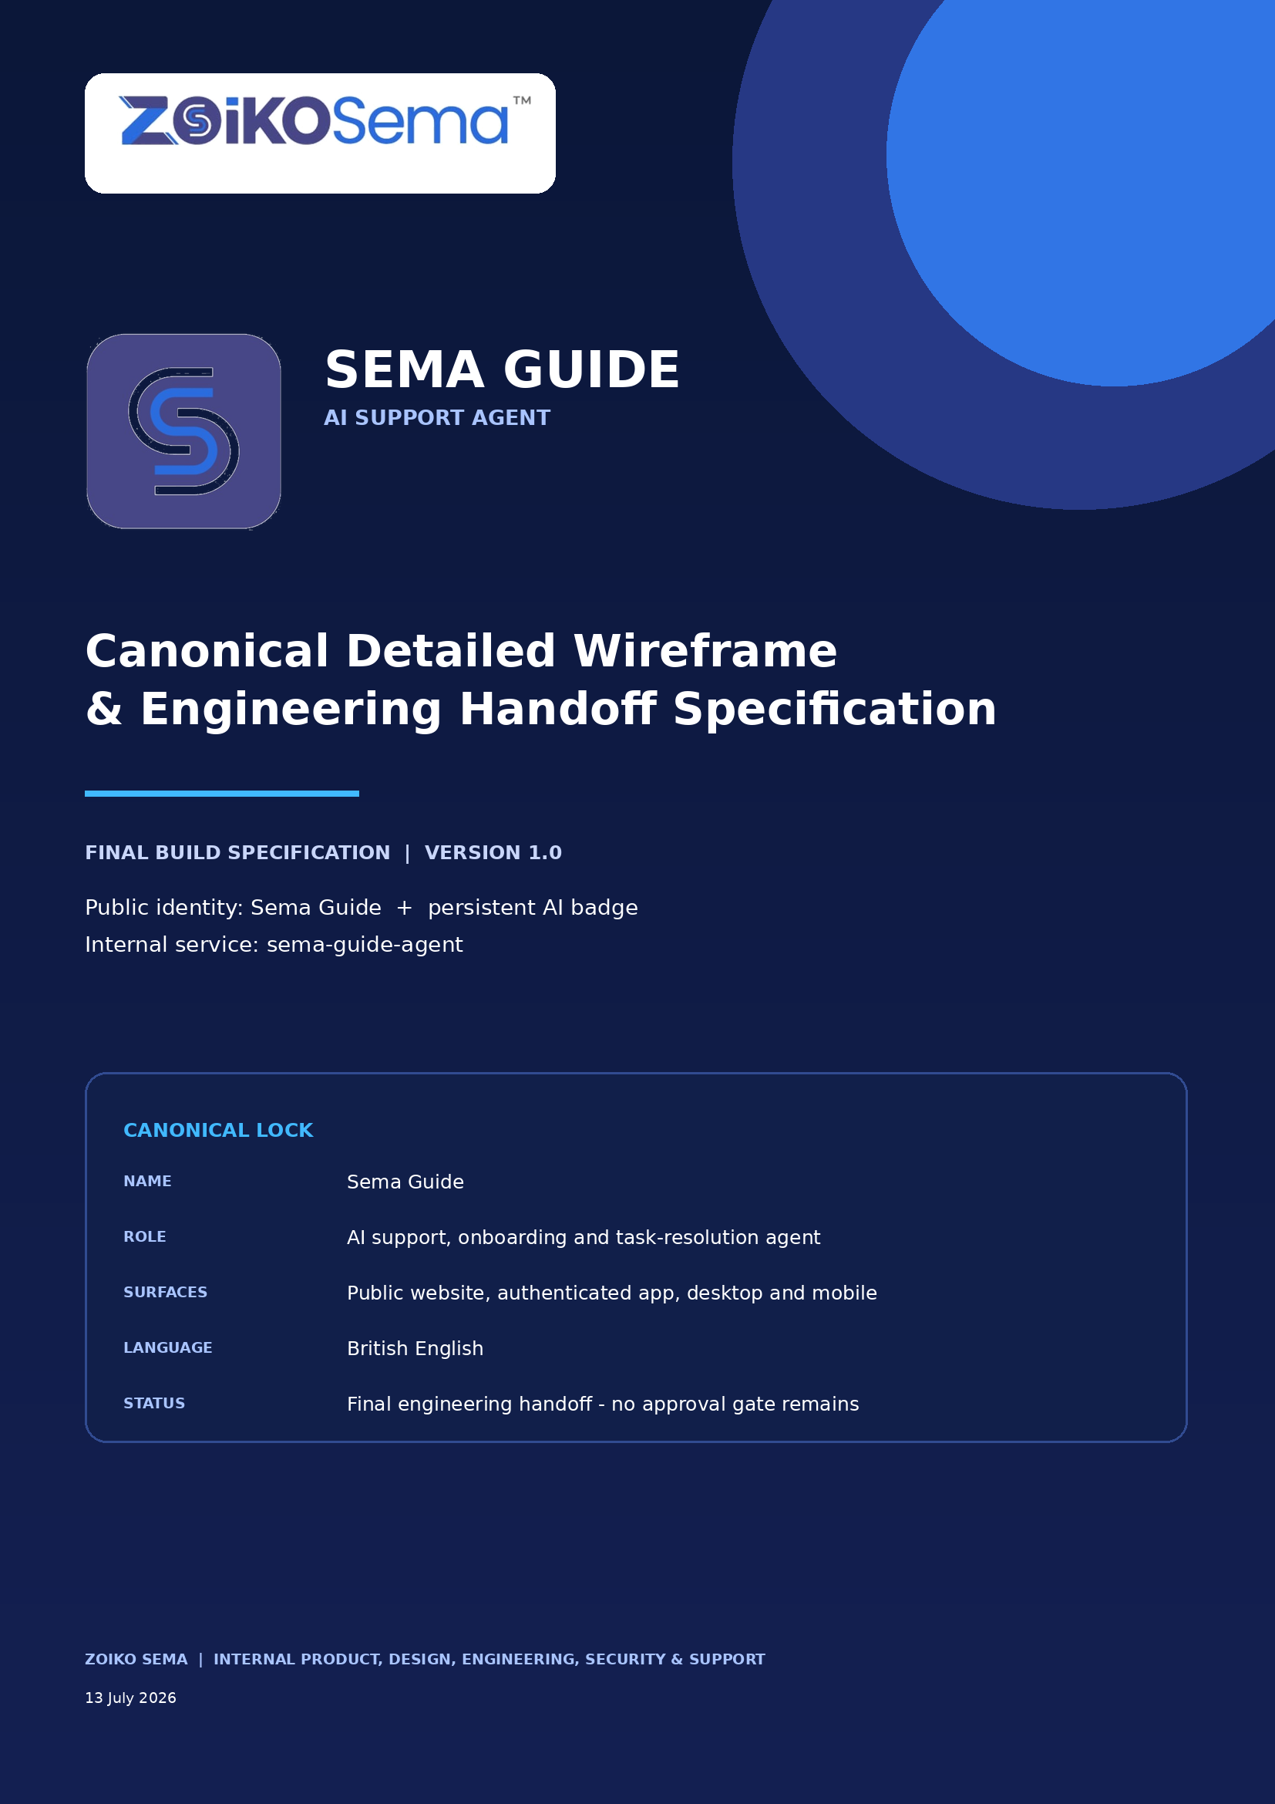

Document Control
Field | Locked decision
Document | Zoiko Sema - Sema Guide Canonical Detailed Wireframe & Engineering Handoff Specification
Document ID | ZS-SG-WF-01 v1.0
Status | Final build specification - recommendations incorporated; no approval gate remains
Public identity | Sema Guide with a separate, persistent AI badge
Formal descriptor | Zoiko Sema AI support, onboarding and task-resolution agent
Internal service identifier | sema-guide-agent
Owner | Zoiko Sema Product and Engineering
Consumers | Product, UI/UX, Web, App, AI, Platform, Security, Privacy, Support, QA and Analytics
Surfaces | Public website; authenticated web app; desktop app; mobile app; in-meeting help panel
Language convention | British English
Date | 13 July 2026
Classification | Internal engineering and product handoff

Canonical lock
The customer-facing name is Sema Guide. “AI” is a disclosure badge, not part of the core name. “Chatbot”, “bot”, “virtual agent” and human-style names are prohibited in primary UI. Sema Interpreter remains the separate live spoken-language interpretation agent.

Document Map
- 1. Executive lock and critical revisions
- 2. Naming, semantics and product taxonomy
- 3. Product scope, boundaries and operating modes
- 4. Reference review of the supplied Zoom interface
- 5. Experience principles and non-negotiables
- 6. Information architecture and surface rules
- 7. Launcher, shell and canonical desktop wireframe
- 8. Conversation components and response-card system
- 9. Contextual quick actions and intent routing
- 10. Human handoff and support operations
- 11. Identity, permissions, entitlement and tenant policy
- 12. Tool governance and consequential actions
- 13. AI orchestration, grounding and response validation
- 14. Privacy, retention, consent and data residency
- 15. Security, abuse prevention and Confidential Mode
- 16. Accessibility, localisation and responsive behaviour
- 17. Administrator controls and operational management
- 18. APIs, data contracts, state model and events
- 19. Failure handling, observability and quality metrics
- 20. Delivery phases, QA matrix and release gates
- Appendices A-D: canonical copy, tool registry, event schema and prohibited patterns

1. Executive Lock and Critical Revisions
Sema Guide is the canonical Zoiko Sema support identity. It is designed as a governed AI support and task-resolution agent, not a decorative FAQ widget. The experience must answer verified questions, guide users through product tasks, execute authorised low-risk actions, and transfer context to a human without forcing repetition.

1.1 Revisions incorporated
Defect in the earlier direction | Final correction
The public identity was not fully separated from the underlying technology. | Use Sema Guide as the product identity; display AI as a persistent disclosure badge; keep “agent” in the descriptor and internal architecture.
Public website, authenticated support and in-meeting help were treated too similarly. | One platform, three policy-aware modes with different data access, quick actions, authentication and tool permissions.
Quick actions mixed support, sales, navigation and account tasks. | Rank actions by surface, page context, identity, role, plan, recent failure and incident state; show no more than six at once.
The visual shell risked duplicating Zoiko Sema branding. | Show the full wordmark in a standalone website panel; show only favicon + Sema Guide when the host product header already carries the wordmark.
The generic AI disclaimer was too broad. | Use precise, contextual qualification: identify AI, identify data use, expose sources, and require confirmation for consequential actions.
Transcript and retention controls were not separated. | Model live processing, support history, export, analytics, safety logs, model-improvement use and legal retention as distinct purposes and controls.
Human escalation was framed as a last resort. | Permit direct human requests at any time; preserve authorised context; expose what will be shared before transfer.
Tool execution requirements were incomplete. | Every tool declares role, entitlement, policy, confirmation, idempotency, audit, rollback and failure behaviour.
Accessibility was treated as a checklist rather than behaviour. | Define keyboard, focus, screen-reader announcement, target size, reflow, reduced-motion and recoverable-help rules per component.
Knowledge grounding did not define precedence. | Tenant policy and live account state outrank general product documentation; unrestricted web retrieval is off by default.
No hard line existed between support help and meeting content. | Opening Sema Guide in a meeting does not grant access to meeting audio, video, chat, files or confidential content.
The earlier specification lacked implementation sequencing. | Ship in gated phases: grounded answers, support handoff, account-aware diagnostics, low-risk actions, then governed task execution.

1.2 Release position
- Sema Guide is approved as the canonical name and UI identity.
- The official Zoiko Sema wordmark and favicon supplied with this specification are the only approved brand assets.
- The panel is a support surface; it is not a meeting participant and is excluded from participant counts.
- No consequential action may be executed without an explicit preview and confirmation unless the action is reversible, user-initiated and pre-authorised by policy.
- Enterprise customer content is not used for foundation-model training by default.

2. Naming, Semantics and Product Taxonomy

2.1 Final name: Sema Guide
“Guide” is the strongest functional noun for this role. It conveys direction through unfamiliar product, support and administrative tasks without pretending to be a person. The phrase reads naturally, is easy to pronounce, remains understandable across markets, and scales from explanation to governed action.
Criterion | Weight | Sema Guide | Why it wins
Immediate clarity | 20% | 19/20 | Users understand that it helps them find a path or complete a task.
Enterprise trust | 15% | 15/15 | Professional and non-anthropomorphic; does not imitate a human representative.
Global usability | 15% | 14/15 | Short, pronounceable and semantically accessible.
Product extensibility | 15% | 15/15 | Supports FAQ, onboarding, diagnostics, workflow guidance and authorised actions.
Brand fit | 15% | 15/15 | Creates a clean family with Sema Interpreter, Sema Notes and Sema AI.
Distinctiveness | 10% | 9/10 | More ownable than Virtual Agent or Support Bot while staying descriptive.
Accessibility of meaning | 10% | 10/10 | Avoids idiom, metaphor and specialist vocabulary.
Total | 100% | 97/100 | Canonical selection.

2.2 Rejected alternatives
Candidate | Decision | Reason
Sema Virtual Agent | Reject | Category label rather than a product identity; impersonal and generic.
Sema Translator / Sema Translator AI | Reject for this surface | Reserved conceptually for language translation; conflicts with Sema Interpreter and does not describe support.
Sema Assist | Reject | Clear but generic; reads more like a feature verb than a durable service identity.
Sema Concierge | Reject | Premium but hospitality-coded, culturally less universal and prone to over-promising white-glove service.
Sema Navigator | Reject | Strong directional meaning but biased toward navigation rather than issue resolution.
Sema Companion | Reject | Overly anthropomorphic and consumer-oriented.
Sema Bot | Prohibited | Technically reductive and below the product’s enterprise position.
Human personal name | Prohibited | Creates identity ambiguity and weakens AI transparency.

2.3 Canonical naming architecture
Layer | Required string
Public product name | Sema Guide
Visible classification | AI
Header subtitle | Zoiko Sema support
Formal descriptor | AI support, onboarding and task-resolution agent
Launcher tooltip | Ask Sema Guide
Accessible launcher name | Open Sema Guide, Zoiko Sema’s AI support agent
Sender label | Sema Guide · AI
Internal agent ID | sema-guide
Internal service ID | sema-guide-agent
Conversation service | sema-guide-conversation-service
Orchestrator | sema-guide-orchestrator

2.4 Product family boundary
Capability | Role | Must not be confused with
Sema AI | Umbrella intelligence layer across Zoiko Sema. | A single chatbot or support widget.
Sema Guide | Support, onboarding, product guidance and governed task resolution. | Sema Interpreter or an ordinary human support representative.
Sema Interpreter | Live spoken-language interpretation during meetings and calls. | Website support, document translation or customer-service chat.
Sema Notes | Meeting notes, summaries and follow-up artefacts. | Support transcripts or customer-service case notes.

3. Product Scope, Boundaries and Operating Modes

3.1 Core jobs to be done
1. Answer product questions using approved Zoiko Sema knowledge and clearly expose the source.
2. Guide users to the correct page, control or workflow without creating navigation loops.
3. Diagnose common meeting, browser, device, account and integration problems.
4. Explain plans, quotas, entitlements, policy restrictions and Confidential Mode behaviour.
5. Perform approved low-risk actions through governed tools.
6. Prepare consequential actions for explicit user review and confirmation.
7. Create support cases and transfer authorised context to a human specialist.
8. Adapt language, copy and controls to identity, role, plan, tenant policy, jurisdiction and accessibility needs.

3.2 Explicit non-goals
- It is not a general-purpose open-web assistant.
- It does not listen to meeting audio or read meeting content simply because it is opened in a meeting.
- It does not impersonate a person, present a human photograph, or claim emotions or personal experience.
- It does not provide irreversible administrative, security or billing actions autonomously.
- It does not replace the Help Centre, status page, product navigation or human support; it orchestrates them.
- It does not silently use customer conversations to train foundation models.

3.3 Operating modes
Mode | Primary context | Data access | Permitted outcomes
Public guidance | Anonymous or pre-authenticated website visitor. | Public product content, public status information, session-local context. | Answer, route, qualify sales interest, troubleshoot generic access, create verified contact request.
Authenticated support | Signed-in user in web, desktop or mobile app. | User profile, plan, entitlements, authorised workspace and diagnostic data. | Account-aware answers, diagnostics, support history, low-risk actions and support case creation.
Administrator support | Authorised tenant administrator. | Role-scoped tenant policy, audit, billing, integration and entitlement data. | Explain and prepare administrative changes; execute only tools allowed by policy.
In-meeting help | Participant or host opens the panel during a meeting. | Meeting shell metadata only; no content access by default. | Device help, control guidance, policy explanation, support handoff.

4. Reference Review of the Supplied Zoom Interface
The supplied Zoom panel is a useful baseline for recognisable placement, a persistent composer, quick actions and a small overflow menu. It is not the target experience. The Zoiko Sema implementation must correct the following structural weaknesses visible in the reference.
Observed pattern | Assessment | Zoiko Sema requirement
“Zoom Virtual Agent” header | Generic category name; no ownable identity. | Use Sema Guide with a separate AI badge.
Photographic headset avatar plus “BOT” label | Creates avoidable human/AI ambiguity. | Use the official Zoiko Sema favicon; never a human portrait.
Three-message introduction: “Hi”, “One moment”, “How can I help?” | Adds latency and message clutter without user value. | One concise disclosure and immediate context-aware actions.
Quick actions mix upgrade, meeting access, missing meetings and sales. | No clear intent grouping or contextual ranking. | Separate recommended, support and commercial actions; rank by page and identity.
“Mute Chat” menu item | Ambiguous: could mean audio, bot output or notifications. | Use “Mute notifications”.
Download transcript and end chat | Useful controls but insufficient privacy explanation. | Expose export eligibility, retention, deletion scope and enterprise policy.
Generic retention statement at the bottom | Broad purpose; no period, choice or tenant-specific policy. | Use a contextual privacy panel with precise purposes and current retention.
No visible sources or confidence boundary | Users cannot distinguish documented guidance from generated language. | Expose source, scope and verification state on factual answers.
Sales representative is the only human route | Not a general support escalation path. | Provide direct support handoff at any time with consented context transfer.
No action-governance distinction | Navigation, explanation and account changes appear equivalent. | Preview, confirm, authorise and audit every consequential action.

5. Experience Principles and Non-Negotiables
Principle | Engineering interpretation
Resolve before deflecting | Optimise for verified resolution and task progress, not containment or raw chatbot deflection.
AI transparency without visual noise | Persistent AI badge, explicit opening disclosure and distinct AI/human sender states; no repeated warnings in every message.
Grounded by default | Use approved knowledge, tenant policy and live account state; mark unverified answers explicitly.
Context, not surveillance | Use only the context required for the user’s task and make sensitive data access visible.
Action with control | No hidden tool execution. Consequential actions require a preview, explicit confirmation and an audit record.
Human access is a right, not a failure | A user may request a person at any time; repeated AI failure automatically promotes the handoff option.
Progressive disclosure | Show the answer and next action first; place technical detail, logs and privacy explanations behind clear controls.
Accessible by construction | Keyboard, screen-reader, zoom, reflow and reduced-motion behaviours are designed per state and tested as release gates.
Policy-aware everywhere | Role, entitlement, tenant policy, jurisdiction, data residency and Confidential Mode are enforced server-side.
One identity, multiple modes | The name and visual identity remain stable while permissions, copy and quick actions adapt to the surface.

6. Information Architecture and Surface Rules

6.1 Launcher
Attribute | Desktop / web | Mobile
Default position | Bottom-right with collision detection for cookie banners, accessibility tools and fixed CTAs. | Entry from Help tab, floating launcher where permitted, or in-product support menu.
Size | 56 x 56 px; 44 x 44 px minimum interactive target. | 56 x 56 px; safe-area offset.
Visual | Official Zoiko Sema favicon, original colours, restrained shadow, optional status dot. | Same favicon; no permanent animation.
Tooltip | Ask Sema Guide. | Not required; accessible name remains mandatory.
Open behaviour | Docked panel, 400-440 px wide; preserve underlying page. | Full-screen sheet; never a narrow floating panel.
Dismissal | Escape or Close; focus returns to launcher; session preserved unless explicitly ended. | Native back and Close; session preserved.

6.2 Header branding rule
- Standalone website panel: full official Zoiko Sema wordmark in the shell header; favicon beside the Sema Guide identity row.
- Authenticated product shell already showing the Zoiko Sema wordmark: do not duplicate it; use favicon + Sema Guide + AI badge.
- Never reconstruct the supplied wordmark with live text. Never recolour, distort, crop or replace the supplied favicon.

6.3 Header controls
Control | Canonical label | Behaviour
Minimise | Minimise Sema Guide | Return to launcher; preserve unread state and session.
Overflow | More options | Open notifications, language, privacy, export, clear and end-session controls.
Close | Close Sema Guide | Close the surface; do not imply deletion.
Status | Online / Connecting / Human joined / Degraded / Offline | Expose service state in text, not colour alone.

6.4 Overflow menu
Notifications On >
Language English >
Privacy and data >
Download conversation >
Clear conversation >
------------------------------------------------
End support session

“Mute chat” is prohibited. Use “Mute notifications”. “Clear conversation” must explain the difference between clearing the local view, deleting support history and records retained by security, legal or enterprise policy.

7. Canonical Desktop Wireframe
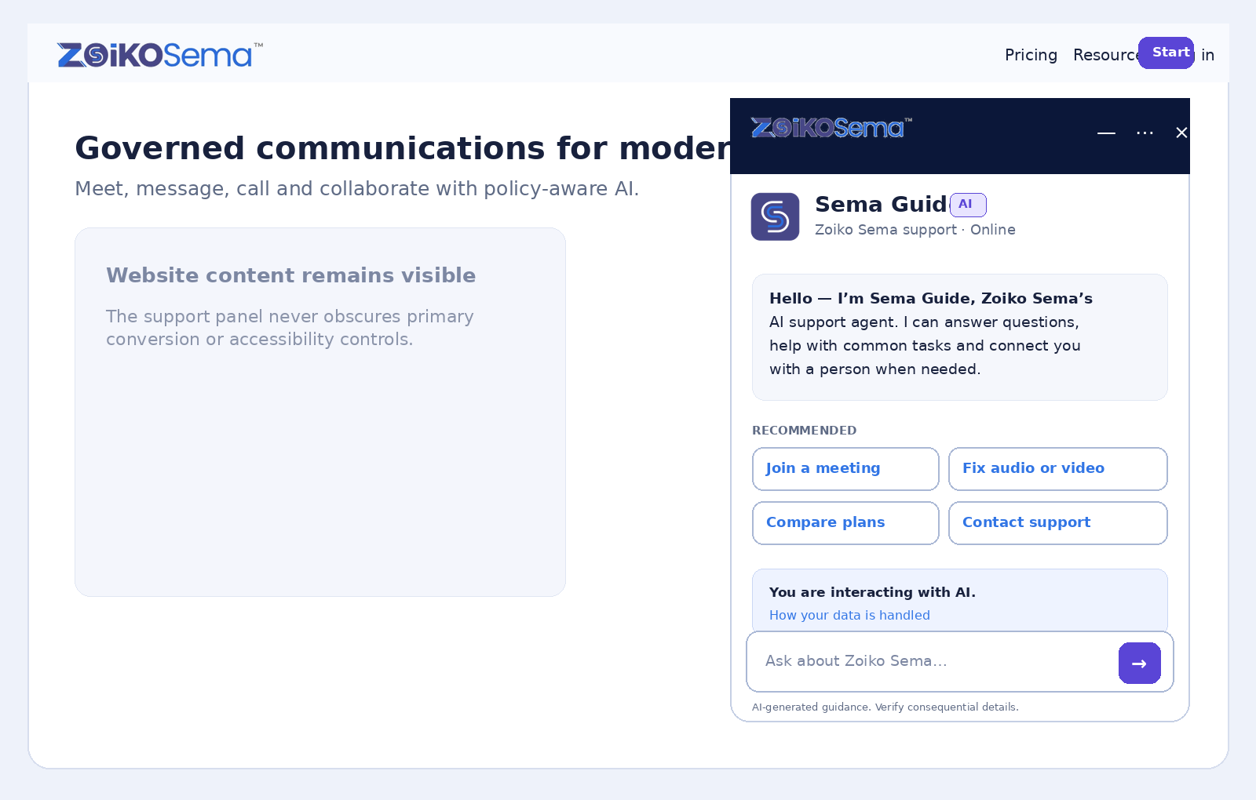
Figure 1. Standalone website welcome state using the official Zoiko Sema wordmark, favicon and colour system.

7.1 Welcome copy
Canonical introduction
Hello - I’m Sema Guide, Zoiko Sema’s AI support agent. I can answer questions, help you complete common tasks and connect you with a person when needed.
Element | Required copy / rule
AI disclosure | You are interacting with an AI system.
Privacy summary | Messages are processed to answer your request. Enterprise retention and data-use settings may apply.
Privacy action | How your data is handled
Composer placeholder | Ask about Zoiko Sema…
Footer qualification | AI-generated guidance. Verify consequential details.
Agent sender | Sema Guide · AI
Human sender | [Name] · Zoiko Sema Support · Human specialist

7.2 Welcome-state quick actions
Show four primary actions by default and no more than six. The server returns ranked actions; the client renders only authorised actions. The first slot is reserved for the most likely user goal.
Context | Default ranked actions
Anonymous homepage | Explore Zoiko Sema; Compare plans; Join a meeting; Contact support.
Join a Meeting page | Join with meeting ID; I cannot join; Test audio and video; Contact support.
Pricing page | Compare plans; Explain AI usage; Estimate seats; Contact sales.
Authenticated home | Join my next meeting; Start a meeting; Schedule a meeting; Fix audio or video.
Administrator console | AI and agentic controls; Meeting policies; Audit and compliance; Billing and entitlements.
System Status page | Current incidents; My affected services; Notify me; Contact support.

7.3 Visual layout rules
- Panel width: 400-440 px; maximum height: viewport minus 48 px; 24 px edge offset.
- Header height: 64-72 px; identity row: 72-84 px; composer remains sticky.
- Message content width never exceeds 70 characters per line at default zoom.
- Primary actions use Sema action violet; links and informative secondary actions use approved logo blue.
- Red is reserved for destructive action, hard failure or service unavailability.
- No decorative animation while the user is reading or typing. Processing animation respects reduced-motion preferences.

8. Conversation Components and Response-Card System
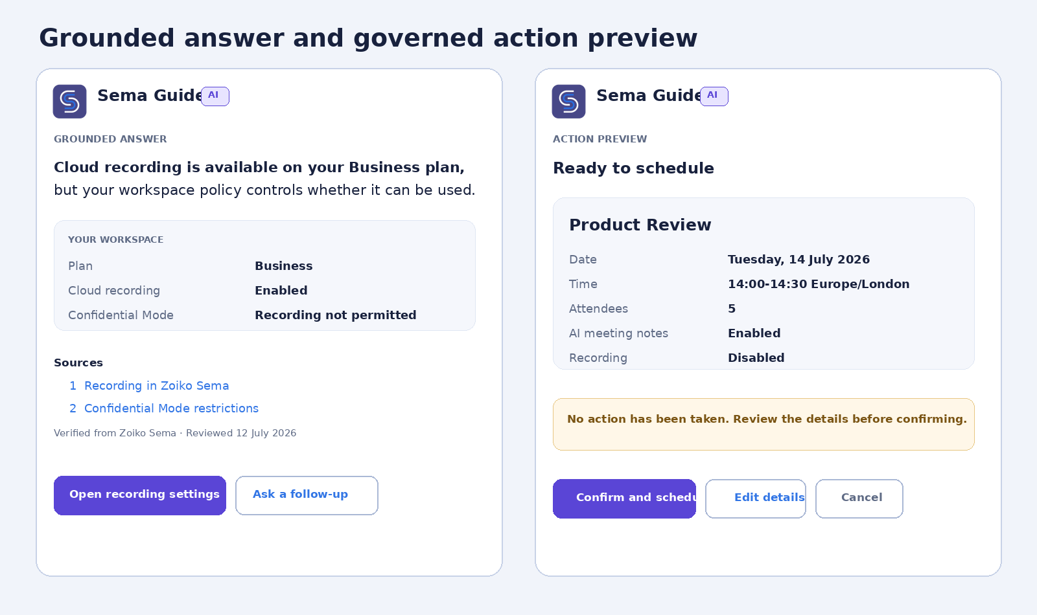
Figure 2. Verified answer and explicit action-preview patterns.

8.1 Message construction
Layer | Rule
Lead answer | One direct answer or status statement. Do not begin with filler.
Qualification | State any condition, policy dependency, uncertainty or missing context immediately.
Evidence | Expose source title, source class and reviewed/updated time where relevant.
Next action | Offer one primary action and up to two secondary actions.
Escalation | Expose a human route when unresolved, high-impact, repeatedly failed or explicitly requested.
Length | No more than three short paragraphs before expandable detail; use cards for structured data.

8.2 Required cards
Card | Minimum fields | Action policy
Grounded answer | Answer, scope, source, source status, reviewed date, tenant override where applicable. | Read-only; links may navigate.
Diagnostic | Detected condition, evidence, ordered fix, retest control, diagnostic-data disclosure. | Read-only until user invokes a test or permission action.
System status | Service, state, scope, last update, incident link. | May subscribe user only after consent.
Plan and entitlement | Feature, required plan, user plan, entitlement state, policy override. | Upgrade or sales actions remain separate from support resolution.
Action preview | Exact proposed change, affected objects, consequences, policy, audit note. | Explicit confirmation required.
Action result | Success/failure, object reference, changes made, rollback route. | Never imply success before the tool confirms.
Support case | Reference, priority, response target, attachments and diagnostics shared. | Case creation requires identity and data-sharing confirmation.
Human queue | Channel, estimated wait or response window, notification behaviour, cancellation. | No repeated AI interruption after handoff is queued.

8.3 Processing status
Operation | Visible status
Knowledge retrieval | Searching Zoiko Sema Help…
Workspace lookup | Checking your workspace settings…
Diagnostic | Testing your microphone access…
Action preparation | Preparing the change for your review…
Tool execution | Applying the confirmed change…
Handoff | Connecting you with Zoiko Sema Support…

Do not emit “One moment” as a standalone message. For operations longer than three seconds, show the current task, a cancellable state where safe, and a fallback if the operation fails.

9. Contextual Quick Actions and Intent Routing

9.1 Ranking inputs
- Current surface and page route.
- Authentication state, user role and workspace.
- Plan, entitlement and tenant policy.
- Recent failed action or diagnostic result.
- Active service incident affecting the user.
- User locale, language and accessibility preferences.
- Campaign or referral context only when consented and relevant.

9.2 Ranking rules
1. Filter prohibited, unauthorised and unavailable actions before ranking.
2. Prioritise recovery from the user’s current failure over product discovery or sales.
3. Keep support and commercial intents visibly separated.
4. Do not show an upgrade action as the primary response to a technical problem unless lack of entitlement is the verified cause.
5. Use no more than two rows of actions in the welcome state.
6. After the first user message, replace generic quick actions with task-relevant follow-ups.
7. Never return an action that the client cannot execute or route successfully.

9.3 Intent classes
Class | Examples | Default route
Information | What is Confidential Mode? Which plan includes recording? | Grounded answer.
Navigation | Where are meeting policies? | Deep link with explanation.
Troubleshooting | My microphone is not working. | Diagnostic workflow.
Account-aware lookup | What is my plan? Why is this locked? | Authenticated read-only tool.
Low-risk action | Create a support case; subscribe to incident updates. | Tool call with disclosure or consent.
Consequential action | Schedule a meeting; change a policy; upgrade a plan. | Action preview and explicit confirmation.
Human request | Talk to a person. | Immediate handoff workflow.
Unsupported / risky | Request outside scope, secrets, prohibited content. | Refuse or redirect; preserve support access where safe.

10. Human Handoff and Support Operations
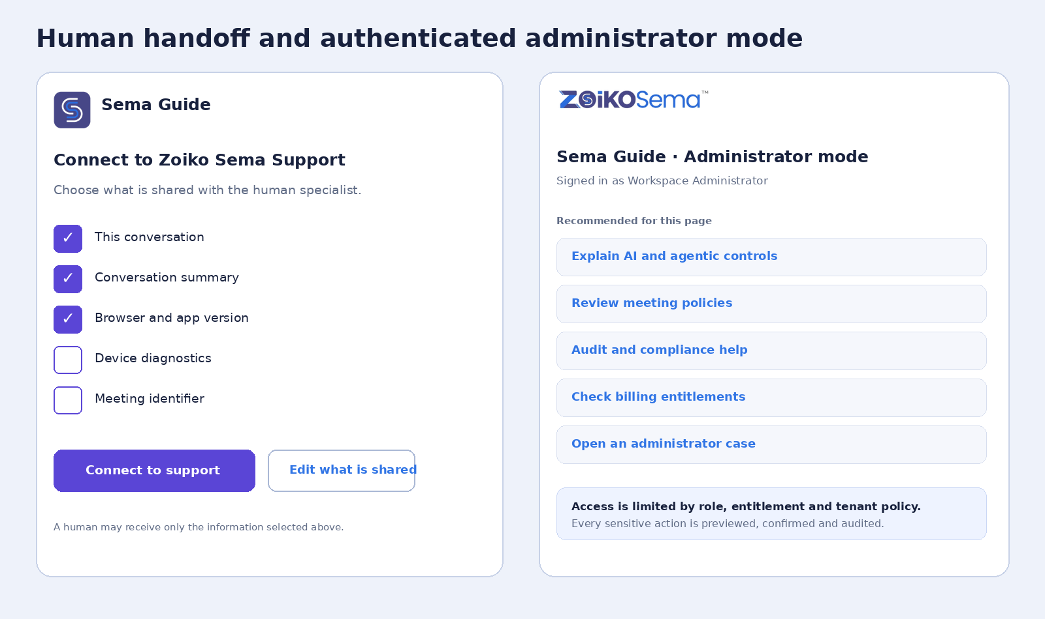
Figure 3. Consent-based context transfer and administrator mode.

10.1 Handoff triggers
- Explicit request for a human, person, representative, support specialist or sales specialist.
- Two unsuccessful resolution loops for the same verified intent.
- High-impact billing, security, account-lockout, data-loss or compliance issue.
- Unsupported language or accessibility need that prevents effective AI interaction.
- Policy requires human approval or the required tool is unavailable.
- Low-confidence answer where incorrect guidance could cause consequential harm.

10.2 Consent and transfer payload
Data item | Default | User control
Conversation transcript | On | May deselect unless required for the selected channel.
Structured conversation summary | On | May review before transfer.
Browser and app version | On for technical support | May deselect.
Device diagnostics | Off | Explicit opt-in.
Meeting identifier | Off | Explicit opt-in or system-required with explanation.
Workspace and entitlement context | On when authenticated | Role-scoped and server-enforced.
Attachments | Off unless already submitted for support | List files and classifications before transfer.

10.3 Queue and human state
- Present expected wait or response window only when backed by the support system.
- Allow the user to close the panel and receive an in-product or email notification, subject to consent.
- When a human joins, the header changes to the specialist’s verified name and “Human specialist”.
- Sema Guide moves into background assist mode and does not reply unless the human invokes it or leaves.
- The human receives the task, verified facts, steps attempted, tool outcomes and consented diagnostics - not an unfiltered hidden transcript summary.

11. Identity, Permissions, Entitlement and Tenant Policy
State | Allowed data | Blocked data / action
Anonymous | Public documentation, public status, session-local diagnostics. | Account, billing, meeting and workspace data.
Authenticated user | Own profile, plan, usage, meetings and authorised workspace context. | Other users’ private data; administrator-only controls.
Guest participant | Minimum meeting-shell metadata required for access help. | Roster export, content, recordings, tenant administration.
Workspace administrator | Policy, role, audit, entitlement and integration data within assigned permissions. | Owner-only or security-restricted actions unless separately authorised.
Support specialist | Data explicitly shared through support policy and case permissions. | Broad tenant access outside the case purpose.

11.1 Enforcement order
1. Resolve identity and tenant.
2. Resolve role and delegated authority.
3. Resolve plan and feature entitlement.
4. Apply tenant policy, deny precedence and jurisdiction controls.
5. Apply session risk and step-up authentication requirements.
6. Authorise knowledge source and tool.
7. Execute or return a policy-safe alternative.
8. Record the policy decision and correlation ID.

11.2 Step-up authentication
Require recent authentication, passkey or equivalent step-up for sensitive account, billing, identity, export, policy and security operations. The agent must never collect credentials or one-time authentication codes in chat.

12. Tool Governance and Consequential Actions

12.1 Tool contract
Required field | Purpose
tool_id and version | Stable audit and compatibility reference.
purpose | User-facing explanation of why the tool is invoked.
required_role | Minimum role or delegated authority.
required_entitlement | Plan or feature gate.
policy_scope | Tenant, jurisdiction and Confidential Mode restrictions.
input schema | Validated, minimal and classified fields.
confirmation class | None, disclosure, explicit confirmation or human approval.
idempotency key | Prevents duplicate execution.
timeout and retry | Bounded failure behaviour; no unsafe repeated writes.
rollback | Reversal path where supported.
audit fields | Actor, target, before/after, policy decision, correlation and result.
failure route | Retry, alternative workflow or support handoff.

12.2 Action classes
Class | Examples | Rule
Read-only | Check status, retrieve plan, inspect entitlement, locate documentation. | No confirmation; expose data source and scope.
Low-risk reversible | Subscribe to incident updates, open device test, create a standard case. | Clear disclosure; confirmation where personal data or notifications are involved.
Consequential | Schedule a meeting, change a setting, invite attendees, change notification preferences, upgrade. | Preview exact outcome; explicit confirmation; audit; idempotency.
Human-controlled | Change enterprise security policy, remove owner, alter retention, export confidential data. | Agent may explain and prepare; authorised human performs or approves.
Prohibited autonomous | Delete account, disable audit, expose secrets, make irreversible billing change. | No agent execution path.

12.3 Action preview requirements
- Exact object and target tenant or workspace.
- Before and proposed after state.
- People affected and notifications that will be sent.
- Financial, privacy, retention or access consequence.
- Whether the action is reversible and for how long.
- Policy or administrator approval that applies.
- Primary Confirm action; secondary Edit and Cancel actions.

13. AI Orchestration, Grounding and Response Validation

13.1 Canonical execution order
Request intake
-> identity and tenant resolution
-> input safety and secret detection
-> intent and risk classification
-> policy and entitlement decision
-> clarification gate, if required
-> approved knowledge retrieval and/or tool planning
-> source rerank and tenant-policy precedence
-> response or action-preview composition
-> citation, policy, safety and action validator
-> response contract
-> ordered audit and analytics events

13.2 Knowledge precedence
1. Live tenant policy and current account state.
2. Live entitlement, billing and service-status systems.
3. Approved Zoiko Sema product documentation.
4. Approved support procedures and integration documentation.
5. Curated external vendor documentation for enabled integrations.
6. General model knowledge only for non-factual explanation and never as a hidden source of current product truth.

13.3 Source states
State | Visible treatment
Tenant verified | Based on your workspace settings.
Live system verified | Based on current Zoiko Sema service data.
Documentation verified | Verified from Zoiko Sema Help.
Curated external | Based on approved [vendor] documentation.
General guidance | General guidance - not verified against your workspace.
Unable to verify | I could not verify this from approved information.

13.4 Validator release blocks
- Unsupported source claim or fabricated citation.
- Answer contradicts tenant policy, entitlement or live system state.
- Consequential action offered without confirmation metadata.
- Sensitive data disclosed beyond the authorised scope.
- Human identity ambiguity or missing AI classification.
- Unqualified current-state claim without a current source.
- Unsafe instruction, secret request or tool argument leakage.

14. Privacy, Retention, Consent and Data Residency

14.1 Separate processing purposes
Purpose | Default treatment | User / tenant control
Live inference | Required to answer the current request. | End session; disable the feature at tenant level where supported.
Conversation history | Off for anonymous sessions after expiry; tenant-defined for authenticated support. | Clear local view; request deletion; administrator retention policy.
Support case record | Stored according to support and legal policy. | Case-specific disclosure and deletion rights subject to obligations.
Security and abuse logs | Minimal metadata with controlled retention. | Administrator and privacy policy; not presented as model training.
Product analytics | Minimised event data; content-free by default. | Consent and tenant analytics controls where required.
Quality review | Sampled and access-controlled; redacted where possible. | Enterprise opt-out and reviewer audit.
Model improvement / training | Off for enterprise customer content by default. | Separate explicit programme and lawful disclosure if ever enabled.
Transcript export | Disabled unless identity and policy allow. | User-initiated; auditable; export classification applies.

14.2 Contextual privacy panel
How this conversation is handled
Used to answer your request Yes
Stored in support history 30 days - workspace policy
Used to improve foundation models No
Shared with a human if you request support Only with your confirmation
Data region United Kingdom
[Manage privacy choices] [Read privacy notice]

14.3 Data minimisation
- Collect the minimum identity and diagnostic data required for the selected task.
- Redact credentials, authentication codes, private keys, payment-card data and obvious secrets before model processing or storage.
- Do not attach meeting content, recordings, transcripts or files to a support case without explicit selection and policy approval.
- Use regional processing and storage according to tenant residency policy; record the selected region in the audit event.

15. Security, Abuse Prevention and Confidential Mode

15.1 Security controls
Control | Requirement
Session security | Short-lived signed session token; CSRF protection; secure cookie or token storage; replay resistance.
Rate limiting | Per IP, identity, tenant, session and tool; stronger limits for anonymous and write operations.
Input protection | Malware scanning, secret detection, prompt-injection filtering and attachment type validation.
Output protection | Sensitive-data filtering, source validation, safe link allow-list and action-schema validation.
Tool isolation | Brokered execution; no model-direct credentials; scoped service identities; network and tenant isolation.
Audit integrity | Ordered immutable or tamper-evident events for policy and tool actions.
Support access | Case-bound, least-privilege, time-limited access with human audit.
Incident mode | Disable tools or the full agent independently; retain Help Centre and human support routes.

15.2 Confidential Mode
Confidential Mode active
Sema Guide can help with settings and controls but cannot access meeting audio, video, chat, shared files, transcripts or other meeting content.
- Opening the panel does not create a participant, media stream or hidden listener.
- Meeting content attachment is blocked unless an explicit policy-approved secure support workflow exists.
- No automatic transcript, summary, recording or AI context is taken from the meeting.
- Only shell metadata needed to troubleshoot access or controls may be used, and that access must be visible and auditable.

16. Accessibility, Localisation and Responsive Behaviour
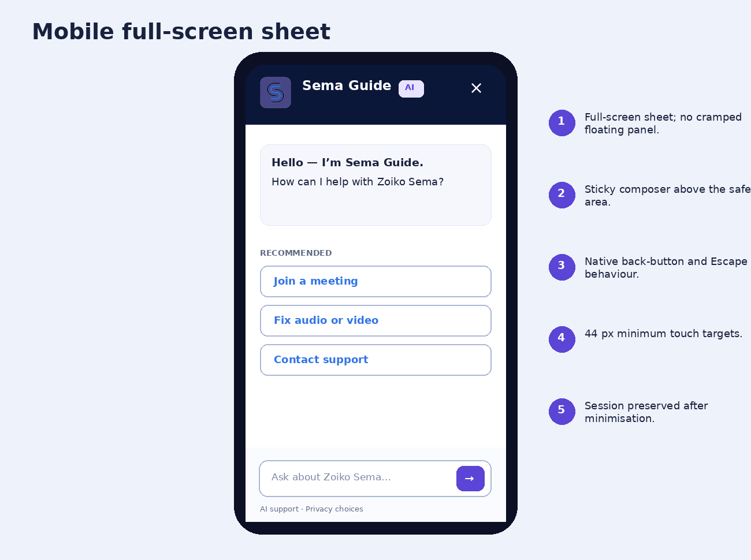
Figure 4. Mobile implementation uses a full-screen support sheet and sticky composer.

16.1 WCAG 2.2 AA release requirements
Area | Release requirement
Keyboard | Every control reachable; logical order; Escape closes overlays; focus returns to launcher.
Focus | Visible indicator; never obscured by sticky composer, menu or cookie banner.
Screen reader | Named regions, labelled controls, AI/human sender identity, polite announcements, no focus theft on new messages.
Touch | 44 x 44 px minimum primary targets; spacing prevents accidental activation.
Zoom and reflow | Usable at 200% text zoom and 400% browser zoom; no two-dimensional scrolling for ordinary content.
Colour and status | Text/icon accompanies colour; contrast meets AA; brand assets retain original colours.
Motion | Reduced-motion mode; no pulsing launcher or continuous decorative animation.
Time | No forced response timer; warn before authenticated session expiry and preserve draft where safe.
Help consistency | The support entry point remains in a consistent location across equivalent pages.
Human alternative | Direct human route remains accessible without completing repeated AI steps.

16.2 Localisation
- Externalise all copy, quick actions, errors, dates, numbers and status labels.
- Support right-to-left layout, bidirectional content and locale-aware line breaking.
- Do not infer the language from nationality or workspace location; use user preference and explicit switching.
- Preserve product names, plan names and policy terms according to the approved glossary.
- Human handoff must retain the detected language and request a matching queue where available.

16.3 Responsive behaviour
Viewport | Behaviour
Desktop >= 1024 px | Docked 400-440 px panel; optional resize within tested limits.
Tablet 768-1023 px | Docked panel up to 48% of viewport; underlying task remains visible.
Mobile < 768 px | Full-screen sheet with compact header and sticky composer.
Embedded in meeting | Side panel integrated with the meeting shell; never represented as a participant tile.

17. Administrator Controls and Operational Management
Control group | Required capabilities
Availability | Enable/disable by tenant, surface, user group, role, region and incident state.
Brand and copy | View locked identity; configure approved greeting variants and supported languages without altering the name or AI disclosure.
Knowledge | Approve sources, set precedence, publish versions, review stale content and roll back.
Tools | Enable tools, assign roles, set confirmation class, define limits and emergency-disable.
Handoff | Configure channels, queues, hours, languages, consented payload and escalation rules.
Privacy | Retention, transcript export, analytics, residency, quality review and model-improvement settings.
Safety | Blocked topics, abuse thresholds, attachment rules, prompt-injection controls and support overrides.
Quality | Resolution, source coverage, unanswered intents, tool failures, handoff quality and accessibility defects.
Audit | Search policy decisions, tool calls, configuration changes, exports and support access.
Release management | Draft, test, approve, stage, publish, version, compare and roll back configuration.

17.1 Administrator restrictions
- Administrators cannot rename Sema Guide, remove the AI badge or substitute a human avatar.
- Configuration cannot grant a tool more permission than the server-side product role and tenant policy allow.
- Production knowledge and tool changes require versioning, test evidence and an attributable publisher.
- Analytics dashboards must not encourage deflection at the expense of user resolution or access to humans.

18. APIs, Data Contracts, State Model and Events

18.1 Response contract
{
"conversation_id": "sgc_01J...",
"message_id": "sgm_01J...",
"agent": {
"id": "sema-guide",
"display_name": "Sema Guide",
"classification": "ai"
},
"mode": "authenticated_support",
"response_type": "grounded_answer",
"message": "Cloud recording is enabled for your workspace.",
"verification": {
"state": "tenant_verified",
"as_of": "2026-07-13T09:40:00Z"
},
"sources": [{
"title": "Recording in Zoiko Sema",
"source_type": "zoiko_sema_help",
"version": "2026-07-12",
"uri": "/help/recording"
}],
"actions": [{
"id": "open_recording_settings",
"label": "Open recording settings",
"class": "navigation",
"requires_confirmation": false
}],
"policy": {
"decision": "allow",
"restrictions": []
},
"correlation_id": "corr_..."
}

18.2 Conversation states
CLOSED -> WELCOME -> INTENT_DETECTION
-> GROUNDED_ANSWER
-> COLLECT_REQUIRED_CONTEXT
-> AUTHENTICATION_REQUIRED
-> PREPARE_ACTION -> AWAIT_CONFIRMATION -> EXECUTE_ACTION -> ACTION_RESULT
-> HUMAN_HANDOFF -> QUEUED -> HUMAN_JOINED
-> POLICY_BLOCKED
-> DEGRADED
-> UNRESOLVED -> HUMAN_HANDOFF
-> SESSION_ENDED

18.3 Core event model
Event | Minimum payload
guide.opened | surface, route, mode, locale, anonymous/authenticated flag.
intent.detected | intent class, confidence band, risk band, clarification required.
knowledge.retrieved | source IDs, versions, precedence, tenant scope, latency.
answer.delivered | verification state, citation count, response type, validator result.
action.previewed | tool, target, confirmation class, policy decision.
action.confirmed | actor, authentication strength, idempotency key.
action.completed | result, before/after hash, rollback availability, latency.
handoff.requested | reason, channel, consented data classes.
handoff.joined | queue, specialist ID, wait time, context-transfer result.
privacy.changed | setting, old/new value, actor, tenant.
session.ended | resolution state, feedback, retention policy applied.

19. Failure Handling, Observability and Quality Metrics

19.1 Canonical failure copy
Failure | Required response
No verified answer | I could not verify that from approved Zoiko Sema information. I can search a different help area or connect you with support.
Tool failed before change | I found the correct setting, but I could not update it. No changes were made.
Tool failed after partial change | State exactly what changed, what did not, recovery steps and case reference; never use a generic success state.
Policy blocked | Your organisation does not permit this action through Sema Guide. [View policy] [Contact your administrator]
Authentication required | Please sign in to view account-specific information. [Sign in] [Continue with general help]
Service degraded | Sema Guide is temporarily limited. Zoiko Sema meetings remain available. [System status] [Help Centre] [Contact support]
Attachment rejected | Explain file type, size, malware, secret or policy reason and offer a safe alternative.

19.2 Success metrics
Metric | Definition / guardrail
Verified resolution rate | User task resolved with a verified answer or confirmed action.
First-contact resolution | No repeat support contact for the same intent within the defined window.
Time to useful answer | From user submission to first verified, actionable content.
Tool success rate | Confirmed tool executions completed once and with correct result.
Unsupported-answer rate | Answers delivered without adequate approved grounding; target approaches zero.
Citation coverage | Share of factual product/account answers with appropriate verification metadata.
Human handoff quality | Context accepted, no repetition, correct queue and resolution outcome.
Repeat failure rate | Same intent cycles without meaningful progress.
Accessibility defect rate | Automated and manual failures by component and assistive technology.
Safety and privacy events | Secret detections, over-broad data access, blocked exports and policy violations.
User satisfaction | Resolution-specific feedback; do not use satisfaction alone as proof of correctness.

19.3 Observability
- End-to-end correlation ID across client, gateway, policy, retrieval, model, tool, support and audit systems.
- Separate latency budgets for shell open, first token, grounded answer, tool preview and tool execution.
- Dashboards by tenant, mode, language, surface, intent, source, model version and tool version.
- Alert on source outage, citation drop, policy divergence, tool retries, duplicate writes, handoff failure and safety spikes.
- No raw customer content in general telemetry; use classified, minimised diagnostic fields.

20. Delivery Phases, QA Matrix and Release Gates

20.1 Phased implementation
Phase | Scope | Exit gate
Phase 0 - Shell and governance | Official branding, launcher, AI disclosure, privacy shell, identity modes, accessibility baseline, event pipeline. | No production model or tools until shell, policy and audit tests pass.
Phase 1 - Grounded guidance | Approved Help Centre retrieval, citations, page-aware quick actions, unsupported-answer handling. | Source accuracy, no fabricated citations, accessibility AA and safe anonymous mode.
Phase 2 - Support handoff | Case creation, consented context transfer, queue status, human state and transcript policy. | No user repetition in supported cases; consent and access audits pass.
Phase 3 - Account-aware diagnostics | Plan, entitlement, meeting, device and integration read-only tools. | Role/tenant isolation, current-state accuracy and data minimisation pass.
Phase 4 - Governed actions | Low-risk and consequential tools with preview, confirmation, idempotency and rollback. | Zero duplicate writes; policy and audit evidence complete.
Phase 5 - Optimisation | Multilingual expansion, proactive incident context, quality learning and administrator tuning. | Fairness, language quality, operational and privacy review pass.

20.2 Release-blocking acceptance criteria
1. The supplied official Zoiko Sema wordmark and favicon render without alteration on all supported themes and resolutions.
2. Sema Guide is the visible identity and AI remains persistently disclosed.
3. No human portrait, personal name, “BOT”, “virtual agent” or generic chatbot label appears as the primary identity.
4. Public, authenticated, administrator and in-meeting modes enforce different data and tool permissions.
5. Quick actions are context-ranked, authorised and limited to six.
6. Every factual product, policy, entitlement and current-state answer exposes the appropriate verification state.
7. Unverified answers are qualified and cannot trigger consequential actions.
8. Users can request a human at any time; transfer shows and records the selected data.
9. Consequential actions show a complete preview and require explicit confirmation.
10. All write tools are idempotent, policy-checked, audited and recoverable or safely escalated.
11. Credentials, authentication codes, keys and full payment-card data are never requested in ordinary chat.
12. Attachments are type-checked, scanned, classified and policy-limited.
13. Enterprise customer conversation content is not used for foundation-model training by default.
14. Privacy, retention, export and deletion behaviour is available in context and reflects tenant policy.
15. Confidential Mode content is inaccessible to Sema Guide unless a separately approved secure support workflow explicitly grants access.
16. The interface meets WCAG 2.2 AA through automated and manual assistive-technology testing.
17. AI and human messages are visually and programmatically distinct.
18. Failure messages accurately state whether any change occurred.
19. No silent unrestricted web retrieval is available.
20. All policy decisions, tool calls, exports, support access and configuration changes produce attributable audit events.

20.3 Minimum QA matrix
Test domain | Mandatory coverage
Functional | Every state, intent class, card, menu item, tool class, handoff route and session lifecycle.
Identity and policy | Anonymous, user, guest, administrator, support specialist, cross-tenant and revoked-role cases.
Accessibility | Keyboard-only, screen readers, 200% text, 400% reflow, high contrast, reduced motion, touch and voice input.
Security | Prompt injection, data exfiltration, cross-tenant access, tool abuse, replay, duplicate write, attachment malware and secret leakage.
Privacy | Consent, retention, delete, export, residency, quality review, human transfer and model-training defaults.
Resilience | Knowledge outage, model outage, policy outage, tool timeout, partial execution, support queue outage and offline state.
Localisation | Long strings, RTL, mixed scripts, locale dates/numbers, unsupported language and human queue matching.
Performance | Cold open, warm open, first useful answer, retrieval, tool preview, execution and handoff latency budgets.

Appendix A - Canonical Copy Catalogue
State / component | Approved copy
Launcher | Ask Sema Guide
Accessible launcher | Open Sema Guide, Zoiko Sema’s AI support agent
Identity | Sema Guide [AI]
Subtitle | Zoiko Sema support
Introduction | Hello - I’m Sema Guide, Zoiko Sema’s AI support agent. I can answer questions, help you complete common tasks and connect you with a person when needed.
AI disclosure | You are interacting with an AI system.
Composer | Ask about Zoiko Sema…
Notifications | Mute notifications
Privacy link | How your data is handled
Human action | Connect to support
Unsupported answer | I could not verify that from approved Zoiko Sema information.
Policy block | Your organisation does not permit this action through Sema Guide.
Confidential Mode | Sema Guide can help with settings and controls but cannot access meeting content.
End session | End support session

Appendix B - Example Tool Registry Record
tool_id: schedule_meeting.v1
purpose: Create a Zoiko Sema meeting after user review
required_role: authenticated_user
required_entitlement: meetings.schedule
policy_scope:
confidential_mode: allowed
guest_user: denied
confirmation_class: explicit
idempotency: required
inputs:
title: restricted_text
start_at: datetime
end_at: datetime
timezone: iana_timezone
attendees: personal_data
ai_notes: boolean
recording: boolean
before_execute:
- resolve tenant policy
- validate attendee permissions
- show exact action preview
audit:
- actor_id
- tenant_id
- before_state
- requested_state
- policy_decision
- correlation_id
rollback: cancel_created_meeting
failure_route: preserve draft and offer support

Appendix C - Prohibited UI and Behaviour Patterns
Prohibited pattern | Reason
Human photographic avatar for Sema Guide | Creates identity ambiguity.
Primary label “BOT”, “Chatbot” or “Virtual Agent” | Weakens product identity and enterprise position.
Sema Guide AI as the only visible name | AI is a classification badge, not the identity.
Standalone “One moment” messages | Adds noise without information.
“Mute chat” | Ambiguous control language.
Upgrade CTA as default response to a support fault | Conflicts with resolution-first support.
Hidden tool execution | Removes user control and audit clarity.
Generic success before tool confirmation | May misrepresent system state.
Silent web search | Introduces unapproved and potentially stale sources.
Meeting-content ingestion on panel open | Violates purpose limitation and Confidential Mode boundary.
Permanent animated launcher | Distracting and inaccessible.
Dismissal that deletes data without explanation | Conflates close, clear, delete and end-session semantics.

Appendix D - Final Engineering Lock
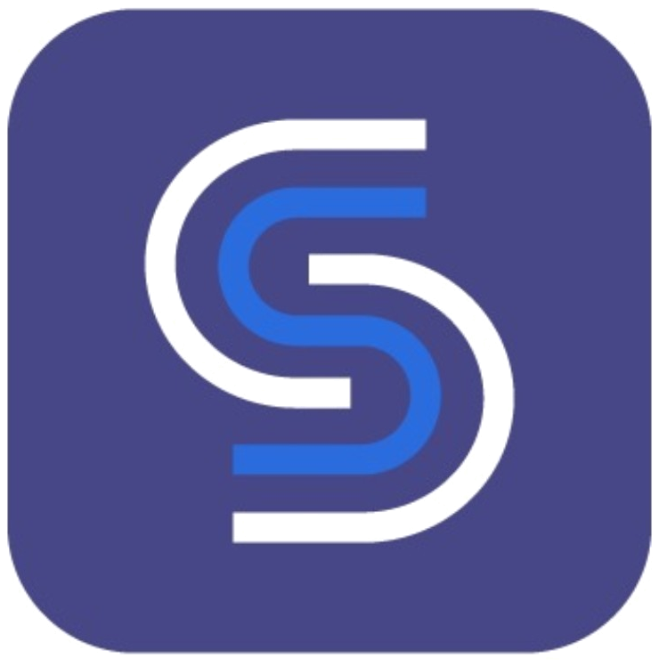
Locked item | Build value
Public identity | Sema Guide
Visible classification | Persistent AI badge
Header subtitle | Zoiko Sema support
Internal service | sema-guide-agent
Brand assets | Only the supplied official Zoiko Sema wordmark and favicon
Human handoff | Direct, consent-based and context-preserving
Confidential Mode | No meeting-content access by default
Foundation-model training | Enterprise customer content excluded by default
Change control | Versioned architecture and product change record required

Build exactly this identity
This specification is the build baseline for product, design, engineering, AI, platform, security, privacy, support and QA. Sema Interpreter remains the separate live spoken-language interpretation agent. Any deviation affecting identity, AI disclosure, data access, tool permissions, Confidential Mode, human handoff, privacy or accessibility requires a versioned architecture and product change record.

