
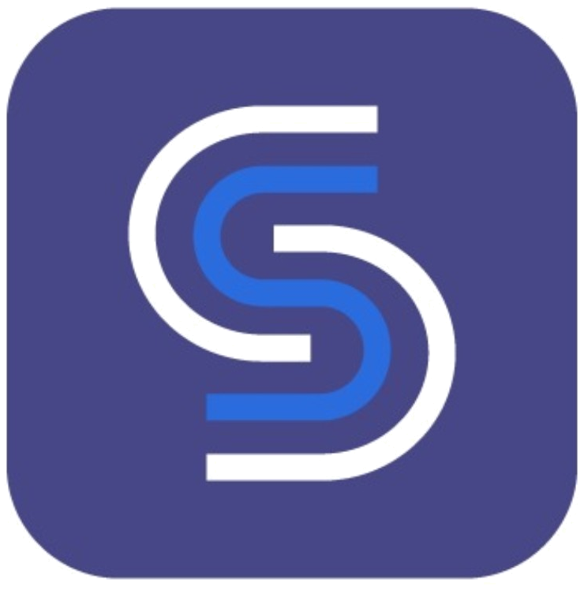
SEMA GUIDE
Privacy & Data Center
Detailed Wireframe and Engineering Implementation Specification
Document ID | ZS-SG-PRIV-01
Version | 1.0
Date | July 14, 2026
Status | Implementation baseline - pending founder approval of Item 1
Scope | Overflow menu > Privacy & data only
Classification | Zoiko Group Internal - Product, Design, Engineering, Security, Privacy and QA
Language | American English
Supersedes | Prior first-pass Privacy & data wireframe in full
Canonical principle
Show the user the actual data state of this conversation, the governing policy and the controls that can be exercised now.

0. Document Map
Section | Contents
1 | Executive lock and critical refinements
2 | Scope, users and non-goals
3 | Experience architecture and navigation
4 | Canonical desktop wireframe
5 | Component-level UI specification
6 | State and policy model
7 | Privacy use, retention and AI-model disclosures
8 | Human support and third-party access
9 | User privacy controls
10 | Responsive and accessibility requirements
11 | Technical architecture and API contracts
12 | Security, audit and observability
13 | Failure, offline and degraded states
14 | QA matrix and release gates
15 | Engineering handoff checklist

1. Executive Lock and Critical Refinements
Final product and engineering decisions for the marked Privacy & data item.
LOCKED PRODUCT DECISION
Selecting Privacy & data opens an in-context, evidence-driven privacy center inside the existing Sema Guide panel. It does not redirect to a generic legal page and it does not close, clear or restart the conversation.

The first-pass direction was correct but required stronger implementation discipline. The refined version below incorporates the following corrections:
- Runtime truth, not static copy. Every state value is supplied by an authoritative service. The client must never infer or guess retention, human access, model use, processing region or meeting-content access.
- Tri-state status model. Sensitive status values support Yes, No and Unavailable. An unavailable lookup must never be displayed as No.
- Clear is not delete. Clear conversation, delete stored conversation data and end support session are separate operations with separate confirmations and audit events.
- No consent theater. Only genuinely optional processing is shown as a toggle. Service-required, security-required or organization-managed processing is explained rather than presented as optional.
- Organization-managed clarity. Workspace-controlled settings identify the organization, policy name, policy version and last change date.
- Meeting-content boundary. Opening Sema Guide does not grant access to meeting audio, video, chat, screen share, recordings or transcripts. In-meeting help uses the minimum control metadata needed for support.
- Explicit AI-use separation. Live inference, retrieval, safety processing, product analytics, human review and foundation-model training are disclosed as separate purposes.
- Actionable privacy. The surface provides download, deletion, optional-use management, support-sharing management and privacy-request workflows without forcing users through a long legal notice.
- Resilient disclosure. When a policy service is unavailable, the UI states that the value is unavailable and provides a safe fallback. It does not substitute a default.
- Preserved continuity. Back and close actions preserve conversation messages, composer draft, scroll position, attachments and any pending support handoff.

1.1 Final menu placement
Sema Guide overflow menu
Mute notifications
Clear conversation
Talk to a person
----------------------------
Privacy & data < current item
About Sema Guide < next item, pending approval

SCOPE CONTROL
This document specifies Privacy & data only. About Sema Guide remains out of scope until this item is approved.

2. Scope, Users and Non-Goals

2.1 In scope
- Anonymous website visitors using Sema Guide.
- Authenticated members and workspace administrators.
- Guest meeting participants using in-meeting help.
- Normal meetings and Confidential Mode meetings.
- Current-session data state, processing purposes, retention, model use, human access and user controls.
- Export, deletion, optional-use, support-sharing and privacy-request workflows.
- Web, desktop, tablet and mobile presentations.
- Server-authoritative policy, audit, security and accessibility requirements.

2.2 Out of scope
- The legal drafting of Zoiko Sema privacy notices and data-processing terms.
- Administration of tenant-wide privacy policies outside the Sema Guide surface.
- About Sema Guide, agent capability disclosure and agent-version history.
- General cookie preference design beyond the deep link from this surface.
- Human support console design except for consented data handoff and access-state presentation.

2.3 Non-goals
- No dark patterns, forced consent or preselected optional processing.
- No generic reassurance language without a supporting state or policy.
- No display of raw internal identifiers, IP addresses, model-routing details or security secrets.
- No promise of a privacy right that is not available for the user, jurisdiction or relationship.
- No use of client-side assumptions as a substitute for authorization or policy enforcement.

3. Experience Architecture and Navigation

3.1 Navigation model
Privacy & data replaces the conversation body inside the current Sema Guide shell. The Sema Guide header remains visible, while the secondary screen adds a back control and a dedicated title. This preserves identity, context and focus.
Control | Behavior | Must preserve
Back | Return to the exact prior conversation state. | Messages, scroll position, composer draft, attachment state, pending tool or handoff state.
Close | Close the entire Sema Guide panel. | Conversation remains stored according to policy; no implied deletion.
Overflow | Remain available only where it does not conflict with a confirmation modal. | Session and privacy state.
External policy link | Open in an accessible document surface or new browser tab. | Sema Guide session remains active.
Deep link | Allow signed-in users to return to the same privacy subsection. | Identity and authorization revalidated on open.

3.2 Information architecture
- Current session - live data access and access-state summary.
- How your information is used - purpose-by-purpose disclosure.
- Storage and retention - active retention and processing-region policy.
- AI model use - inference, grounding, improvement, review and training status.
- Human support and providers - current access, sharing controls and provider categories.
- Your privacy controls - download, delete, optional uses, sharing and privacy requests.
- Policies and support - privacy notice, Trust Center, subprocessors and privacy contact.

3.3 Performance targets
Metric | Target | Fallback
Panel transition | Privacy shell interactive within 300 ms from local navigation. | Show shell immediately with skeleton rows.
Policy context | p95 response within 800 ms; full state within 1.5 seconds. | Mark unresolved values as Loading, then Unavailable after timeout.
No stale safety status | Human access, model use and meeting-content state refreshed on open and after relevant events. | Display last verified time.
Export initiation | Confirmation visible within 300 ms; server job acknowledged within 2 seconds. | Provide request reference and asynchronous completion.
Deletion initiation | Server acceptance within 2 seconds. | Show Pending with reference; never claim Completed early.

4. Canonical Desktop Wireframe
Figure 1 is the canonical desktop arrangement. It is a product wireframe, not a marketing composition. Engineering must use approved Zoiko Sema logo and favicon assets without redrawing, recoloring or substituting a generic S.
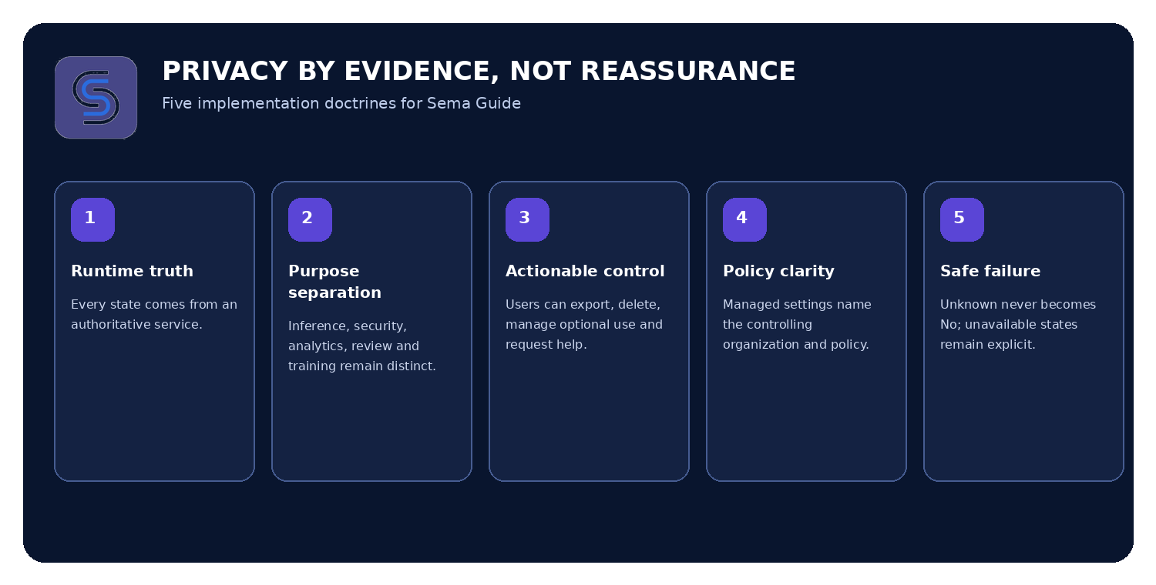
Implementation doctrine for the Privacy & data surface

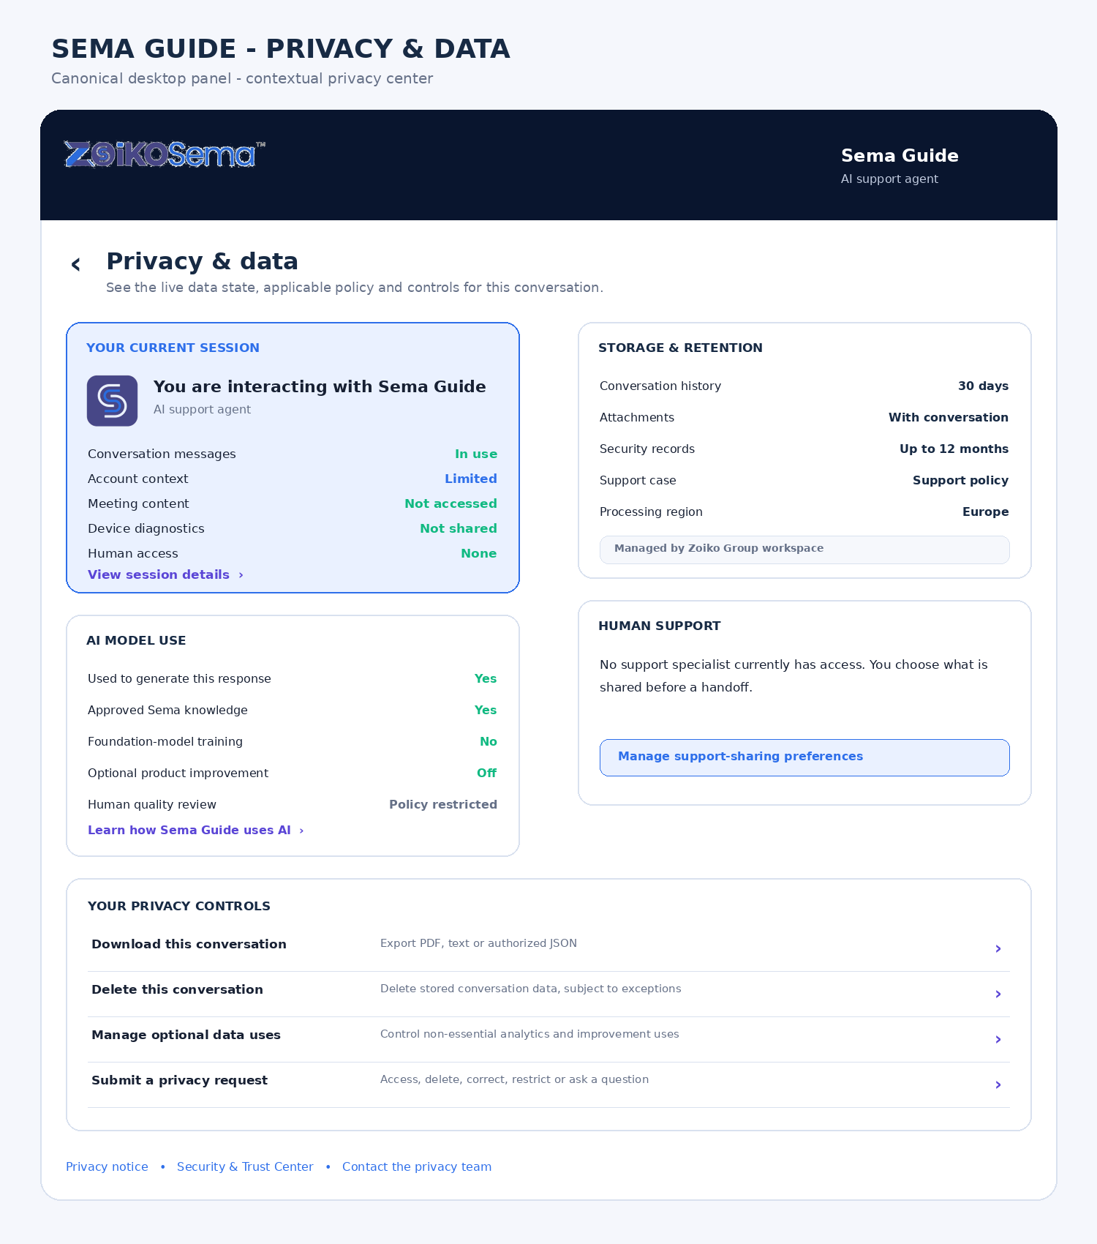
Figure 1. Canonical desktop Privacy & data center

4.1 Layout grid
Element | Desktop specification
Panel width | 420-480 px inside Sema Guide; full product mockups may show a larger engineering inspection view.
Header | 72-84 px; sticky; back, title, Sema Guide subtitle and close.
Content | Single scroll container with 20-24 px side padding and 16 px section gaps.
Cards | 12-16 px radius; 1 px neutral border; no decorative gradients inside data-state cards.
Status values | Right-aligned text plus icon where useful; never color alone.
Primary actions | Full-width rows or buttons with explicit labels; destructive action separated visually.
Footer resources | Compact links after controls; policy version and last-updated metadata.

5. Component-Level UI Specification

5.1 Header
Component | Canonical copy | Behavior
Title | Privacy & data | Level-one dialog heading; receives focus on open.
Subtitle | Sema Guide | Reinforces agent identity without duplicating the full wordmark.
Back | Accessible name: Back to conversation | Returns without state loss.
Close | Accessible name: Close Sema Guide | Closes panel; does not delete or end human support.
Loading state | Loading privacy settings | Announced once through polite live region.

5.2 Current-session card
PRIMARY SCREEN ELEMENT
The current-session card must appear first and must be populated from runtime truth. It is the user-facing evidence layer for the active conversation.

Row | Allowed values | Authoritative source
Conversation messages | In use; Not retained; Saved to support history; Unavailable | Conversation service
Account context | Not available; Limited; In use; Unavailable | Identity and context broker
Workspace context | Not available; In use; Managed by organization; Unavailable | Tenant policy service
Meeting content | Not accessed; Limited metadata only; Authorized feature access; Unavailable | Meeting policy gateway
Device diagnostics | Not shared; Shared for this request; Expired; Unavailable | Diagnostics consent service
Attachments | None; count and status; quarantined; deleted; unavailable | Secure attachment service
Human access | None; Requested; Waiting; Active; Ended; Unavailable | Support handoff service
Processing region | Region name; Multi-region under policy; Unavailable | Residency service

Canonical AI and meeting-content disclosure
Required copy
You are interacting with Sema Guide, an AI support agent. Meeting audio, video, chat and screen content are not accessed merely because Sema Guide is open.

Expanded session details
Field | Display rule
Conversation reference | Display shortened external reference only; allow copy.
Signed-in state | Display signed-in user or Anonymous session.
Workspace | Display only when authorized and verified.
Conversation start | Localized date and time with time zone.
Human access | Display current and previous access records for this session.
Tools used | Human-readable tool categories; no internal tool names or secrets.
External web search | Used, Not used or Unavailable.
Last verified | Timestamp for the status snapshot.

5.3 Purpose disclosure cards
Purpose | Summary | Required detail
Answer and resolve your request | Processes messages and minimum relevant context. | List included and excluded data categories.
Maintain support history | Allows return to a conversation and continuity with support. | Identify user choice, product default, workspace policy or support-case requirement.
Protect the service | Detects fraud, malicious files, unauthorized access, spam and abuse. | Describe proportionate records; do not imply indefinite retention.
Operational analytics | Measures reliability, unresolved topics and tool success. | Separate aggregated telemetry from conversation-content review.
Optional improvement | Improves Sema Guide only when law, policy and user choice permit. | Show default, scope, effect of disabling and exclusions.

5.4 Storage and retention card
Field | Example presentation | Rule
Conversation history | 30 days after the last message | Dynamic from active policy; never hard-coded in UI.
Anonymous session | Until browser-session expiration | Explain session token and verification.
Attachments | Deleted with conversation unless attached to an authorized support case | Show case exception.
Security records | Up to 12 months | Display policy maximum, not an unsupported average.
Support case | Per applicable support policy | Link to policy or show exact period when available.
Legal hold | Applied only when authorized | Do not expose confidential case details.
Policy owner | Managed by Zoiko Group | Show organization and policy version.
Processing region | Europe | Do not infer from IP address.

UNAVAILABLE POLICY STATE
Retention period unavailable. We could not retrieve the applicable retention policy. No estimate has been substituted.

5.5 AI model use card
Processing type | Display | Default engineering rule
Live inference | Yes | Required to generate a response; not presented as optional.
Grounded retrieval | Yes / No / Unavailable | Identify approved Sema knowledge and tenant policy sources.
Safety processing | Required | Explain purpose; no opt-out toggle.
Foundation-model training | No / Yes / Unavailable | Enterprise default No; never collapse into product improvement.
Optional product improvement | Off / On / Managed | Off by default for enterprise; genuine choice only.
Human quality review | Not permitted / Policy restricted / Eligible / Submitted | Must identify the governing rule.
Personalization | Off / On / Managed | Explain use of recent support history and deletion impact.

5.6 Human support card
State | Canonical presentation | User action
None | No support specialist currently has access to this conversation. | Manage sharing preferences.
Requested | Human support requested; nothing shared yet. | Review and confirm data package.
Waiting | Support request is queued. | Cancel, leave a message or keep waiting.
Active | Show named specialist, access start time and shared data categories. | View access details; end human access where permitted.
Ended | Show access-ended timestamp and any attached support case. | Review case or request deletion where applicable.
Unavailable | Human-access status unavailable. | Retry or contact privacy support; do not display None.

6. State and Policy Model
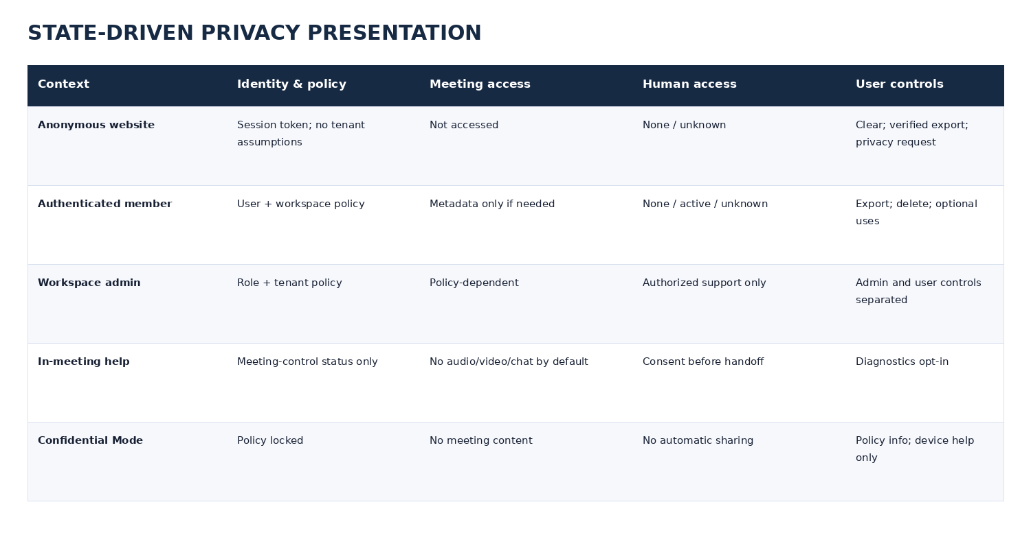
Figure 2. State-driven presentation matrix

6.1 Core state dimensions
Dimension | Values
Identity | Anonymous; authenticated user; guest participant; workspace administrator; support specialist.
Policy ownership | User-configurable; workspace-managed; service-required; legally required; unavailable.
Meeting mode | No meeting; standard meeting; in-meeting help; Confidential Mode.
Data access | Not accessed; limited metadata; active; previously shared; expired; unavailable.
Human access | None; requested; queued; active; ended; unavailable.
Conversation storage | Ephemeral; retained; attached to support case; deletion pending; deleted; legal hold.
Connectivity | Online; partial service; offline; stale snapshot.

6.2 Organization-managed settings
Managed by your organization
Zoiko Group has configured this setting for its workspace.
Policy: AI and Agentic Controls v2.1
Policy version: 2.1
Last changed: July 11, 2026
Contact: Workspace Administrator
[View applicable policy]

A managed setting uses a lock icon, remains readable, exposes the controlling source and is not rendered as an active toggle. Server authorization remains authoritative.

6.3 Confidential Mode
CONFIDENTIAL MODE ACTIVE
Sema Guide may explain device settings, meeting controls, access issues and policy. It cannot access meeting audio, video, chat, shared screens, shared files, transcripts, recordings or AI meeting summaries.

- Place the governance card immediately below the privacy header.
- Use the approved Confidential Mode visual treatment, not error red unless a failure exists.
- Block meeting-content attachment from the normal composer unless a separately authorized workflow exists.
- Do not permit human-support handoff to include confidential meeting content automatically.
- Log the policy decision without logging prohibited content.

7. Privacy Use, Retention and AI-Model Disclosures

7.1 Processing-purpose contract
Purpose ID | Purpose | Optional? | UI treatment
support_resolution | Answer, troubleshoot and complete authorized tasks | No | Explain; no toggle.
support_history | Maintain user or support continuity | Policy-dependent | Show retention and controlling source.
security_abuse | Protect accounts, service and users | No | Explain; no toggle.
operational_telemetry | Measure performance and reliability | Policy-dependent | Explain aggregated scope.
product_improvement | Improve Sema Guide with eligible content | Yes where enabled | Off by default; user control only when legally valid.
human_quality_review | Authorized review for support, safety or QA | Policy-dependent | Show eligibility and actual submission state.
foundation_training | Train general-purpose foundation models | Policy-dependent | Explicit Yes/No/Unavailable; enterprise default No.

7.2 No-consent-theater rule
RELEASE-BLOCKING RULE
Do not show a toggle for processing that is required to deliver support, secure the service, satisfy legal obligations or enforce workspace policy. Present the purpose, scope and controlling source instead.

7.3 Retention decision rules
- Fetch retention from the authoritative policy service using conversation, tenant, identity, region and support-case context.
- Display exact duration or policy phrase returned by the service; do not calculate or round in the client.
- Identify exceptions such as support-case attachment, legal hold and security-record retention.
- When the value is unknown, display Unavailable and the last successful verification time.
- Refresh after creation of a support case, human handoff, attachment upload, policy change or deletion request.
- Ensure deletion status reflects actual server state: Requested, Pending, Completed, Partially completed or Rejected with reason.

8. Human Support and Third-Party Access

8.1 Consent package before handoff
Data category | Default | Rule
Conversation history | Selected | User may deselect unless needed to create the requested case.
Account and plan details | Selected when relevant | Only minimum fields; role and entitlement enforced.
Steps already attempted | Selected | Generated summary must be reviewable.
Browser and app diagnostics | Not selected | Explicit opt-in; show exact fields.
Meeting identifier | Not selected | Use only when needed; never include meeting content by default.
Uploaded attachments | Not selected | List each file; scanning and classification required.
Confidential Mode content | Never selected | Blocked unless a separate authorized process exists.

8.2 Active human-access view
HUMAN ACCESS ACTIVE
Amelia R. - Zoiko Sema Support
Access began: 2:42 PM
Support case: ZS-28417
Information shared
Conversation history
Account and plan details
Steps already attempted
[View access details] [End human access]

8.3 Provider categories
- Cloud hosting and storage providers.
- Approved AI-processing providers.
- Customer-support infrastructure providers.
- Security, fraud-prevention and abuse-detection providers.
- Malware scanning and secure attachment providers.
- Analytics providers where enabled by policy.
The user-facing surface links to the current subprocessor list. Avoid vague terms such as partners when a more precise category is available.

9. User Privacy Controls

9.1 Canonical order
- Download this conversation.
- Delete this conversation.
- Manage optional data uses.
- Manage support-sharing preferences.
- Submit a privacy request.

9.2 Clear, delete and end session are distinct
Action | Effect | Confirmation
Clear conversation | Removes visible messages from the active UI and starts a new conversation. Stored data follows policy. | Confirm visible reset; explain storage impact.
Delete conversation | Deletes stored conversation data subject to stated exceptions. | Strong confirmation; type DELETE where appropriate; server status required.
End support session | Ends the active interaction and human queue; does not inherently delete data. | Confirm impact on queue or specialist connection.
Delete support case | Separate support workflow; may have contractual or legal restrictions. | Not performed through conversation deletion.

9.3 Download workflow
Requirement | Specification
Formats | PDF; plain text; JSON for authorized enterprise users.
Content selection | Messages, sources, action results and optional technical session details.
Identity | Authenticated user or verified anonymous-session token.
Policy | Export can be disabled or restricted by workspace policy.
Security | Short-lived signed download URL; encrypted at rest and in transit; audit event.
Redaction | Deleted, redacted or restricted content must not reappear in export.
Disclosure | Warn that the export may contain sensitive information and must be stored securely.

9.4 Deletion workflow
DELETE THIS CONVERSATION?
This deletes the stored Sema Guide conversation from support history.
It does not delete:
- An independently created support case
- Security records that must be retained
- Records subject to legal hold
- Authorized audit records
Type DELETE to continue.
[Delete conversation] [Cancel]

DELETION STATUS
Never display Completed until the deletion service confirms completion. If deletion is asynchronous, show Pending with a request reference and notify the user when the final state is available.

9.5 Optional data uses
Setting | Default | Availability
Aggregated product analytics | Workspace policy | Display control only when user choice applies.
Improve Sema Guide with eligible conversation content | Off | Enterprise default Off; no service penalty for declining.
Human review of submitted feedback | Off | Separate from automatic quality review permitted by policy.
Personalized help from recent support history | Policy-dependent | Explain data scope and deletion effect.
Security and abuse monitoring | Required | No toggle; explain requirement.

9.6 Privacy request
Request type | Flow requirement
Access | Identify applicable data categories and verification requirements.
Delete | Separate from single-conversation deletion where broader data is requested.
Correct | Collect the record or field to be corrected.
Object or restrict | Present only where applicable; route to privacy operations.
Manage sale or sharing choices | Show only for applicable jurisdiction and data relationship.
Privacy question | Allow free-text question and contact preference.

10. Responsive and Accessibility Requirements

10.1 Mobile wireframe
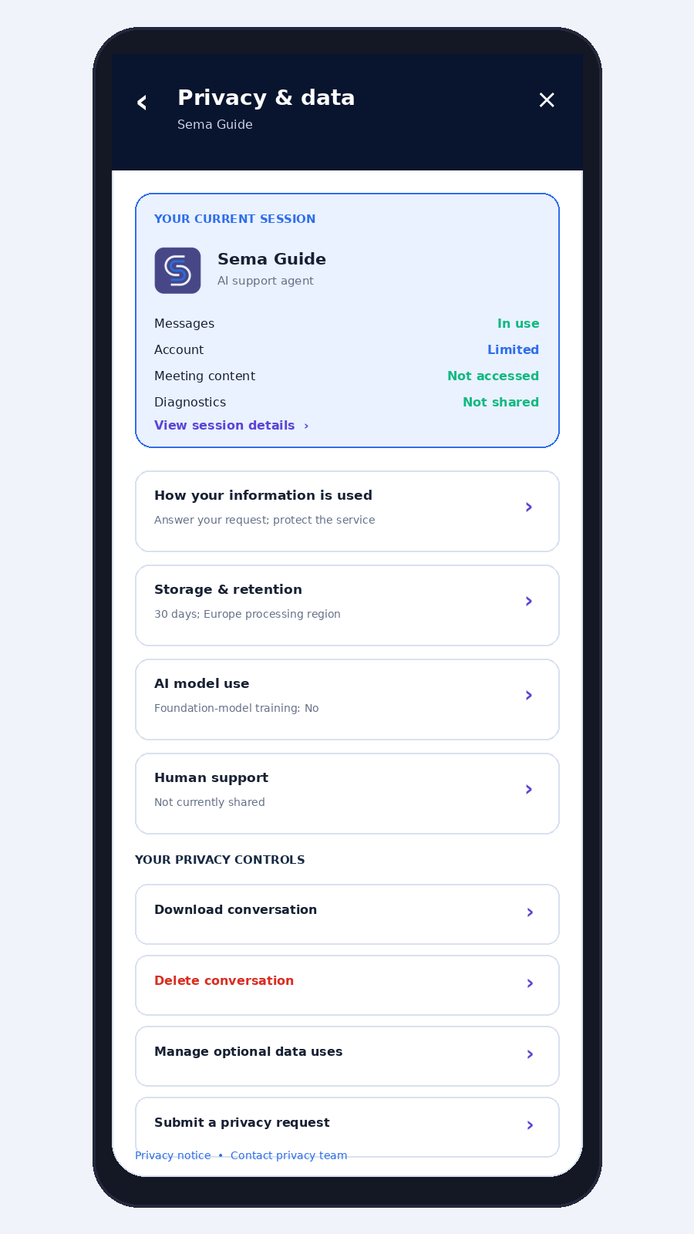
Figure 3. Canonical mobile full-screen sheet

10.2 Responsive behavior
Viewport | Behavior
Desktop | Docked panel; single scroll container; sticky header.
Tablet | 420-480 px panel or up to 50% viewport; no content occlusion of critical controls.
Mobile | Full-screen sheet with sticky header, single-column cards and safe-area-aware action regions.
200% zoom | No horizontal scrolling for ordinary text; cards reflow vertically.
RTL locales | Mirrored directional controls; status and numbers remain semantically correct.

10.3 WCAG 2.2 AA requirements
- Focus moves to the Privacy & data heading on open and returns to the overflow trigger on close.
- Back, close, accordions, toggles, links and confirmations are fully keyboard operable.
- Each status uses visible text; color is supplementary only.
- Loading, export, deletion and human-access changes use polite live regions.
- Unknown or unavailable values are announced accurately.
- Managed controls expose the reason they are unavailable.
- Primary touch targets are at least 44 by 44 CSS pixels.
- Text remains usable at 200% zoom and with browser text spacing overrides.
- Destructive actions are separated spatially and not identified solely by red.
- Reduced motion, high contrast and screen-reader navigation are supported.

11. Technical Architecture and API Contracts

11.1 Authoritative service dependencies
Data | System of record
Identity and authentication | ZoikoID
Workspace and organization | Tenant service
Roles and permissions | Authorization service
Entitlements | Entitlement service
Retention and optional-use policy | Policy engine
Conversation state | Sema Guide conversation service
AI-use status | AI governance service
Meeting-content access | Meeting policy gateway
Human access and handoff | Support handoff service
Attachments | Secure attachment service
Processing region | Residency service
Privacy request | Privacy operations service
Audit evidence | Audit service

11.2 Recommended endpoint set
Method and route | Purpose | Authorization
GET /v1/sema-guide/conversations/{id}/privacy-context | Retrieve current session, policy, model use, human access and available controls. | Conversation owner, verified session or authorized support.
POST /v1/sema-guide/conversations/{id}/exports | Create an export job. | Export permission and step-up where required.
GET /v1/sema-guide/exports/{jobId} | Retrieve export status and short-lived download URL. | Export requester only.
POST /v1/sema-guide/conversations/{id}/deletion-requests | Submit conversation deletion. | Owner or verified session; policy and legal hold check.
PATCH /v1/sema-guide/privacy-preferences | Change genuinely optional uses. | Authenticated user; tenant policy enforced.
POST /v1/sema-guide/conversations/{id}/support-sharing-consent | Record exact handoff data package. | Conversation owner; consent version recorded.
POST /v1/privacy/requests | Submit a broader privacy request. | Identity verification based on request type.

11.3 Privacy-context response contract
{
"conversation_id": "sgc_01J...",
"identity_state": "authenticated",
"snapshot": {
"verified_at": "2026-07-14T14:18:00Z",
"status": "current"
},
"current_session": {
"conversation_messages": "in_use",
"account_context": "limited",
"workspace_context": "managed",
"meeting_content": "not_accessed",
"device_diagnostics": "not_shared",
"attachments_count": 0,
"human_access": "none"
},
"retention": {
"conversation": {"value": 30, "unit": "days"},
"security_logs": {"maximum": 365, "unit": "days"},
"policy_source": "tenant",
"policy_name": "Zoiko Group Sema Privacy Policy",
"policy_version": "1.0"
},
"ai_use": {
"live_inference": "required",
"grounded_retrieval": "enabled",
"foundation_model_training": "disabled",
"optional_product_improvement": "disabled",
"human_quality_review": "policy_restricted"
},
"processing_region": "europe",
"controls": {
"download": "allowed",
"delete": "allowed",
"optional_uses": "available",
"support_sharing": "available",
"privacy_request": "available"
}
}

11.4 Status enum rule
NO FALSE NEGATIVES
For privacy-sensitive fields, the API and UI must support unknown and unavailable. A timeout, authorization failure or missing record must never be mapped to No, None, Disabled or Not accessed.

12. Security, Audit and Observability

12.1 Security requirements
- Enforce authorization on the server for every privacy-context field and action.
- Return only the minimum fields required for the user-facing state.
- Use short-lived, single-purpose signed URLs for exports.
- Encrypt exports and deletion-request evidence at rest and in transit.
- Require step-up authentication for high-risk exports or deletion where policy requires it.
- Rate-limit export, deletion and privacy-request endpoints.
- Scan attachments before inclusion in support handoff or export.
- Redact secrets, authentication codes and restricted fields from generated summaries.
- Prevent cross-tenant references, logs and cache leakage.
- Expire cached privacy context rapidly and invalidate on policy, handoff, attachment or deletion events.

12.2 Required audit events
SEMA_GUIDE_PRIVACY_CENTER_OPENED
SEMA_GUIDE_SESSION_DETAILS_VIEWED
SEMA_GUIDE_RETENTION_DETAILS_VIEWED
SEMA_GUIDE_AI_USE_DETAILS_VIEWED
SEMA_GUIDE_OPTIONAL_DATA_USE_CHANGED
SEMA_GUIDE_EXPORT_REQUESTED
SEMA_GUIDE_EXPORT_COMPLETED
SEMA_GUIDE_DELETION_REQUESTED
SEMA_GUIDE_DELETION_STATUS_CHANGED
SEMA_GUIDE_SUPPORT_SHARING_CHANGED
SEMA_GUIDE_HUMAN_ACCESS_VIEWED
SEMA_GUIDE_PRIVACY_REQUEST_STARTED
SEMA_GUIDE_PRIVACY_REQUEST_SUBMITTED
SEMA_GUIDE_PRIVACY_POLICY_OPENED

Each event contains tenant ID, pseudonymous user or session ID, conversation reference, policy version, authorization decision, result, timestamp, processing region, correlation ID and error code where applicable. Audit records must not duplicate full conversation content.

12.3 Product analytics
Metric | Purpose
Privacy center open rate | Discoverability and trust behavior.
State load success and latency | Service reliability.
Unavailable-field rate | Detect policy and integration gaps.
Export completion rate | Workflow health; not content analysis.
Deletion completion time | Operational compliance and queue health.
Optional-use change rate | Control usability; never optimize for opt-in.
Human-sharing review completion | Handoff transparency.
Accessibility failure rate | Release quality and regression detection.

13. Failure, Offline and Degraded States
Failure | Canonical message | Permitted actions
Policy service unavailable | Privacy settings are temporarily unavailable. No policy values have been estimated. | Try again; general privacy notice; privacy support.
Human access unavailable | We could not verify whether a support specialist has accessed this conversation. | Retry; contact privacy support.
Export failed | The download could not be prepared. Your conversation has not been changed. | Retry; create support request.
Deletion failed | The conversation was not deleted. No deletion has been recorded. | Retry; submit privacy request.
Deletion pending | Your deletion request is being processed. | View status; keep request reference.
Unauthorized action | This action is not available for your account. Your organization manages this setting. | View policy; contact administrator.
Offline | Privacy details require a connection. A cached snapshot is shown only if its age is visible. | Retry when online; open downloaded policy if available.
Stale snapshot | Some values may have changed since the last verification. | Refresh now.

13.1 Loading behavior
- Show the shell and section labels immediately.
- Use skeleton rows without placeholder values that resemble real status.
- Load critical current-session and AI-use states before lower-priority policy resources.
- After the timeout threshold, convert unresolved rows to Unavailable with a retry action.
- Announce the completed state once; do not repeatedly interrupt screen readers.

14. QA Matrix and Release Gates

14.1 Minimum test matrix
Area | Required scenarios
Identity | Anonymous, authenticated member, admin, guest, expired session, wrong tenant.
Policy | User choice, organization managed, required processing, legal hold, policy unavailable.
Meeting | No meeting, standard meeting, in-meeting help, Confidential Mode.
Human access | None, requested, queued, active, ended, unavailable.
Storage | Ephemeral, retained, support case, deletion pending, deleted, partial deletion.
Controls | Export allowed/blocked, deletion allowed/blocked, optional uses available/managed, privacy request.
Connectivity | Fast, slow, timeout, partial service, offline, stale cache.
Accessibility | Keyboard, screen reader, 200% zoom, high contrast, reduced motion, RTL.
Localization | American English baseline, long translations, date/time/region formatting.
Security | Cross-tenant denial, privilege escalation, replay, rate limit, signed URL expiry, redaction.

14.2 Release-blocking acceptance criteria
- The Privacy & data screen opens inside the current Sema Guide shell and preserves conversation state.
- The current-session card is populated from authoritative runtime services.
- Sema Guide is explicitly identified as an AI support agent.
- Meeting-content access is represented accurately for standard and Confidential Mode sessions.
- Privacy-sensitive fields support Unavailable and never map unknown to No.
- Retention values and policy ownership are dynamic and traceable to a policy version.
- Live inference, safety processing, product improvement, human review and foundation-model training are separated.
- Foundation-model training is explicitly shown; enterprise default is No.
- Only genuinely optional processing is rendered as a toggle.
- Organization-managed controls identify the controlling organization and policy.
- Human-access status is visible and refreshed after handoff events.
- The user reviews the exact data package before human support receives it.
- Clear conversation, delete conversation and end session have distinct behavior and copy.
- Export enforces identity, authorization, policy, redaction and short-lived delivery.
- Deletion status is server-confirmed and never reported completed early.
- Anonymous, authenticated, admin, in-meeting and Confidential Mode states render correctly.
- Processing region is supplied by the residency service and is not inferred from IP address.
- Failure states do not substitute reassuring default values.
- The interface meets WCAG 2.2 AA and passes keyboard and screen-reader acceptance tests.
- All visible copy uses American English.
- Official Zoiko Sema logo and favicon assets are used without reconstruction, recoloring or distortion.
- Every consequential action generates a minimal, privacy-safe audit record.
- Cross-tenant and unauthorized access tests pass.
- About Sema Guide is not implemented as part of this work package.

15. Engineering Handoff Checklist
Owner | Deliverable
Product | Approve canonical copy, state order, control order and scope boundary.
UI/UX | Produce Figma components for desktop, mobile, loading, managed, Confidential Mode and failure states.
Front end | Implement state-driven rendering, keyboard behavior, live regions, deep links and non-lossy navigation.
Conversation platform | Expose conversation storage, attachment and deletion states.
Policy engine | Return retention, optional-use, policy ownership and version data.
AI governance | Return model-use and human-review status as explicit enums.
Meeting platform | Return meeting-content access and Confidential Mode decision.
Support | Expose human-access state and consented handoff package.
Security | Review authorization, export delivery, redaction, rate limits and cross-tenant isolation.
Privacy/Legal | Validate purpose language, jurisdiction routing, rights workflows and exception copy.
QA | Execute the full state, accessibility, security, localization and degraded-service matrix.
Analytics | Instrument reliability and control usability without optimizing for consent or data sharing.

15.1 Definition of done
IMPLEMENTATION COMPLETE
The work package is complete only when design assets, API schemas, server authorization, policy integration, audit events, accessibility evidence, security tests and QA evidence are all attached to the release record. A visually complete screen without authoritative data services is not complete.

15.2 Canonical copy lock
Location | Approved copy
Menu item | Privacy & data
Screen title | Privacy & data
Subtitle | Sema Guide
Opening disclosure | You are interacting with Sema Guide, an AI support agent.
Session assurance | See what Sema Guide is using, how long information is retained and which controls are available to you.
Meeting-content statement | Meeting audio, video, chat and screen content are not accessed merely because Sema Guide is open.
Training statement | Used to train foundation models: No
Human-access statement | No support specialist currently has access to this conversation.
Footer statement | Privacy settings may be controlled by your organization and applicable law.

NEXT ITEM
About Sema Guide remains pending. Do not begin its design or engineering implementation until the Privacy & data item is approved or explicitly revised.

