**REPORT**

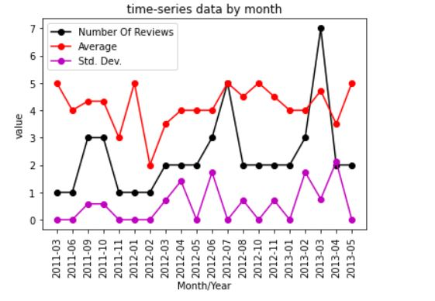

**In the timeseries data we have xaxis as year_month and y axis as the value.**

**There are three legends in the data. One shows the count of reviews that is nothing but no of reviews given , average that is nothing but average of review and third is standard deviation. Many of the month we have only single review so standard deviation is none for them which we have marked as zero. The data currenty doesnot show any significant insight.**

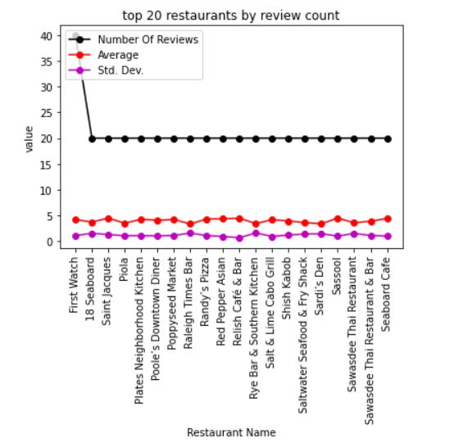

**The second plot is of top 20 restaurants by review counts.There are three legends in the data. One shows the count of reviews that is nothing but no of reviews given , average that is nothing but average of review and third is standard deviation. We can see the no of reviews are highest 40 for the First watch restaurant and there after its 20 only.**

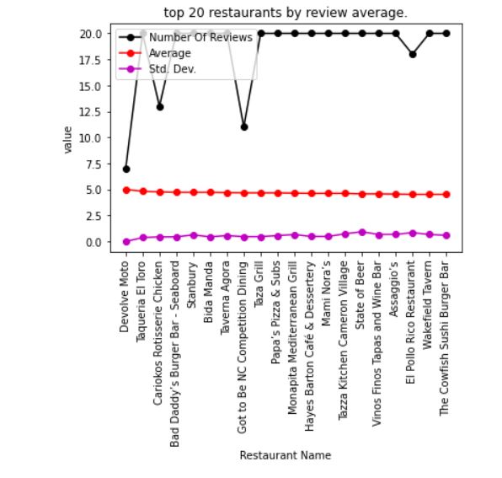

**The second plot is of top 20 restaurants by average ratings.There are three legends in the data. One shows the count of reviews that is nothing but no of reviews given , average that is nothing but average of review and third is standard deviation. We can see the rating is highest for Devolve Monte though its no of reviews are less**