**Occlusion**

The Occlusion model is based on CarMaker's Traffic Objects (TO) and Nearest Point (NP) data output.

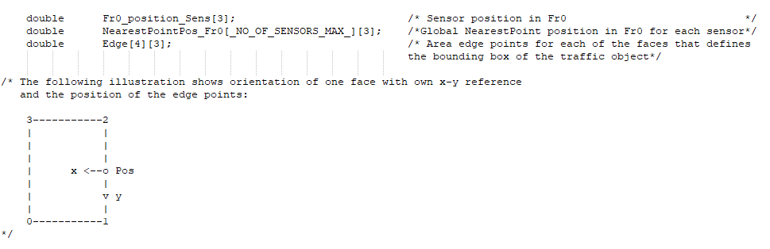

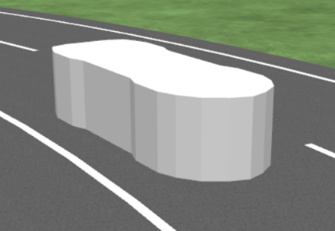This information is used to determine intersection points between the Sensor-NP direction and all surfaces of traffic objects (i.e., defined by surface corners A1, B1,C1 D1 and A2, B2, C2, D2) situated closer than the current NP.

CarMaker Traffic object bounding box

**Intersection points**

Each TO surface defines a 2D plane embedded in 3D space, with points situated in the plane satisfying equation:

a*x + b*y + c*z +d = 0 Eq. (1)

The direction defined by the Sensor (xS, yS, zS) and the NP of the reference TO (xNP, yNP, zNP) can be parametrized using:

(x, y,z) = (xS, yS, zS) + t * (xNP, yNP, zNP) for −∞ < t < ∞ Eq. (2)

The model determines intersection points between the Sensor-NP direction (for the NP of the reference TO) and surface planes of all other TOs (with planes defined by TO surface corners, e.g., (A1, B1, C1, D1); (A2, B2, C2, D2) …).

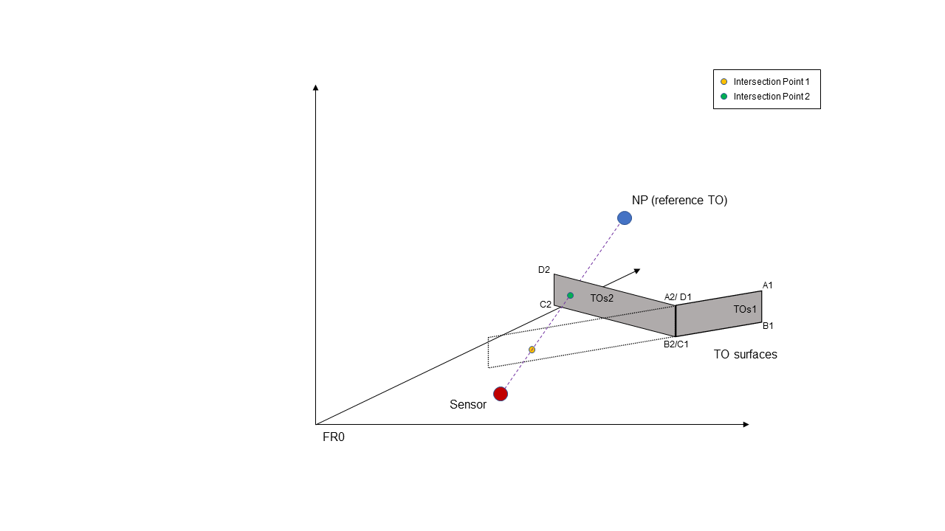

**Intersection location**

The final step in the Occlusion estimation is to determine the location of the intersection points. This is achieved by calculating the sum of all angles formed by lines from the intersection point to the four corners of the TO surface (the intersection point is inside the polygon if ∑θi = 2π, polygon (A2, B2, C, D2); ∑θi < 2π otherwise, polygon (A1, B1, C1, D1)).

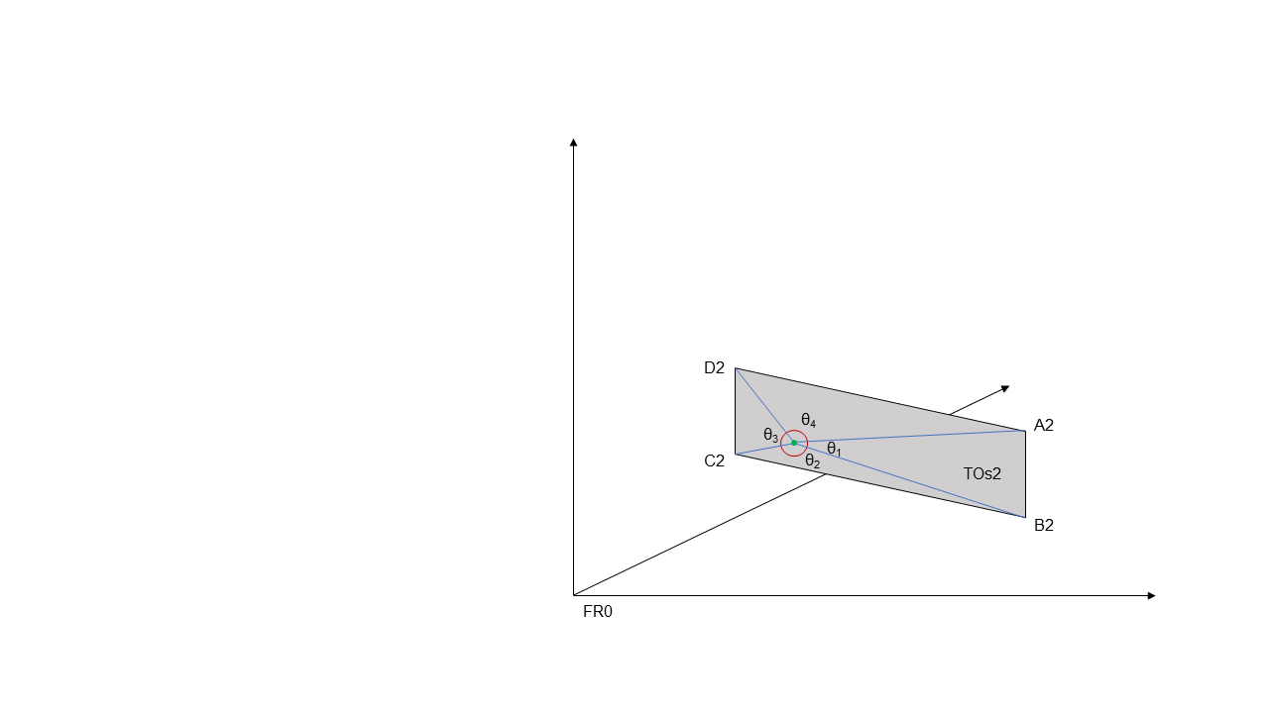

Occlusion is estimated for all traffic objects which are closer to the sensor than the nearest point of the reference traffic object.

