**Cross-echoes**

Cross-echoes are modelled using virtual sensors situated at the midpoint between the transmitting and receiving real ultrasonic sensors (USS). The model considers cross-echoes between adjacent sensors only, such that the number of virtual ultrasonic sensors (vUSS) is equal to that of real sensors (Fig. 1, blue: USS, yellow: vUSS).

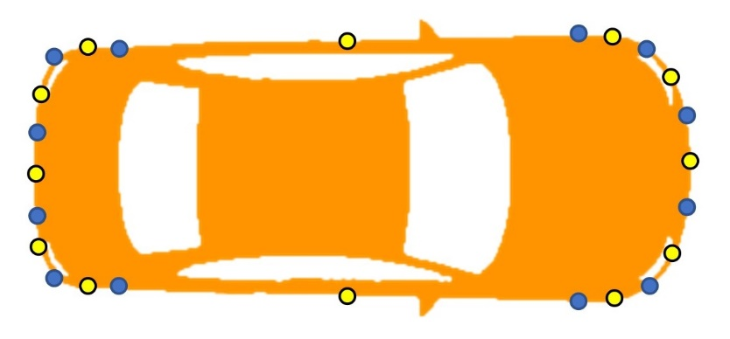

Figure 1. Vehicle with 12 real sensors (blue) and 12 virtual sensors (yellow) situated at the midpoint between adjacent real sensors.

**Determination of nearest points**

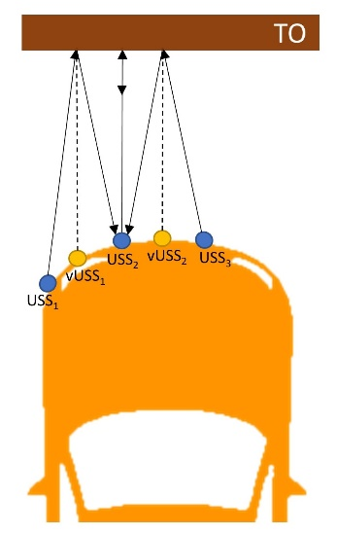

Figure 2. Schematic  
representation of direct and cross-echoes for USS2 (solid lines). Dotted lines represent the normals from virtual sensors on the TO surface.

Sound reflection occurs when sound travelling through air bounces off a different material, with the angle of incidence equal to the angle of reflection. The normal to the reflective surface at the cross-reflection point intersects the line described by the positions of the transmitting and receiving sensors at the midpoint between the real sensors (Fig. 2, dotted lines). The model places the vUSS at the midpoint (Fig. 2, yellow circles), with coordinates calculated as:

xv1 = (x1 + x2) / 2, yv1 = (y1 + y2) / 2, zv1 = (z1 + z2) / 2

where (xv1, yv1,zv1) are the coordinates of vUSS1, and (x1, y1,z1) and (x2, y2,z2) are the coordinates of real sensors 1 and 2, respectively.

The nearest point (NP) for the cross-reflection is calculated as the projection of the vUSS position onto the traffic object (TO) surface.

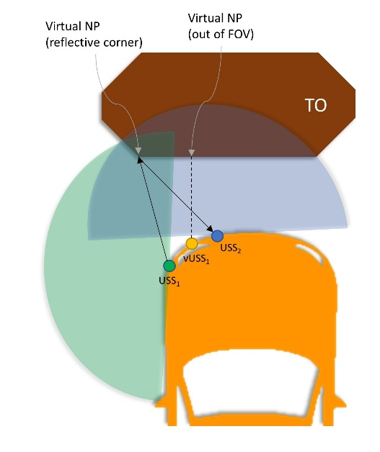**Virtual sensor Field of View (FoV)**

The FoV of virtual sensors is taken as the overlap of the FoVs of the neighboring real sensors. Virtual NPs (i.e., cross-reflection NPs) are considered valid if they are situated in the FoV of both the transmitting and the receiving real sensors (Fig. 3, green and blue areas, respectively). The model evaluates the cross-reflection NP (i.e., vUSS projection onto TO surfaces; Fig. 3, dotted line) and, if it is situated outside vUSS FoV, an alternative cross-reflection NP is evaluated (i.e., nearest reflective corner; Fig. 3, solid lines).   
In addition, the azimuth of virtual sensor is calculated as the mean azimuth of the neighboring real sensors.**Corner reflectivity**

Figure 3. FoV of virtual sensor 1 (vUSS1) shown as the overlap of FoVs of the neighboring real sensors (USS1 and USS2).

To evaluate corner reflectivity, for both real and virtual sensors, the model makes use of the so-called tile FoVs of the TO tiles (or surfaces) forming the corner. The FoV of a tile is described by a semicircle with its arc limits defined as the direction of the normal to the tile +/-90 degrees (Fig. 4, green and red semicircles). For each sensor, the model takes a valid reflection point from a corner (or valid NP) for both direct and cross-reflections if a USS or a vUSS, respectively, is situated in the FoV of both tiles forming the corner (Fig. 4, USS1 and vUSS1).

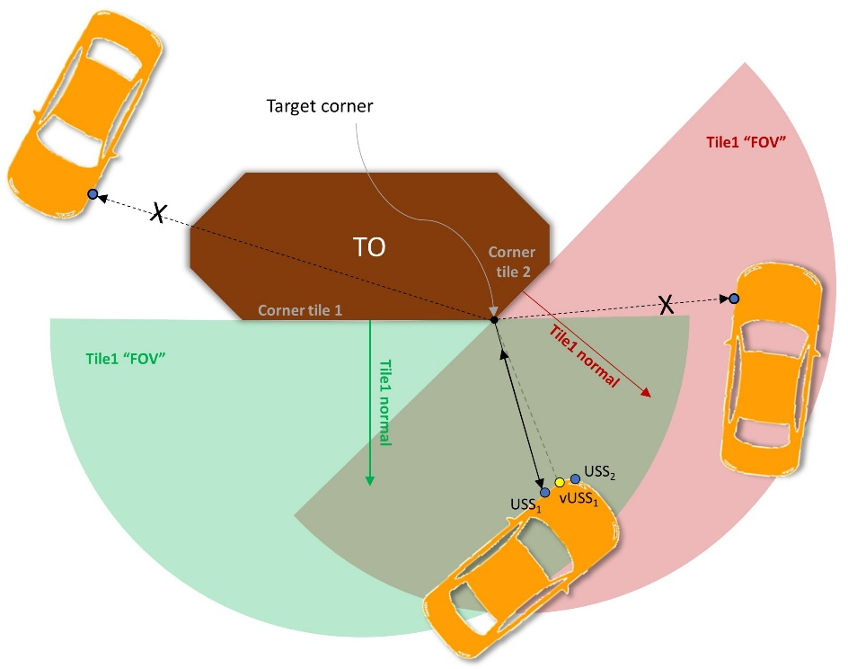

Figure 4. Corner reflectivity evaluation.   
For the target corner, the model generates a direct or cross-reflection for a specific sensor if the sensor (real USS or virtual USS) is situated in the FOV of both tiles 1 and 2. The tile FOV limits are defined as the direction of the normal +/- 90 ͦ(normals: green and red arrows, FoVs: green and red semicircles).

**Curb cross-reflection**

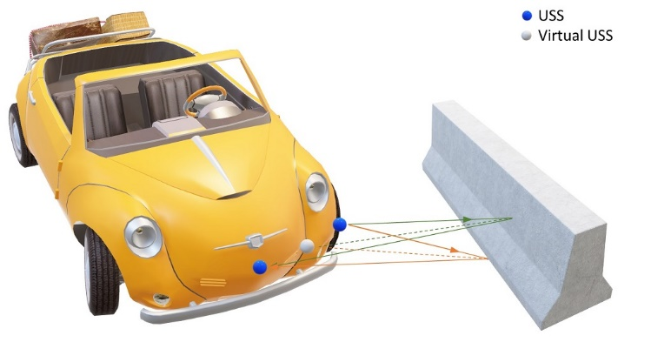In addition to cross-reflection from TO surfaces and corners, the model generates an additional cross-reflection NP for TOs which contact the ground, such as curbs or walls (Fig. 5). For each initial virtual NP (vNP), defined as the projection of the vUSS onto the TO tile (Fig. 5, green lines: cross-echoes from a vNP), a second cross-reflection is generated from a new vNP with the same (x, y) coordinates as the initial one, but placed on the TO-ground contact line (z = 0; Fig. 5, orange lines).

Figure 5. Cross-reflections from curbs and walls. In addition to the cross-echoes from the TO surface (green lines), an additional cross-echo is generated from the TO-ground contact line (orange).

**Cross-echo occlusion**

The model evaluates occlusion for cross-reflections similarly to occlusion for direct reflections (see Occlusion documentation). However, for a given virtual NP both the transmitting USS to NP direction and the receiving USS to NP direction are evaluated. The vNP is considered valid only if both directions are unoccluded.