Dataset: <https://www.kaggle.com/datasets/mohamedbakhet/amazon-books-reviews?select=Books_rating.csv>

This dataset provides a diverse collection of book reviews, showcasing the opinions of several readers on more than 212,404 distinct books. The site, which has 3 million reviews [number of records], is a lively place where readers from all walks of life come together. Each review has a unique number that connects the reviewer with the book.

**Book Details:**

Every book is given a unique ID, which is shown with its title and price. The price information is particularly thorough and covers a wide range of prices, which reflects the books' varied economic backgrounds.

**Data Columns Insights:**

User_id: Unique identifier for the user who reviewed the book.

profileName: The name of the user who reviewed the book.

review/helpfulness: shows how helpful other users thought the review was; for example, "2/3" indicates that two out of three users thought the review was helpful.

review/score: A reviewer assigns the book a score between 0 and 5.

review/time: Timestamp for when the review was posted.

review/summary: A brief summary of the review text.

review/text: The full text of the review.

**Uploading Data:**

First Program : o summarize number of reviews for each book **[Summarization pattern]]**

Execution:

Code:

Execution log:

Outputs:

**Second Proogram:** Filter the distinct booknames in the dataset **[Filtering Pattern]**

Execution

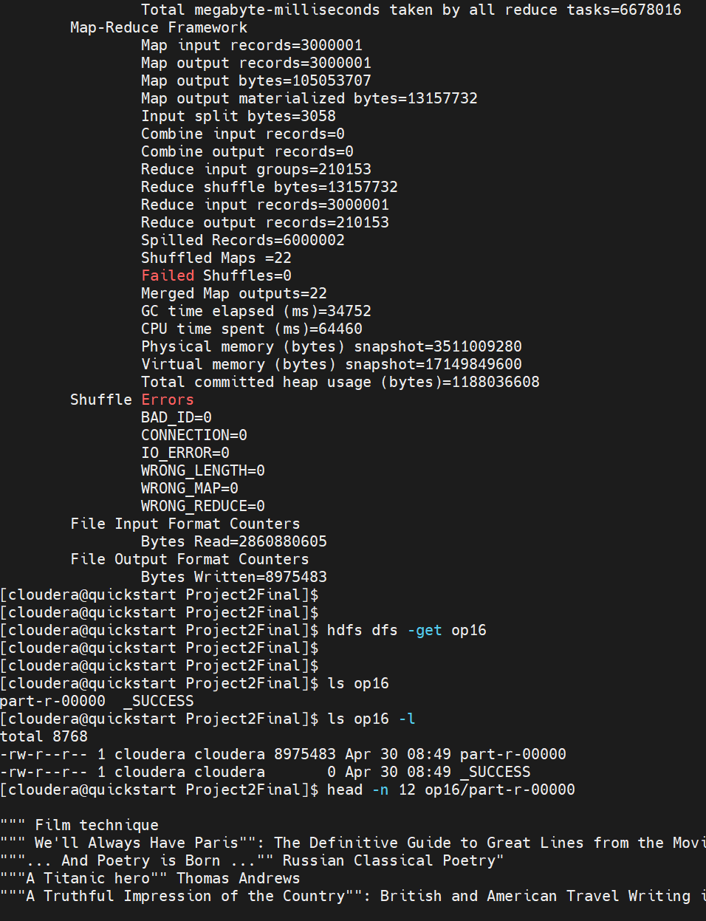

Outputs:

