Activity 02

Create a project in XCode with the name “**LastName_MoviesApp**”. You have to create an application where you need to select the movies and book the tickets. This app requires you to use images, please download the images.zip and paste all the images in assets section of your project.

1. Your application will have two view controllers, first being default controller ]”**ViewController”,** change the name to “**MovieShowsViewController**”and the second one which you need to create “**BookingDetailsViewController”**.
2. In the **MovieShowsViewController** you should have the following objects:

* **Image View:** You will be displaying the images for the movie here.
* **Previous Button:** This Button is used to navigate to the previous movies.This button should be disabled when ever you navigate to the first movie.
* **Next Button :** This button is used to navigate to the next movies. This button should be disabled when we reach last movie.
* **Two labels**: One label for displaying the movie name and other to display the cost for the movie.
* **Two text fields**: One text field for entering your name for booking and the other to enter number of tickets.
* **Book Tickets Button:** When you click this button, it should navigate to the next View Controller.

1. In the **BookingDetailsViewController,** you should have the following objects:

* **Four labels**: One label for showing name on the booking, second label for displaying the Movie Name which you have selected, Third label for displaying number of tickets which you have entered in the previous screen, fourth label for displaying the total cost of the tickets.

1. Use the Array for storing movie names and ticket cost.

var details = [["Avatar","12"],["No Time To Die","10"],["Shang Chi","15"],["Joker","20"]]

First value is the name of the movie and the second value is the cost per ticket.

Following given screenshots demonstrate the flow of an app:

1. On the load of app, your app should show the view similar to the below screenshot

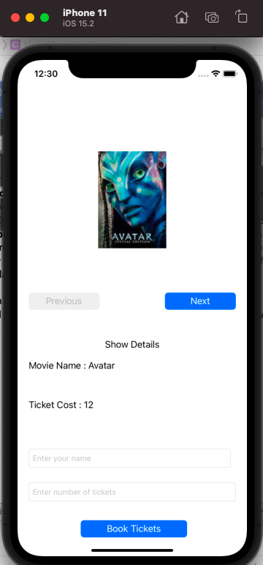

b. When you click next button, it should navigate to the next movie

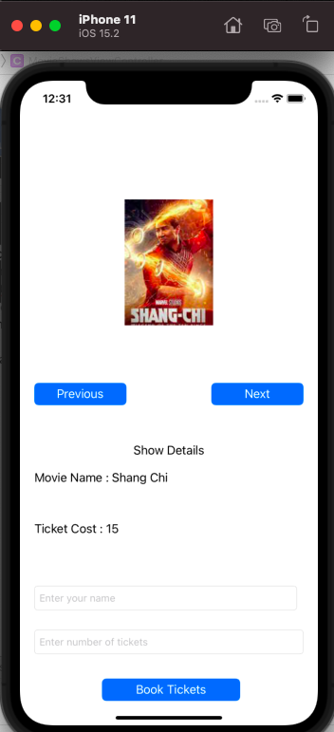

c. when you move to the last movie, next button should be disabled and it should display as follows.

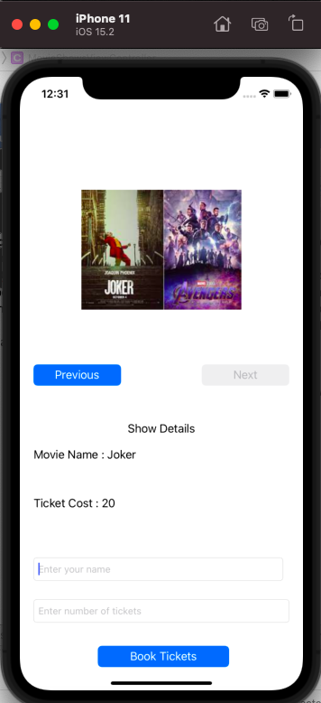

d. You should enter the name in first text field and number of tickets in the second text field.

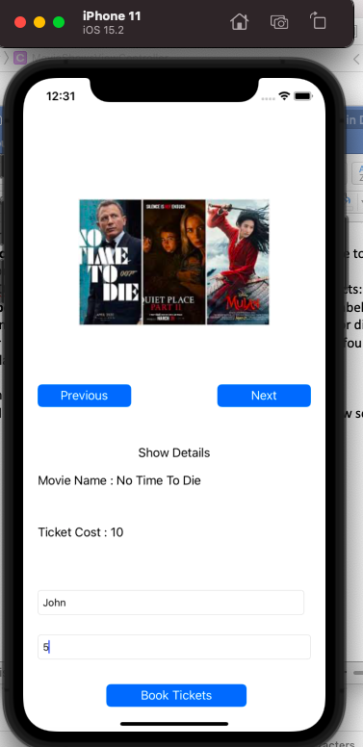

e. When you click on book tickets button, it should navigate to next screen and should display all the details.

