Interrupt Handling in Device Driver

Before writing any interrupt program, you should keep the following points in mind.

1. Interrupt handlers can not enter sleep, so to avoid calls to some functions which has sleep.
2. When the interrupt handler has part of the code to enter the critical section, use spinlocks lock, rather than mutexes. Because if it couldn’t take mutex it will go to sleep until it takes the mute.
3. When the interrupt handler has part of the code to enter the critical section, use spinlocks lock, rather than mutexes. Because if it couldn’t take mutex it will go to sleep until it takes the mute.
4. The interrupt handlers must be executed as soon as possible. To ensure this, it is best to split the implementation into two parts, the top half and the bottom half. The top half of the handler will get the job done as soon as possible and then work late on the bottom half, which can be done with softirq or tasklet or workqueue.
5. Interrupt handlers can not be called repeatedly. When a handler is already executing, its corresponding IRQ must be disabled until the handler is done.
6. Interrupt handlers can be interrupted by higher authority handlers. If you want to avoid being interrupted by a highly qualified handler, you can mark the interrupt handler as a fast handler. However, if too many are marked as fast handlers, the performance of the system will be degraded, because the interrupt latency will be longer.

Functions Related to Interrupt
request_irq(unsigned int irq,irq_handler_t handler,unsigned long flags,const char *name,void *dev_id)

Register an IRQ, the parameters are as follows:
irq: IRQ number to allocate.
handler: This is Interrupt handler function.This function will be invoked whenever the operating system receives the interrupt.The data type of return is irq_handler_t, if its return value is IRQ_HANDLED, it indicates that the processing is completed successfully, but if the return value is IRQ_NONE, the processing fails.
flags: can be either zero or a bit mask of one or more of the flags defined in
linux/interrupt.h. The most important of these flags are:
IRQF_DISABLED
IRQF_SAMPLE_RANDOM
IRQF_SHARED
IRQF_TIMER
name: Used to identify the device name using this IRQ, for example, cat / proc / interrupts will list the IRQ number and device name.
dev_id: IRQ shared by many devices. When an interrupt handler is freed, dev provides a unique cookie to enable the removal of only the desired interrupt handler from the interrupt line. Without this parameter, it would be impossible for the kernel to know which handler to remove on a given interrupt line. You can pass NULL here if the line is not shared, but you must pass a unique cookie if your interrupt line is shared. This pointer is also passed into the interrupt handler on each invocation. A common practice is to pass the driver's device structure. This pointer is unique and might be useful to have within the handlers.

Return
returns zero on success and nonzero value indicates an error.
request_irq() cannot be called from interrupt context (other situations where code cannot block), because it can block.

free_irq(unsigned int irq,void *dev_id)
irq: IRQ number.
dev_id: is the last parameter of request_irq.

enable_irq(unsigned int irq)
Re-enable interrupt disabled by disable_irq or disable_irq_nosync.

disable_irq(unsigned int irq)
Disable an IRQ from issuing an interrupt.
disable_irq_nosync(unsigned int irq)
Disable an IRQ from issuing an interrupt, but wait until there is an interrupt handler being executed.

in_irq()
returns true when in interrupt handler

in_interrupt()
returns true when in interrupt handler or bottom half

Interrupt Flags
IRQF_DISABLED.
- When set, this flag instructs the kernel to disable all interrupts when executing this interrupt handler.
- When unset, interrupt handlers run with all interrupts except their own enabled.
Most interrupt handlers do not set this flag, as disabling all interrupts is bad form. Its use is reserved for performance-sensitive interrupts that execute quickly. This flag is the current manifestation of the SA_INTERRUPT flag, which in the past distinguished between “fast” and “slow” interrupts.
IRQF_SAMPLE_RANDOM. This flag specifies that interrupts generated by this device should contribute to the kernel entropy pool. The kernel entropy pool provides truly random numbers derived from various random events. If this flag is specified, the timing of interrupts from this device is fed to the pool as entropy. Do not set this if your device issues interrupt at a predictable rate (e.g. the system timer) or can be influenced by external attackers (e.g. a networking device). On the other hand, most other hardware generates an interrupt at non-deterministic times and is, therefore, a good source of entropy.
- IRQF_TIMER. This flag specifies that this handler process interrupts the system timer.
- IRQF_SHARED. This flag specifies that the interrupt line can be shared among multiple interrupt handlers. Each handler registered on a given line must specify this flag; otherwise, only one handler can exist per line.

Registering an interrupt handler
#define IRQ_NO 11

if (request_irq(IRQ_NO, irq_handler, IRQF_SHARED, "etx_device", (void *)(irq_handler))) {
printk(KERN_INFO "my_device: cannot register IRQ ");
goto irq;
}

Interrupt Handler
static irqreturn_t irq_handler(int irq,void *dev_id) {
printk(KERN_INFO "Shared IRQ: Interrupt Occurred");
return IRQ_HANDLED;
}

char_interrupt.c
Execution:-
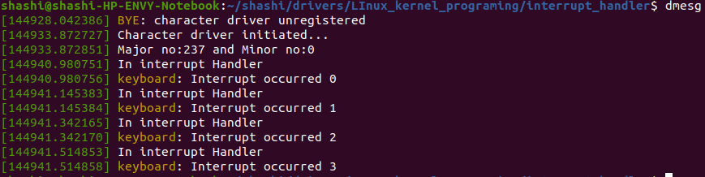
sudo char_interrupt.ko

Reference Link:-
https://embetronicx.com/tutorials/linux/device-drivers/linux-device-driver-tutorial-part-13-interrupt-example-program-in-linux-kernel/

