Best Singapore Summer Activities: Top Outdoor Activities to Do in Singapore During Summer
Meta Description: Every tourist can find the ideal combination of Singapore summer activities, like beaches, gardens, safaris, rooftop views and thrilling outdoor experiences in Singapore summer activities.
Singapore summer activities are perfect for travellers who want adventure, sightseeing, beaches, gardens, and exciting outdoor experiences in one destination. Singapore is one of the best destinations to visit during summer because there is always something exciting to do outdoors. From beautiful beaches and rooftop attractions to thrilling adventure parks and nature trails, the city offers endless experiences for every type of traveller. Whether you are planning a family holiday, a trip with friends, or a solo adventure, there are many Singapore summer activities that can make your vacation memorable.
The summer season is the perfect time to explore the city’s famous attractions, enjoy outdoor adventures, and experience Singapore’s lively atmosphere. If you are searching for the best things to do in Singapore summer, this guide covers the top places and activities that you should not miss.

1. Relax at Sentosa Island - Singapore Summer Activities
Singapore summer activities is complete without mentioning Sentosa Island. It is one of the most popular places for both tourists and locals because it offers beaches, water sports, adventure parks, and entertainment all in one place.
You can spend your day relaxing at Siloso Beach, trying kayaking or paddleboarding, or simply enjoying the beach clubs with music and food. If you love adventure, you can visit Mega Adventure Park, where you can try ziplining and obstacle courses.
Sentosa island also features many famous attractions , making it one of the best places to visit during in singapore like Universal Studios Singapore, Skyline Luge, and Adventure Cove Waterpark, making it one of the best Singapore outdoor attractions for summer.
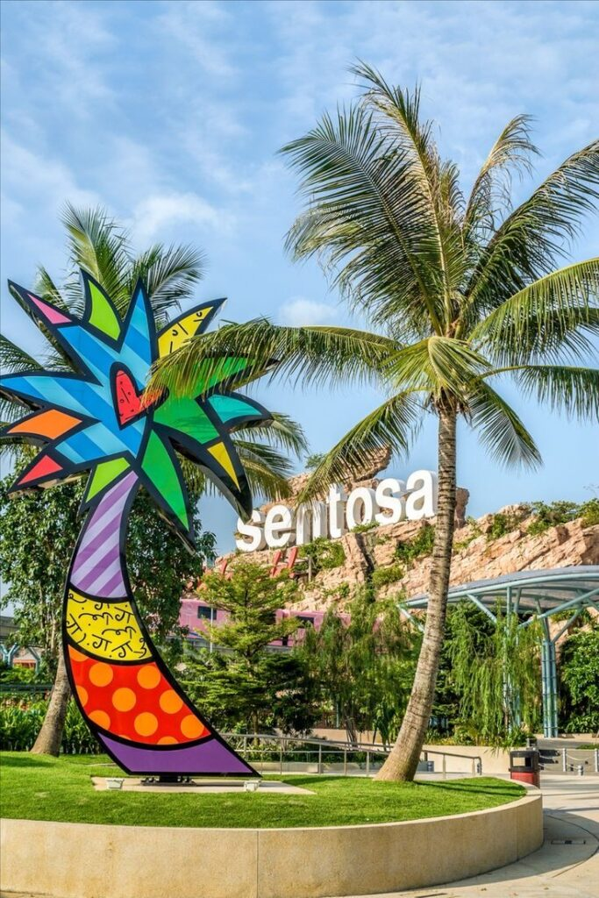

2. Visit Gardens by the Bay- Singapore Summer Activities
Gardens by the Bay is one of the most beautiful outdoor attractions in Singapore. During summer evenings, the weather becomes more comfortable, making it the perfect time to explore this stunning garden.
The Supertree Grove is the main highlight, especially during the light and music show at night. You can also walk through the outdoor gardens, enjoy the waterfront views, and take beautiful photos.
If you want to escape the summer heat , you can explore the cool indoor spaces of cloud forest and flower Dome . Even though these are indoor attractions, the surrounding gardens and outdoor spaces make it one of the top Singapore outdoor attractions.
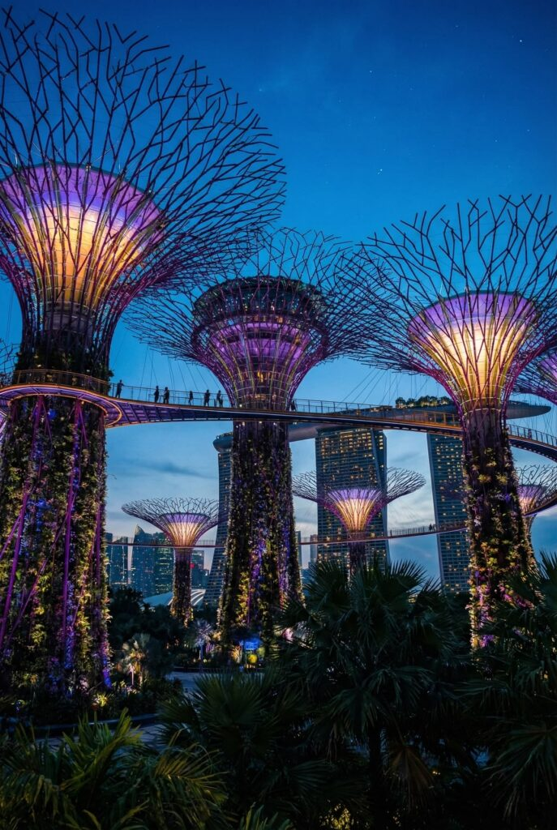

3. Enjoy a Night Safari Adventure - Singapore Summer Activities
One of the most unique things to do in Singapore summer is visiting the Night Safari. Since Singapore can be hot during the day, many travellers prefer outdoor activities in the evening.
The Night Safari offers a chance to see animals in their natural nighttime environment. You can take the tram ride, walk through jungle trails, and spot animals like tigers, elephants, and leopards.
This experience is perfect for families and couples who want something different from regular sightseeing.
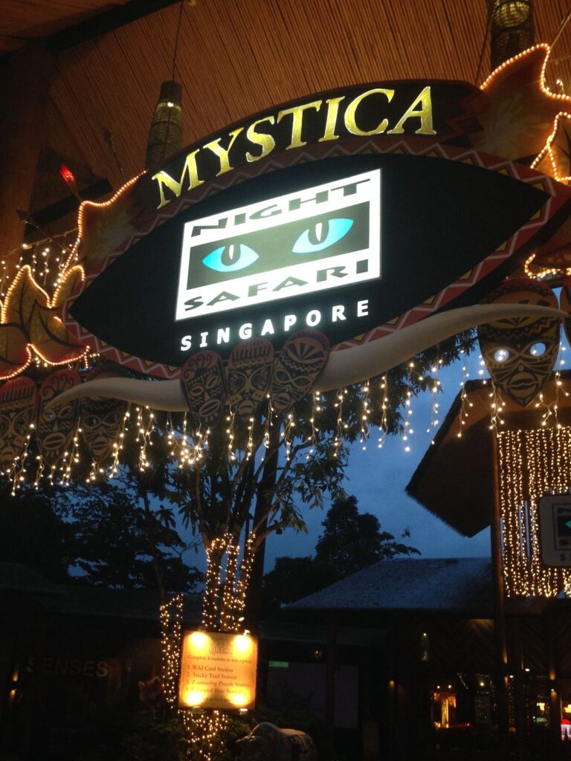

4. Explore Marina Bay Waterfront
Marina Bay is one of the most iconic areas in Singapore and a must-visit during summer. The waterfront area is perfect for evening walks because the weather is cooler and the skyline looks beautiful at sunset.
You can enjoy a walk along the Marina waterfront , watch the Spectra light and water show, or visit near by attractions like the Helix Bridge and Merlion Park.
For stunning city views , visit the observation deck at Marina Bay Sands Skypark. It is one of the best places to enjoy Singapore’s skyline and take memorable photos.
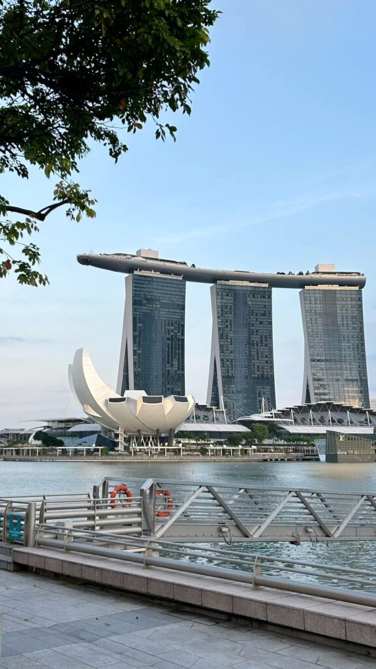

5. Go Cycling at East Coast Park
If you enjoy outdoor sports, East Coast Park is one of the best places to visit during summer. It is a large coastal park where you can cycle, skate, jog, or simply relax by the sea.
Bicycle rentals are easily available, making it simple to explore the long cycling tracks. You can also enjoy barbecue spots, beachside cafes, and picnic areas.
East Coast Park is one of the most peaceful Singapore outdoor attractions, especially for travellers who want to escape the busy city and enjoy nature.
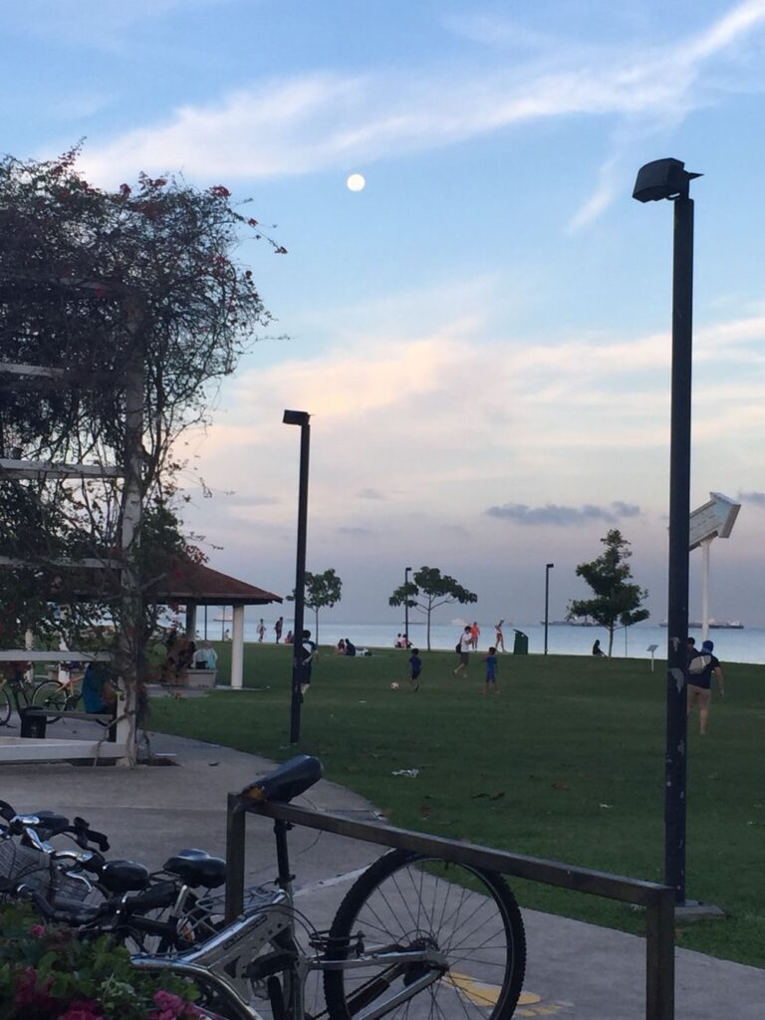

6. Take a River Cruise at Clarke Quay
A river cruise is one of the most relaxing Singapore summer activities. The Singapore River looks especially beautiful in the evening when the city lights reflect on the water.
You can take a traditional bumboat cruise from Clarke Quay and pass by famous landmarks like Marina Bay Sands, Merlion Park, and Boat Quay.
After the cruise, you can explore Clarke Quay’s restaurants, cafes, and nightlife spots. It is a great way to enjoy Singapore’s lively atmosphere during summer.
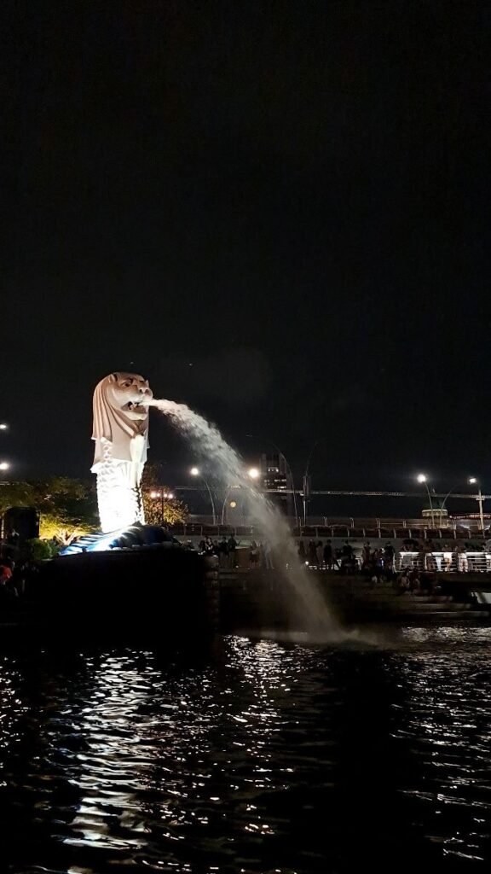

7. Visit Singapore Zoo
Singapore Zoo is one of the most famous zoo in the world and an excellent place for a summer outing. The zoo is known for its open and natural habitats, which make the experience more enjoyable.
You can spend hours exploring different sections, watching animal shows, and even feeding some animals. There are also water play areas for children, which make it a great family-friendly destination.
To avoid the midday heat, it is better to visit the zoo early in the morning.
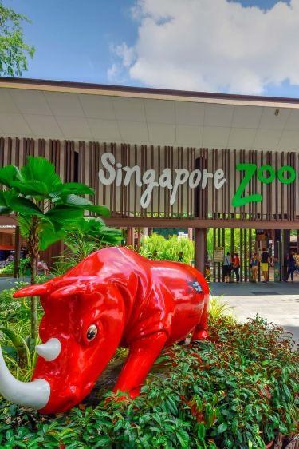

8. Hike at MacRitchie Reservoir
For nature lovers, hiking at MacRitchie Reservoir is one of the best things to do in Singapore in the summer. This natural area offers walking trails, forest views, and peaceful surroundings.
The TreeTop Walk is the most famous attraction here because it gives visitors a chance to walk above the forest canopy and enjoy scenic views.
MacRitchie Reservoir is ideal for people who want a break from city attractions and prefer a more adventurous outdoor experience.
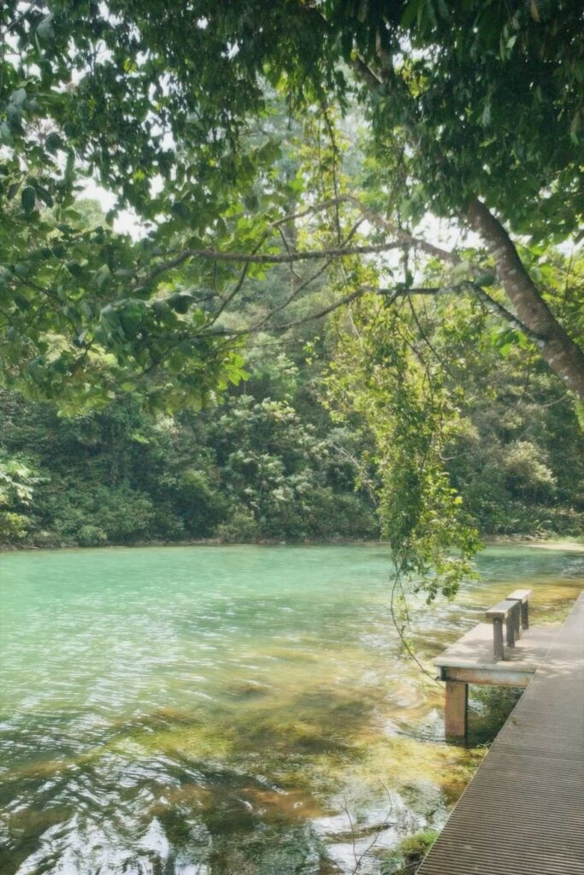

9. Spend Time at Singapore Botanic Gardens
The Singapore Botanic Gardens is a UNESCO World Heritage Site and one of the most relaxing places to visit during summer. The gardens are full of greenery, lakes, walking paths, and picnic spots.
You can visit the National Orchid Garden, enjoy a peaceful morning walk, or simply relax under the shade of large trees.
This attraction is perfect for families, couples, and anyone who enjoys spending time outdoors.
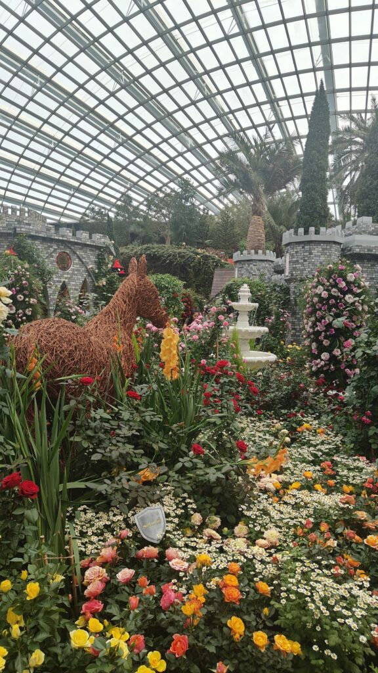

10. Watch the Sunset at Mount Faber Peak
Mount Faber Peak is one of the best places in Singapore to enjoy panoramic views of the city and the sea. It is especially beautiful during sunset when the sky changes colour and the city lights start to appear.
You can take the cable car from Mount Faber to Sentosa Island for an unforgettable experience. The cable car ride offers incredible views and is one of the most exciting Singapore summer activities.
Mount Faber also offers restaurants and scenic viewing decks , making it an ideal spot for a relaxing evening .


Tips for Enjoying Singapore During Summer
- Wear light and comfortable clothes because Singapore can be hot and humid.
- Carry sunscreen, sunglasses, and a water bottle.
- Plan outdoor activities in the early morning or evening to avoid the hottest part of the day.
- Use public transport because it is fast, affordable, and well-connected.
- Keep an umbrella with you because sudden rain showers are common.

Final Thoughts
Singapore is full of exciting experiences during summer, whether you enjoy beaches, gardens, adventure sports, or sightseeing. From Sentosa Island and Marina Bay to MacRitchie Reservoir and East Coast Park, there are many Singapore summer activities for every traveller.
If you are looking for the best things to do in Singapore summer, these outdoor attractions can help you make the most of your trip. With beautiful scenery, modern attractions, and endless entertainment, Singapore is the perfect summer destination for families, couples, and solo travellers alike.
Contact Us

