Best Thailand Summer Beach Activities That Will Blow Your Mind (2026 Guide)
April 7, 2026


Thailand Summer Beach isn’t just a destination—it’s an experience packed with turquoise waters, vibrant marine life, and unforgettable island adventures. If you’re searching for the best Thailand summer beach or planning Thailand island hopping or Krabi summer travel, this guide is exactly what you need.
Let’s dive into the most exciting beach activities you absolutely cannot miss. 👇

Island Hopping in Thailand – The Ultimate Thailand Summer Beach Adventure
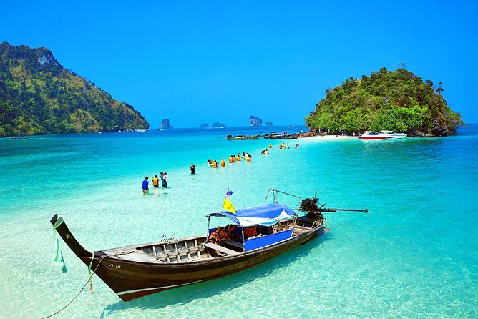
Island hopping is one of the most popular activities when visiting Thailand. It allows you to explore multiple islands in a single day, each offering unique sights Views and experiences.
This activity is perfect for those who want to experience different beaches, enjoy swimming, and explore hidden lagoons. It is also one of the best ways to enjoy Thailand island hopping during summer.
Tip: Start early in the morning to avoid crowds and harsh sunlight.
Best Place for Island Hopping in Thailand:
The best location for island hopping is Phuket and Krabi (especially Phang Nga Bay and the Phi Phi Islands), as they offer the most famous routes, stunning landscapes, and well-organized tours.

Snorkeling in Crystal-Clear Waters – Thailand Summer Beach
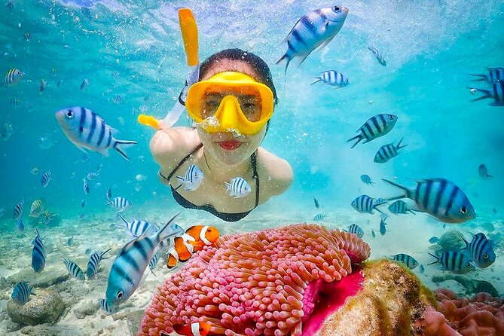
Snorkeling is a must-try activity on Thailand summer beaches. The underwater world here is vibrant and full of life.
You can see colorful coral reefs, tropical fish, and sometimes even sea turtles. The clear visibility makes snorkeling easy and enjoyable even for beginners.
You don’t need advanced skills or heavy equipment, making it a budget-friendly and easy activity for travelers. Early morning snorkeling is highly recommended as the water is clearer and marine life is more active during this time.
Best Place for Snorkeling in Thailand:
The best locations for snorkeling are the Similan Islands (for crystal-clear water and rich marine life) and Phi Phi Islands (for easy access and scenic beauty near Phuket).

Speedboat Tours for a Thrilling Experience – Thailand Summer Beach
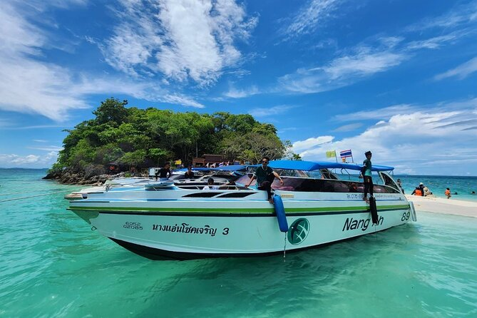
If you want to add excitement to your trip, speed boat tours are a great option. These tours allow you to cover more islands in less time while enjoying a thrilling and adventures ride across the ocean.
Speedboats are commonly used for Phuket Krabi summer travel, especially for tourists who have limited time but want to explore more places.
It is an ideal activity for adventure seekers who enjoy fast-paced travel and stunning sea views.
These tours combine high-speed adventure with breathtaking views of islands, making your Phuket Krabi summer travel more exciting and efficient.
Best Place for Speedboat Tours in Thailand:
The best locations are Phuket and Krabi (especially routes covering Phi Phi Islands and Phang Nga Bay), as they offer the most scenic routes, well-organized tours, and access to multiple islands in a single trip.

Relaxing on Thailand’s Beautiful Beaches – Thailand Summer Beach

Not every moment of your trip needs to be adventurous. Sometimes, the best thing you can do is simply relax.
Thailand’s summer beaches are known for their soft white sand, warm waters, and peaceful environment. You can lie down under palm trees, enjoy a fresh coconut drink, and listen to the sound of waves.
The peaceful atmosphere of Thailand summer beaches makes it perfect for sunbathing, reading, or simply enjoying the ocean breeze.
You can also indulge in beachside massages and fresh tropical drinks while taking in the stunning coastal views. It’s the perfect way to slow down and fully enjoy your Phuket Krabi summer travel experience.
Best Place to Relax on Beaches in Thailand:
The best locations are Railay Beach (for peaceful vibes and scenic cliffs), Maya Bay (for iconic beauty), and Patong Beach (for relaxation with nearby cafes and activities).

Parasailing – A View from Above

Parasailing is one of the most exciting beach activities in Thailand. It gives you a chance to see the ocean and coastline from a completely different perspective.
As you fly high above the water, you can enjoy panoramic views of islands and beaches. It is both thrilling and peaceful at the same time.
It is a safe and beginner-friendly activity, guided by trained professionals to ensure a smooth experience. This makes it a perfect mix of adventure and scenic beauty during your Phuket and Krabi summer travel.
Best Place for Parasailing in Thailand:
The best locations are Patong Beach and Karon Beach in Phuket, as they offer well-organized activities, safety measures, and the most scenic aerial views.

Sunset Watching – A Magical Experience
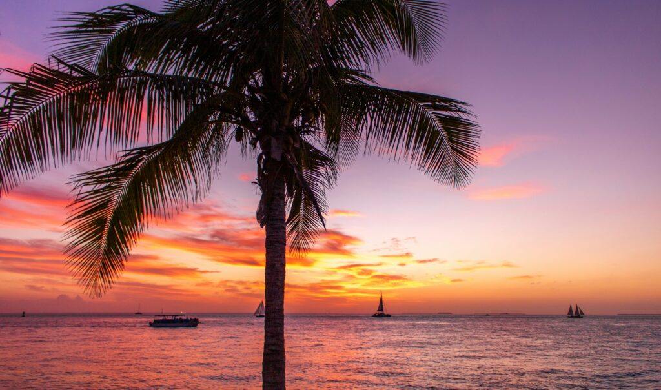
Watching the sunset in Thailand is an unforgettable experience. The sky turns into beautiful shades of orange, pink, and purple, creating a magical atmosphere.
It is the perfect way to relax after a long day of exploring and adds a romantic touch to your trip.
Sunset watching—a magical experience—is one of the most peaceful moments you can enjoy on Thailand summer beaches, as the sky transforms into stunning shades of orange, pink, and purple. The calm surroundings and gentle ocean waves create a perfect atmosphere to relax and unwind.
Best Place for Sunset Watching in Thailand:
The best locations are Promthep Cape (for dramatic panoramic views) and Railay Beach (for a peaceful sunset by the sea), making them perfect for relaxation and romantic moments.

Beach Parties and Nightlife—Thailand Summer Beach
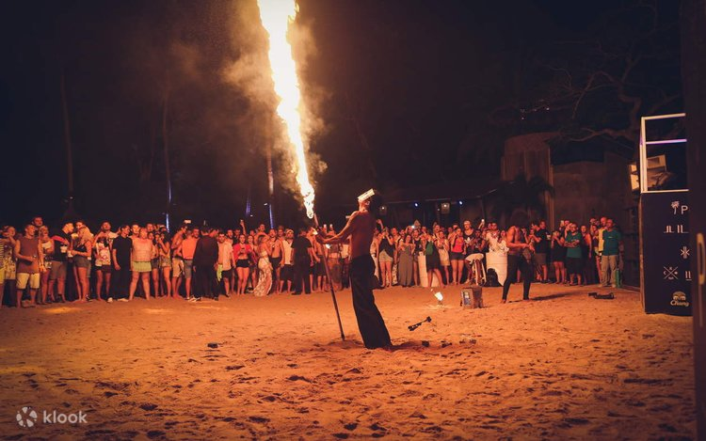
Thailand is also famous for its vibrant beach nightlife. After sunset, many beaches transform into lively party spots.
You can enjoy fire shows, music, and dance performances. The Full Moon Party in Koh Phangan is especially popular among tourists.
Beach Parties and Nightlife
From lively beach clubs in Phuket to famous Full Moon parties, there is something for every kind of traveler.
Whether you prefer a calm beach bar or an energetic party, Thailand offers a wide range of nightlife options.
Best Place for Beach Parties and Nightlife in Thailand:
The best locations are Koh Phangan (for the Full Moon Party), Phuket (for beach clubs and nightlife), and Krabi (for a more relaxed evening vibe).

Frequently Asked Questions (FAQs)
1. What are the best Thailand summer beaches to visit?
The best Thailand summer beaches include Railay Beach in Krabi, Patong Beach in Phuket, Maya Bay in Phi Phi Islands, and Coral Island. These beaches are known for their clear water, soft sand, and scenic beauty, making them perfect for summer travel.

2. Is summer a good time for Thailand island hopping?
Yes, summer is a great time for Thailand island hopping, especially in destinations like Phuket and Krabi. While there may be occasional rain, most days are sunny, and the islands are less crowded, making it ideal for exploring.

3. What activities can I do on Thailand summer beaches?
You can enjoy a wide range of activities such as island hopping, snorkeling, parasailing, speed boat tours, beach relaxation, and nightlife. These activities make Thailand summer beaches perfect for both adventure and relaxation.

4. Which is better for summer travel: Phuket or Krabi?
Both Phuket and Krabi are excellent for summer travel. Phuket is known for its nightlife and water sports, while Krabi offers more peaceful beaches and natural beauty. Choosing between them depends on your travel preferences.

5. Is snorkeling safe in Thailand?
Yes, snorkeling in Thailand is generally safe, especially in popular tourist areas like Phi Phi Islands and Similan Islands. However, it is always recommended to follow safety instructions and use proper equipment.

Final Thoughts
Thailand is one of the best destinations for summer travel, offering a perfect combination of adventure, relaxation, and entertainment. From island hopping and snorkeling to beach parties and sunset views, every experience is unique and memorable.
If you are planning your next vacation, exploring Thailand summer beaches and enjoying Phuket Krabi summer travel should definitely be on your list.
contact us
AI Detection screenshot
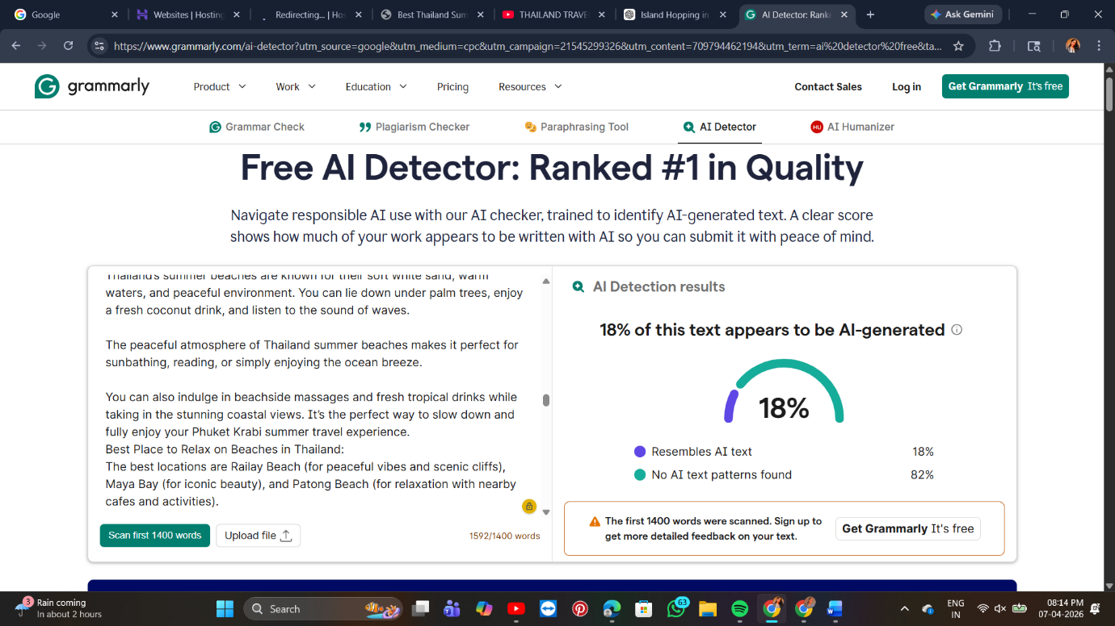

SEO Rank Math
