Must-Try Thai Foods for Travelers Visiting in Autumn
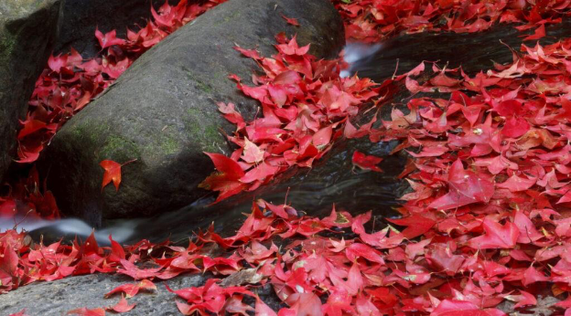
The In-Between Season: An Autumn Guide to Thai Food for Travelers
If you’ve been reading any of the chronicles of the “Thaizers” or the “Bangkok Gluttons” in this world, you know that Thailand doesn’t really do “Autumn,” pumpkin-spice-latte style. Instead of changing leaves and chilled winds, September through November marks a gorgeous, humid, flavor-laden bridge.
This is the transition from the “Green Season” to the “Cool Season.” The rains start to abate, the fields are a neon emerald and the markets change.
For the Thai food-obsessed traveler, it’s arguably the best time to come. The humidity cries for refreshing zing, while in the North cooling evenings demand something soul-warming.
So if you are, by chance, traveling during these months — put down the generic tourist menus. So here’s your authoritative Thai food guide to the best Thai eats of Autumn:
1. Khao Soi (Curry Noodle Soup):
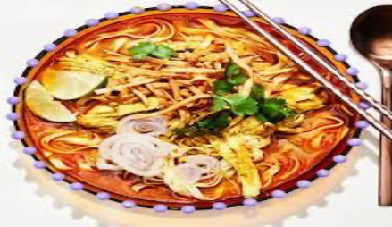
As the calendar turns to November, the northern highlands around Chiang Mai and Chiang Rai start to experience a genuine "chill" (well, 18°C feels chilly to us!). This is the spiritual home of Khao Soi.
It is a rich, coconut-milk-based curry soup, deeply fragrant with turmeric and ginger, served over soft egg noodles and topped with a nest of crispy fried noodles.
- Why in Autumn? It’s the ultimate "hug in a bowl." The depth of the spices provides a gentle heat that perfectly matches the misty mornings of the North.
- Pro Tip: Always squeeze the lime and add the pickled mustard greens provided on the side; the acidity cuts through the richness of the coconut milk.
2. Kha Gai (Chicken Galangal Soup):
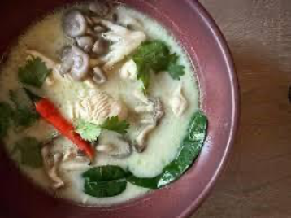
September and October still see the occasional monsoon downpour. When the rain drums on the corrugated tin roofs of a street-side stall, there is no better Thai food list entry than Tom Kha Gai.
Unlike its famous cousin, Tom Yum, which is fiery and sharp, Tom Kha is silky and soothing. The star here isn't the chili, but the Galangal (a woody, citrusy relative of ginger).
- Why in Autumn? Galangal and lemongrass are traditional Thai remedies for the "sniffles" that often come with the changing weather. It’s medicinal, but tastes like heaven.
3. Stir-Fried Baby Corn with Mushrooms:
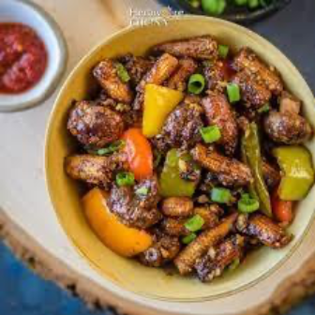
In September, Thai farmers take advantage of the late rains to harvest some of the sweetest baby corn you will ever taste.You’ll see it in markets, bright yellow and incredibly crisp.
A simple stir-fry (Pad Pak) featuring this seasonal corn and earthy straw mushrooms (which thrive in the humidity of early autumn) is a revelation. It’s a testament to how Thai dishes rely on the freshness of the source.
4. Gaeng Juet (Clear Vegetable Soup):
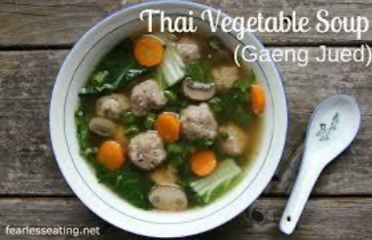
In November, Thailand celebrates Loy Krathong, the Festival of Lights. As thousands of flickering candles float down the rivers, the air feels celebratory but calm.
Traditional festival spreads often feature Gaeng Juet. It is a clear, "bland" (in the best way possible) soup made with minced pork, silken tofu, and seasonal gourds like Luffa.
- The Vibe: It balances out the spicy salads and heavy curries often served at festivities, acting as a palate cleanser under the moonlight.
5. The "King" and "Queen" of the Market
No Thai food guide is complete without the fruit, and Autumn is a major transition period for Thailand's orchards.
Mangosteen (The Queen): Their season usually winds down by October. Grab them while you can! The snowy-white segments inside the purple hull are sweet, tangy, and incredibly cooling.
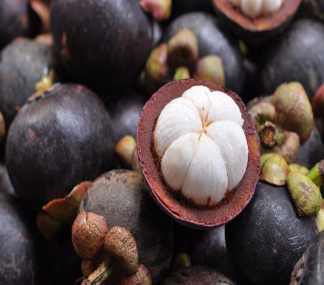
Dragon Fruit: Peak season hits right in the middle of Autumn. Look for the variety with deep magenta flesh—it’s sweeter than the white-fleshed version and packed with antioxidants to keep your travel energy high.
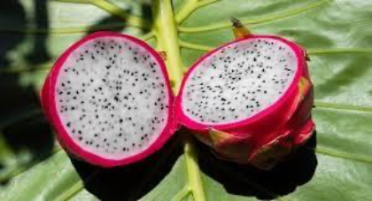
The "Secret" Autumn Ingredient: The Pumpkin
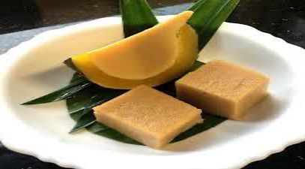
While the West is busy carving them, Thailand is eating them. In October and November, you’ll find Sangkaya Fak Thong—a whole pumpkin steamed with a rich coconut custard inside. It’s sliced like a cake and sold at street stalls. It’s creamy, earthy, and naturally sweet—a must-try for any traveler looking Authentic Thai food.
Tips for Thriving this Autumn as a Foodie:
Follow the Steam: During September, you want to seek out vendors with large steaming pots. These vendors typically represent “Suki” (or “Chim Chum”–which means “hot pot”) stalls that provide both social and warm atmospheres and whose ingredients are always fresh.
Seek the “End of Rain” Festivals: Most provinces will throw food fairs to celebrate the harvest. In Central Thailand, you’ll find Thai food festivals at the temples in October—and it’s here you can find rare regional snacks.
Spicy Food Isn’t Your Enemy: Thai believe that hot, spicy food helps regulate your body temperature; therefore, on humid October days, you could indulge in a spicy aus Som Tam (Papaya salad), which may produce perspiration and therefore cool you off.
If falling in love with Thailand is one of your goals, you cannot help but to burst with all five senses during the Autumn Season. The AIR is crisp, there are not as many people and the food—from the rich, buttery gold curries of the North, and all the seasonal produce from Central Thailand—is at its best.
Let this Thai Food list lead you through the Thai street food market like a local, whether you are slurping noodles in the Chiang Mai back alley, or sharing Pumpkin custard on the streets of Bangkok, you are likely to find a photographer’s perspective of food in Thailand this Autumn.
