5 Singapore Best water park and island Escapes in Singapore for summer
-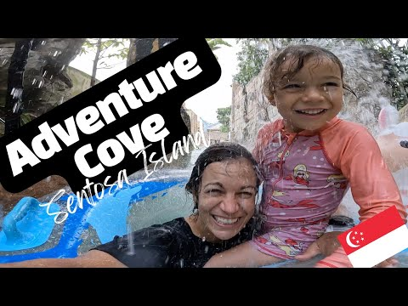
Singapore water park is one of the best attractions for summer travel Many people like to visit this country because it offers both fun and relaxation together. If you enjoy water rides and also want to spend peaceful time near beaches, then Singapore is a very good choice. A Singapore water park along with island activities makes the whole trip more interesting and enjoyable.
In my opinion, Singapore is not only for luxury travel but also for normal travelers who want a good experience without too much stress. You can plan your trip easily and enjoy many activities in one place.
Why singapore is Good for summer travel
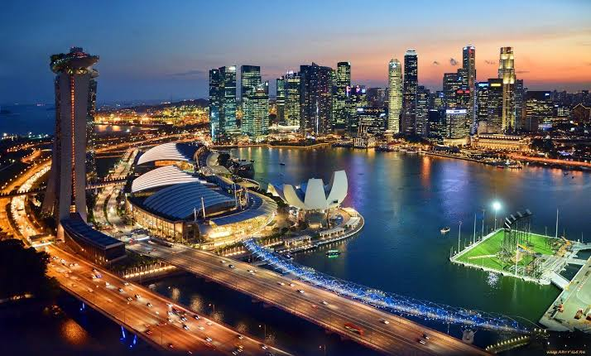
Singapore has a tropical climate, which means the weather is mostly warm and humid. Because of this, water parks and beaches are very popular here. During summer, people like to spend more time in water to feel fresh.
Another good thing about this place is that it is very clean and well-managed. Transport is easy, and you can travel from one place to another without confusion. I feel this makes it a comfortable destination, especially for first-time travelers.
Also, there are many options for both adventure and relaxation. You can enjoy exciting rides in a Singapore water park and later relax on a beach the same day.
Best Singapore water park Experience
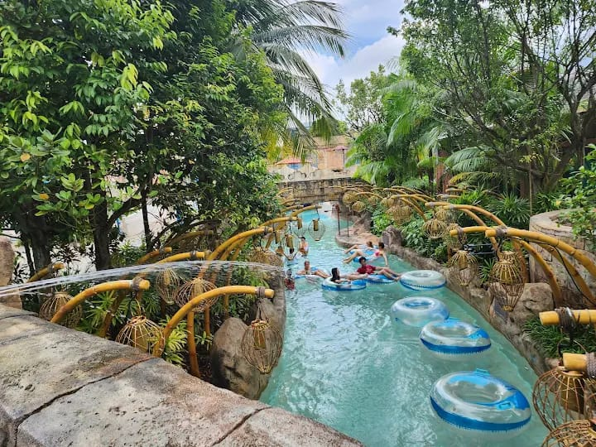
.Visiting a Singapore water park is one of the best things to do during your trip. These water parks are designed for all age groups, so everyone can enjoy.
Adventure Cove Waterpark is one of the most famous places. Here you can try different water slides, wave pools, and even snorkeling with fish. It is a unique experience and many people find it very exciting.
At the same time, if you want something more budget-friendly, you can choose other options as well. Not every good experience has to be expensive. That is why many visitors look for affordable water parks in Singapore.
Wild wild wet: Budget-Friendly Singapore water park
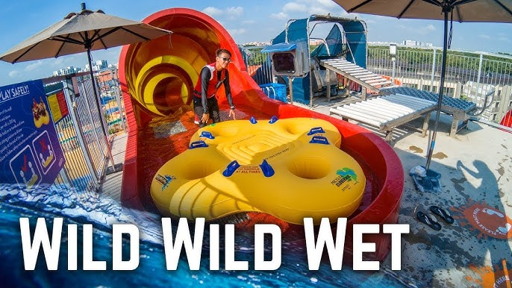
Wild Wild Wet is a very good Singapore water park if you are traveling on a budget. It is located in Pasir Ris and is popular among students and families.
The ticket price is around SGD 20–26 on weekdays and SGD 28–35 on weekends, which is quite reasonable compared to other water parks. Because of this, many people prefer this place.
There are many fun rides like Vortex and Royal Flush. You can also spend time in the lazy river if you just want to relax. The environment is clean and safe, which is important for visitors.
I personally feel that Wild Wild Wet is a good option if you want to enjoy water rides without spending too much money.
Top Sentosa Island Activities you Must Try
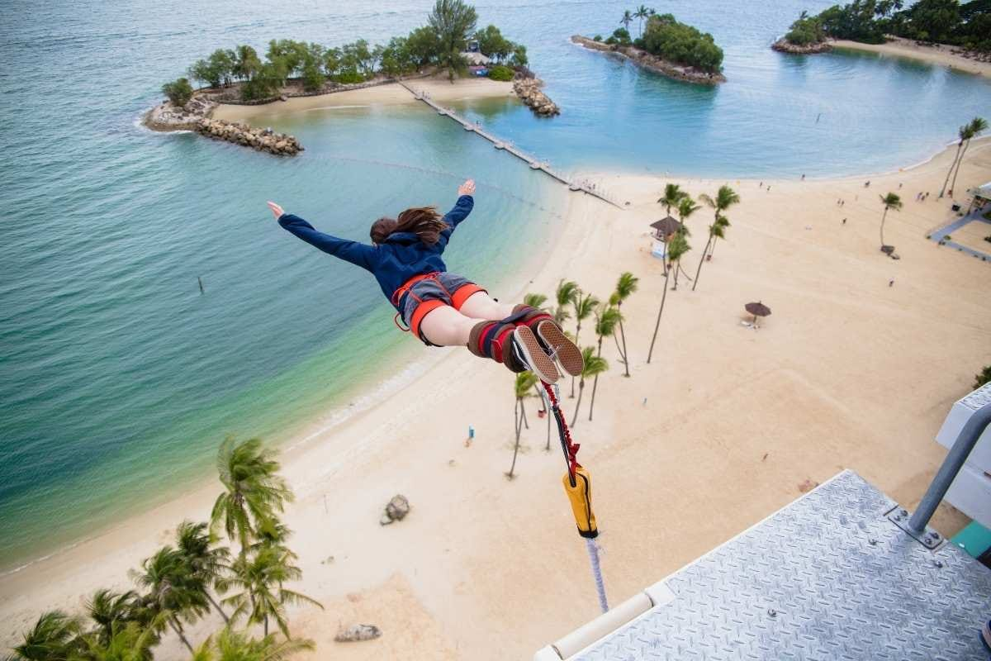
Sentosa Island is one of the main attraction in Singapore. There are many exciting Sentosa Island activities that you should try when you visit.
One of the most popular place here is Universal Studios Singapore, It has many rides and shows, and people of all ages can enjoy it. Even if you are not very adventurous, you will still find something interesting.
Another good activity is the cable car ride. From the top, you can see the sea and the whole island, which looks very beautiful. It is a calm and relaxing experience.
If you like something fun and different, you can try Skyline Luge. It is simple but very enjoyable, and many tourists try it at least once

Singapore Beach Summer Experience
Singapore is not only about buildings and attractions. It also has some very nice beaches, especially on Sentosa Island. These beaches are perfect for relaxing during summer.
Siloso Beach is more active and lively. You will see people playing games and enjoying music. It is good if you like a fun environment.
Palawan Beach is more suitable for families. It is clean and peaceful, and children can also enjoy here.
Tanjong Beach is quieter compared to others. If you want to spend some calm time, this is a good option.
In my opinion, evening is the best time to visit beaches. The weather becomes cooler, and the sunset looks very beautiful.

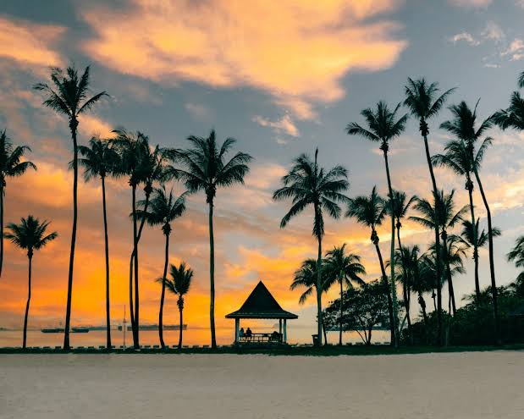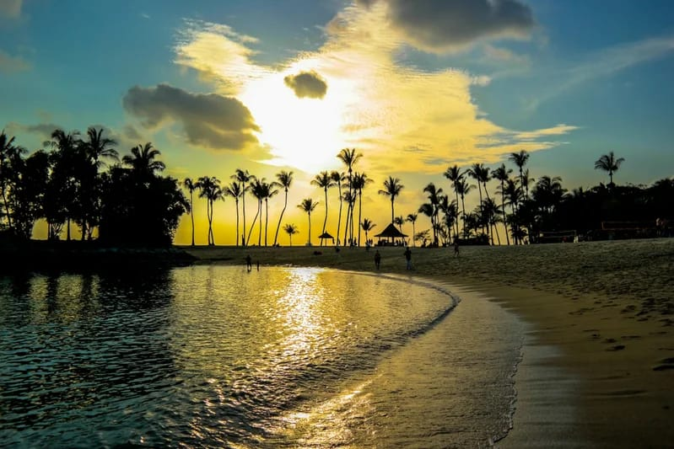
Best Time to visit Singapore Water Park And Beaches
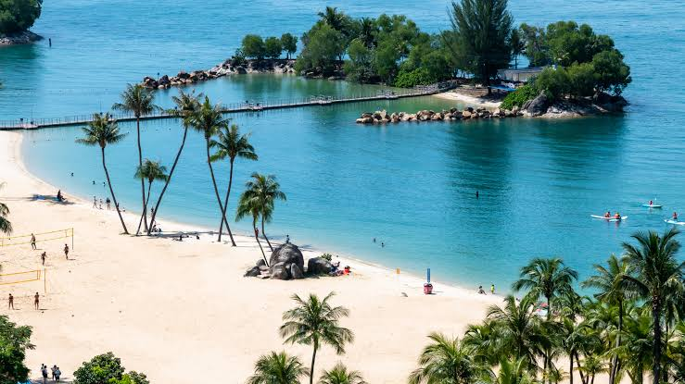
The best time to visit a Singapore water park and enjoy beaches is from March to August. During this time, the weather is warm, which is perfect for water activities.
You can enjoy swimming, water slides, and beach time more comfortably in this season. Although Singapore can be visited all year, summer months are more suitable for outdoor fun.
It is better to visit water parks on weekdays because weekends can be crowded. For beaches, evening time is more comfortable because the heat is less.
Travel Tips For Visiting Singapore Water Park
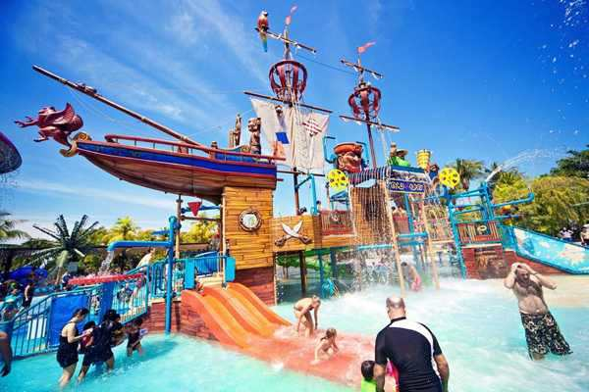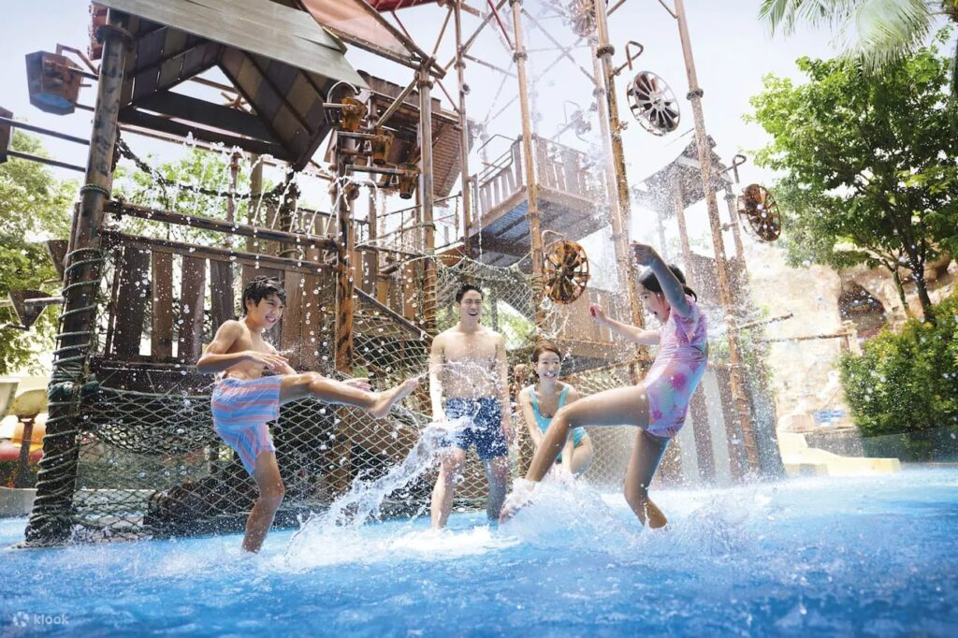
Before visiting a Singapore water park, it is good to plan a few things in advance.
First, try to book your tickets online. This can help you save both time and money. Many times, online booking gives discounts.
Wear comfortable clothes and proper swimwear. Also, carry sunscreen because the weather is hot. Slippers are also useful because the ground can be warm.
Drink enough water during your visit to stay hydrated. Try to reach early in the morning so you can enjoy more rides without waiting too long
.
Lockers are available in most water parks, so you can keep your belongings safely. Always follow safety rules to avoid any problems
Budget Planing For Singapore Tips
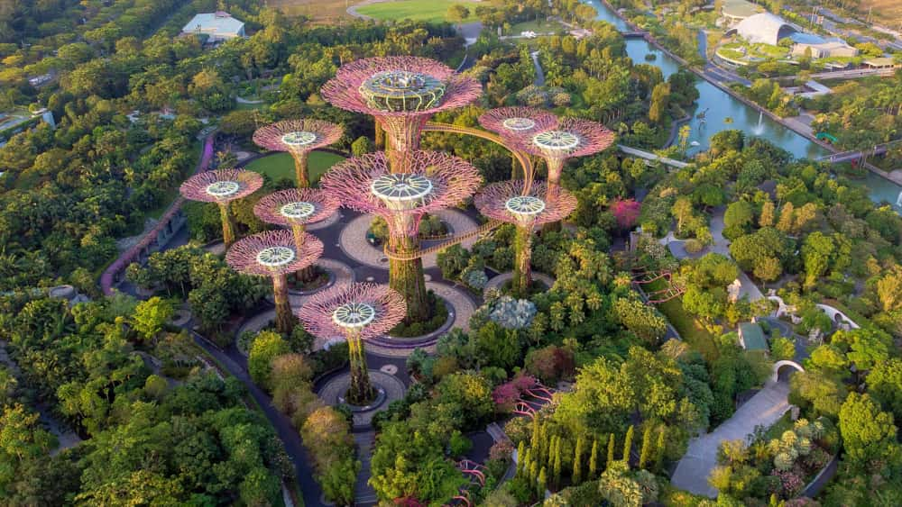
Planning your budget is important before visiting Singapore. It helps you manage your money and enjoy the trip without stress.
First, decide your number of days. Around 4–5 days are enough to explore places like a Singapore water park and beaches. Book flights early to save money and choose budget hotels instead of expensive ones
.
You can eat at local food courts to reduce food costs. For travel, use MRT and buses because they are cheaper than taxis. Also, try to book attraction tickets online for better deals.
In my opinion, keeping a daily budget helps you avoid overspending and makes your trip more comfortable.
Conclusion
The singapore water park experience is perfect for summer travel, Many tourists visit singapore water park every year for fun and relaxation. You can enjoy exciting rides at a Singapore water park, explore different Sentosa Island activities, and also spend peaceful time at clean and beautiful beaches. This combination makes Singapore different from many other places.
One good thing about Singapore is that everything is well managed. Transport is easy, places are clean, and tourists feel safe. Because of this, even first-time travelers can enjoy their trip without much confusion. You can plan your days easily and cover many attractions without feeling too tired.
Another advantage is that you can travel according to your budget. There are both expensive and budget-friendly options available for hotels, food, and activities. If you plan properly, you can enjoy most places without spending too much money.
In my opinion, Singapore is a very balanced travel destination. It is not only about adventure but also about relaxing and spending quality time. Whether you go with family, friends, or your partner, you will find something enjoyable for everyone.
Overall, visiting Singapore can be a memorable experience. From water parks to island activities and beach time, everything adds to a perfect summer holiday. If you are planning your next trip, Singapore is definitely a place you should consider
you may visit also contact us
.Why Singapore is Good for summer travel
. Best Singapore water park Experience
.wild wild wet: Budget-Friendly Singapore water park
.Top Sentosa Island Activities you Must Try
.Singapore Beaches Summer Experience
. Travel Tips For Visiting Singapore Water Park
.Budget Planing for Singapore tips
Rank math Seo
