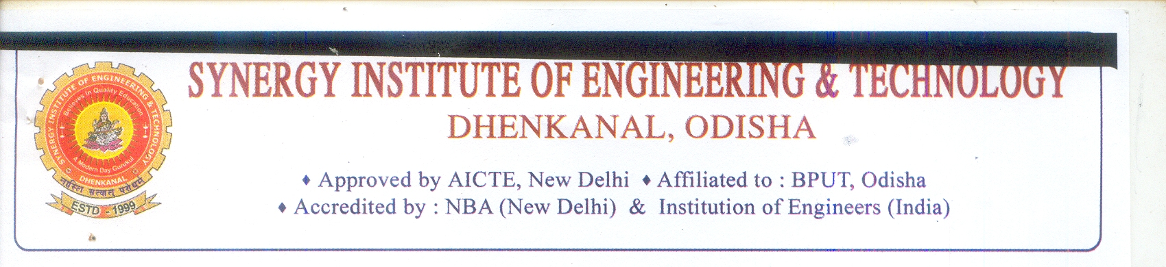

**Date: 15-04-2014**

From,

Prof.(Dr) C R Deo

Principal,

SIET , Dhenkanal

To,

The Sr. Project Manager,

T10kT Programme, Department of CSE, KReSIT Bldg.,

IIT Bombay, Mumbai-400076

**Permission Letter for Main Workshop**

This is to certify that **Prof Nirjharinee Parida** is a regular teaching employee in the department of **Computer Science & Engineering** of our Institute with a designation of Asst. Professor. He/ She is permitted to attend the workshop on Computer Networking, under the National Mission on Education through ICT (MHRD, Govt. Of India) from 30/6/2014 to 05/7/2014 in Gandhi Engineering College, Bhubaneswar (RCID: 1194)

The Institute has no objection to him/her participating in the workshop. We will make sure that no official duties will be delegated which may affect his/ her participation, during the workshop.

I ensure that the participant will follow the below mentioned conditions:

1. He/ She will complete all online activities for one week equivalent of full time work, during 22nd May to 29th June 2014 prior to the one week of face to face interaction through A-view video transmission at the selected Remote Center which will commence from 30th June to 5th July 2014.

2. He/ She will report to the local organizers well in time.

3. He/ She will attempt to complete the workshop with full attendance.

I will make sure that the nominated staff will be regular in attending the workshop and will complete all the assignments given during the workshop. I understand that otherwise his/her certificate is liable to be withheld by IIT Bombay.

