

VILNIUS GEDIMINAS TECHNICAL UNIVERSITY

FACULTY OF ____________________________________
DEPARTMENT OF ________________________________________

EXAMPLE

Shashikanth Hosur Ramegowda, Shaeed Khan, Rimsha Tariq

TRANSFORMERS AND THEIR APPLICATION IN NATURAL LANGUAGE PROCESSING (NLP) TASKS
A comparative study of Transformer, recurrent and classical models for sentiment classification

Group Project Paper

______________________________ study programme, state code ___________
______________________________ specialisation
___________________________ study field

Vilnius, 2026

CONTENTS
CONTENTS 2
ABSTRACT 4
TEAM AND DISTRIBUTION OF WORK 5
1. INTRODUCTION 6
1.1. Relevance of the topic 6
1.2. Problem statement 6
1.3. Aim and objectives 6
1.4. Research object and methods 7
1.5. Structure of the paper 7
2. LITERATURE REVIEW 8
2.1. Search strategy 8
2.2. From word vectors to the Transformer 8
2.3. Families of pre-trained Transformer models 8
2.4. Transformers for sentiment analysis and text classification 9
2.5. Research in Lithuania 9
2.6. Comparative summary 10
2.7. Conclusions of the literature review 10
3. METHODOLOGY OF THE PRACTICAL PART 12
3.1. Problem formulation 12
3.2. Dataset 12
3.3. Compared models (competitors) 13
3.4. Evaluation criteria 13
3.5. Design and structure of the developed program 14
3.6. The Transformer architecture 15
3.6.1. Tokenisation and input embeddings 15
3.6.2. Positional encoding 16
3.6.3. Scaled dot-product attention 16
3.6.4. Multi-head attention 16
3.6.5. Feed-forward network, residual connections and layer normalisation 16
3.6.6. Computational complexity 17
3.7. Mathematical methods of training and evaluation 17
3.7.1. Pre-training objective 17
3.7.2. Fine-tuning for classification 17
3.7.3. Optimisation 17
3.7.4. TF-IDF representation 18
3.7.5. Classical classifiers 18
3.7.6. Bidirectional LSTM 18
3.7.7. Zero-shot classification by natural language inference 19
3.7.8. Evaluation metrics and statistical tests 19

ABSTRACT
This project paper studies the Transformer architecture and its application to natural language processing (NLP) tasks. The theoretical part explains how self-attention, multi-head attention, positional encoding and large-scale pre-training replaced recurrent neural networks as the dominant approach in NLP, and reviews the main families of Transformer models (encoder-only BERT-type models, decoder-only GPT-type models and encoder–decoder models such as T5 and BART). The literature review covers international research and research carried out in Lithuania, including work on Lithuanian sentiment analysis, the trilingual LitLat BERT model and the first open Lithuanian large language models. It concludes that most published comparisons are done on GPU servers with large models, while evidence on what Transformers offer under realistic resource limits (a laptop CPU, a few thousand labelled examples) is scarce.
The practical part answers this question experimentally on binary sentiment classification of movie-review sentences (Stanford Sentiment Treebank, SST-2). Ten models from four families were implemented in Python (PyTorch, Hugging Face Transformers, scikit-learn) and compared under one protocol: three classical TF-IDF models, a bidirectional LSTM trained from scratch, three Transformer encoders that we fine-tuned ourselves on a CPU (BERT-tiny, BERT-small and DistilBERT), and three ready-made Transformer models used without any training (an in-domain DistilBERT, an out-of-domain Twitter RoBERTa and a zero-shot natural language inference model). Models were evaluated by accuracy, macro F1, training time, inference latency and size, as well as on linguistically difficult subsets with negation and contrast. A learning-curve experiment measured how much labelled data each approach needs.
Keywords: Transformer, self-attention, BERT, DistilBERT, fine-tuning, transfer learning, sentiment analysis, natural language processing.

TEAM AND DISTRIBUTION OF WORK
The project was carried out by a team of three students. The work was divided as shown in Table 0, while all members took part in the formulation of the problem, the discussion of the results and the editing of the final text.
Table 0. Distribution of work among the team members
Team member | Main responsibilities
Shashikanth Hosur Ramegowda | Problem formulation, experiment design, implementation of the Transformer fine-tuning program, Chapters 3.5–3.7 and 4, presentation
Shaeed Khan | Literature search in Google Scholar and Web of Science, literature review (Chapter 2), classical and BiLSTM baselines, references
Rimsha Tariq | Introduction and theoretical part on the Transformer architecture (Chapters 1, 3.1–3.4, 3.6), evaluation of ready-made models, error analysis, conclusions

1. INTRODUCTION

1.1. Relevance of the topic
Natural language processing (NLP) is the branch of artificial intelligence that enables computers to analyse, understand and generate human language. For decades the field relied on hand-crafted features and statistical models such as n-gram language models, naive Bayes classifiers and support vector machines. In the 2010s these were gradually replaced by neural networks: word embeddings such as word2vec (Mikolov et al., 2013) gave words dense vector representations, and recurrent neural networks, in particular long short-term memory networks (Hochreiter & Schmidhuber, 1997), became the standard way to model sentences. Recurrent networks, however, process text one token at a time. This makes training slow, because the computation cannot be parallelised over the sequence, and makes it difficult to capture dependencies between words that are far apart.
In 2017 Vaswani et al. proposed the Transformer, an architecture that discards recurrence entirely and relies only on the attention mechanism. Every token in a sentence can directly "look at" every other token, and all positions are processed in parallel. Within two years the Transformer became the foundation of almost every state-of-the-art NLP system. BERT (Devlin et al., 2019) showed that a Transformer encoder pre-trained on unlabelled text can be fine-tuned to beat previous results on eleven language understanding tasks, and the GPT series (Radford et al., 2018; Brown et al., 2020) showed that a Transformer decoder trained to predict the next word becomes a general-purpose text generator able to solve tasks from a few examples. Today Transformers power machine translation, search engines, chat assistants, code generation tools and document analysis systems, and the same architecture has spread to computer vision, speech and biology.
The topic is relevant for three reasons. First, Transformers are now the default tool of NLP practitioners, so engineers need to understand both how they work and when they are worth their cost. Second, the computational price of these models is high: training and even running them requires far more memory and energy than classical methods (Strubell et al., 2019), so an informed choice between a small classical model, a compact Transformer and a large pre-trained model has a real economic and environmental impact. Third, for smaller languages such as Lithuanian, the question of how well Transformer methods transfer with limited labelled data is directly connected to the digital sustainability of the language (Ulčar & Robnik-Šikonja, 2021; Nakvosas et al., 2024).

1.2. Problem statement
Published benchmarks usually report the accuracy of the largest models, trained on GPU clusters with the full training set. A student, a small company or a public institution, by contrast, often has only an ordinary computer, a limited number of labelled examples and a need for fast predictions. The research problem of this project is therefore formulated as follows: how large is the practical advantage of Transformer models over classical and recurrent approaches for a typical NLP task (sentiment classification), and at what cost in training time, inference latency and model size, when all experiments are carried out on a standard CPU-only laptop?

1.3. Aim and objectives
The aim of the project is to analyse the Transformer architecture and its applications in NLP and to evaluate experimentally the effectiveness of Transformer-based models for sentiment classification in comparison with classical machine learning and recurrent neural network methods.
To reach the aim, the following objectives were set:
- to review the theoretical foundations of the Transformer architecture (self-attention, multi-head attention, positional encoding, pre-training and fine-tuning);
- to review scientific literature on Transformer models and their applications in NLP, in Lithuania and worldwide, and to identify gaps;
- to define the experimental methodology: dataset, compared models (competitors), evaluation criteria and the mathematical methods used;
- to implement the classical, recurrent and Transformer-based classifiers in Python and to run a comparative experiment on the SST-2 dataset under equal conditions;
- to analyse the results in terms of quality, data efficiency, speed and model size, including an error analysis on sentences with negation and contrast;
- to formulate conclusions and practical recommendations for choosing a model.

1.4. Research object and methods
The research object is Transformer-based language models applied to text classification. The research methods are analysis of scientific literature, comparative analysis, computational experiment (training and evaluation of models), statistical evaluation of the results and visualisation of attention weights.

1.5. Structure of the paper
The paper consists of an introduction, four main chapters, general conclusions and a list of references. Chapter 2 reviews the literature. Chapter 3 describes the methodology of the practical part: the problem formulation, the dataset, the compared models, the evaluation criteria, the design of the developed program and the mathematical methods. Chapter 4 presents the implementation and the results of the experiments. Chapter 5 summarises the conclusions. The source code of the program is provided together with the paper.

2. LITERATURE REVIEW

2.1. Search strategy
The literature was collected from Google Scholar and Web of Science, supplemented with the ACL Anthology (the main open archive of computational linguistics) and arXiv for the most recent preprints. The core search query was:
("transformer" OR "BERT" OR "self-attention" OR "pre-trained language model") AND ("natural language processing" OR "text classification" OR "sentiment analysis")
For the Lithuanian part the query was narrowed with the terms ("Lithuanian" OR "Baltic languages"). Both databases return thousands of records for the core query, so the results were sorted by relevance and citation count and screened by title and abstract. The inclusion criteria were: (1) the publication proposes or evaluates a Transformer-based model or an important predecessor; (2) it reports results on a text classification or language understanding task, or describes a widely used model; (3) it is peer-reviewed or a widely cited technical report. Seminal works (the original Transformer, BERT, GPT, RoBERTa, DistilBERT and others) were added through backward citation tracking. About 40 publications were kept for analysis; the most important of them are summarised in Table 2.1.

2.2. From word vectors to the Transformer
Early neural approaches represented each word by a static vector, learned with word2vec (Mikolov et al., 2013) or similar methods, and combined these vectors with convolutional (Kim, 2014) or recurrent networks. Such vectors cannot distinguish the meanings of an ambiguous word in different contexts. Bahdanau et al. (2015) introduced the attention mechanism for machine translation, allowing the decoder of a recurrent model to focus on the relevant parts of the source sentence. Contextual representations followed: ELMo (Peters et al., 2018) computed word vectors with a deep bidirectional LSTM language model, and ULMFiT (Howard & Ruder, 2018) showed that a pre-trained language model can be fine-tuned for text classification with very little labelled data. These works established the "pre-train, then fine-tune" paradigm that the Transformer later made dominant.
Vaswani et al. (2017) proposed the Transformer, an encoder–decoder model built entirely from self-attention and feed-forward layers. On English–German and English–French translation it achieved better quality than recurrent and convolutional systems at a fraction of the training cost, because all positions of a sentence are processed in parallel. The architecture is described in detail in Chapter 3.

2.3. Families of pre-trained Transformer models
Three families of models grew out of the original architecture.
Encoder-only models. BERT (Devlin et al., 2019) pre-trains a Transformer encoder with masked language modelling, in which 15% of the tokens are hidden and the model has to predict them from the context on both sides. BERT-base (110 million parameters) and BERT-large (340 million) set new records on the GLUE benchmark (Wang et al., 2019), including SST-2 sentiment classification. RoBERTa (Liu et al., 2019) showed that BERT was under-trained and obtained better results simply by training longer on more data, with larger batches and without the next-sentence prediction task. ALBERT (Lan et al., 2020) reduced the number of parameters through factorised embeddings and cross-layer parameter sharing; ELECTRA (Clark et al., 2020) replaced masked language modelling with a more sample-efficient "replaced token detection" objective; DeBERTa (He et al., 2021) separated content and position information in attention and was the first model to exceed the human baseline on the SuperGLUE benchmark. XLM-RoBERTa (Conneau et al., 2020) extended the approach to 100 languages, including Lithuanian.
Compact encoders. Because large encoders are expensive at inference time, a line of research focuses on compression. DistilBERT (Sanh et al., 2019) uses knowledge distillation to train a 6-layer student from the 12-layer BERT teacher; it is 40% smaller and 60% faster while retaining about 97% of BERT's language understanding performance. Turc et al. (2019) released a set of 24 compact BERT models (from BERT-tiny with 2 layers to BERT-base) and showed that pre-training compact models directly is important for good results. Tay et al. (2022) survey "efficient Transformers" that reduce the quadratic cost of attention for long sequences.
Decoder-only and encoder–decoder models. GPT (Radford et al., 2018) pre-trains a Transformer decoder as a left-to-right language model. GPT-3 (Brown et al., 2020), with 175 billion parameters, showed that a sufficiently large model can perform new tasks from instructions and a few examples placed in the prompt (in-context learning) without any fine-tuning. Instruction tuning with human feedback (Ouyang et al., 2022) made such models usable as assistants. Encoder–decoder models such as T5 (Raffel et al., 2020), which casts every task as text-to-text, and BART (Lewis et al., 2020) are particularly strong for generation tasks such as summarisation and translation.

2.4. Transformers for sentiment analysis and text classification
Sentiment analysis is one of the most studied text classification tasks (Zhang et al., 2018; Minaee et al., 2021). Its standard benchmarks include the Stanford Sentiment Treebank (Socher et al., 2013) and the IMDb movie reviews dataset (Maas et al., 2011). Classical methods based on bag-of-words or TF-IDF features with linear classifiers (Joachims, 1998) reach about 79–83% accuracy on SST-2, recurrent and convolutional networks reach 84–88%, and fine-tuned Transformers exceed 90%: BERT-base reports 93.5%, RoBERTa-large 96.4% and the largest T5 model 97.5% on the GLUE test set.
Sun et al. (2019) studied how to fine-tune BERT for text classification and showed that the choice of learning rate, layer-wise learning rates and further in-domain pre-training strongly influence the result. Yin et al. (2019) proposed zero-shot text classification by reformulating classification as natural language inference (NLI): the text is the premise and a sentence such as "This text is about sport" is the hypothesis. This allows a model trained on NLI data to classify text into arbitrary labels without any task-specific training examples. Barbieri et al. (2020) and Loureiro et al. (2022) trained RoBERTa models on Twitter data and showed that domain-specific pre-training matters for social-media text. Zhang et al. (2024) evaluated large language models such as ChatGPT on sentiment tasks and found that, while zero-shot LLMs are competitive on simple binary sentiment, smaller fine-tuned models still outperform them on tasks that require structured or fine-grained sentiment understanding.
A separate stream of work analyses what Transformers learn. Clark et al. (2019) and Rogers et al. (2020) showed that individual attention heads in BERT specialise in syntactic relations such as direct objects or coreference, whereas Jain and Wallace (2019) warned that attention weights should not automatically be interpreted as explanations of a prediction.

2.5. Research in Lithuania
Lithuanian is a morphologically rich language with free word order and relatively few annotated resources, which makes it a challenging case for NLP. Kapočiūtė-Dzikienė et al. (2013) compared machine learning and lexicon-based approaches for sentiment classification of Lithuanian Internet comments and found that the specifics of the language (rich inflection, non-normative spelling in comments) strongly affect the choice of features. In a later study, Kapočiūtė-Dzikienė, Damaševičius and Woźniak (2019) compared traditional classifiers (multinomial naive Bayes, support vector machines) with deep neural networks (LSTM and CNN with word embeddings) on a dataset of Lithuanian comments in a three-class setting (positive, negative, neutral). Interestingly, the best traditional method (naive Bayes, about 0.735 accuracy) outperformed the best deep learning model (CNN with FastText embeddings, about 0.706), showing that neural models without pre-training do not automatically win when data are limited.
The arrival of Transformers changed the situation for Baltic languages. Ulčar and Robnik-Šikonja (2021) trained LitLat BERT, a trilingual Lithuanian–Latvian–English model based on the XLM-RoBERTa architecture, and showed that the size of the training corpus and of the vocabulary strongly determine the quality of BERT models for the Baltic languages; models trained for a few languages outperform massively multilingual models on most tasks. Vileikytė, Lukoševičius and Stankevičius (2024) from Kaunas University of Technology fine-tuned multilingual BERT and T5 models for sentiment analysis of Lithuanian online reviews from several domains, reporting high accuracy on clearly polar reviews and lower accuracy on ambiguous middle ratings. Nakvosas, Daniušis and Mulevičius (2024) from the Vilnius company Neurotechnology released the first open Llama2-based large language models for Lithuanian (7 and 13 billion parameters), pre-trained on more than 14 billion Lithuanian tokens, together with translated evaluation benchmarks.

2.6. Comparative summary
Table 2.1 summarises the most relevant works. It is later used to place the results of our experiments in context.
Table 2.1. Summary of the reviewed works most relevant to this project
Authors (year) | Model / approach | Task, data | Main result / relevance
Socher et al. (2013) | Recursive neural tensor network | SST sentiment, EN | Created SST; NB ≈ 82%, SVM ≈ 79%, RNTN 85.4% (binary)
Vaswani et al. (2017) | Transformer (self-attention only) | Machine translation | Better BLEU than RNN/CNN at lower training cost
Devlin et al. (2019) | BERT, masked LM pre-training | GLUE incl. SST-2 | SST-2 test 93.5% (base) / 94.9% (large)
Liu et al. (2019) | RoBERTa | GLUE | Longer training, more data: SST-2 96.4%
Sanh et al. (2019) | DistilBERT (distillation) | GLUE | 40% smaller, 60% faster, ~97% of BERT quality
Turc et al. (2019) | Compact BERTs (tiny…base) | GLUE, distillation | Pre-training compact models matters
Yin et al. (2019) | Zero-shot via NLI entailment | Topic, emotion, situation | Classification without task-labelled data
Brown et al. (2020) | GPT-3, in-context learning | Many NLP tasks | Few-shot learning without fine-tuning
Kapočiūtė-Dzikienė et al. (2019) | NB, SVM vs LSTM, CNN | Lithuanian comments, 3 classes | Traditional NB 0.735 > best deep 0.706 accuracy
Ulčar & Robnik-Šikonja (2021) | LitLat BERT (XLM-R based) | LT, LV, EN tasks | Trilingual model beats massively multilingual
Vileikytė et al. (2024) | Fine-tuned BERT and T5 | Lithuanian reviews, multi-domain | High accuracy on clearly polar reviews
Nakvosas et al. (2024) | Open Llama2 7B/13B for Lithuanian | LT language modelling | First open Lithuanian LLMs, 14B+ tokens
Zhang et al. (2024) | LLMs (ChatGPT etc.) vs fine-tuned | 13 sentiment tasks | Small fine-tuned models still win on complex tasks

2.7. Conclusions of the literature review
The review leads to the following conclusions, which define the gap addressed by this project:
- Transformer models are the state of the art for text classification; on SST-2 fine-tuned Transformers exceed 90% accuracy, compared with roughly 79–83% for classical models.
- Almost all reported results are obtained on GPU hardware with the full training set. The cost side of the comparison (training time on ordinary hardware, inference latency, model size) is rarely reported together with accuracy.
- Lithuanian studies show that without pre-training, deep networks do not necessarily outperform classical methods on small datasets (Kapočiūtė-Dzikienė et al., 2019), while recent Transformer-based work (Ulčar & Robnik-Šikonja, 2021; Vileikytė et al., 2024) indicates that pre-training is the key factor. The data efficiency of compact pre-trained models under a fixed budget of labelled examples is insufficiently studied.
- Ready-made models available in public model hubs (off-the-shelf, cross-domain and zero-shot) are increasingly used in practice instead of training, but their behaviour compared with a model fine-tuned on in-domain data is seldom measured under one protocol.
Therefore, the practical part of this project compares classical, recurrent, fine-tuned Transformer and ready-made Transformer models under identical conditions on a CPU-only computer, measuring both quality and cost, and studies how the advantage of pre-training depends on the amount of labelled data.

3. METHODOLOGY OF THE PRACTICAL PART

3.1. Problem formulation
The practical task is binary sentiment classification of English sentences. Given a sentence x = (w₁, w₂, …, wₙ), the goal is to learn a function f(x) → y, where y ∈ {0, 1} denotes negative or positive sentiment. The classifier is learned from a labelled training set D = {(xᵢ, yᵢ)}, i = 1, …, N, and its quality is measured on a separate test set that is never used for training or model selection.
Sentiment classification was chosen for three reasons. First, it is one of the most common real-world applications of NLP (customer reviews, social media monitoring, product feedback). Second, it is a standard benchmark with published results for all model families, so our results can be compared with the literature (Table 2.1). Third, the task contains linguistic phenomena that are difficult for simple models, such as negation ("not good"), contrast ("the plot is weak, but the acting is great") and sarcasm, which makes it a good test of the contextual understanding provided by self-attention.
The experiment is designed to answer the following research questions:
- RQ1. How much more accurate are Transformer models than classical and recurrent models on the same data?
- RQ2. What is the cost of this improvement in training time, inference latency and model size on CPU-only hardware?
- RQ3. How does the advantage of a pre-trained Transformer depend on the number of labelled training examples?
- RQ4. How well do ready-made models (off-the-shelf in-domain, out-of-domain and zero-shot) perform compared with models trained on the task data?
- RQ5. Are Transformers better at linguistically difficult sentences with negation and contrast?

3.2. Dataset
The Stanford Sentiment Treebank (SST) was built by Socher et al. (2013) from 11,855 sentences of movie reviews from the website Rotten Tomatoes. Each sentence was parsed into a tree and every phrase was annotated by three human judges. The binary version SST-2, included in the GLUE benchmark (Wang et al., 2019), removes neutral sentences and contains 67,349 training phrases and sentences and 872 validation sentences. Test labels of GLUE are hidden, therefore, following common practice, we used the official validation set as our held-out test set. For model selection (choosing the best epoch) we randomly separated 2,000 examples from the training data as a development set, stratified by class. The resulting splits are shown in Table 3.1.
Table 3.1. Data splits used in the experiment (SST-2)
Split | Source | Size | Positive share | Mean length, words
Train | SST-2 train minus dev | 65 349 | 55.8% | 9.4
Dev | 2 000 random from SST-2 train | 2 000 | 55.8% | 9.6
Test | SST-2 official validation | 872 | 50.9% | 19.5

The training data are slightly imbalanced towards the positive class (about 56%), while the test set is almost balanced. The training set contains many short phrases (the average length is below 10 words), whereas the test set contains complete sentences of about 19 words on average. This difference between training and test distributions is part of the challenge: models must generalise from phrases to whole sentences.

3.3. Compared models (competitors)
Ten models were selected to represent four approaches that a practitioner can realistically choose from. They are listed in Table 3.2.
Table 3.2. Compared models (competitors)
Family | Model | Pre-trained | Trained by us | Parameters
Classical | TF-IDF + Multinomial Naive Bayes | no | yes (65k) | 0.1 M*
Classical | TF-IDF + Logistic Regression | no | yes (65k) | 74 k*
Classical | TF-IDF + Linear SVM | no | yes (65k) | 74 k*
Recurrent | BiLSTM, random embeddings | no | yes (65k) | –
Transformer, fine-tuned | BERT-tiny (Turc et al., 2019) | yes | yes (8k) | –
Transformer, fine-tuned | BERT-small (Turc et al., 2019) | yes | yes (8k) | –
Transformer, fine-tuned | DistilBERT-base-uncased | yes | yes (8k) | –
Transformer, ready-made | DistilBERT fine-tuned on SST-2 (public) | yes | no | –
Transformer, ready-made | Twitter-RoBERTa sentiment (public) | yes | no | –
Transformer, zero-shot | NLI DistilRoBERTa cross-encoder | yes | no | –

The classical models represent the pre-neural approach and serve as strong, cheap baselines. The bidirectional LSTM represents the pre-Transformer neural approach, trained from scratch without pre-training. The three fine-tuned Transformers differ only in size (4.4, 29 and 67 million parameters), which allows us to observe how quality and cost scale with model size. BERT-tiny (2 layers, hidden size 128) and BERT-small (4 layers, hidden size 512) are compact BERT models pre-trained and released by Google together with the study of Turc et al. (2019); DistilBERT is the distilled version of BERT-base (Sanh et al., 2019). The three ready-made models represent the "use a public model as a service" scenario: a DistilBERT model that has already been fine-tuned on SST-2 by its authors (the best case of reuse), a RoBERTa model trained for sentiment on tweets (a different domain, Loureiro et al., 2022) and a zero-shot NLI model (Yin et al., 2019) that has never seen sentiment labels.

3.4. Evaluation criteria
Each model is evaluated by the following criteria:
- Accuracy, macro-averaged precision, recall and F1 score on the 872-sentence test set (quality).
- Training time in seconds on the same computer (cost of building the model).
- Inference latency in milliseconds per sentence, measured as total prediction time for the test set divided by the number of sentences, with batches of 32 (cost of using the model).
- Number of trainable parameters (memory footprint and storage).
- Accuracy on two linguistically difficult subsets: sentences containing negation words (not, no, never, n't, nothing, nor, neither) and sentences containing contrast markers (but, although, though, yet, however).
- Data efficiency: accuracy as a function of the number of labelled training examples (500, 1,000, 2,000, 4,000 and 8,000), measured for the TF-IDF logistic regression baseline and for the fine-tuned BERT-small model.
To check whether differences between models are statistically meaningful, 95% bootstrap confidence intervals of accuracy and McNemar's test for paired predictions are computed (Section 3.7.8).
All experiments were run on a laptop with an Intel Core i5-8365U processor (4 cores, 8 threads, 1.6 GHz base frequency), 16 GB of RAM and no GPU, under Windows 11, Python 3.11, PyTorch 2 (CPU build), Hugging Face Transformers and scikit-learn. A fixed random seed (42) was used for data splits, sampling and model initialisation.

3.5. Design and structure of the developed program
The program is organised as a pipeline of independent Python scripts that communicate through files (Figure 3.1). This design makes every stage reproducible separately and allows long-running training jobs to be executed in the background.
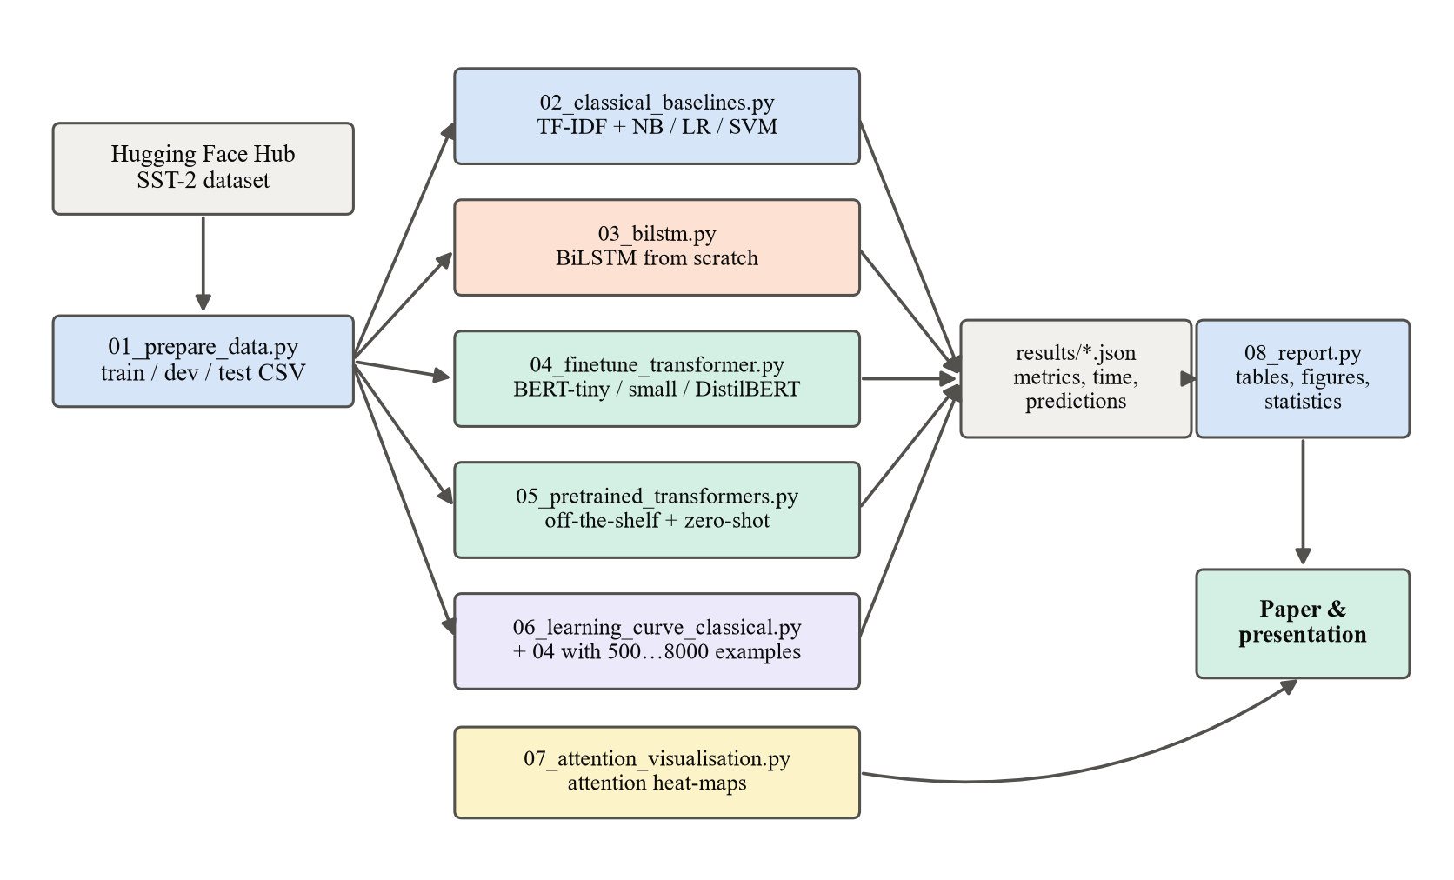
Fig. 3.1. Structure of the developed program (pipeline of Python modules)
The modules are:
- utils.py – shared functions: loading of data splits, computation of metrics, timing and saving of results in JSON format;
- 01_prepare_data.py – downloads SST-2 through the Hugging Face datasets library and writes the train, dev and test splits to CSV files;
- 02_classical_baselines.py – builds the TF-IDF representation and trains the naive Bayes, logistic regression and linear SVM classifiers;
- 03_bilstm.py – implements the tokeniser, the vocabulary and the BiLSTM network in PyTorch and trains it with early model selection on the dev set;
- 04_finetune_transformer.py – a generic fine-tuning program: given the name of any pre-trained encoder from the Hugging Face hub and the number of training examples, it adds a classification head and trains the whole network with AdamW and a linear warm-up schedule;
- 05_pretrained_transformers.py – evaluates the three ready-made models through the Transformers pipeline interface;
- 06_learning_curve_classical.py – trains the classical baseline on the same subsets as the Transformer learning curve;
- 07_attention_visualisation.py – extracts and plots the self-attention weights of a fine-tuned model for an example sentence;
- 08_report.py – collects all JSON results, produces the tables and figures, the subset (negation and contrast) analysis and the statistical tests.
Every model writes a result file with the same structure (model name, family, training size, training time, latency, number of parameters, metrics, confusion matrix and the list of predictions). Saving the individual predictions makes it possible to compute paired statistics and error analyses afterwards without re-running the models.

3.6. The Transformer architecture
This section describes the architecture used by all Transformer models in the experiment. The encoder of the original Transformer (Vaswani et al., 2017), which is the basis of BERT, DistilBERT and RoBERTa, is shown in Figure 3.2. An encoder is a stack of L identical layers; each layer contains a multi-head self-attention sub-layer and a position-wise feed-forward sub-layer, both wrapped with a residual connection and layer normalisation.
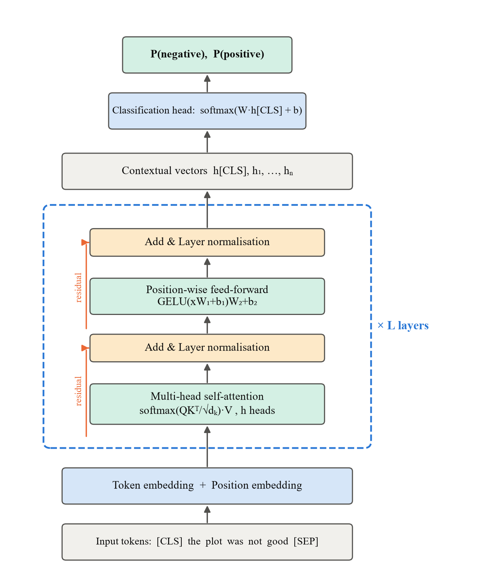
Fig. 3.2. Transformer encoder with a classification head, as used for sentiment classification

3.6.1. Tokenisation and input embeddings
Text is first split into sub-word units. BERT models use WordPiece (Wu et al., 2016) and RoBERTa uses byte-pair encoding (Sennrich et al., 2016). Frequent words are kept whole, while rare words are split into pieces (for example, "unwatchable" → "un", "##watch", "##able"), so the vocabulary is limited (about 30,000 units for BERT) and no word is ever out of vocabulary. A special [CLS] token is added at the beginning of every input and [SEP] at the end. Each token is mapped to a vector of dimension d (d = 128 for BERT-tiny, 512 for BERT-small and 768 for DistilBERT) by an embedding matrix E.

3.6.2. Positional encoding
Self-attention by itself is permutation-invariant: it treats a sentence as a bag of tokens. Information about word order is therefore added to the embeddings. The original Transformer used fixed sinusoidal encodings:
(3.1)
where pos is the position of the token and i is the index of the dimension. BERT-type models instead learn a position embedding vector for each position up to 512. The input of the first layer is the sum of the token embedding and the position embedding: h⁽⁰⁾ₜ = E(wₜ) + P(t).

3.6.3. Scaled dot-product attention
The central operation of the Transformer is attention. Every token representation is projected into three vectors: a query q, a key k and a value v. For a sequence of n tokens these are stacked into matrices Q, K, V ∈ ℝⁿˣᵈᵏ, obtained from the input H by learned projections:
(3.2)
Attention is then computed as:
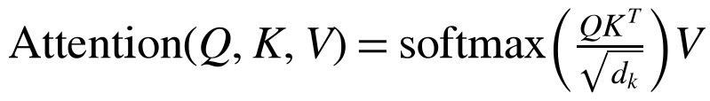 (3.3)
The matrix product Q·Kᵀ gives an n × n matrix of similarity scores between every pair of tokens. The softmax function, applied to each row, turns the scores into weights that are positive and sum to one:
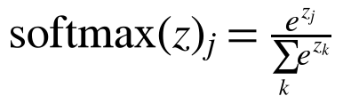 (3.4)
The output for each token is a weighted average of the value vectors of all tokens, so a word can directly gather information from any other word in the sentence regardless of distance. Division by √d_k prevents the dot products from becoming very large for high dimensions, which would push the softmax into regions with extremely small gradients. In our task, for example, the representation of the word "good" in "not good" can attend strongly to "not", which allows the model to represent the negated meaning.

3.6.4. Multi-head attention
Instead of a single attention function, the Transformer runs h attention "heads" in parallel, each with its own projection matrices of dimension d_k = d / h:
(3.5)
Different heads can specialise in different relations, for example one head may link adjectives with the nouns they modify while another links negation words with their scope (Clark et al., 2019). BERT-tiny uses 2 heads, BERT-small 8 heads and DistilBERT 12 heads per layer.

3.6.5. Feed-forward network, residual connections and layer normalisation
After attention, each position is processed independently by a two-layer feed-forward network:
(3.6)
where the inner dimension is usually 4d and GELU is the Gaussian error linear unit activation used in BERT (the original Transformer used ReLU). Each sub-layer is wrapped by a residual connection followed by layer normalisation (Ba et al., 2016):
(3.7)
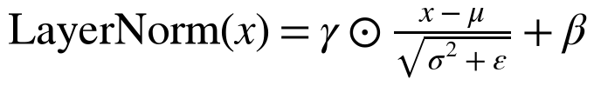 (3.8)
where μ and σ² are the mean and variance of the vector x, and γ and β are learned parameters. Residual connections allow gradients to flow through deep stacks, and normalisation stabilises training.

3.6.6. Computational complexity
Self-attention compares every token with every other token, so one layer requires O(n²·d) operations for a sequence of length n, compared with O(n·d²) for a recurrent layer. However, all n positions are computed in parallel, whereas a recurrent network needs n sequential steps. For short and medium sequences (n < d), which is the case for sentences, self-attention is both faster and better at modelling long-range dependencies. For very long documents the quadratic cost becomes a limitation, which motivated efficient Transformer variants (Tay et al., 2022). In our experiment the maximum length was set to 64 tokens, which covers more than 99% of SST-2 sentences.

3.7. Mathematical methods of training and evaluation

3.7.1. Pre-training objective
BERT-type encoders are pre-trained by masked language modelling. A random 15% of the input tokens are selected; most of them are replaced by a [MASK] token, and the model is trained to predict the original tokens from the context. If M is the set of masked positions, the loss is
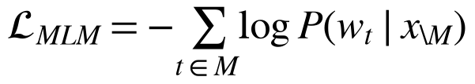 (3.9)
Because the model sees the context on both sides of the masked word, it learns deep bidirectional representations. DistilBERT is additionally trained to imitate the output distribution of the BERT-base teacher (knowledge distillation). Pre-training is extremely expensive (days on many GPUs or TPUs), therefore in this project we use publicly released pre-trained weights and only perform the fine-tuning step.

3.7.2. Fine-tuning for classification
For classification, the final hidden vector of the [CLS] token, h_CLS ∈ ℝᵈ, is used as the representation of the whole sentence. A new classification layer with weights W ∈ ℝ²ˣᵈ and bias b is added on top:
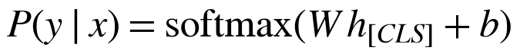 (3.10)
All parameters (the pre-trained encoder and the new layer) are trained together by minimising the cross-entropy loss over the training set:
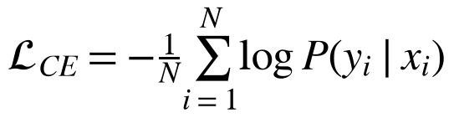 (3.11)

3.7.3. Optimisation
Parameters are updated with AdamW (Loshchilov & Hutter, 2019), a variant of Adam (Kingma & Ba, 2015) with decoupled weight decay. For gradient gₜ at step t:
(3.12)
where m̂ₜ and v̂ₜ are bias-corrected moment estimates, λ = 0.01 is the weight decay and ηₜ is the learning rate. The learning rate follows a linear schedule: it grows from 0 to its peak value during the first 10% of steps (warm-up) and then decreases linearly to 0. Warm-up prevents large, destructive updates of the pre-trained weights at the beginning of training. Gradients are clipped to a maximum norm of 1.0. The hyper-parameters used are shown in Table 3.3; they follow the recommendations of Devlin et al. (2019) and Sun et al. (2019), with a higher learning rate for the smallest models, which is usual for compact BERT variants.
Table 3.3. Fine-tuning hyper-parameters
Hyper-parameter | BERT-tiny | BERT-small | DistilBERT
Layers / hidden size / heads | 2 / 128 / 2 | 4 / 512 / 8 | 6 / 768 / 12
Training examples | 8 000 | 8 000 | 8 000
Epochs (best epoch kept by dev accuracy) | 3 | 3 | 2
Peak learning rate | 2·10⁻⁴ | 1·10⁻⁴ | 5·10⁻⁵
Batch size / maximum length | 32 / 64 | 32 / 64 | 32 / 64
Warm-up / schedule | 10% / linear | 10% / linear | 10% / linear
Weight decay / gradient clipping | 0.01 / 1.0 | 0.01 / 1.0 | 0.01 / 1.0

3.7.4. TF-IDF representation
For the classical models every sentence is represented as a sparse vector of TF-IDF weights of unigrams and bigrams:
(3.13)
where tf(t, d) is the frequency of term t in sentence d (logarithmically damped), N is the number of sentences and df(t) is the number of sentences containing t. Each vector is normalised to unit length. Terms that appear in fewer than two training sentences are ignored. TF-IDF gives high weights to words that are frequent in a sentence but rare in the collection, but it ignores word order beyond bigrams and cannot represent the meaning of unseen words.

3.7.5. Classical classifiers
Multinomial naive Bayes applies Bayes' theorem with the assumption that features are conditionally independent given the class: P(y | x) ∝ P(y) Πⱼ P(tⱼ | y)^(xⱼ), with Laplace (additive) smoothing α = 0.5.
Logistic regression models the probability of the positive class as P(y = 1 | x) = σ(wᵀx + b), where σ(z) = 1 / (1 + e⁻ᶻ), and minimises the L2-regularised log-loss (inverse regularisation strength C = 4).
The linear support vector machine finds the hyperplane with the maximum margin by minimising the regularised hinge loss:
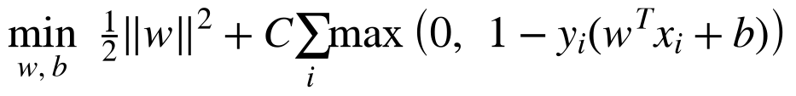 (3.14)
with labels coded as yᵢ ∈ {−1, +1} and C = 0.5.

3.7.6. Bidirectional LSTM
The recurrent baseline processes the sequence of word embeddings with an LSTM cell (Hochreiter & Schmidhuber, 1997), defined by the gates:
(3.15)
(3.16)
The forget, input and output gates (fₜ, iₜ, oₜ) control what information is kept in the memory cell cₜ. A bidirectional LSTM runs one LSTM from left to right and another from right to left and concatenates their hidden states. The sentence representation is obtained by max-pooling over time, followed by dropout (p = 0.3) and a linear output layer. Embeddings (dimension 128) and all weights are initialised randomly, i.e. the model has no pre-trained knowledge. It is trained for 4 epochs with Adam (learning rate 0.001, batch size 64), and the epoch with the best dev accuracy is kept.

3.7.7. Zero-shot classification by natural language inference
An NLI model receives a premise p and a hypothesis h and predicts whether p entails, contradicts or is neutral to h. For zero-shot classification (Yin et al., 2019), the sentence is used as the premise and, for each candidate label c, a hypothesis is built from a template, here "The sentiment of this movie review is c." The entailment scores of the candidate labels are normalised with softmax, and the label with the highest entailment probability is predicted:
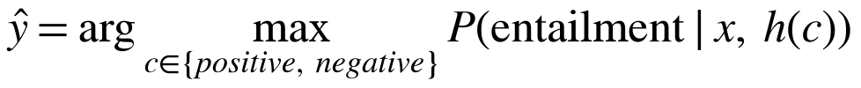 (3.17)
No sentiment-labelled data are used, so the method shows how much a Transformer can achieve purely from general language understanding.

3.7.8. Evaluation metrics and statistical tests
With TP, TN, FP and FN denoting true positives, true negatives, false positives and false negatives:
(3.18)
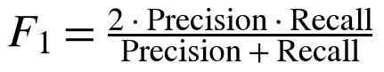 (3.19)
Precision, recall and F1 are computed for each class and averaged (macro average), so both classes have equal weight.
The test set contains only 872 sentences, so a difference of one percentage point corresponds to about nine sentences. To quantify uncertainty, 95% confidence intervals of accuracy are estimated with the bootstrap: the test set is resampled with replacement 2,000 times, accuracy is computed for each resample, and the 2.5th and 97.5th percentiles are taken. To test whether two models differ significantly, McNemar's test is applied to their paired predictions. If b is the number of sentences classified correctly only by model A and c the number classified correctly only by model B, then under the null hypothesis of equal accuracy b ~ Binomial(b + c, 0.5). We use the exact binomial version of the test, with significance level 0.05.

