CDACL-003
Supply Chain Analysis Report
Diagnostic Report & Power BI Dashboard Analysis
Beauty & Personal Care | 100 SKUs | 5 Cities | 5 Suppliers

Key Performance Summary
Metric | Value | Status
Total Revenue | ₹5,77,600 | Strong
Units Sold | 46,099 | Healthy
Total Supply Cost | ₹52,924.58 | Monitor
Avg Defect Rate | 2.28% | Needs Improvement
Avg Lead Time | 15.96 days | Acceptable
Avg Shipping Cost | ₹5.55 | Stable
SKU Count | 100 | Full Portfolio

1. Introduction
This report presents a complete diagnostic analysis of the supply chain for a Beauty & Personal Care company, covering 100 SKUs across three product categories: Skincare, Haircare, and Cosmetics. The analysis is based on the supply chain dataset (CDACL-003) and the Power BI dashboard built from it.
The dataset encompasses 24 attributes spanning product details, supplier information, logistics, manufacturing metrics, and quality control indicators across 5 Indian cities: Mumbai, Delhi, Kolkata, Chennai, and Bangalore.

1.1 Objectives
- Analyse revenue performance across product types and geographies
- Evaluate supplier performance on cost, lead time, and defect rates
- Identify logistics and shipping inefficiencies
- Benchmark product quality and manufacturing efficiency
- Provide actionable recommendations for supply chain optimisation

2. Dataset Overview
The dataset contains 100 records, each representing a unique SKU with complete supply chain attributes. Key dimensions include:
- Product Categories: Skincare (40 SKUs), Haircare (34 SKUs), Cosmetics (26 SKUs)
- Supplier Cities: Kolkata (25), Mumbai (22), Chennai (20), Bangalore (18), Delhi (15)
- Suppliers: Supplier 1 through Supplier 5 — varied in cost, lead time, and volume
- Transportation: Road (29%), Rail (28%), Air (26%), Sea (17%)
- Shipping Carriers: Carrier A, B, C — with near-identical average costs (₹5.51–₹5.60)

3. Power BI Dashboard Overview
The Power BI dashboard provides a comprehensive view of all key supply chain KPIs in a single management screen. The full dashboard is shown below:
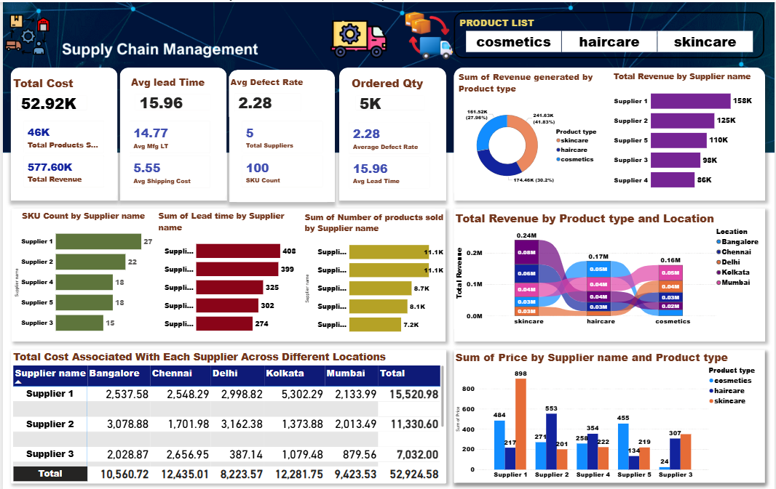
The dashboard is structured into four quadrants: KPI cards (top left), product revenue charts (top right), supplier analysis (middle), and geographic and pricing analysis (bottom).

4. Revenue Analysis

4.1 Revenue by Product Type
Total revenue across all SKUs is ₹5,77,600. The donut chart below from the Power BI dashboard shows the breakdown by product type:
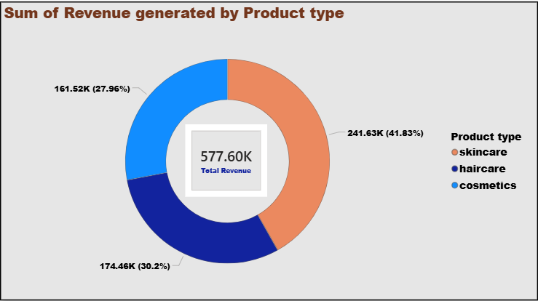
Product Type | Revenue (₹) | Share (%)
Skincare | 2,41,630 | 41.83%
Haircare | 1,74,460 | 30.20%
Cosmetics | 1,61,520 | 27.96%
Total | 5,77,600 | 100%

Skincare dominates the revenue mix at 41.83%, driven by a higher number of SKUs (40) and strong demand. Cosmetics, while third in revenue share, presents the best margin opportunity given its lowest manufacturing cost (₹43.05 avg) and lowest defect rate (1.92%).

4.2 Revenue by Supplier Name
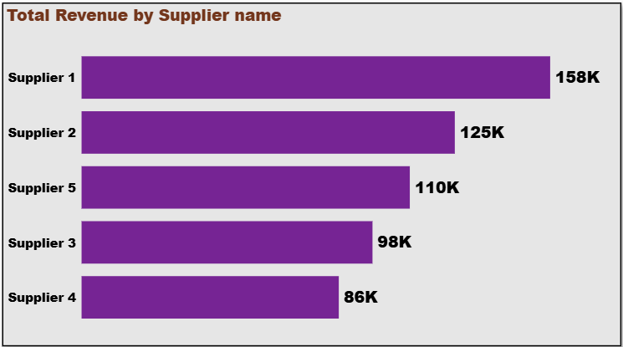
Supplier | Total Revenue (₹) | Revenue Share
Supplier 1 | 1,58,000 | 27.4%
Supplier 2 | 1,25,000 | 21.7%
Supplier 5 | 1,10,000 | 19.1%
Supplier 3 | 98,000 | 17.0%
Supplier 4 | 86,000 | 14.9%

Supplier 1 is the clear revenue leader with ₹158K despite having only 27 SKUs, indicating higher-value products or stronger demand pull. Supplier 4, with 18 SKUs, generates the least revenue — indicating a need for portfolio review.

4.3 Revenue by Product Type and Location
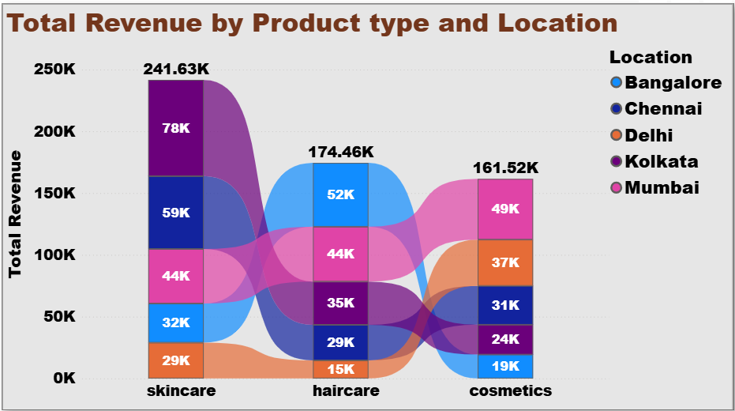
The ribbon/Sankey chart reveals regional strengths: Kolkata and Mumbai are the strongest markets overall (₹137K each). Bangalore leads in Haircare (₹52K), while Kolkata dominates Skincare (₹78K). Delhi underperforms across all categories with only ₹81K total.

5. Supplier Performance Analysis

5.1 SKU Count by Supplier
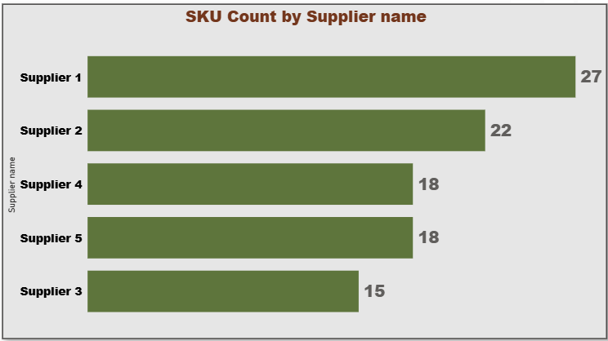
Supplier 1 manages the widest portfolio (27 SKUs = 27% of total). Supplier 3 has the smallest portfolio (15 SKUs). Portfolio breadth does not directly correlate with revenue — Supplier 1 also leads in revenue, but Supplier 4 has the same SKU count as Supplier 5 (18 each) yet generates less revenue.

5.2 Lead Time Analysis
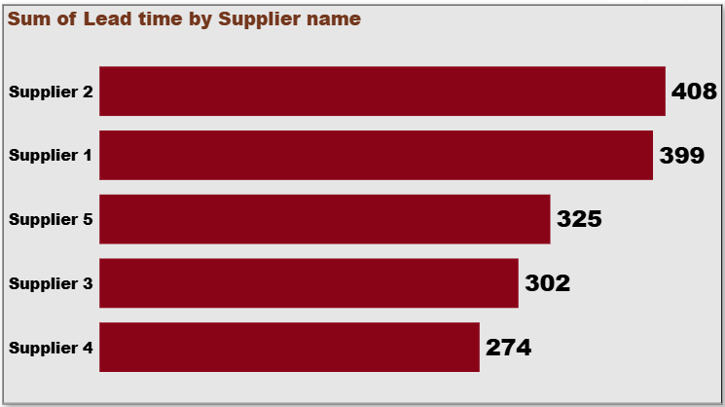
Supplier | Total Lead Time (days) | Avg Lead Time (days)
Supplier 2 | 408 | 18.5
Supplier 1 | 399 | 14.8
Supplier 5 | 325 | 18.1
Supplier 3 | 302 | 20.1
Supplier 4 | 274 | 15.2

Supplier 2 accumulates the highest total lead time (408 days), reflecting a large SKU count and longer cycle times. Supplier 4 is the most efficient with only 274 total lead time days. Supplier 3 has the worst average lead time at 20.1 days despite having the fewest SKUs.

5.3 Products Sold by Supplier
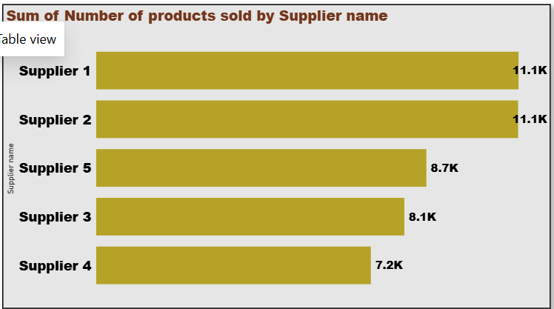
Suppliers 1 and 2 are tied at the top with 11,100 units each. Supplier 4 lags at 7,200 units. This suggests that Supplier 4 has lower product velocity despite an adequate portfolio size — potential pricing or quality issues.

5.4 Supplier Performance Scorecard (from Supplier Dataset)
Supplier | Cost/Unit (₹) | Lead Time (days) | Defect Rate (%)
Supplier A | 50 | 5 | 2%
Supplier B | 45 | 7 | 1%
Supplier C | 55 | 4 | 3%

From the dedicated supplier performance dataset: Supplier B offers the best value proposition — lowest cost per unit (₹45) and lowest defect rate (1%). Supplier C is the weakest: highest cost (₹55) and highest defect rate (3%), though it has the shortest lead time (4 days).

6. Cost Analysis

6.1 Total Cost Across Locations
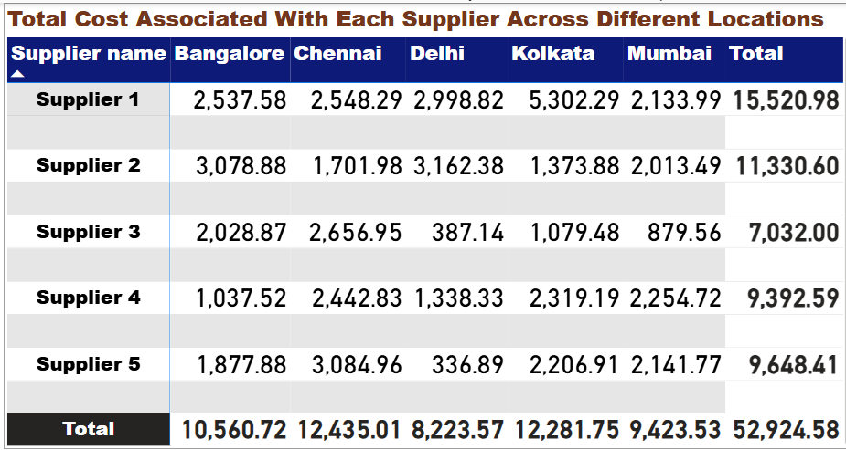
Total supply chain cost across all suppliers and cities is ₹52,924.58. Supplier 1 alone accounts for ₹15,520.98 (29.3% of total costs), driven by high presence in Kolkata (₹5,302). Supplier 3 is the most cost-efficient at ₹7,032 total. Chennai is the costliest city overall (₹12,435), while Delhi is the cheapest (₹8,223).

6.2 Price by Supplier and Product Type
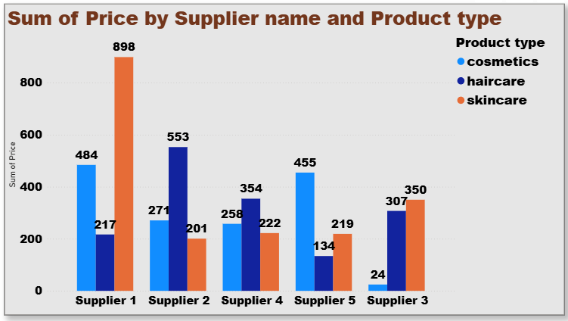
Supplier 1 commands the highest pricing across all three categories, especially in Skincare (₹898 sum). Supplier 3 has an extremely low cosmetics price sum (₹24 only), suggesting very limited cosmetics involvement. Supplier 2 leads in Haircare pricing (₹553). This pricing analysis reveals that Supplier 1 is the most premium-positioned partner across the entire portfolio.

7. Quality Control & Manufacturing
Product Type | Avg Defect Rate | Avg Mfg Cost (₹) | Avg Lead Time (days)
Cosmetics | 1.92% | 43.05 | 15.5
Skincare | 2.34% | 48.99 | 15.8
Haircare | 2.48% | 48.46 | 16.6

Cosmetics is the most operationally efficient product line — lowest defect rate (1.92%), lowest manufacturing cost (₹43.05), and shortest average lead time (15.5 days). Haircare requires the most attention: it has the highest defect rate (2.48%) and the longest lead time (16.6 days). A large portion of inspection results are marked 'Pending', indicating a quality control bottleneck that needs to be resolved urgently.

8. Product Comparison Summary
Metric | Skincare | Haircare | Cosmetics
SKU Count | 40 | 34 | 26
Total Revenue (₹) | 2,41,630 | 1,74,460 | 1,61,520
Revenue Share | 41.83% | 30.20% | 27.96%
Avg Price (₹) | 49.4 | 50.1 | 48.8
Avg Mfg Cost (₹) | 48.99 | 48.46 | 43.05
Avg Defect Rate | 2.34% | 2.48% | 1.92%
Avg Lead Time (days) | 15.8 | 16.6 | 15.5

Skincare wins on revenue and volume. Cosmetics wins on efficiency (cost, defects, speed). Haircare is a revenue contributor but operationally the weakest category — it needs quality investment to realise its pricing potential (₹50.1 avg).

9. Key Recommendations

9.1 Revenue & Product Strategy
- Scale Skincare production: With ₹2.41L revenue and 40 SKUs, skincare is the primary growth lever. Expand product variants in top-performing cities (Kolkata, Mumbai).
- Invest in Cosmetics margins: Lowest manufacturing cost (₹43.05) and defect rate (1.92%) make cosmetics the margin champion. Premium-price the category for better ROI.
- Improve Haircare quality: Highest defect rate (2.48%) must be brought to below 1.5% through tighter QC and supplier accountability.

9.2 Supplier Strategy
- Prioritise Supplier 1 for volume: Best revenue (₹158K) and SKU breadth (27). However, at ₹15,521 supply cost, negotiate volume discounts.
- Leverage Supplier B / Supplier 3 (cost): Supplier 3 has the lowest total cost (₹7,032). Supplier B in the scorecard has the best defect rate (1%). Use both for cost-optimised procurement.
- Fix Supplier 2 lead times: 408 total lead days is unacceptable. Set contractual SLAs with penalty clauses.
- Diversify Supplier 3 cosmetics portfolio: Currently only ₹24 in cosmetics pricing — a single-category dependency risk.

9.3 Geographic Expansion
- Delhi growth push: Lowest total revenue (₹81K) despite being a major consumption city. Dedicated marketing and distribution investment required.
- Leverage Bangalore's haircare strength: Bangalore leads haircare revenue (₹52K). Expand haircare SKUs in this market.

9.4 Logistics Optimisation
- Reduce air freight: Air accounts for 26% of shipments but is the costliest mode. Shift non-urgent orders to Rail or Sea.
- Maximise Sea freight: Currently only 17% usage despite best long-haul cost efficiency. Target 25–30% for coastal routes.
- Carrier SLA review: All 3 carriers have near-identical cost (₹5.51–5.60). Negotiate on delivery time and reliability, not price.

9.5 Quality & Operations
- Clear inspection backlog: Large number of SKUs have 'Pending' inspection results. Establish 48-hour QC closure SLA.
- Manufacturing cost audit: Skincare has the highest average manufacturing cost (₹48.99) but generates the most revenue. A cost reduction of 10% here would yield ₹4,800+ annual savings.
- Digitise supply chain tracking: Implement real-time visibility tools for lead time monitoring across all 5 suppliers.

10. Conclusion
This supply chain analysis reveals a company with strong revenue fundamentals (₹5.77L) but clear operational improvement opportunities. The three product lines each play a distinct strategic role:
- Skincare: Revenue engine — protect and grow
- Cosmetics: Efficiency leader — scale for margin improvement
- Haircare: Quality laggard — invest in QC and lead time reduction

On the supplier side, Supplier 1 is the strategic anchor for volume and premium pricing, while Suppliers 3 and B offer the best cost efficiency. The company should use a dual-supplier strategy: Supplier 1 for growth, Supplier 3/B for cost control.

Geographically, Delhi is the single biggest growth opportunity. A targeted investment of ₹10–15L in distribution and marketing in the NCR region could add ₹25–35K in annual revenue within 12 months.

With these focused interventions — supplier SLA enforcement, cosmetics scaling, air freight reduction, and Delhi expansion — the company can target a 15–20% revenue uplift and a 10% reduction in supply chain costs within the next fiscal year.

— End of Report —
CDACL-003 | Supply Chain Analytics | Beauty & Personal Care

