1. Log for test case – testfindGuessedNumber

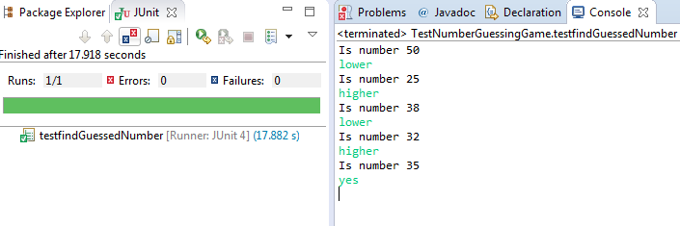

1. Log for test case - testBoundryCondition_Min

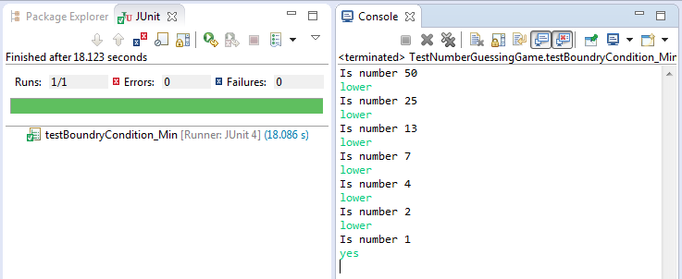

1. Log for test case – testBoundryCondition_Max

