Below is the list of issues identified till now in CPMS.
Issues under Release /ADMIN tab

- If code is changed to V185 instead of V182, we have a dialogue box saying ‘UPDATED & INSERTED’ instead of an error message. And then after submission, it is saved as to original value (V182).

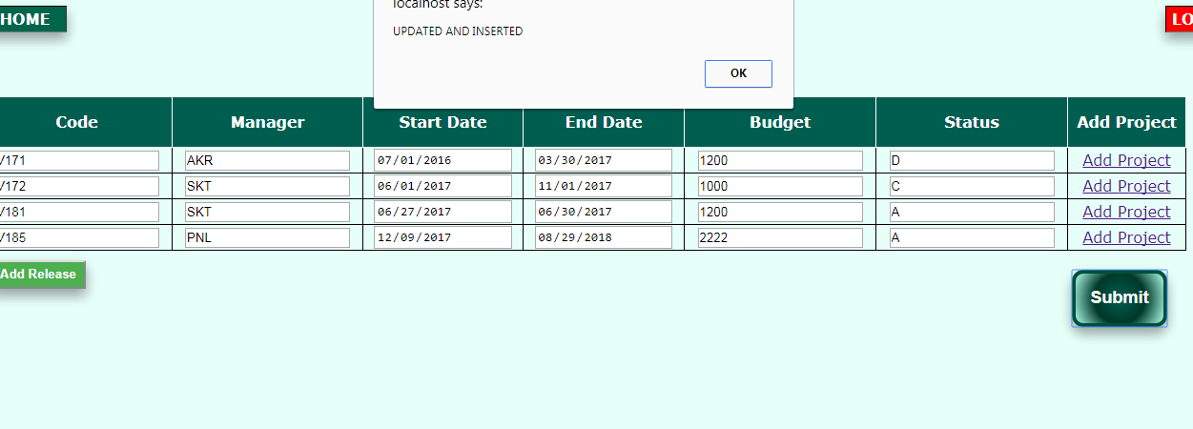
- Also, msg should only be ‘UPDATED successfully’ incase an existing row is updated.
And in case of insertion ’INSERTED successfully’ .

- Manager column should be a dropdown for updation too.
Invalid manager entries are allowed as of now(as above), although after final updation value remains as the original value(if we try to update with invalid entries).

- Invalid ‘Status’ is allowed to be entered as of now .(should be a dropdown).
Also, a row can be updated or inserted with invalid Stutus too.(in the screenshot above, value ‘D’ is inserted)

Add PROJECT hyper link under > Release /ADMIN
- Add project hyperlink should take to only a particular release projects selected.
Release should be the first column in the data table. Also, it should be displayed as prefilled and un-editable field as per the row clicked in release.
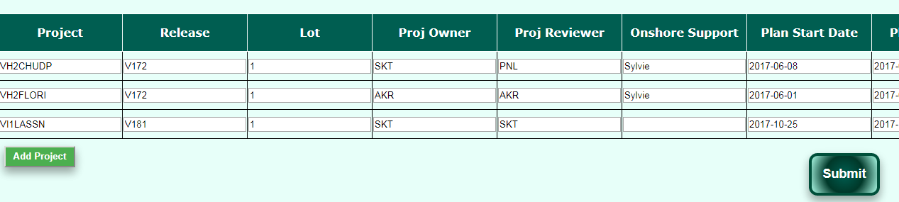
- if point 8 is implemented we can keep a check that we enter correct project name(prefix) like for V171 (VH1****)

- For Updation too, colmns must have drop down for lot , Proj owner, Prject reviewer.Out of which, Lot is being updated wrongly where as the other 2 colmns get the original values if wrong values are entered and instead of having error msg of invalid values entered.We get the message ‘INSERTED & UPDATED’.

- Updation of dates should be from calendar. And invalid date entries should not be allowed

Add task after Add PROJECT hyper link

- Task details not visible after insertion(only 5 rows displayed at a time)

- Project should not be editable. 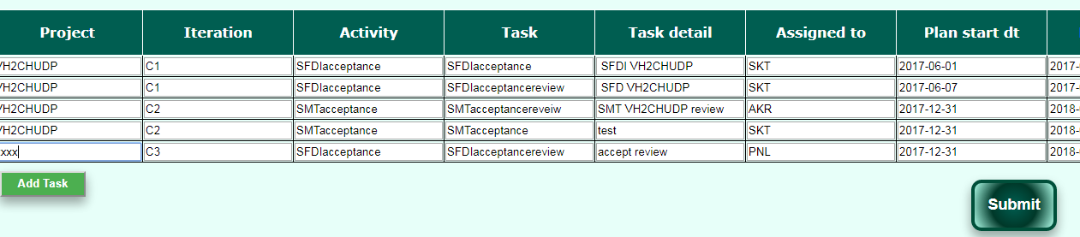

- All the columns having dropdown during insertion should have the same during for updation too otherwise wrong values can be entered. And in some cases, the invalid values are updated where as in some case original values are restored.
This seems a general point for all tables.

- Authority for the admin tab. Everyone should not be allowed to update activities under this tab.

ADMIN/USERS

- Same issues with the table as in Pnt 15.

- Possible set of roles can be defined as dropdown can be made for the same.

ACTIVITY REPORT

- Effort in PD(for a day) to be less than 1 and in multiples of 5(no task to be less than 2 hours)

- Database can be modified to add another column(Actual Budget), RAE should be calculated from it(should not be editable).-->to avoid checking RAE left each time.
Then, RAE can be highlighted for negative values. (That is,for the task running over budget).
Need to check if this is feasible?
When updating for the first time, for a particular combination (Date, Release, Project, Activity, Task, Task detail), we can manually feed Actual Budget.
Each time, we can forcast in the database if rows already exist for such combination, we will fetch Actual Budget and effort from all rows.
RAE = Actual Budget – (sum of effort from above fetched rows)

- Can we keep a track of the effort of a person not exceeding 1 for a day?

- Actual budget for a particular task(Sum of actual budget if a task is assigned to more than 1 person) should not exceed the Planned budget(updated in via ‘add task’).

- Submission leads to successful addition of rows, even if nothing is selected in the row added.

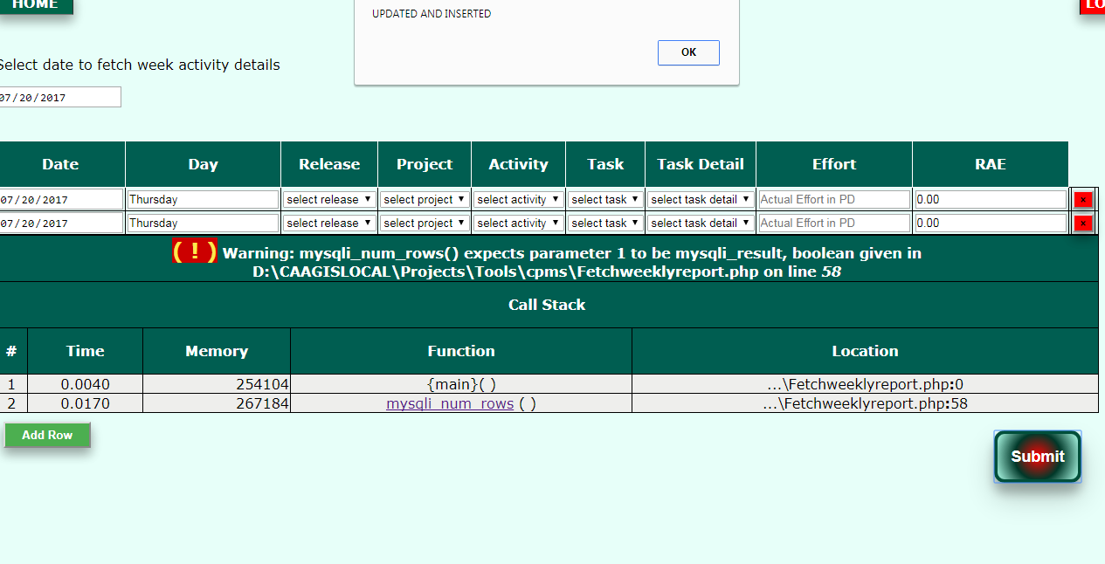

- Should it be allowed to enter such date? We should have a a calendar in a particular range.

