1. What should be the output of the following Script?
v <- c( 2,5.5,6)
t <- c(8, 3, 4)
print(v%/%t)
Answer: 0 1 1
2. You have 25 excel files with names as xx_1.xlsx, xx_2.xlsx,........xx_25.xlsx in a dir.
Write a program to extract the contents of each excel sheet and make it one df.
#load library for xlsx
library (xlsx)
#set the current working directory
setwd ("C://Users//USER_ADMIN//Desktop//R-")
#get all the names of the xlsx files
xlxfilenames = list.files (pattern = "*.xlsx")
data <- lapply (xlxfilenames, function(x) read.xlsx(x, sheetIndex = 1))
#loop to bind the data at row level
for (i in xlxfilenames)
{
data <- rbind(data, read.xlsx(i, sheetIndex = 1))
}
3. If the above 25 files were csv files, what would be your script to read?
Answer: There are many ways out of which one is mentioned below for your reference.
#set working directory
setwd ("C://Users//USER_ADMIN//Desktop//R-")
#reading names of all csv’s in the current working directory
xlfilenames <- list.files (pattern = "OfficeSupplies_*.csv")
#Now we need a place where in read data needs to be stored, hence creating the empty list
xlFullData <- list ()
#Now start reading the data into list from csv
for (i in 1: length (xlfilenames))
{
xlFullData [[i]] <- read.csv (xlfilenames[i])
}
In the current working directory I have below set of CSV files. One is full and another are partial or say created out of full to showcase this example.
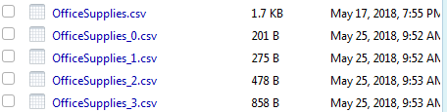
Here first file OfficeSupplies.csv is a full file and others are part of this main file.
