- What are the different methods to call a function in R?
Answer: There are several ways/methods to call a function in R, some are below:
    - We can use directly with the name for example sum(arguments..)
x <-1:4
sum(x) # This is one of the way to call function.
    - Another method is call () example:
this is unevaluated call, so we have a vector called x from point above, using the same
x<-1:4
call(“sum”,x)
#Now it will return sum(1:4) but we will not have final result until it get evaluated
eval(call(“sum”,x)) # Now this will return 10 as final result.
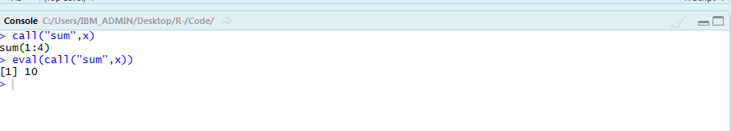
There are other as well like do.call() and recall but I did not had any practicals on that.
- The lazy evaluation of a function means, the argument is evaluated only if it is evaluated only if it is used inside the body of the function. FALSE
- State True or False:
  - Insights driven from descriptive analytics is not meaningful. FALSE
  - The number of values in each Elements of a list, should be equal. TRUE
  - The datasets are not stored in memory of the computer using R. FALSE
  - Data frames and matrices are two dimensional however the array is multidimensional. TRUE

